GitHub: Crdz97 https://github.com/crdz97/csd-380.git
GitLab: https://github.com/BobbyJoeCool/GitLab.git
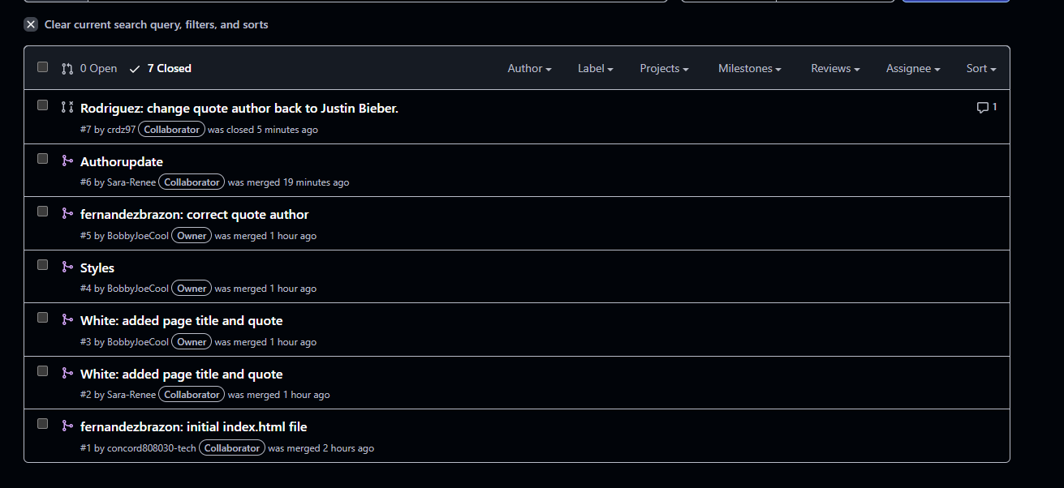
Under styles, committed
