Lightweight Shallow RGB-Thermal Fusion for Roadside Object Detection: Design and Controlled Evaluation
Abstract
Lightweight RGB-thermal detection needs modality-specific representation without excessive inference cost. We implement a YOLO11n shallow dual-branch framework with gated branch fusion (GBF): per-channel means and standard deviations from visible and thermal features condition a channel-wise mixing gate. We compare GBF with four-channel input concatenation (Concat), equal-weight two-branch fusion (TBF), and learned static channel weighting (GSW) on sequence-disjoint R-LiViT data. Concat, GSW, and GBF have three training seeds; TBF is a seed-0 control. GSW attains the highest three-seed mean average precision (mAP) at 0.50 and 0.50–0.95 intersection-over-union thresholds (60.42%/39.40%) at 91.1 frames per second (FPS), whereas GBF attains 59.78%/39.26% at 84.9 FPS. The proposed gate supplies explicit input-conditioned weighting, but does not yield a consistent improvement over static weighting under this protocol.
Keywords: RGB-thermal detection; shallow feature fusion; input-conditioned gating; lightweight object detection; sequence-disjoint evaluation
Acknowledgments: The authors thank the creators of the R-LiViT and LLVIP datasets for making their data available to the research community.
1. Introduction
Roadside object detection faces strong illumination changes, glare, shadows, and nighttime operation. Visible imagery supplies texture and color, while thermal imagery can preserve target contrast under poor light. R-LiViT provides paired roadside RGB and thermal frames [1]; KAIST [2] and LLVIP [3] offer related multispectral settings with different tasks and evaluation protocols. These complementary signals motivate a compact fusion design, but extra branches and conditional gates also consume parameters and inference time. The question is how to construct a traceable shallow fusion interface and whether input conditioning adds a repeatable benefit.
Multispectral detectors use channel exchange, supervised spatial fusion, cross-attention, channel switching, and transformer-based weighting [4–8]. Their backbones, fusion locations, supervision, and compute budgets differ. This makes published accuracy numbers unsuitable as a matched test of a specific shallow gating mechanism. We therefore compare fixed, static-learned, and input-conditioned weighting within one shared detector, while reporting the design and cost of the proposed gate explicitly.
The study asks four bounded questions. RQ1 concerns the design of a modality-specific shallow interface within YOLO11n and the seed-0 observation from an equal-weight branch control. RQ2 compares learned static and input-conditioned channel weights at that interface. RQ3 asks whether any GBF gain over static weighting persists across seeds and justifies its compute cost. RQ4 examines illumination, test-sequence composition, protocol sensitivity, and a separately retrained LLVIP check. The projected-depth branch is exploratory.
Our implementation replaces YOLO11n's first Conv–Conv–C3k2 sequence with independent visible and thermal encoders that meet at the P2/4 interface; the remaining detector is shared. GBF computes per-channel means and standard deviations from both feature maps and predicts complementary channel weights with a 16-unit perceptron. Concat uses RGB (three channels) plus thermal (one channel) as a four-channel input. TBF fixes equal weights after the two stems, and GSW learns 64 input-independent channel coefficients. Concat-to-TBF changes more than one architectural property, so the sequence is a set of interpretable configurations, not a series of perfectly isolated causal interventions.
This work makes three contributions. First, it provides an implemented lightweight dual-branch RGB-thermal detector and an explicit statistics-conditioned, channel-wise GBF mechanism, including initialization and model-graph replacement details. Second, it evaluates GBF against matched simple weighting rules with sequence-disjoint selection and held-out testing, three seeds for Concat/GSW/GBF, and a seed-0 TBF control. Third, it relates accuracy to parameter count, forward speed, gate behavior, and protocol-sensitive uncertainty. The evidence bounds the method's benefit: GSW has the strongest observed three-seed mean, and GBF does not show a consistent additional gain.
The main evidence is the three-seed accuracy and computational comparison. Seed-0 TBF, gate diagnostics, illumination and class breakdowns, and fixed-checkpoint sequence bootstrap help interpret that comparison without being promoted to stable causal or significance claims. Late fusion and separately retrained LLVIP models are supporting checks. Projected depth is confined to an exploratory extension because calibration uses annotations and pre-filling depth coverage is sparse.
Section 2 positions this design against related fusion interfaces. Section 3 specifies the datasets, sequence-disjoint protocol, and measurements. Section 4 defines GBF and the control configurations. Section 5 reports accuracy, cost, diagnostics, and supporting checks. Sections 6 and 7 discuss the observed boundary of input-conditioned fusion and conclude.
2. Related Work
2.1. Multispectral datasets and fusion interfaces
Multispectral detection spans different task definitions and evaluation measures. The KAIST benchmark combines visible and thermal channels for pedestrian detection and evaluates performance across day/night, scale, and occlusion conditions [2]. Its multispectral ACF baseline augments visible descriptors with thermal intensity and gradients. KAIST therefore provides historical context for multispectral sensing, but its handcrafted features and pedestrian miss-rate protocol are not numerically interchangeable with the multiclass AP evaluation used here.
LLVIP provides registered visible–infrared pairs for low-light vision [3]. Its original paper describes 16,836 pairs, while later method papers describe different inventories and split sizes [7], [8]. Our source test folders contain 3,463 pairs; an earlier local build covered only 2,673 because 790 tail stems were omitted by truncation. Section 3.5 describes the complete local inventory and the dataset-specific retraining check.
R-LiViT extends roadside perception with RGB, thermal, and LiDAR recordings and both image-space and three-dimensional annotations [1]. Its published RGB–thermal benchmark combines predictions from separate detectors by NMS, uses a common-field-of-view crop, and reports a three-seed summary. These choices differ from our compact, single-detector setup; Table 7 lists the protocol differences without using published scores for an accuracy ranking.
2.2. Learned modality interaction
MBNet addresses modality imbalance through differential feature exchange and illumination-aware alignment [4]. Its differential module globally pools a difference feature, predicts tanh channel weights, and exchanges complementary information through residual paths at multiple ResNet blocks. This is a relevant precedent for compact pooled descriptors that regulate cross-modal interaction. GBF instead concatenates per-branch means and sample standard deviations and performs a single shallow channel mixture. This distinction defines the present implementation; it does not show that a single fusion location is superior to repeated interaction or that mean/std descriptors outperform differential statistics.
GAFF predicts intra-modality foreground masks and inter-modality spatial weights with supervision derived from detection annotations [5]. Its weights therefore operate at individual spatial locations, whereas GBF broadcasts one mixing coefficient over each feature channel and adds no auxiliary guidance. A controlled comparison would need to account for both the weighting granularity and the supervision strategy; a direct comparison of published scores would not isolate the fusion operator.
ICAFusion iteratively refines modality features with paired cross-attention modules and reduces spatial features to manage attention cost [6]. Both ICAFusion and GBF constrain fusion complexity, but they do so differently: ICAFusion retains spatial-token interaction, whereas GBF compresses each feature channel to mean and standard-deviation statistics before predicting a mixture. This motivates reporting gate dimensions and measured forward time, but it does not support direct speed or accuracy ranking without a common detector, input pipeline, and hardware configuration.
CSSA combines channel switching with spatial attention [7]. Channel scores are obtained from global average pooling and a one-dimensional convolution, and selected channels are replaced by their counterparts from the other modality before spatial weighting. GBF instead uses continuous complementary coefficients and does not introduce spatial attention at the fusion interface. CSSA is therefore a relevant candidate for future common-backbone comparison, but its published two-stream detector is not equivalent to replacing only the operator used in the present shallow interface.
DaFF combines transformer attention with channel-wise attention in a YOLOv5-based multispectral detector [8]. Its channel module concatenates modality features, applies a 1 x 1 convolution, pools spatially, and predicts weights through fully connected layers and softmax. This provides another direct precedent for learned fusion from pooled descriptors. GBF is distinguished here only by its mean/std descriptor, complementary two-branch coefficients, and shallow shared-detector interface; the current ablations do not establish superiority over DaFF's broader spatial-and-channel design.
Table 1. Design-level comparison of representative multispectral fusion methods. Accuracy and parameter costs from different papers are not ranked because architectures and protocols are not matched.
Method | Fusion stage / interface | Input conditioning or descriptor | Weighting scope | Complexity and detector context
MBNet [4] | Repeated residual exchange across multiple stages | Yes; pooled inter-modal difference feature with tanh prediction | Channel weights, spatially broadcast | ResNet-based multispectral detector; not evaluated under the present budget
GAFF [5] | Supervised intermediate fusion | Yes; detection-derived foreground masks | Spatial weighting | Task-aligned supervision; not directly comparable in parameter cost
ICAFusion [6] | Iterative intermediate fusion | Yes; cross-attention between modality tokens | Token / spatial interaction | Repeated attention interaction; not directly comparable in parameter cost
CSSA [7] | Cross-modal feature exchange with attention | Yes; pooled descriptors processed by 1-D convolution | Channel and spatial weighting | Published multispectral detector; not evaluated under the present budget
DaFF [8] | Dual-stream transformer fusion | Yes; fused features pooled and mapped to softmax weights | Channel and spatial weighting | YOLOv5-based detector with transformer processing
GSW (ours) | Single shallow P2/4 fusion interface | No; learned input-independent per-branch vectors | Channel weights, spatially broadcast | +11,408 model parameters over Concat; YOLO11n
GBF (ours) | Single shallow P2/4 fusion interface | Yes; per-branch channel mean and standard deviation | Channel weights, spatially broadcast | +16,544 model parameters over Concat; YOLO11n
These studies establish relevant fusion precedents, rather than an absence of adaptive mechanisms. Our contribution is the specific YOLO11n P2/4 dual-branch implementation, a mean/std-conditioned channel gate, and matched evaluation of equal, static-learned, and input-conditioned weighting. GSW and GBF share the same shallow feature interface and downstream detector; their weighting rules differ.
2.3. Camera–LiDAR and roadside geometric fusion
PointPainting projects image-semantic scores onto LiDAR points before three-dimensional detection, whereas TransFusion uses object queries and spatially modulated cross-attention to retrieve image information for LiDAR-based predictions [9], [10]. Both retain geometric representations and predict 3D boxes. The present pilot instead converts projected range into an image-grid depth channel and retains 2D detection. Their published 3D AP results therefore cannot be used to assess the effectiveness of this 2D depth representation.
InfraDet3D addresses roadside camera–LiDAR fusion through calibration, multiple LiDAR inputs, and association between monocular and LiDAR detections [11]. Its explicit geometric preparation highlights the need to state how calibration is obtained. The depth study here uses label-informed fitting and does not provide an independent calibration-accuracy estimate. Accordingly, the central study remains the RGB–thermal two-branch detector, while the geometric extension is a constrained implementation experiment rather than evidence of general three-modal superiority.
The implementation descriptions of [4], [6], and [11] were consulted in the author-posted arXiv versions identified in References. The design comparison uses only the described mechanisms, not a numerical ranking or a claim that the preprints and final typeset versions are identical.
3. Dataset and Experimental Protocol
3.1. Sequence-disjoint R-LiViT protocol
The main experiment uses 2,400 paired visible and thermal frames from R-LiViT, organized in 200 sequences of 12 frames. Sequence-level partitions contain 120 training sequences (1,440 frames), 40 development sequences (480 frames), and 40 frozen-test sequences (480 frames). Sequences were ordered by nighttime-frame fraction and assigned 3:1:1 round-robin to approximately match the illumination composition. The day/night frame counts are 972/468 for training, 324/156 for development, and 312/168 for test. No sequence identifier crosses a partition. Table 2 reports partition sizes; Table 3 gives the local class-instance counts.
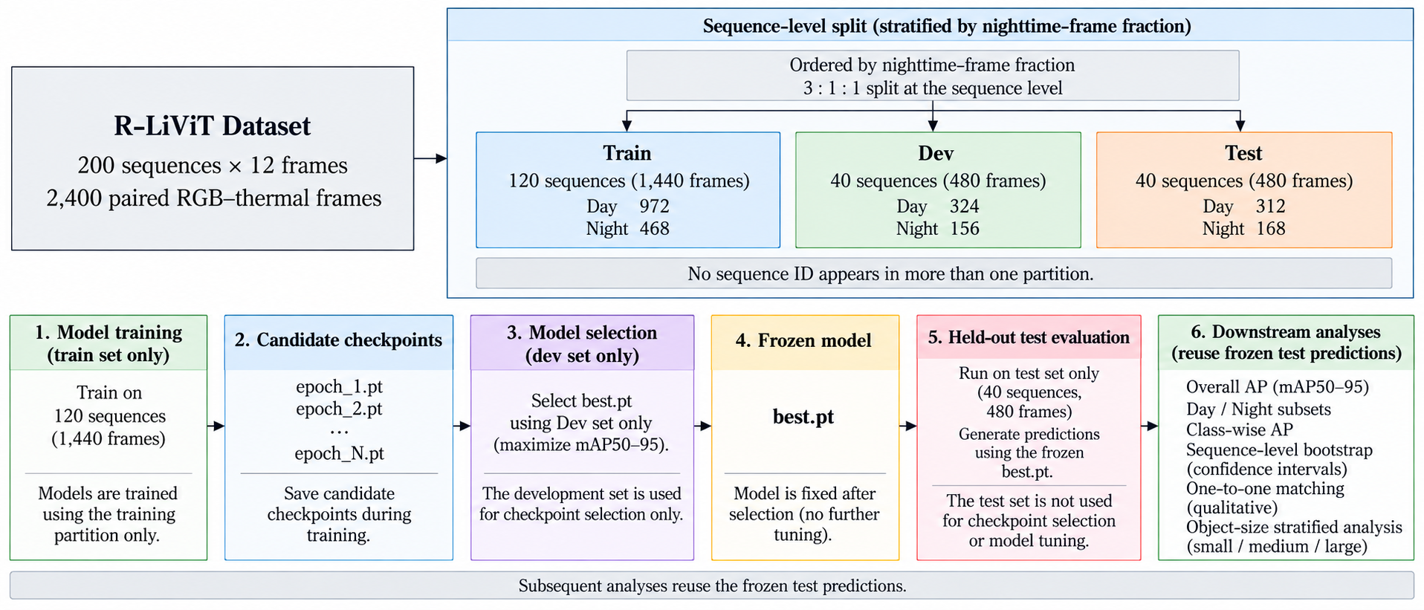
Fig. 1 Sequence-level assignment, development-only checkpoint selection, frozen held-out testing, and reuse of predictions for subgroup and bootstrap analyses
During training, checkpoints are selected on the development partition using development mAP50–95; the installed Ultralytics fitness vector is recorded in the run archive. The test partition is not used for checkpoint selection or model tuning. After choices were fixed, test predictions from the development-selected checkpoints were frozen and reused for subgroup and bootstrap analyses. Uniform pycocotools COCO evaluation of those predictions (Section 3.3) is the source for all reported test AP values.
3.2. Training and checkpoint selection
All runs use YOLO11n initialization, 150 configured epochs (100 for LLVIP), input size 640, batch size 8 (16 for LLVIP), four data-loader workers, and automatic mixed precision. The recorded environment is Ultralytics 8.4.75, Python 3.11.6, PyTorch 2.12.0.dev20260408+cu128, and an NVIDIA RTX 5060 Laptop GPU with 8,151 MiB reported memory. The run-argument records specify mosaic = 1.0 with close_mosaic = 10, fliplr = 0.5, translate = 0.1, scale = 0.5, and HSV settings 0.015/0.7/0.4; the exact transformations executed on four-channel samples are those logged by the trainer at start-up, but the behavior of randaugment and erasing on non-three-channel inputs has not been separately verified. Inspected logs select AdamW with learning rate 0.000909. All per-run arguments, selected epochs, checkpoint hashes, and evaluation commands are archived (protocol_archive.json).
3.3. Accuracy evaluation and uncertainty scope
Evaluation reports class-averaged AP at IoU 0.50 (mAP50) and AP averaged over IoU 0.50–0.95 in steps of 0.05 (mAP50–95), computed with pycocotools on predictions collected at confidence 0.001 with the standard NMS settings. All AP values are percentages and all differences are percentage points. Daytime and nighttime values are computed by evaluating the corresponding image lists directly. Three training seeds (0, 1, 2) are available for the main Concat–GBF–GSW comparison; the remaining ablations and the single-modality components of late fusion are reported for the seeds indicated in each table. Two uncertainty analyses are reported: (i) per-seed values with sample standard deviations, explicitly labeled as descriptive over training seeds, and (ii) a sequence-level bootstrap for the fixed seed-0 checkpoint pair that resamples the 40 held-out test sequences with replacement (3,000 iterations for AP50, 1,000 for AP) and recomputes COCO metrics on the resampled frames, yielding 95% percentile intervals for the sensitivity of method differences to the composition of the test sequences; this bootstrap does not quantify training-seed uncertainty.
Table 2. Sequence-disjoint R-LiViT partitions.
Partition | Sequences | Frames | Day / Night
Train | 120 | 1,440 | 972 / 468
Dev (checkpoint selection) | 40 | 480 | 324 / 156
Test (frozen held-out) | 40 | 480 | 312 / 168

Table 3. Local class-instance counts after label conversion (Bicycle and e-scooter merged into Cyclist).
Class | Train | Dev | Test
Pedestrian | 12,469 | 4,361 | 4,196
Car | 14,971 | 5,208 | 5,492
Cyclist | 2,758 | 809 | 964
Motorcycle | 284 | 75 | 97
Truck | 448 | 155 | 207
Bus | 342 | 95 | 74
Tramway | 210 | 47 | 57

3.4. Computational measurements
Forward timing uses a single model at batch one, 640 × 640, and FP16 on the recorded RTX 5060 Laptop GPU. End-to-end timing includes reading both modality files, letterbox preprocessing, forward inference, and NMS; median and mean are reported separately because disk I/O varies. Parameter counts are direct model counts. THOP-reported operations for the custom fusion implementation are provisional; a manual estimate for the GBF gate path has a different scope and is reported separately.
3.5. LLVIP retraining protocol
The LLVIP check uses 11,025 training pairs, a 1,000-pair development set sampled from the original training partition with seed 42 and recorded in a manifest, and the full 3,463-pair source test split. A truncated local build had omitted 790 test stems; the complete inventory was reconstructed from the source files before evaluation. Concat and GBF were retrained separately on LLVIP, selected by development performance, and evaluated on its test split. This is a dataset-specific check, not zero-shot transfer from R-LiViT.
3.6. Exploratory projected-depth protocol
The depth study operates on a separate, sequence-disjoint subset. Sequence pairs are admitted when their label-informed calibration fit reaches a median residual of at most 60 pixels; 71 pairs qualify, of which 13 are nighttime sequences. Frames are matched between RGB timestamps and LiDAR scans by nearest neighbor with a 0.12 s rejection bound; the realized synchronization offsets have median 19.8 ms and maximum 40.0 ms. After sequence-level 3:1:1 assignment, the subset contains 473 training, 155 development, and 154 test frames (nighttime 103/24/24). Before spatial filling, projected points cover a median of 1.78% of pixels, so the input is a sparse, dilation-filled depth image rather than dense geometry. Calibration itself is fitted from 2D–3D box-bottom correspondences and therefore uses annotation information; this limitation is explicit, and the depth study is described throughout as sequence-disjoint detector evaluation with label-informed calibration.
4. Lightweight Shallow Fusion Design
4.1. Architecture and modality-specific shallow encoding
GBF replaces the first Conv–Conv–C3k2 sequence in YOLO11n with independent visible and thermal encoders and retains one downstream detector. Each encoder produces a 64-channel P2 map at one-quarter input resolution. The original first three modules are merged into one GatedFusion module; subsequent module indices and saved-feature references are remapped. The deeper backbone, feature-aggregation neck, and detection head remain shared. This is a shallow feature-fusion design, not two complete detectors.
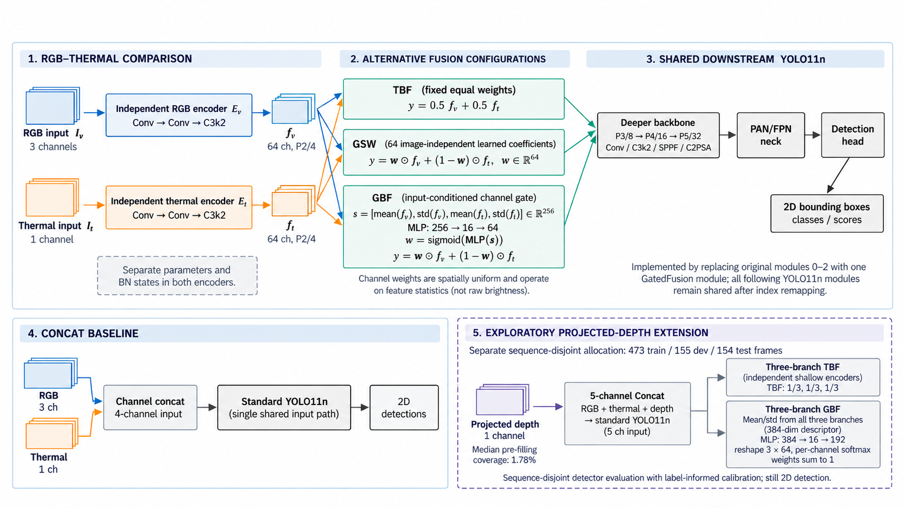
Fig. 2 Shallow visible and thermal encoders, TBF/GSW/GBF fusion rules, shared YOLO11n detector, four-channel Concat control, and separately scoped projected-depth extension
Let the visible input be$I_{v}$ and the thermal input be $I_{t}$. With encoders $E_{v}$ and $E_{t}$, the shallow maps are
$f_{v} = E_{v}(I_{v}), f_{t} = E_{t}(I_{t})$ (1)
For an input divisible by four, $f_{v}$ and $f_{t}$have 64 channels at one-quarter resolution. Both branches use separate parameter objects, including their batch-normalization states, and the fused output has the same shape as either branch. Equation (1) therefore specifies a compatible replacement for the original shallow output without increasing the channel width of the shared detector.
Independent shallow encoding permits modality-specific convolutional filters and batch-normalization states before fusion. This is an architectural property, not an experimentally isolated explanation for any accuracy change. Relative to Concat, introducing two branches also changes parameter count, activation paths, and the route by which sensor information reaches P2. TBF preserves the two shallow branches but fixes their fusion weights, allowing the complete branched configuration to be compared with Concat; it does not isolate a batch-normalization contribution.
4.2. Channel statistics and two-branch gating
GBF conditions its mixing vector on spatial statistics of both branch outputs. For a fixed image and channel, the implementation uses the channel mean and the default sample standard deviation of the flattened spatial values:
$s = [mean(f_{v}), std(f_{v}), mean(f_{t}), std(f_{t})]$ (2)
Statistics are computed independently for each image and channel. The resulting gate is therefore input-conditioned at the image level but spatially uniform within each channel. A two-layer perceptron with a 16-unit hidden layer predicts 64 visible-branch coefficients:
$w = sigma( MLP(s) ), MLP: 256 -> 16 -> 64$ (3)
The thermal coefficient is determined as the complement of the visible coefficient, so no second independently scaled thermal vector is required. This parameterization fixes the total mixing weight to one for each feature channel. Fusion then broadcasts each channel coefficient over the spatial grid:
$y = w ⊙ f_{v} + (1 - w) ⊙ f_{t}$ (4)
The shared detector D receives the fused tensor and produces the usual two-dimensional detection outputs. Equation (4) combines learned features rather than raw image brightness. Moreover, a coefficient is not a calibrated probability that one sensor is correct: its effect depends on the amplitudes and meanings of both encoded channels. Consequently, the diagnostic analysis measures the coefficients themselves and their intervention response, without interpreting them as illumination labels or direct sensor reliability estimates.
The gate contains 5,200 trainable parameters: 4,096 weights and 16 biases in the first linear layer, followed by 1,024 weights and 64 biases in the second. The separate encoders add parameters beyond this gate. The descriptor is spatially pooled, but mean/std computation and the weighted feature sum still operate across the feature map. Table 5 reports measured whole-model parameters and forward speed; its provisional THOP operations and the gate-path manual MAC estimate have distinct scopes.
4.3. Fusion control configurations
Four configurations use the same downstream YOLO11n detector. Concat provides a four-channel RGB (3) plus thermal (1) input with a single shallow path. TBF uses two independent shallow encoders and fixed one-half weights. GSW keeps those encoders but learns a 64-element input-independent sigmoid weighting vector. GBF replaces the static vector with a 256-dimensional descriptor of per-branch means and standard deviations, mapped by a 256–16–64 perceptron to input-conditioned complementary weights. TBF has a verified seed-0 main-protocol result only. The Concat-to-TBF change combines stem separation, normalization states, and parameter/compute changes; the TBF-to-GSW and GSW-to-GBF comparisons more closely target weighting complexity.
4.4. Initialization, model replacement, and precision
Initialization reuses pretrained YOLO11n modules. The visible first convolution takes the first three input-channel slices of the loaded weights, whereas the thermal first convolution uses the first input-channel slice; the remaining shallow modules are deep-copied. When depth is enabled, its first convolution follows the same single-channel initialization rule and its later shallow modules are likewise copied. These branches subsequently optimize independent parameters. The initialization reuses pretrained components but does not preserve the original RGB detector function exactly after the input and fusion structure is changed.
For GBF, the weights of the final perceptron layer are multiplied by 0.1 at initialization and its biases are set to zero. This encourages two-branch coefficients near 0.5 (and three-branch softmax coefficients near one third) without guaranteeing exact equality for every input because the output weights remain nonzero. TBF instead fixes equal weights explicitly, while GSW initializes its image-independent raw coefficients to zero before applying a sigmoid. These choices provide comparable starting points while preserving the distinction among fixed, static-learned, and input-conditioned fusion.
The replacement module is installed when the trainer builds the model and before optimizer construction. The implementation merges the original first three modules into the fusion module and updates downstream layer indices, saved-feature indices, and detection-path references. This ensures that the gate and branch parameters are part of the trained model. The detector loss is unchanged; no auxiliary illumination label or gate-supervision objective is introduced. Accordingly, the coefficients are optimized only through the detection objective, and their semantic behavior must be assessed empirically rather than assumed.
Gate statistics and perceptron operations are computed in FP32 with autocasting disabled locally. Descriptors and perceptron weights are cast for these calculations, after which the mixing coefficients are converted back to the branch-feature dtype before multiplication and summation. This is a numerical precision measure rather than evidence that all diagnostic and ablation paths execute identically.
4.5. Exploratory projected-depth extension
The depth study converts a LiDAR point into camera coordinates using a sequence-specific rotation R and camera position p. With camera-coordinate components, the builder uses a single focal parameter f and the image center as principal point:
$u = f \frac{x}{z} + \frac{W}{2}, v = f \frac{y}{z} + \frac{H}{2}$ (5)
Points must satisfy z > 0.3 and project inside the image. Coordinates are discretized into pixels, and the closest projected point supplies depth when multiple points reach the same pixel. Equation (5) documents the implemented projection model; its geometric adequacy is not established by the detector AP measurements.
Sparse projected depths are expanded into empty pixels for up to 12 iterations with a 5 x 5 dilation kernel. Existing occupied pixels are retained, while newly filled pixels inherit the dilation value from neighboring valid depths. The resulting representation is therefore a projected and spatially filled depth image rather than dense measured geometry or learned depth completion. The encoded depth is quantized to an 8-bit image with exponential normalization:
$d = exp(\frac{-z}{30})$ (6)
No separate validity mask distinguishes directly projected values from dilation-filled values, so both enter the detector through the same channel. This design choice belongs to the depth study and must remain visible when interpreting the depth results.
The third encoder produces$f_{d}$ at the same P2 resolution. Concatenating mean and standard-deviation vectors from all three branches gives a 384-dimensional descriptor. The perceptron maps 384 inputs through 16 hidden units to 192 logits, reshaped as three sets of 64 values. Per-channel softmax normalization and fusion are
$w = softmax(MLP(s)), y = w_{v}⊙ f_{v} + w_{t}⊙f_{t} + w_{d}⊙ f_{d}$ (7)
For each feature channel, the three branch coefficients sum to one. The shared detector still predicts two-dimensional boxes, so the added depth branch does not change the task into 3D detection. The equal-weight three-branch control fixes each branch coefficient to one third.
5. Results and Performance Analysis
Sections 5.1–5.6 contain the three-seed accuracy, measured cost, seed-0 control, gate diagnostics, illumination/class patterns, and fixed-checkpoint bootstrap. Sections 5.7–5.10 examine protocol sensitivity, late fusion, qualitative states, and LLVIP retraining; Section 5.11 reports exploratory depth. The evidence levels differ and are not pooled into one claim of general superiority.
5.1. Three-seed accuracy of the proposed fusion design
Table 4 and Fig. 3 report the frozen held-out COCO results across three seeds. GBF exceeds Concat by +0.40 mAP50 and +0.91 mAP50–95 points on average, but the within-seed differences change sign. GSW has the highest mean values (60.42/39.40), versus 59.78/39.26 for GBF and 59.38/38.35 for Concat. GSW's seed-1 mAP50 is lower than GBF's, while its seed-0 mAP50–95 is also lower. Thus, GBF provides a functioning input-conditioned design but no consistent accuracy advantage over static weighting in these runs; the method-specific compute costs are reported immediately below.
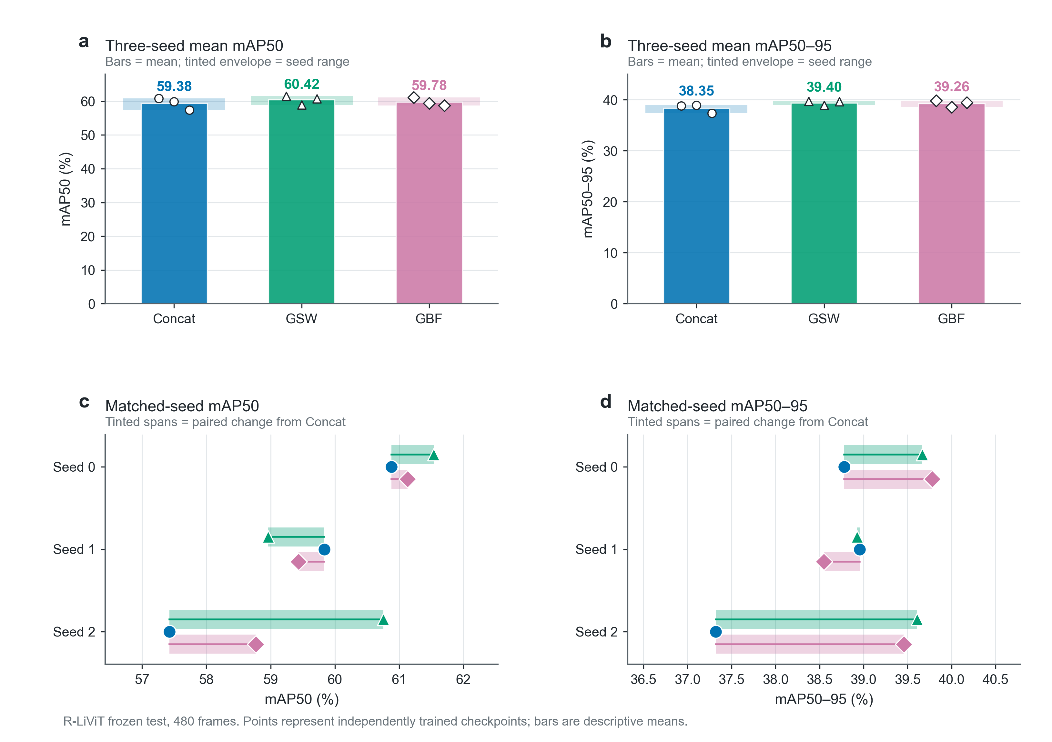
Fig. 3 Per-seed and three-seed mean held-out mAP50 and mAP50–95 from the uniform COCO evaluation
Table 4. Held-out R-LiViT results for three training seeds (AP in percent). Means are descriptive; differences are within-seed GBF minus Concat.
Model | mAP50 (s0/s1/s2) | mean mAP50 | mAP50–95 (s0/s1/s2) | mean mAP50–95
Concat | 60.88 / 59.83 / 57.43 | 59.38 | 38.78 / 38.95 / 37.32 | 38.35
GBF | 61.13 / 59.44 / 58.77 | 59.78 | 39.78 / 38.55 / 39.46 | 39.26
GSW | 61.54 / 58.96 / 60.75 | 60.42 | 39.67 / 38.93 / 39.61 | 39.40
GBF − Concat | +0.25 / −0.39 / +1.34 | +0.40 | +1.00 / −0.40 / +2.14 | +0.91

5.2. Computational cost and deployment measurements
Table 5 reports measured model cost directly after the three-seed accuracy table. GSW has higher mean mAP50 and mAP50–95 than GBF, with fewer parameters and higher model-forward FPS; Concat remains the fastest and smallest model. End-to-end medians are 36.5, 36.4, and 37.7 ms for Concat, GSW, and GBF, respectively. The means vary strongly with disk I/O and are not used to claim an end-to-end speed ranking. The gate-path estimate is 9.8 M manually counted MACs; THOP-reported operations are provisional and are not added to that estimate (Fig. 5b).
Table 5. Model size and measured inference cost for the three-seed main comparison. THOP values are provisional.
Model | Parameters | Forward FPS | End-to-end median / mean (ms) | THOP operations (G)
Concat | 2,591,349 | 95.2 | 36.5 / 59.5 | 3.24
GSW | 2,602,757 | 91.1 | 36.4 / 61.7 | 3.54
GBF | 2,607,893 | 84.9 | 37.7 / 39.1 | 3.54
Note: Forward FPS uses batch 1, 640 × 640, FP16 on one RTX 5060 Laptop GPU. End-to-end latency includes paired disk reads, preprocessing, forward pass, and NMS; the I/O-sensitive means are not a speed ranking. The manually estimated GBF gate path is 9.8 M MACs and is not added to the provisional THOP operations.

5.3. Seed-0 structural and weighting controls
Table 6 compares the four configurations for seed 0 on the same held-out test. Equal-weight TBF obtains 59.67/38.65 mAP50/mAP50–95 versus 60.88/38.78 for Concat, so this one run does not improve aggregate accuracy. GSW reaches 61.54/39.67 and GBF 61.13/39.78; their ordering depends on the metric. Because TBF has only one verified seed, these results cannot establish a stable benefit or penalty from independent stems, nor isolate the contributions of batch normalization and weighting.
Table 6. Seed-0 R-LiViT control results. TBF is a single-seed architectural control; GSW leads mAP50 and GBF leads mAP50–95 and nighttime mAP50 in this run.
Model | mAP50 | mAP50–95 | Day mAP50 | Night mAP50
Concat | 60.88 | 38.78 | 62.11 | 47.88
TBF (w=0.5 fixed) | 59.67 | 38.65 | 61.73 | 45.50
GSW (static learned) | 61.54 | 39.67 | 62.87 | 48.49
GBF (input-conditioned) | 61.13 | 39.78 | 62.57 | 51.04

5.4. GBF gate behavior and intervention
Gate diagnostics were obtained with an earlier development-protocol GBF checkpoint, not a checkpoint from the frozen-test three-seed comparison. The maximum absolute day–night difference in channel-mean coefficients was about 0.018, and mean cross-image channel standard deviation was about 0.004. Replacing the gate with its sample-mean channel vector changed full-evaluation mAP50 from 61.20 to 61.04 and nighttime mAP50 from 54.34 to 53.55 under that earlier protocol. These observations are consistent with weak input dependence at this shallow interface, but do not prove a static rule or explain the newer GSW result causally. The newer three-seed ordering remains mixed (Table 4).
5.5. Illumination and class variation
Direct full-test and nighttime results (Fig. 4a,b) shows differences that vary substantially by seed. GBF minus Concat nighttime mAP50 is +3.2, −5.9, and +3.7 points across seeds 0–2, with a mean near +0.3 point. The nighttime sample standard deviations across three seeds are about 4.9–5.0 points for both models. Consequently, the seed-0 nighttime result cannot be described as a stable GBF benefit. The separate fixed-checkpoint sequence-bootstrap analysis in Section 5.6 addresses test-sequence composition, not training-seed uncertainty. GSW nighttime mAP50 is 48.49/44.94/49.63 (mean 47.69).
Class-level outcomes are heterogeneous (Fig. 4c). On the seed-0 checkpoint, GBF is higher than Concat on Pedestrian (+2.2), Cyclist (+1.7), and Bus (+2.1), comparable on Car and Tramway, and lower on Motorcycle (−2.4), Truck (−2.3). The exceptions show that the aggregate differences are not uniform across classes.
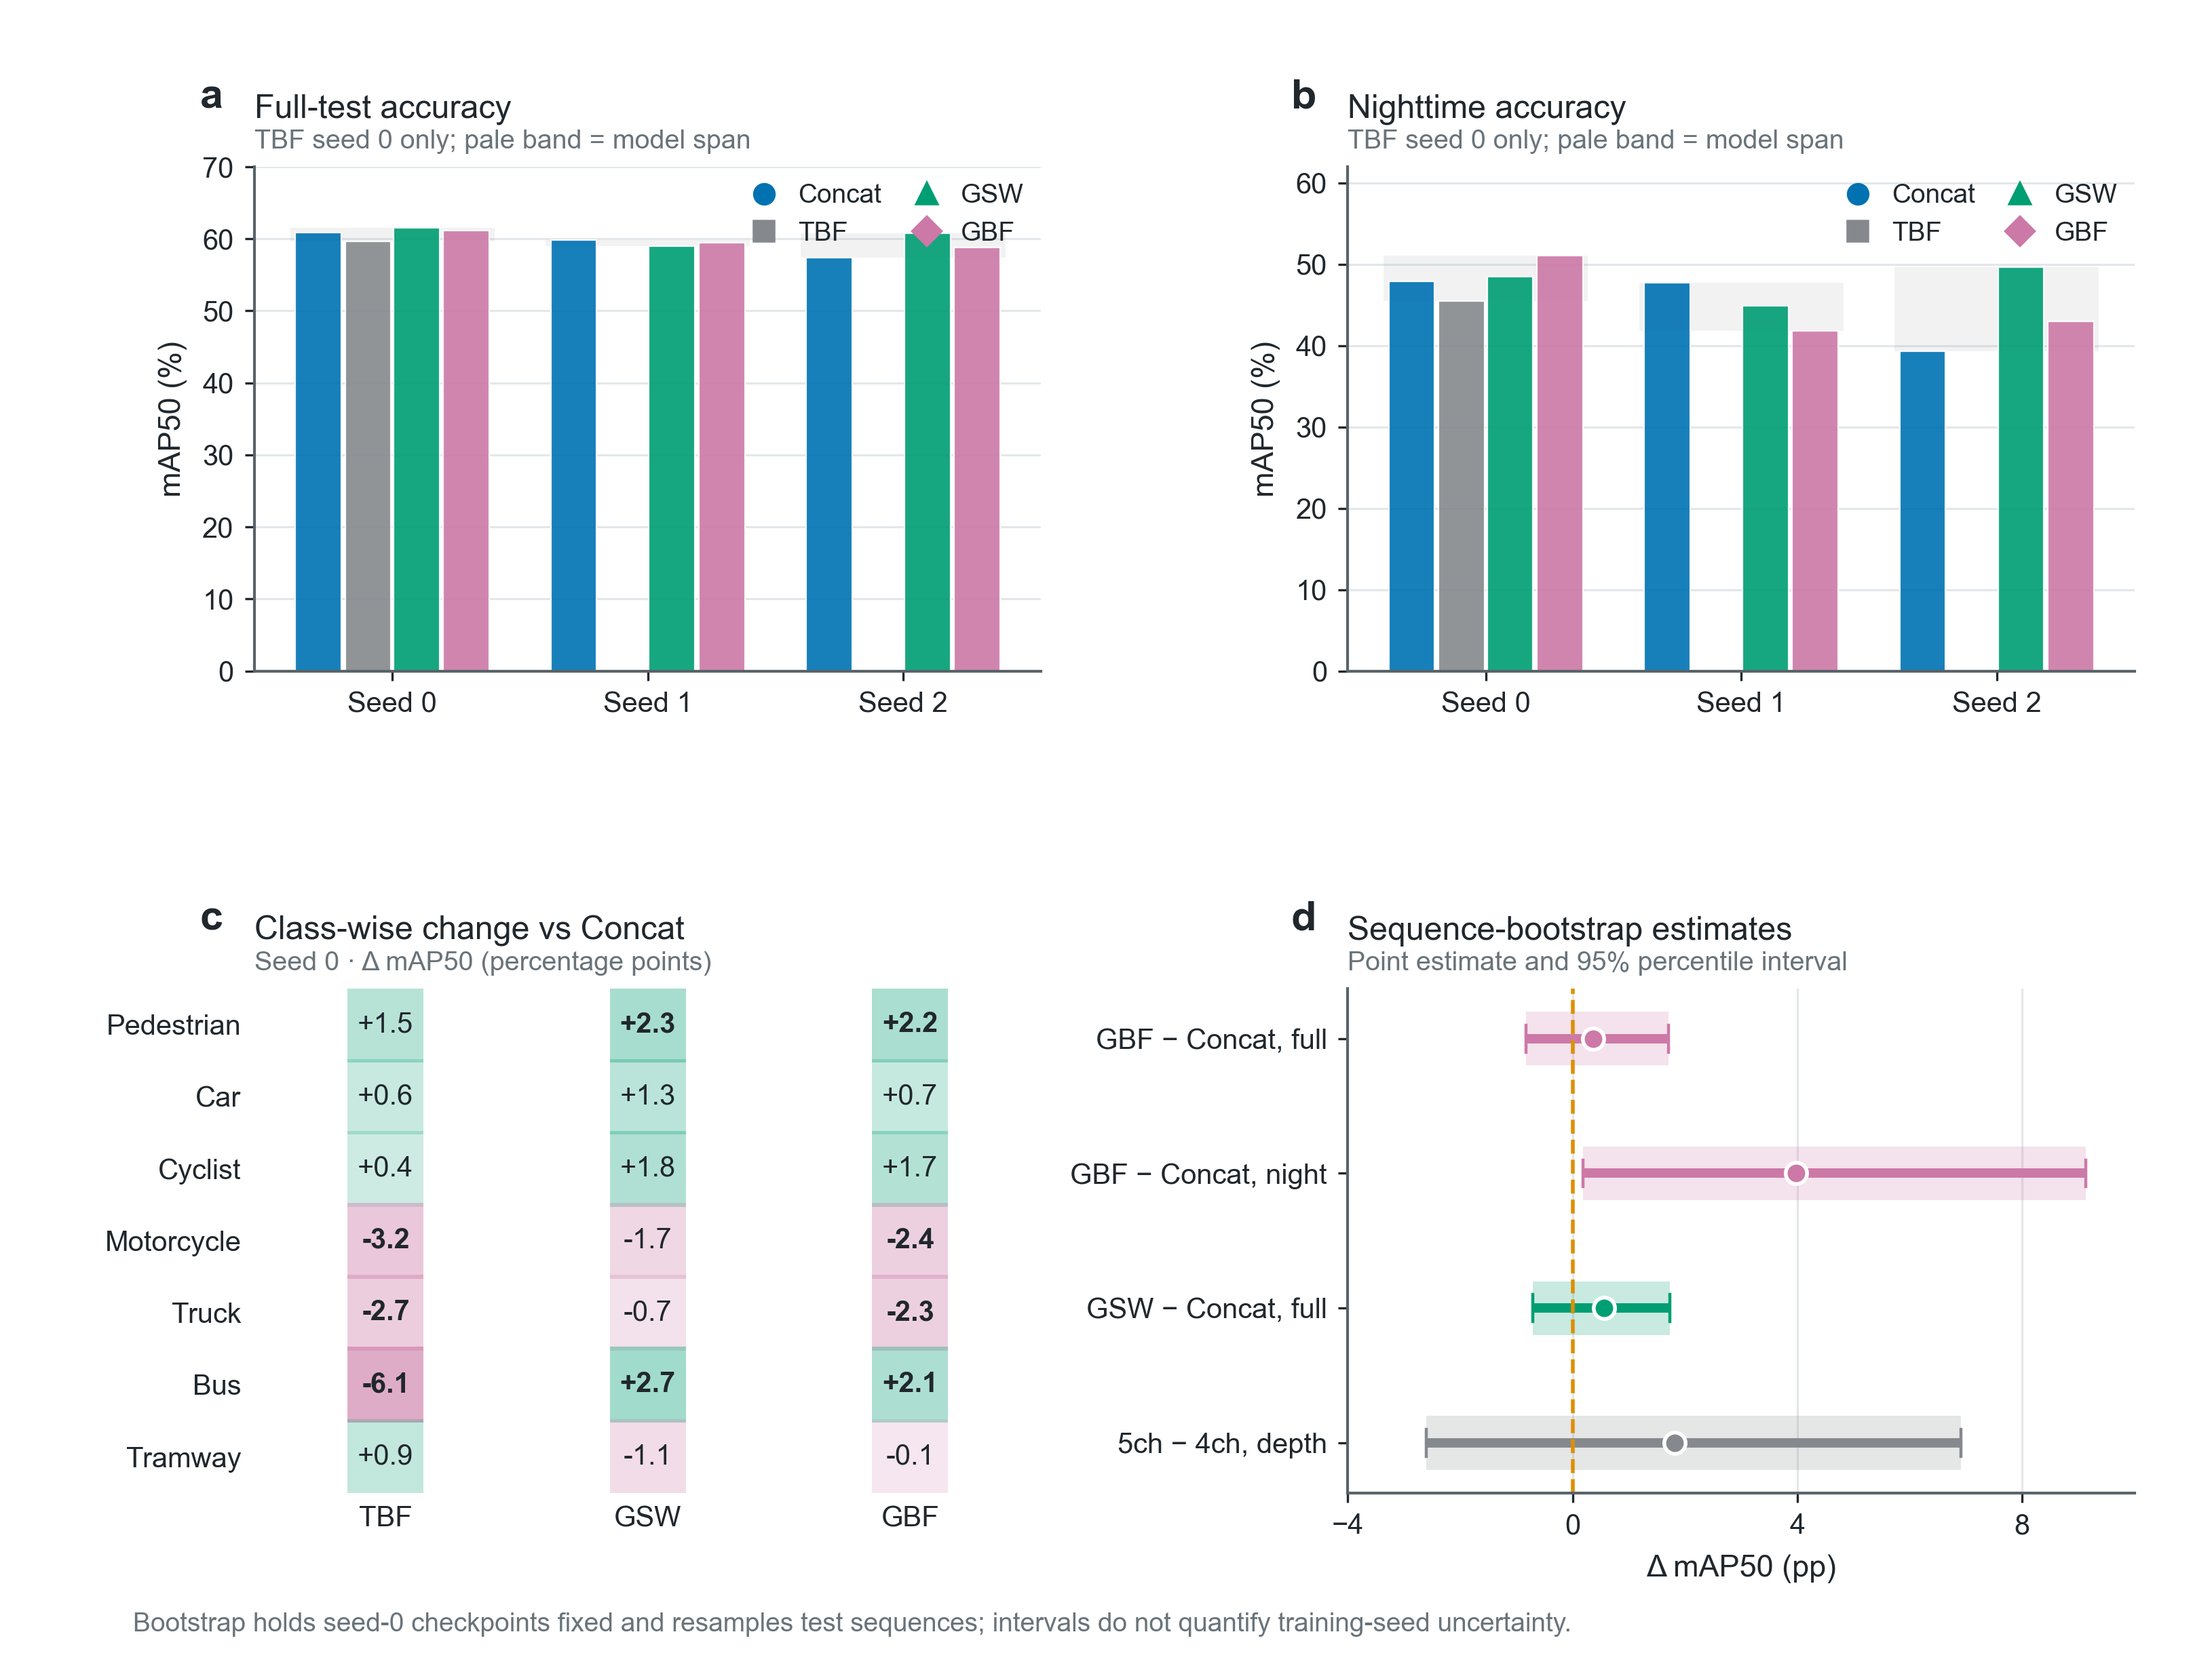
Fig. 4 Full-test and nighttime mAP50 across seeds, seed-0 class-wise change from Concat, and fixed-checkpoint sequence-bootstrap intervals; TBF has seed 0 only, and bootstrap does not quantify training-seed uncertainty
5.6. Fixed-checkpoint sequence bootstrap
The sequence bootstrap resamples the 40 held-out test sequences for the fixed seed-0 checkpoints (3,000 resamples for mAP50 and 1,000 for mAP50–95). For GBF minus Concat, the mAP50 percentile interval is [−0.8, +1.7] percentage points and the mAP50–95 interval is [+0.2, +2.0]. The nighttime mAP50 interval is [+0.2, +9.1]. These intervals describe sensitivity to the particular test sequences for this checkpoint pair; they do not include training-seed uncertainty and are not used as population-level significance tests (Fig. 4d).

5.7. Evaluation-protocol sensitivity
The earlier 160/40 sequence split was itself sequence-disjoint, but used the same 480 frames for checkpoint selection and score reporting. GBF–Concat mAP50 differences there were +2.28/+2.94 and nighttime differences +6.89/+9.98 points in seeds 0/1, versus +0.40 and about +0.3 three-seed mean points here. Training size, sequence and illumination composition, and reporting frames also changed, so the reduction cannot be attributed solely to checkpoint selection. Table 7 compares protocols, not published accuracy.
Table 7. Protocol comparison; methods and data processing are not matched for accuracy ranking.
Aspect | Published R-LiViT benchmark [1] | This work
Split | Official sequence split, reported per day/night | Sequence-disjoint train/dev/test, frozen test
Checkpoint selection | Not specified in the local record | Dev partition only (fitness = dev mAP50–95)
Models | YOLOv8-M, RT-DETR-L, separate-detector NMS fusion | YOLO11n single models; same-recipe late fusion
Input / crop | 800 × 600 common field of view | 640 letterbox, full frame
Classes | Published class set | 7 classes (Bicycle, e-scooter merged into Cyclist)
Seeds | 3-seed summary | 3 seeds for main comparison, per-table elsewhere

5.8. Score-level late-fusion reference
Separately trained RGB-only and thermal-only YOLO11n detectors, merged by NMS, give nighttime mAP50 of 54.32 and 57.34 in matched seeds 0 and 1 (mean 55.83). This is about 9.1 points above GSW's matched nighttime mean, but the two-detector reference uses roughly twice the model parameters and is not a single-model fusion configuration (Fig. 5a). Its recorded end-to-end mean is 76.6 ms; disk-I/O variability limits direct ranking against the single-model latency means.
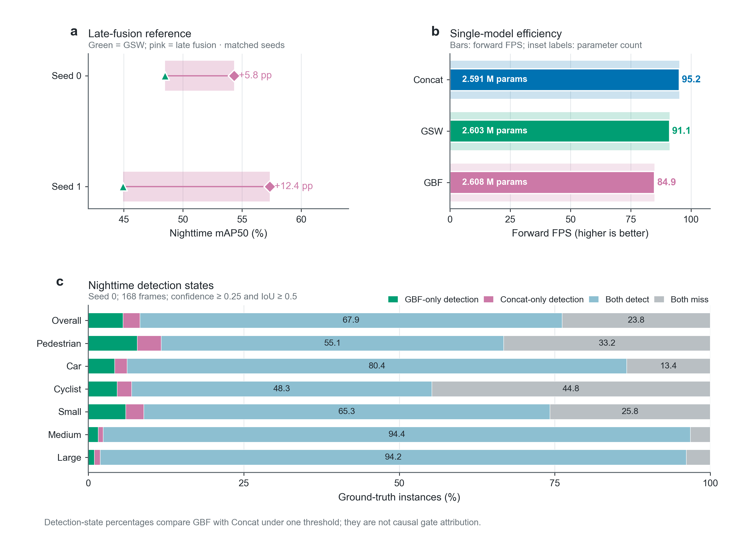
Fig. 5 Matched-seed late-fusion nighttime performance, computational measurements, and threshold-dependent nighttime detection states
5.9. Qualitative detection states
On 168 nighttime test frames, seed-0 predictions at confidence 0.25 were greedily matched to ground truth by descending confidence, class consistency, and IoU at least 0.5. Of the nighttime objects, 144 (5.6%) were missed by Concat but detected by GBF, and 70 (2.7%) had the reverse transition; 1,749 (67.9%) were found by both, and 613 (23.8%) by neither (Fig. 5c). These threshold-dependent states illustrate individual changes, not a stable gain or a causal interpretation of the gate.

5.10. LLVIP dataset-specific retraining check
On LLVIP's complete 3,463-pair test split after dataset-specific retraining and development-based checkpoint selection, two seeds give Concat means of 95.23 mAP50 and 58.79 mAP50–95, versus 95.09/59.78 for GBF (Fig. 6c). GBF is slightly lower on mAP50 in both seeds but higher on mAP50–95. The result is metric-dependent and does not establish equivalence, saturation, or cross-dataset transfer without retraining.

5.11. Exploratory projected-depth extension
Fig. 6a,b reports the sequence-disjoint depth results. Adding the depth branch to Concat changes mAP50 by +1.29, −0.82, and +1.03 points across three matched seeds (mean +0.50), so the direction is mixed; the seed-0 sequence-bootstrap interval spans [−2.6, +6.9] points over 13 test sequences. Dual-branch GBF on the same subset reaches 39.33 mAP50, +1.60 above four-channel Concat. Among five-channel variants at seed 0, equal-weight three-branch TBF (39.98) slightly exceeds gated three-branch GBF (39.49). Additional matched seeds would be needed to establish an ordering. These results demonstrate a working extension under label-informed calibration and 1.78% median pre-filling depth coverage, not general three-modal superiority.
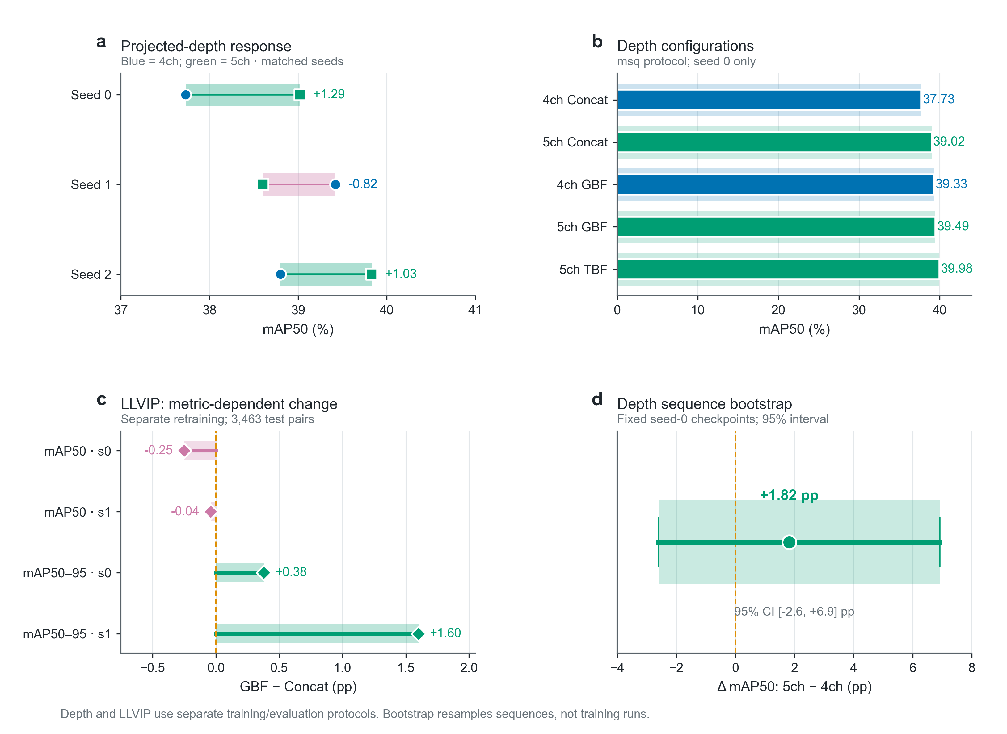
Fig. 6 Exploratory depth and separately retrained LLVIP results with their distinct evaluation scopes
6. Discussion
6.1. What the design and comparisons establish
The implemented dual-branch GBF module combines modality-specific shallow features with an explicit per-channel, input-conditioned mixing rule while keeping the remaining YOLO11n detector shared. That method contribution is separate from the outcome of the comparison. In the observed three-seed R-LiViT evaluation, GSW has higher mean accuracy and forward speed than GBF; GBF does not show a consistent additional benefit over static weighting. The seed-0 TBF result does not establish whether separate stems help or hurt in general. These findings delimit this particular gate and interface rather than all forms of dynamic fusion.
The development-protocol gate diagnostics show small cross-image coefficient variation and a modest mean-substitution effect. This is consistent with a weak conditioning signal from pooled shallow statistics, but is not causal proof of why GBF trails GSW on average. Other possible factors include optimization variability and the different parameter counts (5,200 gate parameters versus 64 static weights); these are hypotheses, not independently isolated explanations. A stronger conditioning descriptor would require its own matched, multi-seed test.
6.2. Accuracy–compute implications
Concat is the smallest and fastest of the measured single models, while GSW attains the strongest observed mean accuracy among them with 2.603 M parameters and 91.1 forward FPS. GBF is larger (2.608 M) and slower (84.9 FPS) without a consistent accuracy gain over GSW. This is an observed accuracy–cost relationship for the tested 640-pixel, batch-one implementation, not a universal optimality claim. Dynamic gating remains a design option when its conditioning signal and benefits can be demonstrated under matched protocols.
6.3. Supporting evidence and scope
The separately retrained LLVIP comparison is small and metric-dependent; it does not establish zero-shot generalization. The projected-depth extension shows that the interface can be expanded to three shallow branches, but its label-informed calibration and 1.78% median pre-filling depth coverage limit the inference that can be drawn from its mixed results. Late fusion, protocol sensitivity, and qualitative states provide context without replacing the core RGB-thermal comparison.
6.4. Limitations
The main comparison has only three training seeds, so its means and sample standard deviations are descriptive. TBF has one verified main-protocol seed. The bootstrap holds seed-0 checkpoints fixed and quantifies test-sequence composition rather than training variation. Gate diagnostics come from an earlier development protocol. The 168 nighttime test frames provide limited support for night-specific conclusions. Depth calibration is annotation-informed and lacks an independent geometric accuracy assessment. THOP's custom-gate count is not validated, and end-to-end timings include variable disk I/O. The comparison set is curated rather than exhaustive; no superiority over unmatched published detectors is claimed.
7. Conclusion
We implement a lightweight YOLO11n RGB-thermal detector with independent shallow encoders and a GBF gate that uses per-channel means and standard deviations to predict complementary weights. Sequence-disjoint R-LiViT testing shows that GSW has the highest observed three-seed mean (60.42 mAP50, 39.40 mAP50–95) and higher forward FPS than GBF. GBF provides an explicit input-conditioned mechanism but no consistent additional accuracy benefit over static weighting in this architecture and protocol. The TBF result is a seed-0 structural control, while gate diagnostics, LLVIP retraining, and projected depth have separate evidential scopes. The design therefore illustrates both a feasible conditional-fusion implementation and the importance of testing its added flexibility against a simple static rule at matched cost and evaluation settings.
Declarations
Author names, affiliations, and corresponding-author contact details:
Author contributions:
Funding: The authors received no funding for this study.
Competing interests: The authors declare that they have no competing interests.
Ethics and data permissions: Ethics approval was not required for this secondary analysis of the publicly released R-LiViT [1] and LLVIP [3] datasets; no new participants were recruited or contacted. The R-LiViT dataset was used under the CC BY 4.0 license with attribution; its released RGB images have visible faces, license plates, and other potentially identifying markings blurred by the dataset authors. LLVIP was used for non-commercial academic research and scientific publication under the dataset provider terms, with citation and without attempting to identify individuals or invade their privacy.
Data availability: The R-LiViT dataset [1] is available at https://doi.org/10.5281/zenodo.16356714. The LLVIP dataset [3] can be accessed through https://bupt-ai-cz.github.io/LLVIP/ subject to the dataset provider terms. The sequence-disjoint split manifests, training and evaluation code, and recorded evaluation results are publicly available at https://github.com/cream-xu/Lightweight-RGB-Thermal-Fusion-for-Roadside-Object-Detection-under-Sequence-Disjoint-Evaluation. The original dataset files are not redistributed in this repository and should be obtained from the respective providers under their terms. Training checkpoints and derived depth images are available from the authors on request.
AI-assisted writing disclosure: OpenAI ChatGPT was used to assist language editing and manuscript organization. The authors retain responsibility for all scientific content and the submitted text.
References
[1] J. Mirlach, L. Wan, A. Wiedholz, H. E. Keen, and A. Eich, "R-LiViT: A LiDAR-Visual-Thermal Dataset Enabling Vulnerable Road User Focused Roadside Perception," in IEEE/CVF International Conference on Computer Vision (ICCV), 2025. https://doi.org/10.1109/iccv51701.2025.02635.
[2] S. Hwang, J. Park, N. Kim, Y. Choi, and I. S. Kweon, "Multispectral Pedestrian Detection: Benchmark Dataset and Baseline," in IEEE Conference on Computer Vision and Pattern Recognition (CVPR), 2015. https://doi.org/10.1109/cvpr.2015.7298706.
[3] X. Jia, C. Zhu, M. Li, W. Tang, and W. Zhou, "LLVIP: A Visible-infrared Paired Dataset for Low-light Vision," in IEEE/CVF International Conference on Computer Vision Workshops (ICCVW), 2021. https://doi.org/10.1109/iccvw54120.2021.00389.
[4] K. Zhou, L. Chen, and X. Cao, "Improving Multispectral Pedestrian Detection by Addressing Modality Imbalance Problems," in European Conference on Computer Vision (ECCV), 2020. https://doi.org/10.1007/978-3-030-58523-5_46. Version read: arXiv:2008.03043v2.
[5] H. Zhang, E. Fromont, S. Lefevre, and B. Avignon, "Guided Attentive Feature Fusion for Multispectral Pedestrian Detection," in IEEE Winter Conference on Applications of Computer Vision (WACV), 2021. https://doi.org/10.1109/wacv48630.2021.00012.
[6] J. Shen, Y. Chen, Y. Liu, X. Zuo, H. Fan, and W. Yang, "ICAFusion: Iterative Cross-Attention Guided Feature Fusion for Multispectral Object Detection," Pattern Recognition, vol. 145, article 109913, 2024. https://doi.org/10.1016/j.patcog.2023.109913. Version read: arXiv:2308.07504v1.
[7] Y. Cao, J. Bin, J. Hamari, E. Blasch, and Z. Liu, "Multimodal Object Detection by Channel Switching and Spatial Attention," in IEEE/CVF Conference on Computer Vision and Pattern Recognition Workshops (CVPRW), 2023. https://doi.org/10.1109/cvprw59228.2023.00046.
[8] A. Althoupety, L.-Y. Wang, W.-C. Feng, and B. Rekabdar, "DaFF: Dual Attentive Feature Fusion for Multispectral Pedestrian Detection," in IEEE/CVF Conference on Computer Vision and Pattern Recognition Workshops (CVPRW), 2024. https://doi.org/10.1109/cvprw63382.2024.00305.
[9] S. Vora, A. H. Lang, B. Helou, and O. Beijbom, "PointPainting: Sequential Fusion for 3D Object Detection," in IEEE/CVF Conference on Computer Vision and Pattern Recognition (CVPR), 2020. https://doi.org/10.1109/cvpr42600.2020.00466.
[10] X. Bai, Z. Hu, X. Zhu, Q. Huang, Y. Chen, H. Fu, and C.-L. Tai, "TransFusion: Robust LiDAR-Camera Fusion for 3D Object Detection with Transformers," in IEEE/CVF Conference on Computer Vision and Pattern Recognition (CVPR), 2022. https://doi.org/10.1109/cvpr52688.2022.00116.
[11] W. Zimmer et al., "InfraDet3D: Multi-Modal 3D Object Detection based on Roadside Infrastructure Camera and LiDAR Sensors," in IEEE Intelligent Vehicles Symposium (IV), 2023. https://doi.org/10.1109/iv55152.2023.10186723. Version read: arXiv:2305.00314v1.

