1.0.1 ANC module

The ANC module is no different from other EHR system modules, in that it requires all health workers to start with logging into the system and go to the reception module which is the entry point into EHR system. All outpatients and inpatients are admitted at the reception, depending on how big the facility is.

After being admitted at the reception, a maternity patient will be added to the doctor’s queue where she will provide her personal details for ANC registration and consultation.

1.0.1.1 ANC registration

ANC registration in EHR involves creating a new ANC record which has a unique ANC number on the EHR facility database. Before a patient record is created as a new one, a nurse/doctor will first have to check the patient record on enrollment using her name or national id number. This process is done to mitigate the problem of record duplication and if the record is not found the doctor/nurse will proceed to create new ANC record.

1.0.1.2 ANC registration process flow

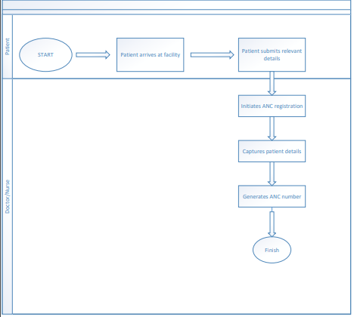

1.0.1.3 ANC registration use case

|  |  |
| --- | --- |
| Use Case Name | ANC registration |
| System | EHR web application |
| Actors | System, Nurse/Doctor |
| Description | This use case describes the process that is followed when a nurse/doctor wants to register a patient onto the ANC module of the EHR web application at a health facility |
| Trigger | A doctor/Nurse wants to record a patient’s pregnancy details on ANC module of the EHR system |
| Normal course | 1. A nurse/doctor searches the patient records on EHR database.  2. If the record is found on the database, the doctor/nurse will start the ANC registration |
| Alternate courses | If the patient record is not found, then the doctor/nurse will initiate new patient record. |
| Business rules | If patient record is not found, ANC registration will not be done and patient will be referred back to the reception. |
| Non-Functional requirements |  |
| Dependencies | Maternity |

**Previous pregnancy**

Registered for ANC

YES> proceed to record any previous pregnancies into the EHR database, it has two entries you choose either delivery or a miscarriage and save

NO> first register current pregnancy in the ANC registration sub module and after that proceed to record any previous pregnancies

**Enrollment**

This shows the captured details of the current pregnancy and the doctor/nurse can edit or update the ANC record and will also be stored in the database of the EHR system.