Chapter 1
Converting Basic To Javascript (Using BTJC)

This chapter will provide step by step instructions on how to …

- Convert and run your first program
- Using Options

Chapter 1 - 1. Convert and Run Your First Program

- If you haven't already d-one so extract “btjc.exe” file, the “commands.txt” file and the “lib” folder from btjc.zip to a folder
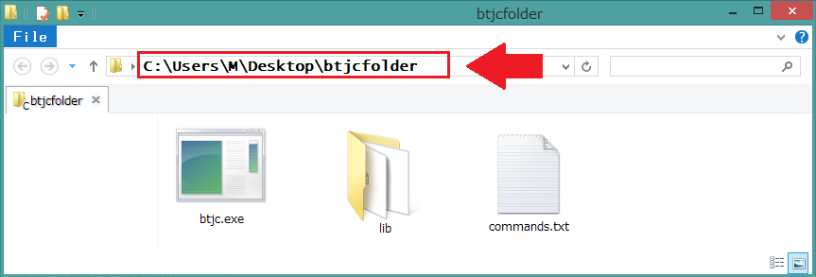
- Copy or remember the path of where btjc.exe was extracted.
e.g. C:\Users\M\Desktop\btjcfolder
- Launch command prompt and cd to the folder where btjc was extracted
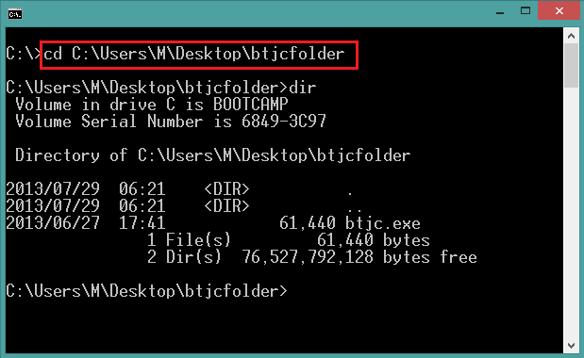
(Type “cd C:\Users\M\Desktop\btjcfolder” into the command prompt)
- Open notepad or any plain text editor. Type in the following program:
INCLUDE HELPER

NEWSCREEN "output"
SCREEN "output"
PRINT "Hello World"

- Save the notepad file in the btjc folder as “helloworld.bas”
- Go back to command prompt and type “btjc.exe helloworld.bas” to convert the bas file to a html javascript page. If the conversion went well, a message that says “code compiled to javascript without errors” should display and a file called “helloworld.html” should have been created in the folder.
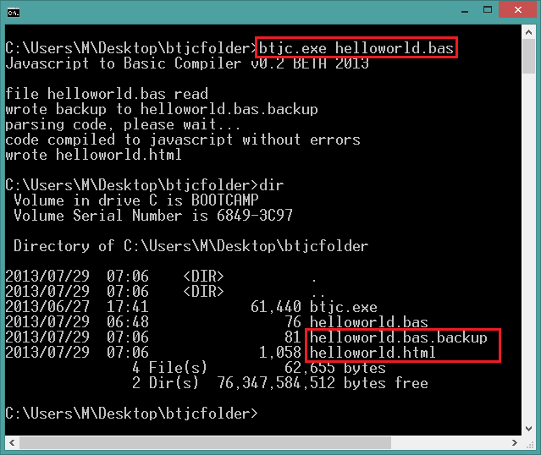
- Open the “helloworld.html” file with the default browser. You should see a page that displays “Hello World”.
- Let's try something more interesting. Rewrite helloworld.bas so it looks like the following program (program on next page):

INCLUDE HELPER

NEWCANVAS "view", 800, 700
CALL SETCANVAS("view")

red = RGB(255,0,0)
green = RGB(0,255,0)
blue = RGB(0,0,255)

CALL LINE(200, 50, 150, 100)
CALL COLOR( blue )
CALL FILLRECT(30, 30, 80, 80)
CALL COLOR( green )
CALL FILLCIRCLE( 130, 130, 30)
CALL COLOR( red )
CALL SETFONT(20, "Arial")
CALL TEXT(210, 80, "Hello World!")

- Repeat steps 5~7. If the program was typed in correctly the following image should display in the browser after converting the program:
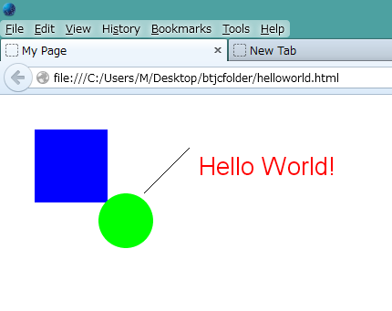

Chapter 1 - 2. Using Options
There are various options that can be selected when converting programs with BTJC.
Type “btjc.exe -h” into the command prompt to show all the options avaliable:
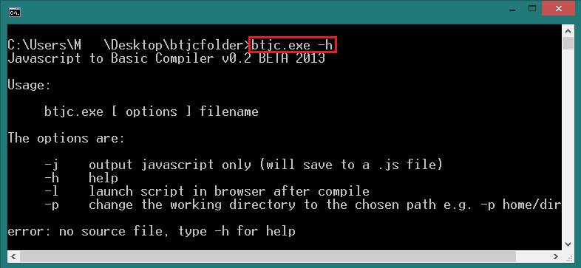
The following is a detailed explanation of each option available in the latest version of BTJC:

“-j” Option : Output Javascript File

Sometimes you may only want the Javascript output for the program. By using the “-j” option, instead of a .html file a .js will be created containing the Javascript output of the program.

E.g. btjc.exe -j helloworld.bas
This will output Javascript of the BASIC program in a file called helloworld.js.

“-l” Option : Launch Browser after Conversion

Instead of having to open the .html file to run the program each time the program has been converted, you can use the -l option to automatically launch the default browser and run the html after the conversion finishes.

E.g. btjc.exe -l helloworld.bas
This will tell BTJC to open helloworld.html with the default browser after the conversion is finished.

“-p” Option : Change Working Directory

When the “-p” option is selected the user can choose a path to a folder where the output files of the conversion will go. The path must be typed after the “-p” with a space.

E.g. btjc.exe -p test/outputfolder helloworld.bas
This will output the “helloworld.html” file to the folder at C:\Users\M\Desktop\btjcfolder\test\outputfolder”

The “-p” option can be combined with the “-j” option to output a javascript file at the selected output folder.

E.g. btjc.exe -p test/outputfolder -j helloworld.bas
This will output the “helloworld.js” file to the folder at C:\Users\M\Desktop\btjcfolder\test\outputfolder”

Chapter 2

Single threaded and Synchronous Programming

Javascript is single threaded and a synchronous programming language. Since the code written in BTJC will be converted to Javascript and ran as Javascript the programmer must know how single threaded and synchronous programs are executed. This chapter will provide hints on this type of programming.

