**ANN Lab 4**

**Hopfield Network**

**5.1 Convergence and attractors**

Training patterns**: X1: 0 0 1 0 1 0 0 1**

**X2: 0 0 0 0 0 1 0 0**

**X3: 0 1 1 0 0 1 0 1**

Input: All combinations of 8 bit binary string

Results: Below are the attractors in this network (14 attractors)

**0 0 0 0 0 1 0 0 x2**

**0 0 1 0 0 1 0 1**

**0 1 1 0 0 1 0 1 x3**

**1 0 0 1 1 0 1 0 inverted x3**

**1 1 0 1 0 1 1 0 inverted x1**

**1 1 0 1 0 0 1 0**

**0 0 0 0 1 0 0 0**

**0 0 1 0 1 0 0 1 x1**

**1 1 1 1 1 0 1 1 inverted x2**

**1 0 0 1 0 1 1 0**

**1 1 0 1 1 0 1 0**

**0 0 1 0 0 0 0 1**

**1 0 1 1 1 0 1 1**

**1 1 1 1 0 1 1 1**

Max with 3 bit errors we can find attractors but with 4 bit errors (half of the bits) any attractor couldn’t be found and no convergence.

Also by changing X from [x1; x2; x3;] to [x1; x2; x3; x1; x1] we get 8 attractors (changing the input pattern, the number of attractors are changed).

**5.2 Sequential update**

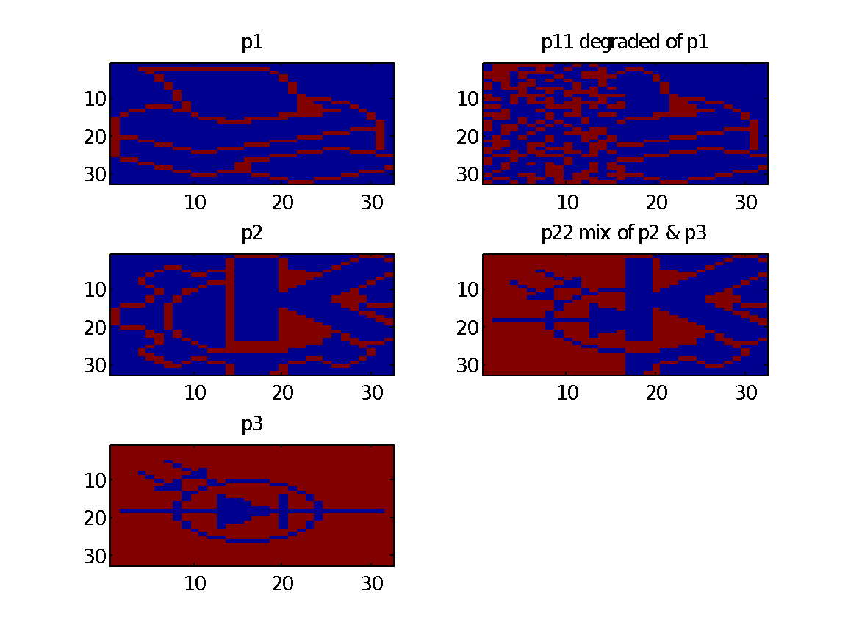

**Synchronous update (Little network):**

(In each iteration updating all units)

With 2 iterations p1 is recovered but in this method p22 is never completed and none of the p2 or p3 is not recovered. 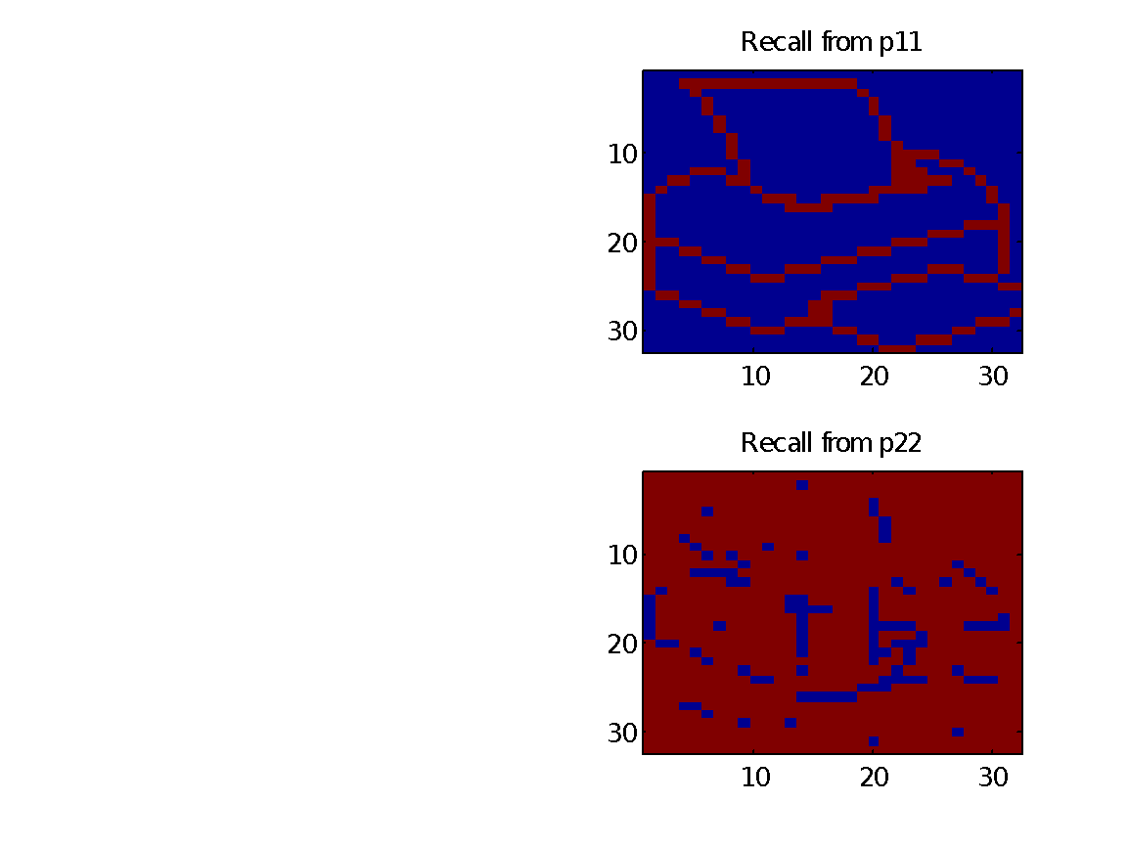

**Asynchronous update: (Select one unit randomly each iteration)**

This method needs more iteration to recover pictures.

**Iteration=100 Iteration=500 Iteration=1000 Iteration=3000**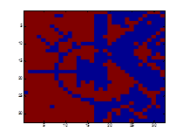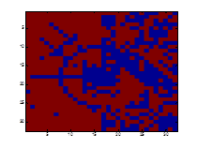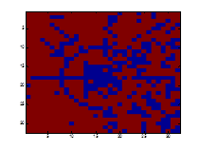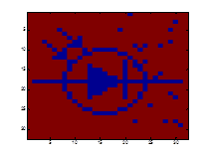

**Iteration=100 Iteration=500 Iteration=1000 Iteration=3000**

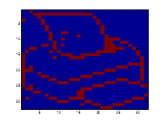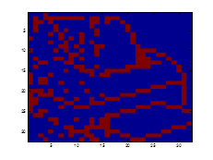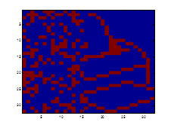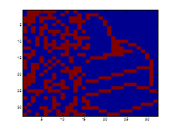

**Asynchronous update (Sequential update):**

(Each iteration updating 10% randomly selected units)

With 40 iterations the p1 and p2 are recovered. This method is very fast and need less iteration for recovering the pictures.

Iteration=10 Iteration=40 Iteration=50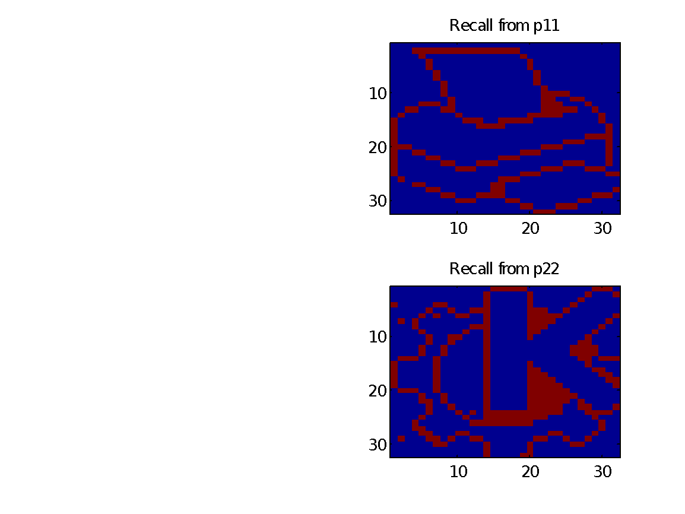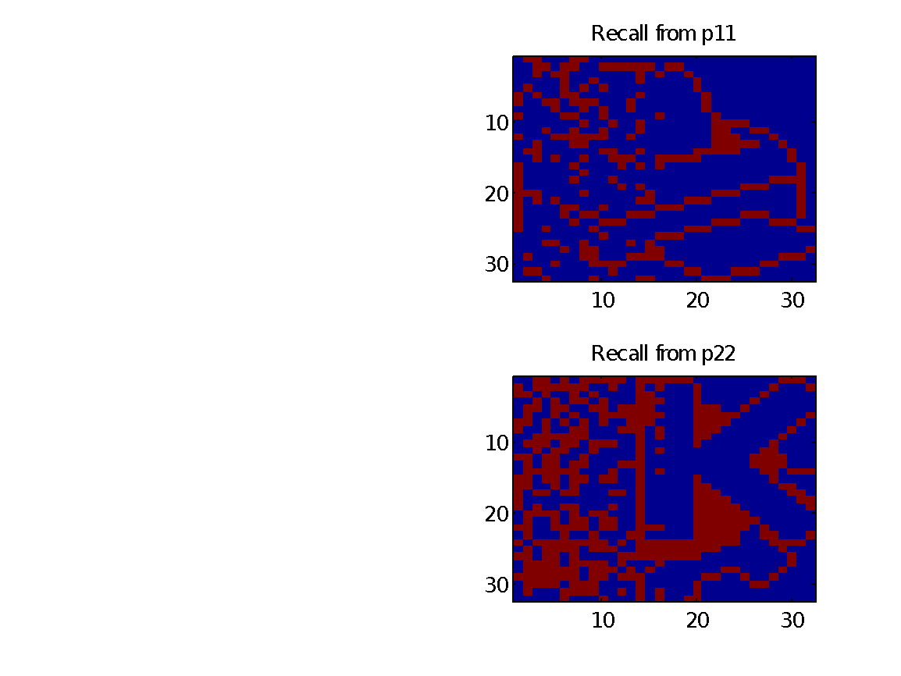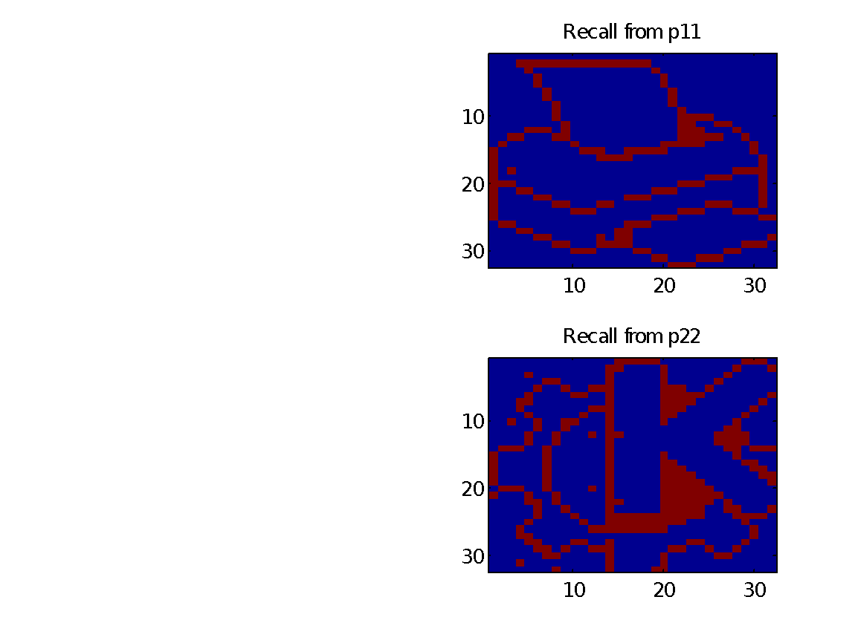

**5.3 Energy**

**• How do you express this calculation in Matlab? (Note: you do not need to use any loops!)**

e = - diag(x * w * x')

**• What is the energy at the different attractors?**

|  |  |
| --- | --- |
| **Test on T5.1:**  e =  -68  -68  -72 | **Test on picture:**  e =  -1473936 (p1)  -1398416 (p2)  -1497344 (p3) |

**• What is the energy at the points of the distorted patterns?**

|  |  |
| --- | --- |
| **Test on T5.1:**  ed_ini =  -40  -36  -24 | **Test on picture:**  ed_ini =  -425964 (p11)  -177664 (p12) |

**• Follow how the energy changes from iteration to iteration when you use the sequential update rule to approach an attractor.**

**Test on T5.1:**

|  |  |
| --- | --- |
| e_out =  -40 -68 -68  -36 -56 -68  -24 -72 -72 | When stuck in a not expected point:  e_out =  -40 -68 -68 -68  -36 -56 -68 -68  -24 -56 -68 -68 …… |

Using sequential update: randomly update 10% units(100)

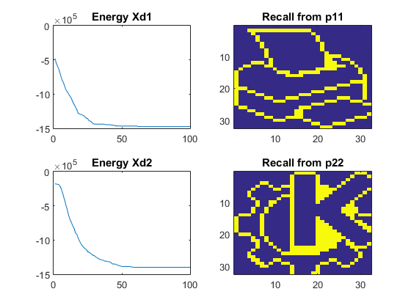

E1(end) = -1473936 = p1

E2(end) = -1398416 = p2

**• Generate a weight matrix by setting the weights to normally distributed random numbers, and try iterating an arbitrary starting state. What happens?**

**• Make the weight matrix symmetric (e.g. by setting w=0.5*(w+w')). What happens now? Why?**

Tset on T5.1

|  |  |
| --- | --- |
| asymmetric | symmetric |

Test on picture:

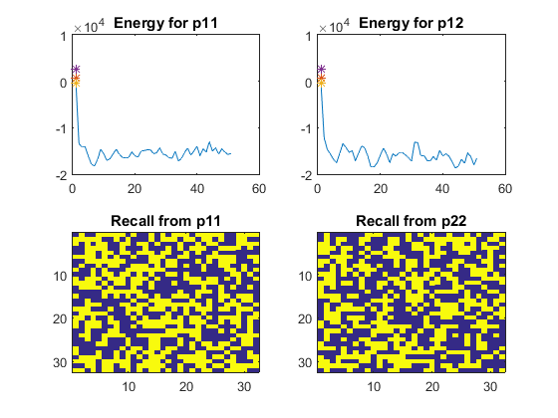

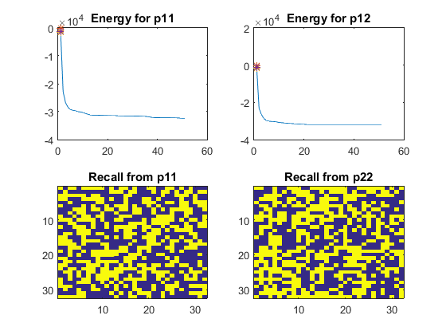

**5.4 Distortion Resistance**

function of flip: flip(p1,5): randomly choose 5 pixels in the picture and turn it to the opposite value, i.e. turn 1 to 0 and 0 to 1.

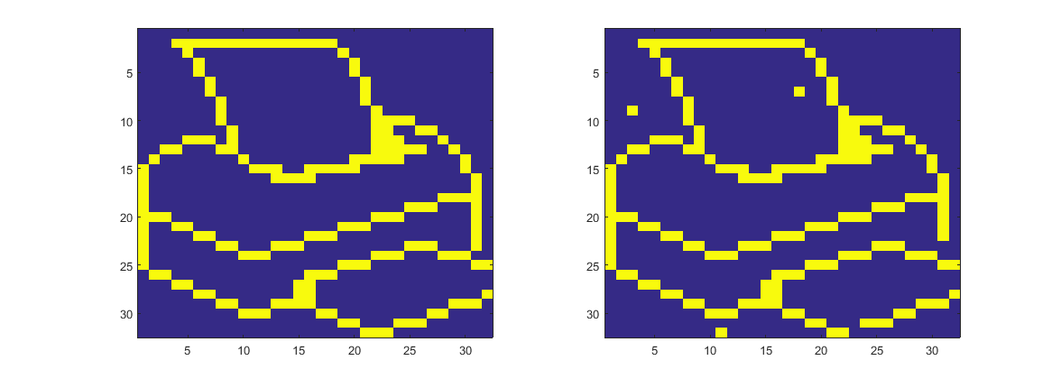

Noise test:

Trained with p1, p2, p3, and also noise is added to p1, p2 and p3

|  |  |
| --- | --- |
| picture 1 | picture 2 |
| picture 3 | Conclusion: a good restoration when noise < 0.4, and when noise > 0.5, the picture tends to restore to an inverse of colour. |

noise = [0, 0.2, 0.35, 0.4, 0.45, 0.5, 0.55, 0.6, 0.65, 0.8, 1];

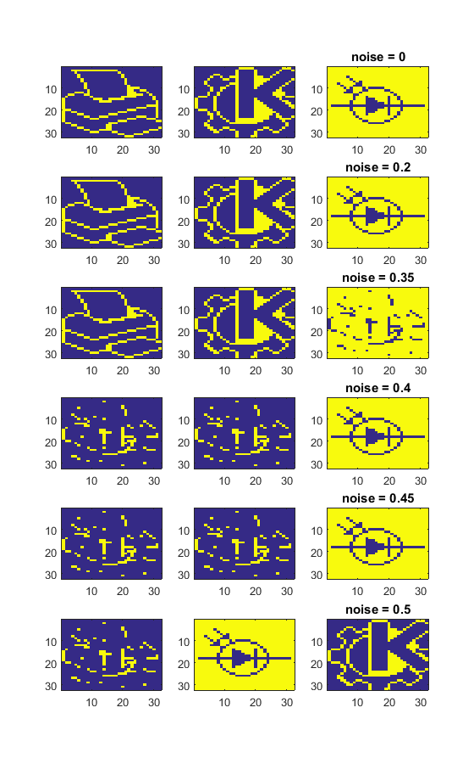

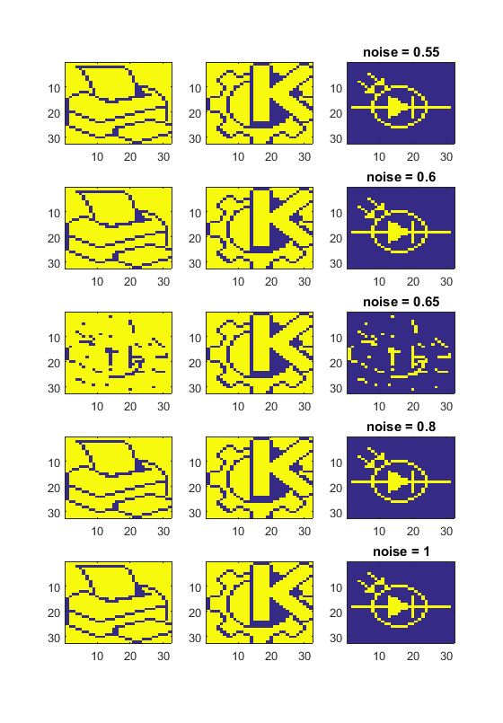

**5.5 capacity**

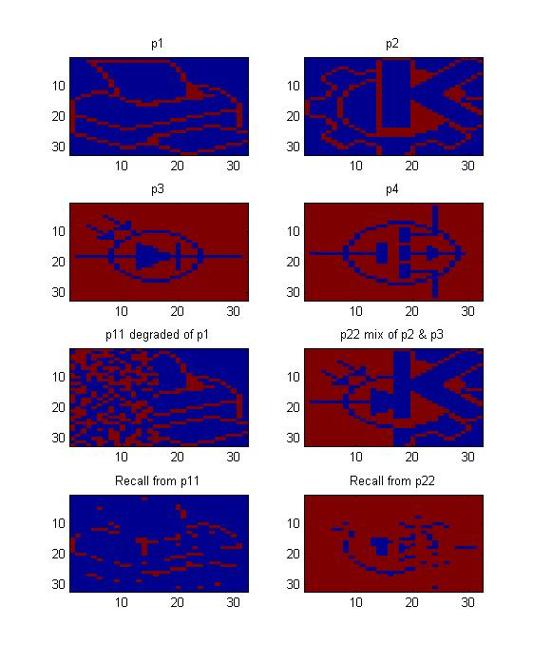

**Result**: by adding p4 into the weight matrix, no patterns could be safely stored after 10 iterations. The drop in performance is abrupt.

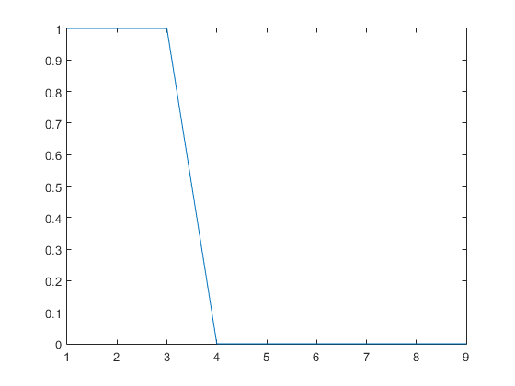

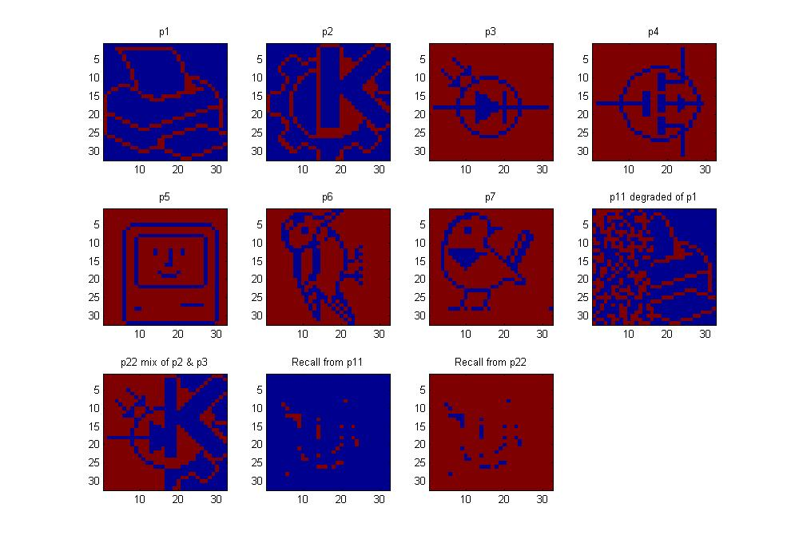

**Result**: by adding some random patterns the memory is partly stored, but not all.

**Difference between random patterns and the pictures**: random pictures have more entropy (more energy in general), hence increases the capacity.

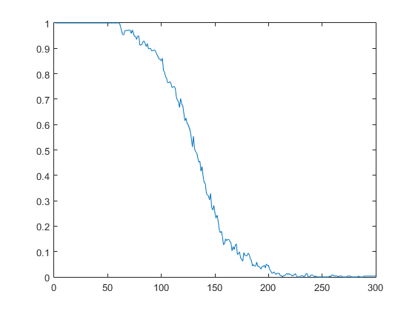

Increasing randomly created training patterns from 1 to 300, the capacity drop as the figure shows. 0.138*1024 = 141.312.

**Stability:**

|  |  |
| --- | --- |
| without setting w to diagnally zero | set w diagnally to zero: |

**Bias:**

without setting w to diagnally zero

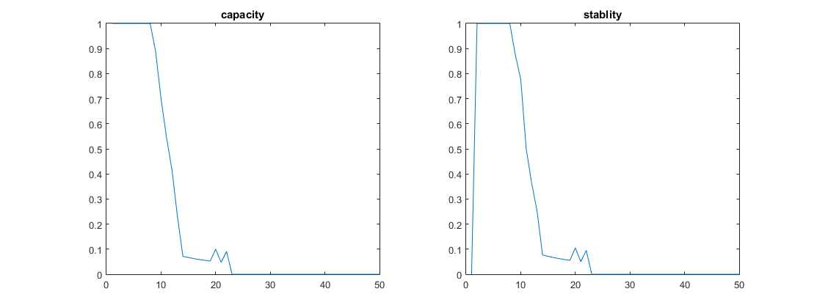

set w diagnally to zero:

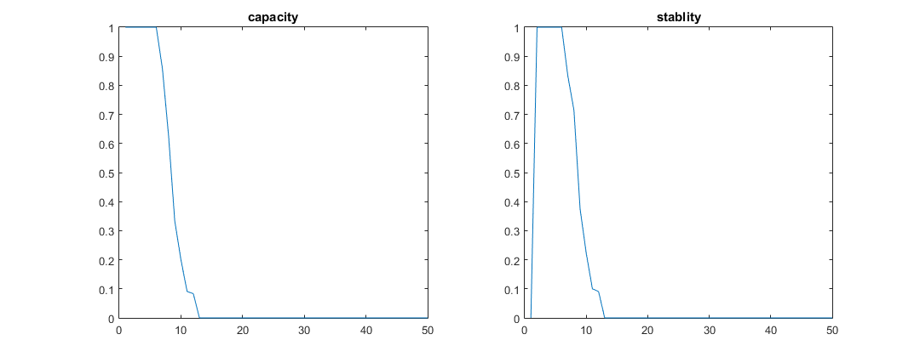

**5.6 sparse patterns**

Set rho = 0.1 and theta = 0.1, the capacity is increased to around 50.

Set rho = 0.05 and theta = 0.1, the capacity is increased to around 110.

