**DreamBeam Source data  
Version 0.0  
8th February 2018  
Oisin Creaner**

This describes the formats for output from DreamBeam in its current state

**Abstract**

Output from dreamBeam works in two main modes: Pointing and FoV. These modes produce data that describes the Jones matrix elements for two different operational requirements. Both modes provide options for plotting this data visually or outputting it to std.out, This output can then be redirected to a file if needed.

Pointing mode defines the Jones matrix elements for a given target based on its celestial coordinates and calculates how these change over a user defined period in user defined intervals. Optionally, this mode may calculate the Jones matrix elements for a single user-defined frequency, or for a variety of frequencies across the bandwidth of the telescope if the user does not supply a frequency.

FoV mode defines the Jones matrix elements for the whole sky at a given instant for a given frequency.

**Outline of Modes**

**dreamBeam**

**FoV**

**1-***ν*

**Pointing**

**n-***ν*

**Plot**

**Print**

**Plot**

**Print**

**Plot**

**Print**

Figure : Outline of modes

**Details of Outputs**

1. Pointing Mode  
   Pointing Mode plots the light curves as observed from a given station in a given band over a given time period at a given set of intervals. Frequency is an optional parameter which allows a user to either specify a frequency to work at (1-*ν*, below) or to require that the system calculate the Jones Matrices for all frequencies in the system. (n-*ν*, below)
   1. 1-*ν*   
      In this mode, the light-curve in Jones matrix terms is calculated for a single frequency over time
      1. Print  
         The print output for this mode consists of a row for each time interval, with each row consisting of the following elements, separated by spaces. *Note: this mode does not include a header.*
         * Frequency (print-formatted Python float)
         * Time (print-formatted Python datetime *YYYY-MM-DD HH:MM:SS*)
         * Four Jones Matrix elements (print-formatted Python complex numbers using the notation (*X.xxxx*+*Y.yyyy*j) in the order
           + [1,1]
           + [1,2]
           + [2,1]
           + [2,2]

**Pointing/1-***ν***/Print**

**For each time interval**

**Float:  
freq**

**datetime:  
time**

**Complex:  
Jones [1,1]**

**Complex:  
Jones [1,2]**

**Complex:  
Jones [2,1]**

**Complex:  
Jones [2,2]**

Figure : Schematic of Print output for single-frequency use of Pointing mode

**Sample Output**

**60000000.0 2012-04-01 01:02:03 (-0.0376926375124+0.0467493608816j) (-0.559791351791+0.0899978276011j) (0.738602661591-0.196422717245j) (0.159103880251-0.0775363649726j)**

**60000000.0 2012-04-01 01:02:04 (-0.0376395582277+0.0467382172651j) (-0.55979972323+0.0899965320884j) (0.738611482535-0.196421498181j) (0.159158232172-0.0775483040615j)**

**60000000.0 2012-04-01 01:02:05 (-0.0375864775634+0.0467270738462j) (-0.559808091231+0.0899952354983j) (0.738620299442-0.196420277746j) (0.159212585231-0.0775602427118j)**

**60000000.0 2012-04-01 01:02:06 (-0.0375333955529+0.0467159306318j) (-0.559816455789+0.0899939378314j) (0.738629112309-0.196419055939j) (0.159266939393-0.0775721809157j)**

* + 1. Plot  
       The plot mode produces an image of the trajectory of the selected pointing and a set of plots of the light curves for that object at the given frequency over the given interval

The trajectory plot (as shown in Figure 3) shows the apparent position of the object at each point in time. *Note: In LOFAR, for a non-core station, these coordinates will not be centred on the pole as the orientation is set for the LOFAR core – Check details of how that works – OC*

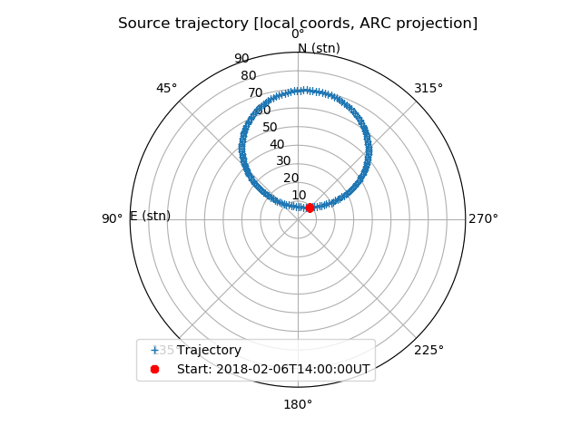

Figure : Sample of plot output of the track of the coordinates of the target object for pointing mode

The Light curve plot displays the p-channel $\left(p=\left|{J\left[1,1\right]}^{2}\right|+\left|{J\left[1,2\right]}^{2}\right|\right)$ and q-channel $\left(q=\left|{J\left[2,1\right]}^{2}\right|+\left|{J\left[2,2\right]}^{2}\right|\right)$ calculated for each point in time against time for the given frequency. *Note: Want to check the implications of these two channels – OC*

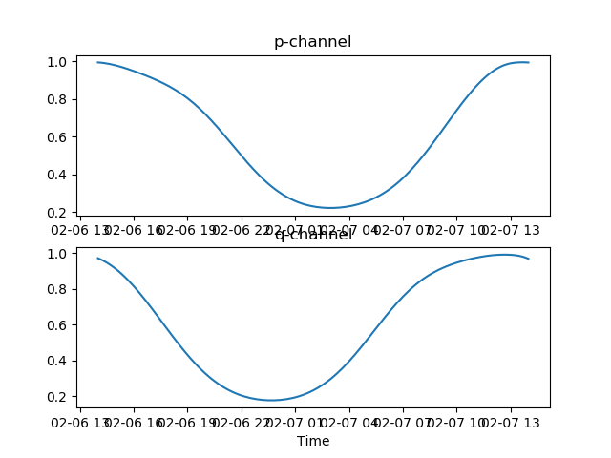

Figure : Sample of Plot output for lightcurve for a single frequency in pointing mode. Time is plotted on the x-axis, p- and q-channel values are plotted on the y-axis.

* 1. n-*ν*In this mode, the light-curve in Jones matrix terms is calculated for a number of (*all possible? – to check*) frequencies over time
     1. Print   
        The print output for this mode consists of a row for each time interval/frequency combination, with a header to describe the columns. Each row consists of the following elements, separated by spaces
        + Time (print-formatted Python datetime *YYYY-MM-DD*T*HH:MM:SS*)
        + Frequency (print-formatted Python float)
        + Four Jones Matrix elements (print-formatted Python complex numbers using the notation (X.xxxx+Y.yyyyj) in the order
          - [1,1]
          - [1,2]
          - [2,1]
          - [2,2]

**Pointing/n-***ν***/Print**

**For each time interval**

**For each frequency**

**Float:  
freq**

**datetime:  
time**

**Complex:  
Jones [1,1]**

**Complex:  
Jones [1,2]**

**Complex:  
Jones [2,1]**

**Complex:  
Jones [2,2]**

**String:  
Header  
Time, Freq, J11, J12, J21, J22**

Figure : Schematic of Print output for multi-frequency use of Pointing mode

Sample Output

Time, Freq, J11, J12, J21, J22

2018-02-06T14:00:00 100000000.0 (0.66341703593+3.81594230048e-05j) (0.734230798413+4.67556454144e-05j) (-0.728670398582-0.000157718454146j) (0.657853576392+0.000149924324324j)

2018-02-06T14:00:00 100195312.5 (0.663422817909+3.78016297019e-05j) (0.734237231341+4.63214173956e-05j) (-0.728672812056-0.000156021203443j) (0.657855732724+0.000148292112886j)

2018-02-06T14:00:00 100390625.0 (0.663428623131+3.74508255174e-05j) (0.734243690078+4.58952493196e-05j) (-0.728675253667-0.000154346887646j) (0.657857914921+0.000146681668139j)

* + 1. Plot  
       The plot mode produces an image of the trajectory of the selected pointing and a set of plots of the light curves for that object at the given frequency over the given interval

The trajectory plot (as shown in Figure 3) shows the apparent position of the object at each point in time. *Note: In LOFAR, for a non-core station, these coordinates will not be centred on the pole as the orientation is set for the LOFAR core – Check details of how that works – OC*

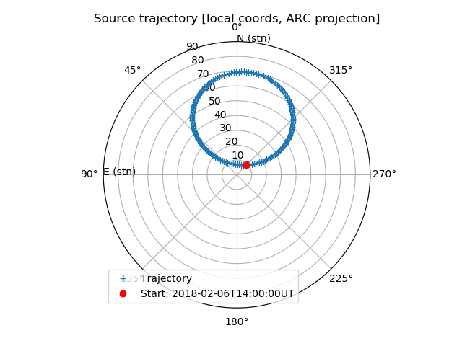

Figure : Sample of plot output of the track of the coordinates of the target object for pointing mode for n-frequencies

The Light curve plot displays the p-channel $\left(p=\left|{J\left[1,1\right]}^{2}\right|+\left|{J\left[1,2\right]}^{2}\right|\right)$ and q-channel $\left(q=\left|{J\left[2,1\right]}^{2}\right|+\left|{J\left[2,2\right]}^{2}\right|\right)$ values calculated for each point in time against time for each frequency. The plot then shows the values in colour, with the time and frequency as x- and y-axes respectively

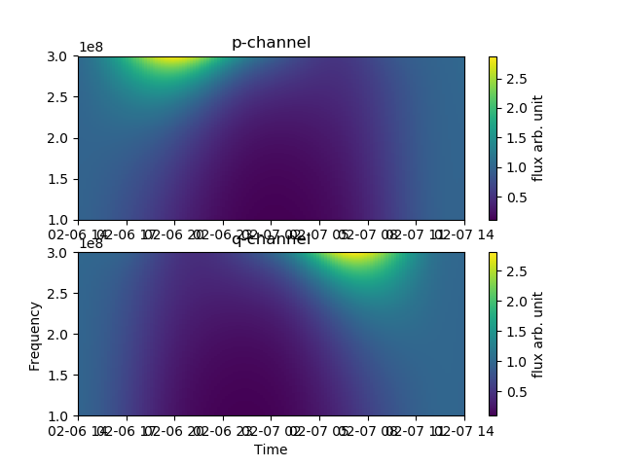

Figure : Sample of Plot output for lightcurve for multiple frequency in pointing mode (*query to raise: Should HBA and LBA output in this mode be identical?*) Time is plotted on the x-axis, frequency on the y-axis, p- and q-channel values are plotted on the z-axis (colour).

1. FoV Mode
   1. Print

The print output for this mode consists of a pair of rows for each time interval, with each alternating row consisting of the following elements, separated by spaces. *Note: this mode produces output with labels for each row.*

* + - * First Row
        + Label (az, el: )
        + Azimuth (print-formatted Python float)
        + Elevation (print-formatted Python float) (*Why not Altitude? - OC*)
      * Alternate Rows
        + Label (Jones: )
        + Four Jones Matrix elements (print-formatted Python complex numbers using the notation (*X.xxxx*+*Y.yyyy*j) in the order

[1,1]

[1,2]

[2,1]

[2,2]

**Pointing/1-***ν***/Print**

**For each Elevation**

**For each Azimuth**

**Float:  
Azimuth**

**Float:  
Elevation**

**Complex:  
Jones [1,1]**

**Complex:  
Jones [1,2]**

**Complex:  
Jones [2,1]**

**Complex:  
Jones [2,2]**

**String:  
label  
az, el:**

**String:  
label  
Jones:**

Figure 8: Schematic of Print output for single-frequency use of Pointing mode

Sample Output (*Query – these values include negative elevations – how come?* *Some of these seem to show different Jones values at different RA (?) values at DEC 90. Isn’t this a constant point?*)

az, el: 0.0 1.57079632679

Jones: (0.808438378389-0.0536168902205j) (-0.174461109928-0.0550466007067j) (0.176809726227-0.0764445107476j) (0.810303656386-0.044823755958j)

az, el: 0.0245436926062 1.57079632679

Jones: (0.803911684752-0.0549513922064j) (-0.19424874567-0.0537143676432j) (0.196640074711-0.0775212195077j) (0.80572271751-0.0429343667736j)

* 1. Plot

The Light curve plot for FoV Mode plots the I, q, u and v parameters as colour against RA and DEC.   
*To be completed – I’m not sure on how RA and DEC are calculated from Altitude and Azimuth (which seem to be the parameters that are used., at least in the docs)*

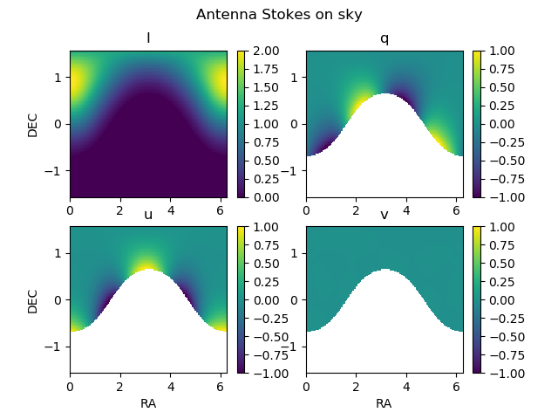

Figure : Sample of plot output for FoV mode. In each plot, RA is used as the x-axis, and DEC as the y-axis. The Stokes parameters, calculated from the Jones Matrices, are plotted on the z-axis (colour)