Name: Christopher Reaney

Assignment: Module 4.2

Date: 09/02/2024

Initial Connection Screenshot

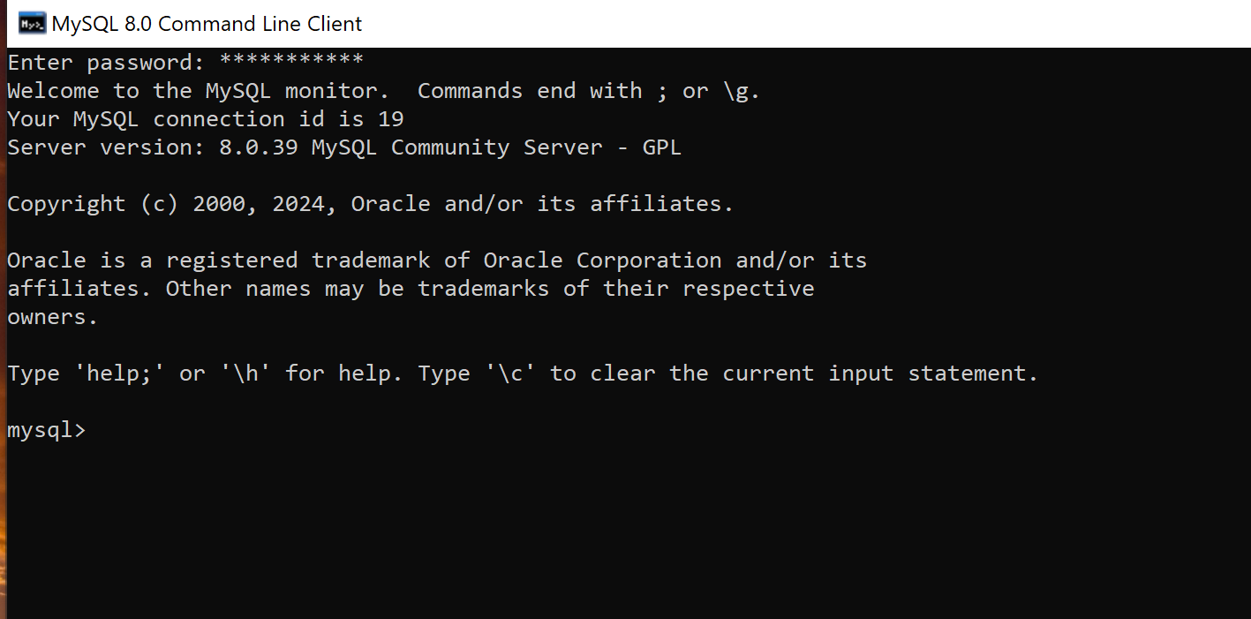

Showing Created Database

