Name: Christopher Reaney

Assignment: Module 3.2

Date: 10/30/24

W3C HTML Validator Screenshot

W3C CSS Validator Screenshot

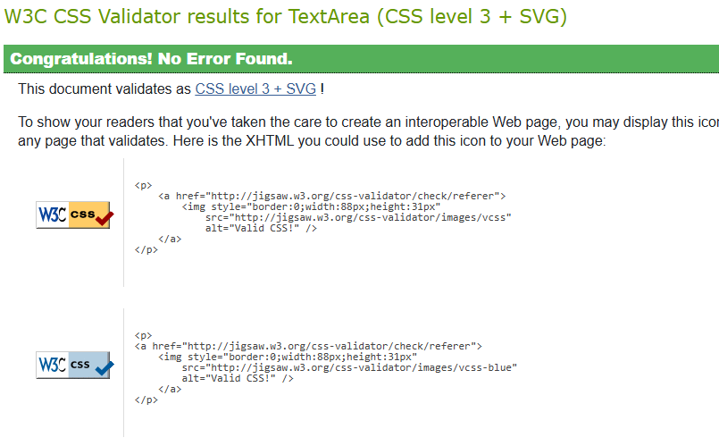

Index Page Screenshot

