Project: ToDo Application
Course: CSD-380 DevOps
Description: Functional test cases based on the Todo Business Requirements document
Date: (2025/06/16)
Jose Franco
Module 4.2 Assignment – Test Plan
TABLE OF CONTENTS
Verify Access to Website via Standard URL > 2
<Create New Todo Task> 3
<Edit a Task> 4
<Validate Empty Task Form Submission> 5
<Custom 404 Page for Invalid URLs> 6

For each test, the developer should: provide a test description, a test objective, the developer name and date tested. For each step, fill out the actions to be taken and describe the expected results, and indicate yes or no for each step depending upon the result. The peer tester should provide their name, date tested, indicate yes or no for each step depending upon the result, and a screenshot (thumbnail) of the result.

Test 1 | < Verify Access to Website via Standard URL >
 | Test Objective: Ensure users can access the Todo site using the standard URL and that the page loads correctly. | Developer: Jose Franco  Date tested: 2025/06/16 | Peer tester: Christopher Reaney  Date tested: 2025/06/17
Step | Action | Expected results: | Developer pass/fail | Tester pass/fail  + Screenshot
1 | Open browser and enter URL | Page loads without error | Yes | Yes  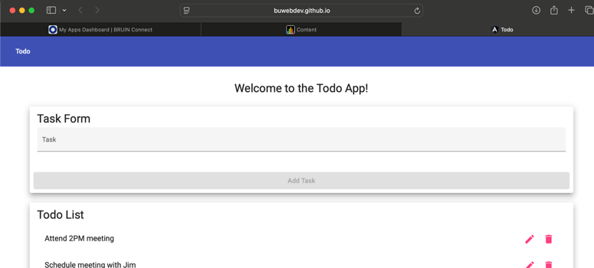
2 | Refresh the browser | Page reloads successfully | Yes | Yes  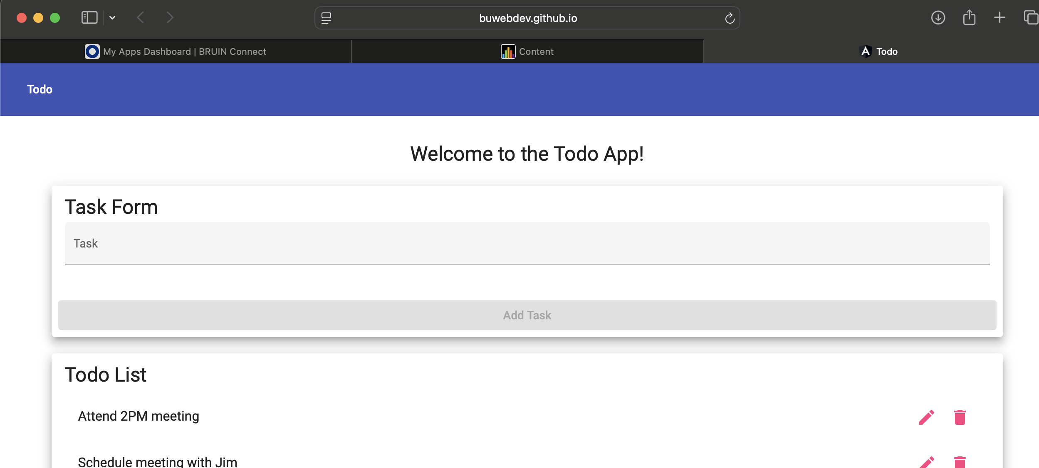
3 | Check the URL uses HTTPS | HTTPS connection is active and secure | Yes | Yes  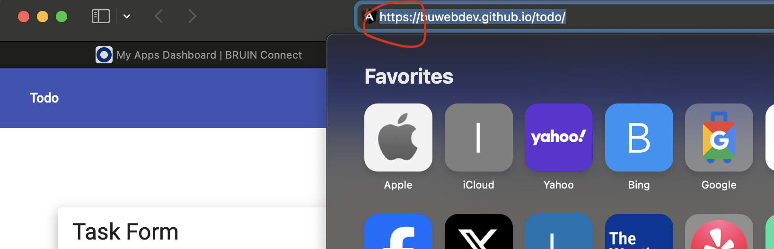
4 | Confirm navigation is responsive | Menu and layout adjust properly on window resize | Yes | Yes  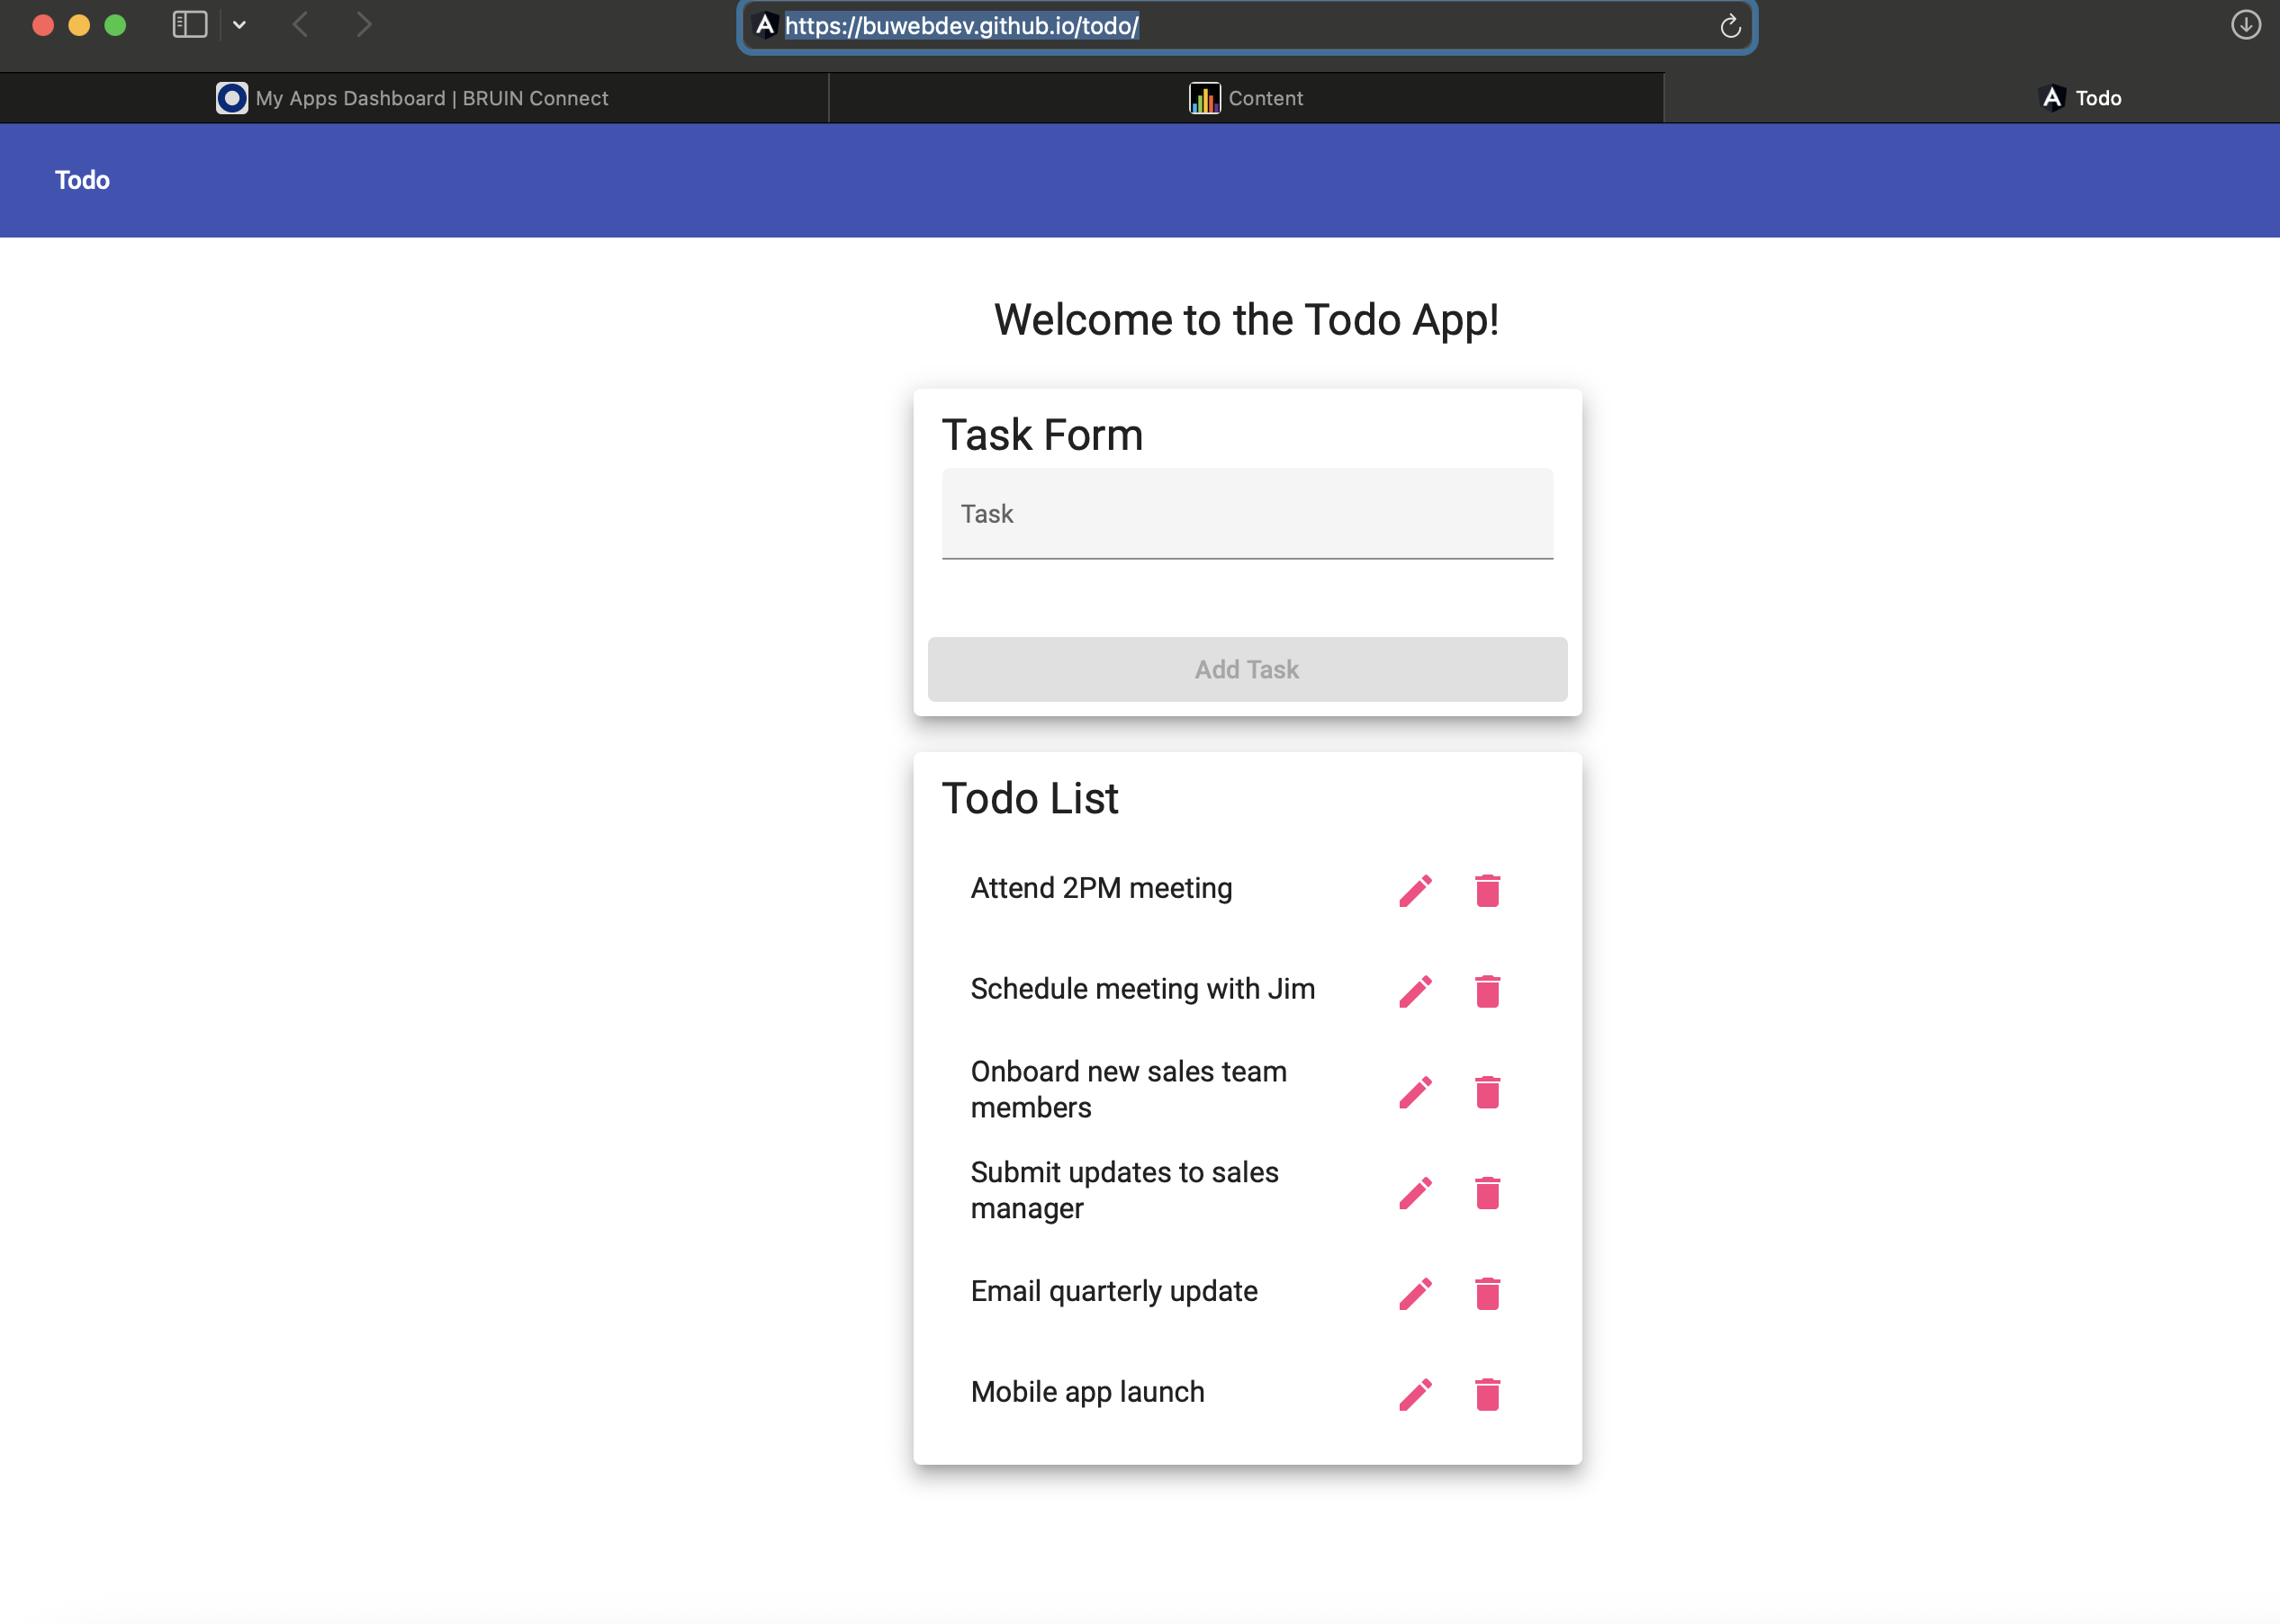
5 | Click on any button or link | Page responds and navigates correctly | Yes | Yes  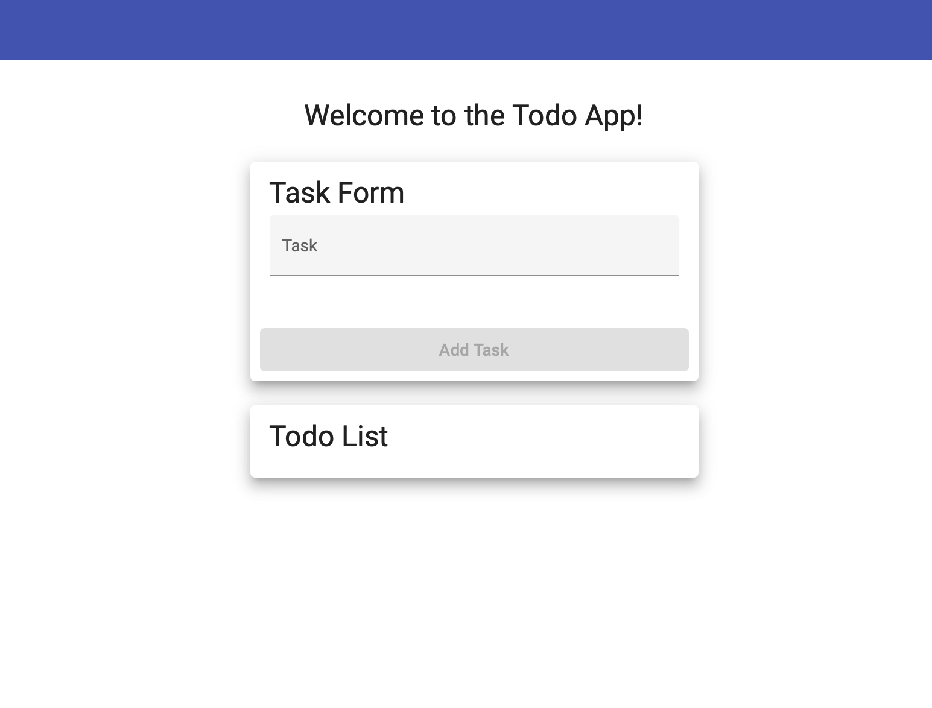
Comments | The application successfully loads via the given URL, and no errors were encountered on refresh. The layout adjusted responsively on window resize, and navigation links functioned as expected. This confirms that the site meets the basic accessibility and availability requirement.  Peer tester comments: No URL provided in test case makes this test impossible to complete. I had to retrieve from another source. The page does resize, but I’m not sure if it resizes appropriately. It looks like it gets smaller as the window gets bigger. I’d still call it a pass overall.

Test 2 | <Create New Todo Task>
 | Test Objective: Ensure users can successfully add a new task. | Developer:Jose Franco  Date tested: 2025/06/16 | Peer tester: Christopher Reaney  Date tested: 2025/06/17
Step | Action | Expected results: | Developer pass/fail | Tester pass/fail
1 | Load the Todo page | Page loads with input form visible | Yes | Yes  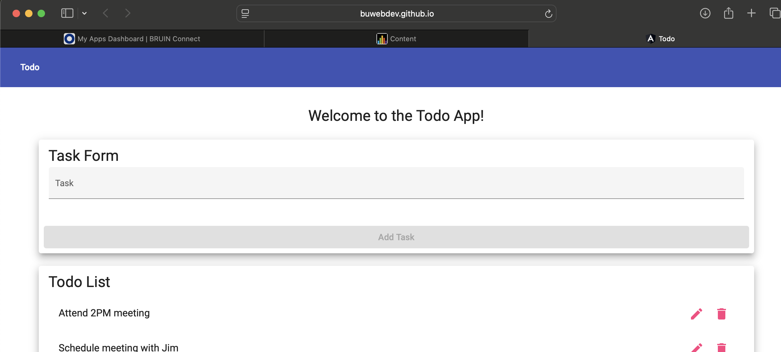
2 | Enter a task name in the input box | Input accepted | Yes | Yes  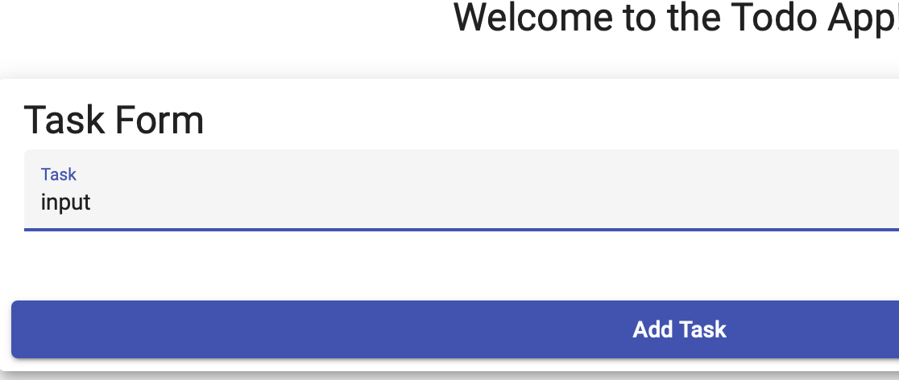
3 | Click the “Add” or “+” button | Task is added to the list below | Yes | Yes
4 | Confirm the new task appears in list | Task is listed with no errors | Yes | Yes  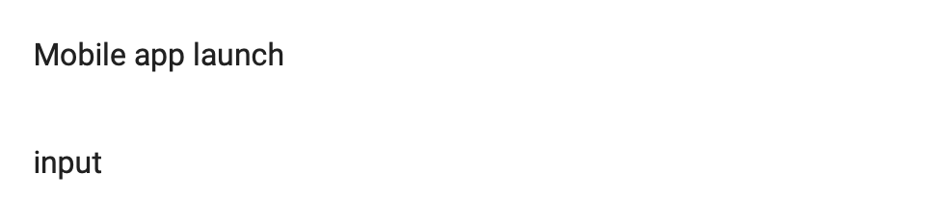
5 | Refresh the page | Task remains if stored persistently | No | No  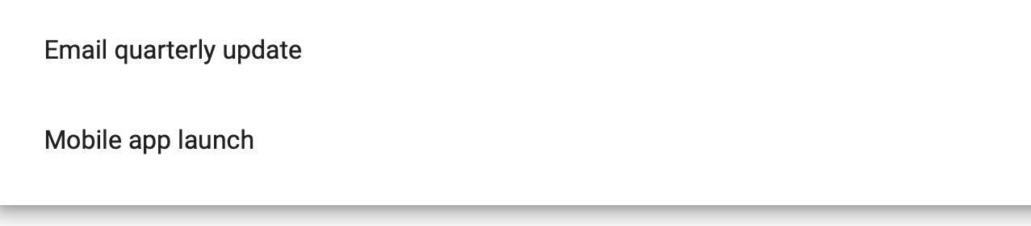
Comments | The create functionality worked smoothly, and newly added tasks appeared instantly in the list. This validates core functionality. One suggestion is to add visual confirmation or animation to show that the task was added.  Peer tester comments: Steps 3 and 4 seem to be doing the same thing for acceptance criteria. There isn’t really a way to take a screenshot of using the add button with no text, so I wonder if they couldn’t just be combined.

Test 3 | <Edit a Task>
 | Test Objective: Confirm that existing tasks can be edited and changes saved | Developer: Jose Franco  Date tested: 2025/06/16 | Peer tester: Christopher Reaney  Date tested: 2025/06/17
Step | Action | Expected results: | Developer pass/fail | Tester pass/fail
1 | Add a new task | Task is created successfully | Yes | Yes  
2 | Click the “Edit” icon or button | Edit form or input becomes active | Yes | Yes  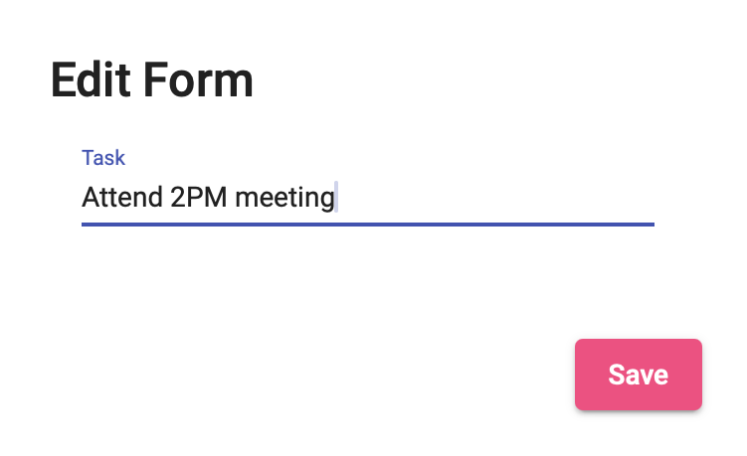
3 | Change the task text | Input accepted | Yes | Yes  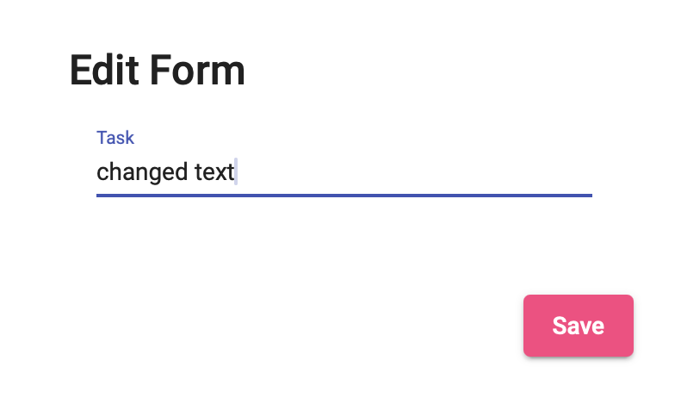
4 | Click “Save” | Task text updates to new value | Yes | Yes  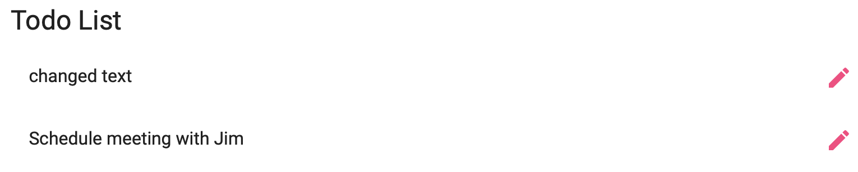
5 | Reload the page | Edited text remains (if data is persisted) | No | No  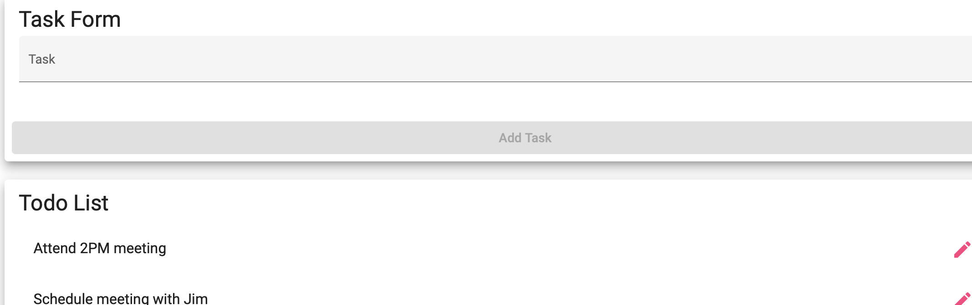
Comments | The edit feature correctly allowed modifying a task and saving changes. It would be helpful to highlight the task while editing or provide a temporary "editing" label. Overall, the functionality is reliable.  Peer tester: If we are testing editing a task, why are we starting the test off by adding a task? It seems like the acceptance criteria for this could be made smaller. Otherwise the test ran pretty smoothly.

Test 4 | <Validate Empty Task Form Submission>
 | Test Objective: Ensure the app blocks users from submitting empty todo entries. | Developer: Jose Franco  Date tested: 2025/06/16 | Peer tester: Christopher Reaney  Date tested: 2025/06/17
Step | Action | Expected results: | Developer pass/fail | Tester pass/fail
1 | Open the Todo page | Input field and add button are visible | Yes | Yes  
2 | Leave input field blank | Input remains empty | Yes | Yes  
3 | Click the “Add” or submit button | No task is added to the list | Yes | Yes  
4 | Check for validation message | Message or alert shown (if implemented) | Yes | No
5 | Enter valid task after that | Task added successfully | Yes | Yes  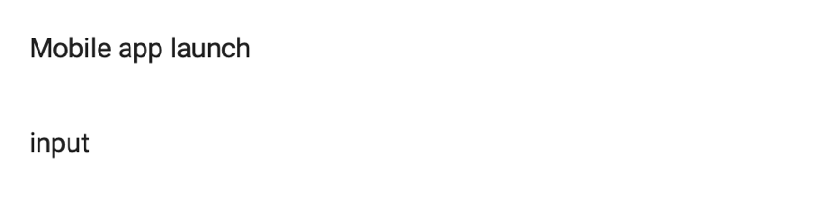
Comments | The form blocked empty submissions, which is great. However, the user experience could be improved by showing a clear validation message or red outline around the input field. The logic works, but UX can be stronger.  Peer tester: Step 2 essentially has the tester do “nothing.” And take a picture of it. I’m not sure that this test would ever fail. You could probably combine steps 2 and 3 and have the same results. For step 4, the box is greyed out, so I don’t think a validation message would be shown. I tried stress testing this by adding special characters, and it appears to just accept anything.

Test 5 | <Custom 404 Page for Invalid URLs>
 | Test Objective: Confirm that the site displays a custom 404 page for invalid routes. | Developer: Jose Franco  Date tested: 2025/06/16 | Peer tester: Christopher Reaney  Date tested: 2025/06/17
Step | Action | Expected results: | Developer pass/fail | Tester pass/fail
1 | Open browser | Navigate to homepage | Yes | Yes  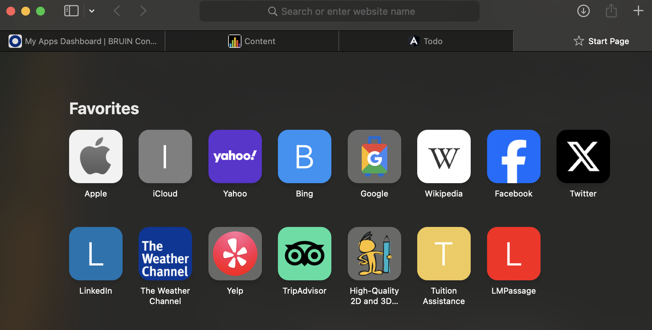
2 | Manually type an invalid sub-path (e.g., `/xyz`) | Page loads with custom 404 error | Yes | Yes  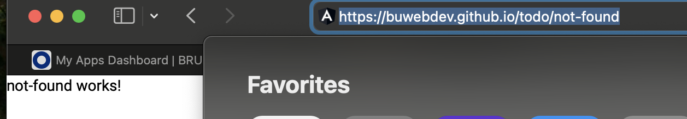
3 | Check for branding/message on 404 page | Page contains project-specific 404 content | Yes | Yes  
4 | Click "Back to home" (if present) | Redirects back to main page | No | No
5 | Try another invalid URL | Same 404 page behavior observed | Yes | Yes  
Comments | A custom 404 page appears for broken or mistyped URLs, which fulfills the requirement. The design could include a “Back to Home” button for smoother recovery. Still, the implementation clearly distinguishes itself from a browser default.  Peer tester: For this test I would have provided at least one invalid URL to use. It’s quite difficult otherwise to validate your results across tests. Also, opening a browser probably doesn’t have much use here on its own, though it is required for testing. Maybe it could be “in a browser, do the following”. Steps 2 and 3 seem to be the same test.

