Project: To DO business Requirements
Course: CSD-380
Description: Test Plan
Date: 6/17/25
To complete the test case plan, fill out the information for Project, Course, Description and Date in the header below.
.
TABLE OF CONTENTS
<DESCRIPTION> 2
<DESCRIPTION> 2
<DESCRIPTION> 3

For each test, the developer should: provide a test description, a test objective, the developer name and date tested. For each step, fill out the actions to be taken and describe the expected results, and indicate yes or no for each step depending upon the result. The peer tester should provide their name, date tested, indicate yes or no for each step depending upon the result, and a screenshot (thumbnail) of the result.

Test 1 | Access Website Through URL
 | Test Objective:  Ensures that users can access the application | Developer: Jason Schriner  Date tested: 2025/06/17 | Peer tester: Christopher Reaney  Date tested: 2025/06/18
Step | Action | Expected results: | Developer pass/fail | Tester pass/fail  + Screenshot
1 | Open a browser | Browser opens successfully | <yes/no> | Yes  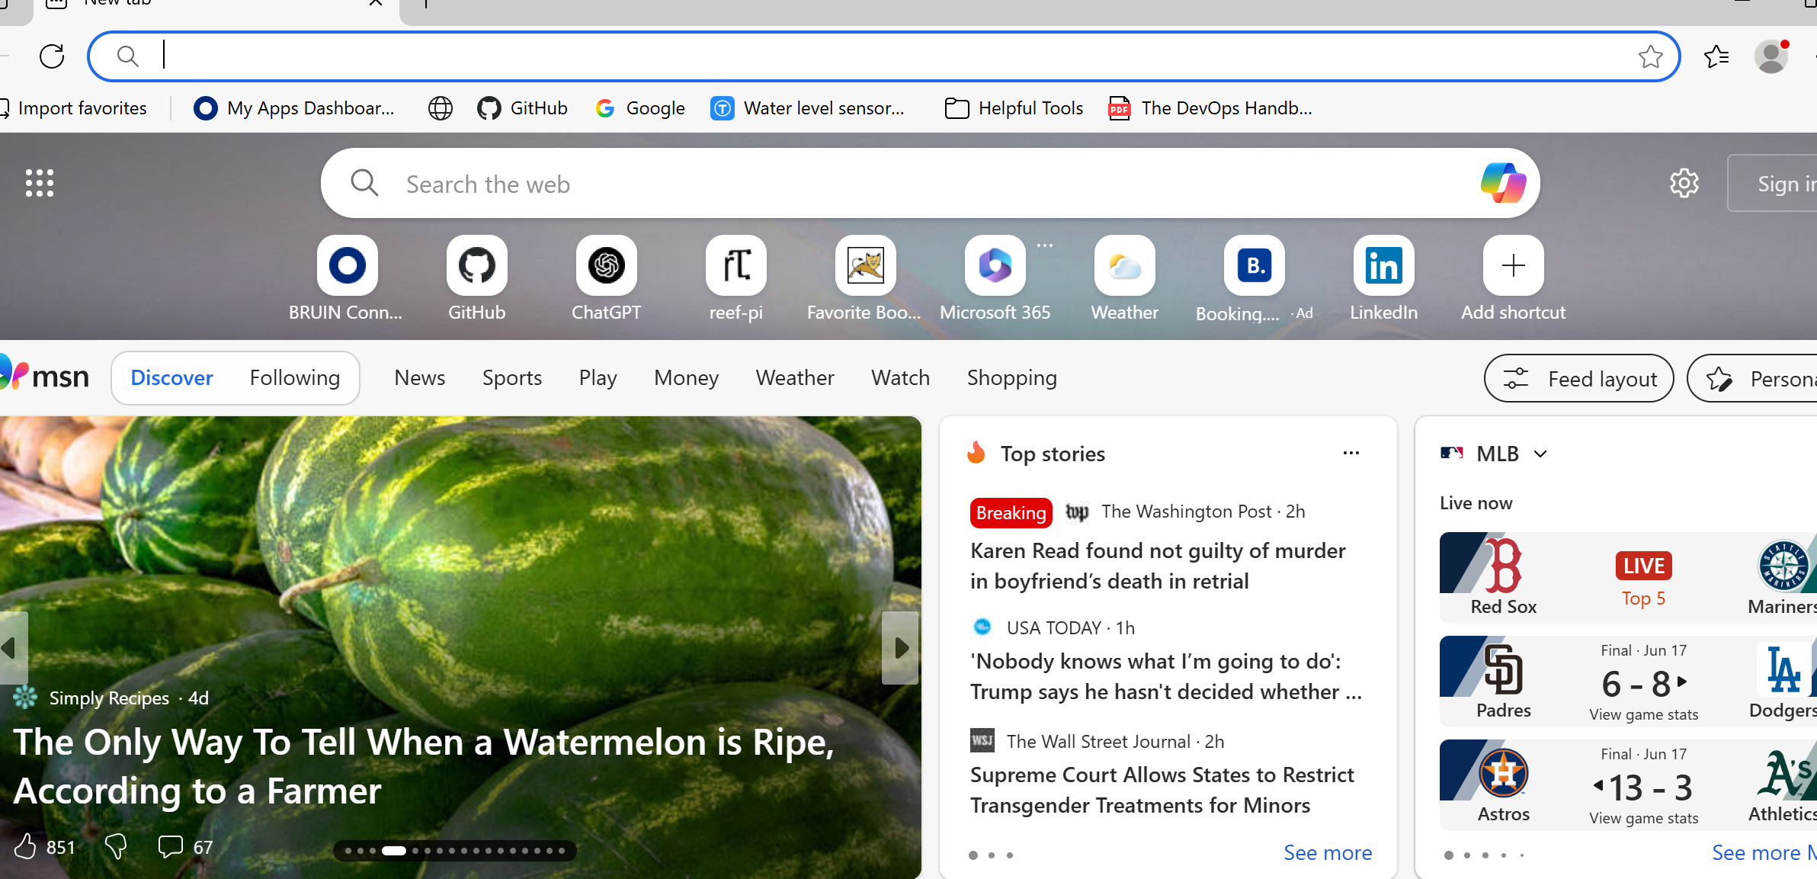
2 | Navigate to https://buwebdev.github.io/todo/ | Page loads without errors | <yes/no> | Yes  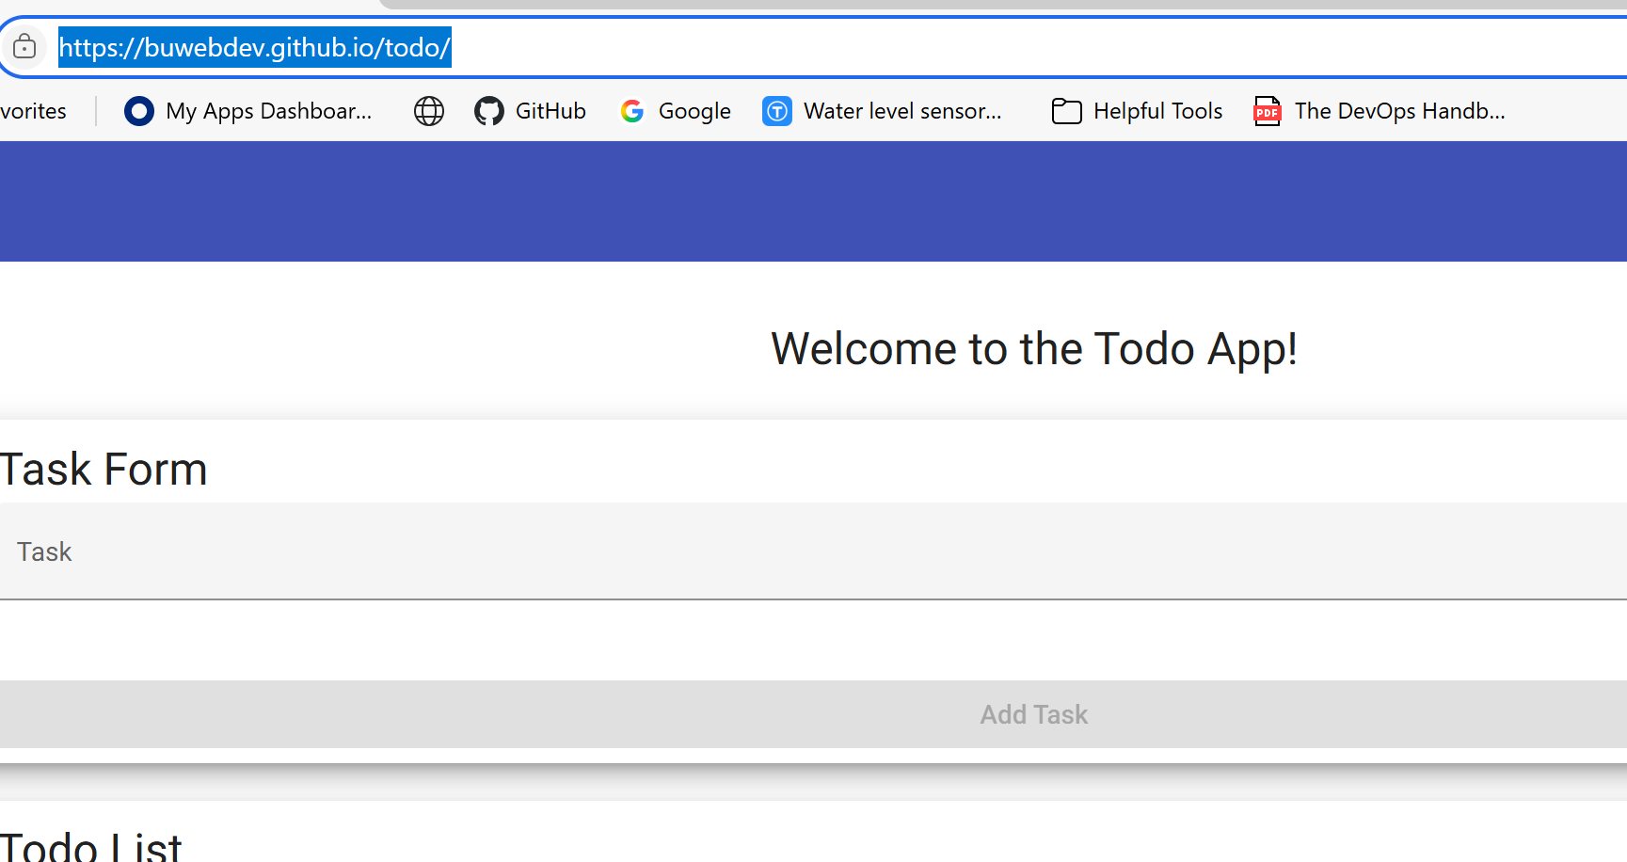
3 | Refresh the page | The browser refreshes the page, the application attempts to load | <yes/no> | Yes  
4 | Confirm browser loads correctly | The application loads without errors | <yes/no> | Yes  
5 | <Enter an action> | <Enter the expected results> | <yes/no> | no
Comments | Peer Tester: These seem to be good, clear test cases, but it appears some of the template is still left over here. Also the developer appears to have not tested this test case, or any of the items in the form (Yes/no hasn’t been filled in). Steps 3 and 4 seem to be testing the same thing.

Test 2 | Create a new to do task item
 | Test Objective:  Item appears on list | Developer: Jason Schriner  Date tested: 2025/06/17 | Peer tester: Christopher Reaney  Date tested: 2025/06/18
Step | Action | Expected results: | Developer pass/fail | Tester pass/fail
1 | Enter a task into the input field | The task appears in the input field, The submit button becomes active | <yes/no> | Yes  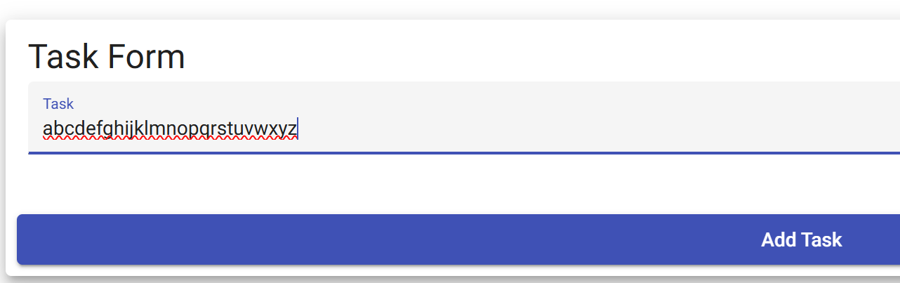
2 | Click the Submit button | The task is added to the list | <yes/no> | Yes  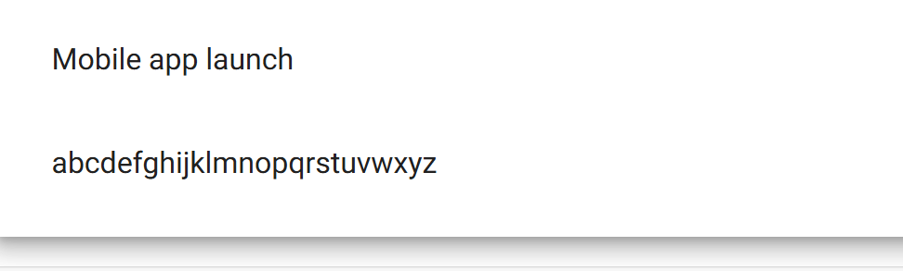
3 | Confirm the task appears on the page | The task is displayed as a new item on  The list | <yes/no> | Yes  
4 | Add another task with different task | The new task should display below the previous task | <yes/no> | Yes  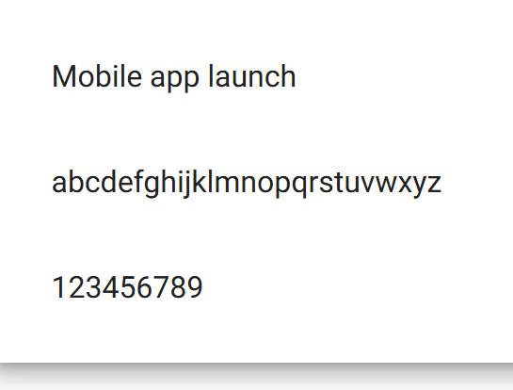
5 | Leave the input field blank and try to submit | Button remains unclickable | <yes/no> | Yes  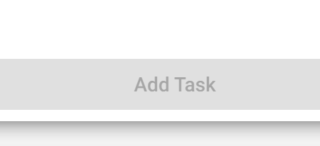
Comments | Peer tester: The test items are clear and easy to understand. Items 2 and 3 seem to have the same result and are testing the same thing as far as I can tell. Step 4’s wording may be a bit confusing, but I think I understood what it was asking.

Test 3 | View a list of To DO task items
 | Test Objective: | Developer: Jason Schriner  Date tested: 2025/06/17 | Peer tester: Christopher Reaney  Date tested: 2025/06/18
Step | Action | Expected results: | Developer pass/fail | Tester pass/fail
1 | Open browser | Browser opens successfully | <yes/no> | Yes  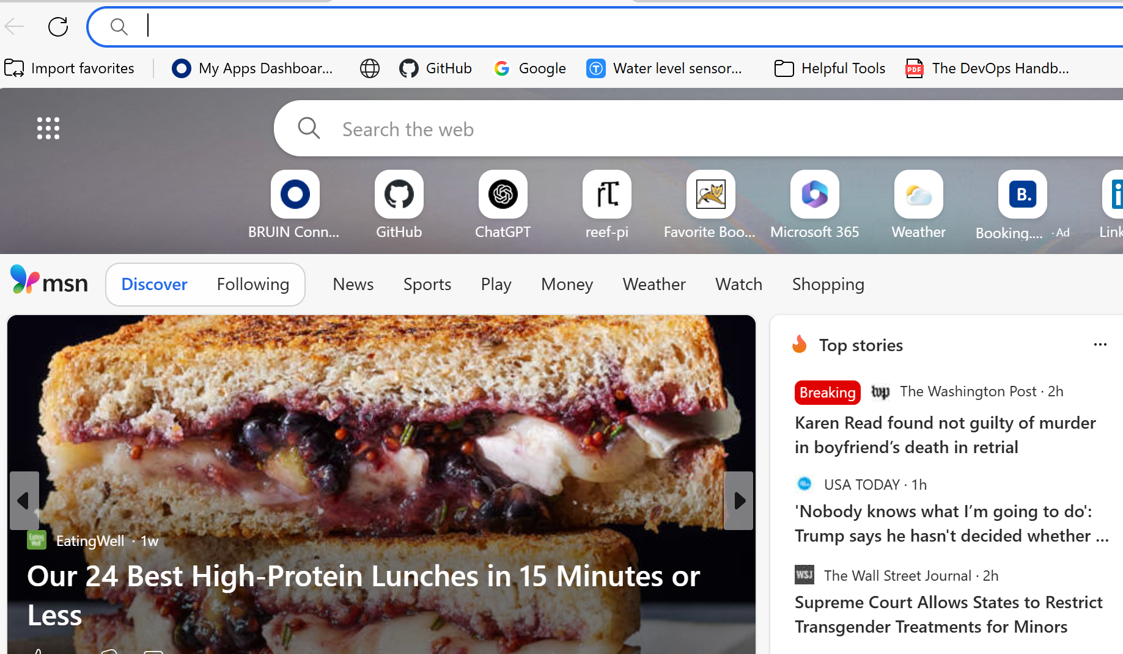
2 | Navigate to https://buwebdev.github.io/todo/ | Page loads without errors | <yes/no> | Yes  
3 | Observe the task list area | A section is present for tasks | <yes/no> | Yes  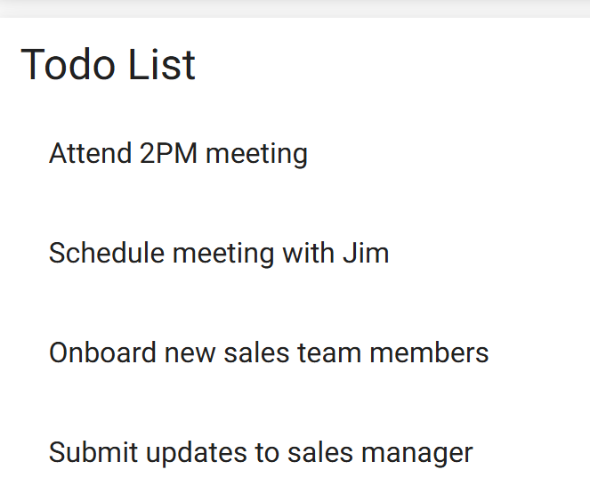
4 | Add a new task using the input | The new tasks appear in the task list | <yes/no> | Yes  
5 | Refresh the page | The tasks reappear in the task list | <yes/no> | No  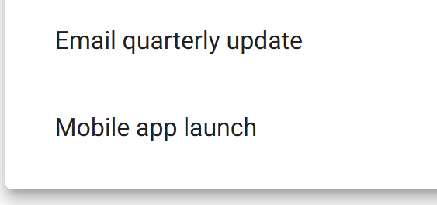
Comments | Peer tester: While the names may be different, it seems like test case 2 and test case 3 are both used for creating and viewing items on the list.

Test 4 | Delete a To Do task
 | Test Objective:  To delete a task | Developer: Jason Schriner  Date tested: 2025/06/17 | Peer tester: Christopher Reaney  Date tested: 2025/06/18
Step | Action | Expected results: | Developer pass/fail | Tester pass/fail
1 | Open browser | Browser opens successfully | <yes/no> | Yes  
2 | Navigate to https://buwebdev.github.io/todo/ | Page loads without errors | <yes/no> | Yes  
3 | Add a new task to the list | Task appears on the list | <yes/no> | Yes  
4 | Click the delete (trash can) icon next to the task | The task is removed from the list | <yes/no> | Yes  
5 | Confirm the task is no longer in the list | The task is no longer present | <yes/no> | Yes  
Comments | Peer tester: I feel as though some of these test cases don’t need to start with “open browser.” It is a requirement for the test, sure, but almost all of the tests make you redo this. I feel like the tests should be more focused on whatever the feature is that we are testing. I also believe we could have tested this without adding a task to the list. Steps 4 and 5 have the same pass/fail criteria.

Test 5 | Edit a To Do item on the task list
 | Test Objective:  To successfully edit a task | Developer: Jason Schriner  Date tested: 2025/06/17 | Peer tester: Christopher Reaney  Date tested: 2025/06/18
Step | Action | Expected results: | Developer pass/fail | Tester pass/fail
1 | Open browser | Browser opens successfully | <yes/no> | Yes  
2 | Navigate to https://buwebdev.github.io/todo/ | Page loads without errors | <yes/no> | Yes  
3 | Click the pen (edit) icon next to the task | Task form appears | <yes/no> | Yes  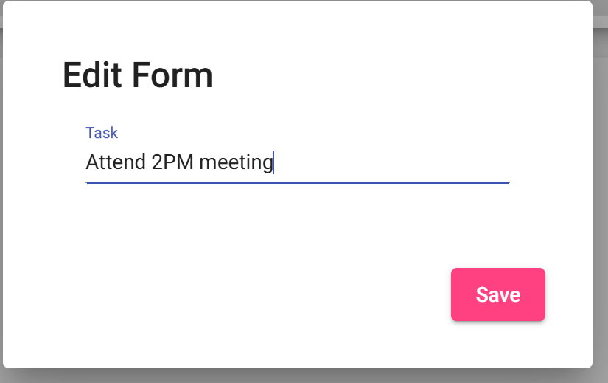
4 | Clear form and replace task | Text clears and new input appears | <yes/no> | Yes  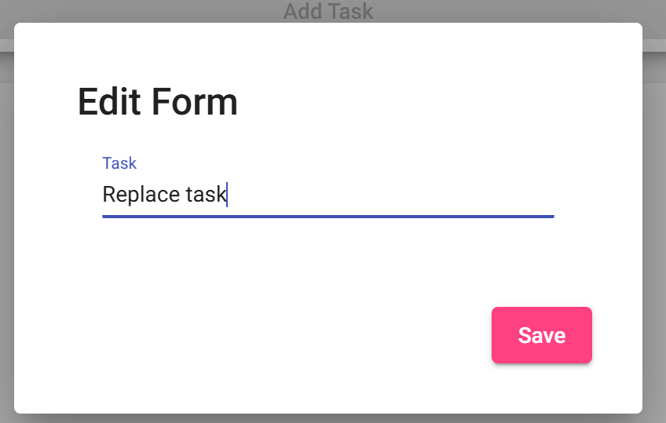
5 | Click save button | Task appears correctly in list | <yes/no> | Yes  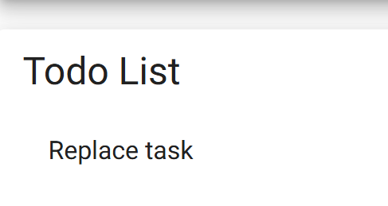
Comments | Peer tester: The test items in this case are well written and easy to understand. I’ll reiterate that it is my personal opinion we do not need to re-test opening the browser in this case.

