
Value Stream Mapping
Name: Christopher Reaney

June 20, 2025
Bellevue university
CSD-380

As college students, one of the most stressful and crucial times of the semester is finals week. Between cramming in long study sessions, organizing notes, balancing group projects, and still trying to sleep and eat like a normal person, there can be a lot going on. I decided to break down my finals prep week using VSM for this assignment. I think that there will be a lot of room to cut down on time.

Value Stream Mapping: Finals Week Prep
Here’s a breakdown of my finals prep routine across the week, color-coded by stage. The goal is to be ready, rested, and to feel confident before each final exam.
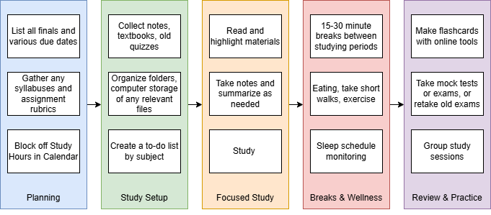
Lean Metrics Analysis
Stage | Estimated Flow Time
Planning | 2 Hours
Study Setup | 3 Hours
Focused Study | 15 Hours
Breaks & General Wellness | 8 Hours
Review & Practice | 7 Hours
Estimated Total Cycle Time | 35 Hours

Optimizing Finals Week
Now that I’ve visualized the process, here’s how I can optimize it:

Eliminate Waste:
- Combine Setup with Planning: A lot of time is wasted setting up study materials multiple times. I can prep all my notes, flashcards, and materials for each subject on Day 1 and avoid repeating the same setup later.
- Cut Down on Passive Breaks: I tend to scroll social media during breaks, which turns 15 minutes into 45. I’ll replace that with quick walks, snacks, or stretch breaks with timers set. Either that, or just pay more attention to the breaks I spend on my phone.

Workflow Orchestration:
- Batch Study Sessions by Subject: Instead of jumping between subjects daily, I’ll dedicate full sessions or full days to each subject. This reduces context switching and increases focus.
- Group Study Placement: I’ll shift group study sessions closer to the exam days when it’s more beneficial to test recall and understanding instead of early in the week.

Governance Ideas:
- Accountability Checkpoints: Set alarms and calendar reminders for start/end times of sessions.
- Study Tracker: Use a checklist to track completed chapters and topics.
- Healthy Boundaries: Enforce a "No Screen" rule after 11 PM to ensure I’m getting decent sleep and not endlessly doom-scrolling or watching mind-numbing videos.

Conclusion
Using a value stream map for finals prep has been a game changer. Instead of approaching the week with a general feeling of dread, I now have a streamlined plan. It’s very interesting how something focused on the world of software development can make real life this much easier. After analyzing and optimizing, I’ve shaved off roughly 5 to 7 hours of unproductive time.

