|  |  |
| --- | --- |
| **Project:** | OpenTact |
| **Title:** | Instructions for Building the OpenTact Headset |
| **Date Created:** | 4/11/2019 |

1. Contents of the Repository
   1. This repository contains design files that can be used to fabricate headsets with three different styles of earcups. The earcup has a mounting plate for a 40mm speaker and several locations to mount microphones.
2. Earcup with Pinna: Headset with a plastic, outer ear
3. Low-Profile Earcup: Headset with low-profile earcups that can be worn under a helmet
4. Full-Profile Earcup: Headset with earcups similar to off-the-shelf earmuffs

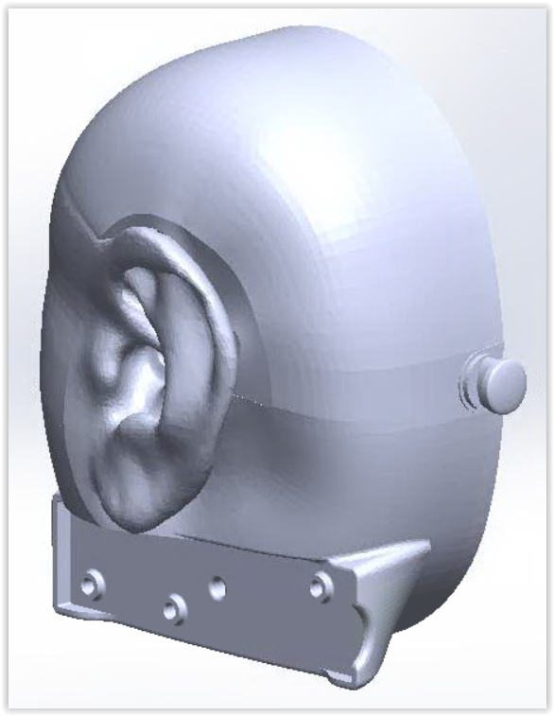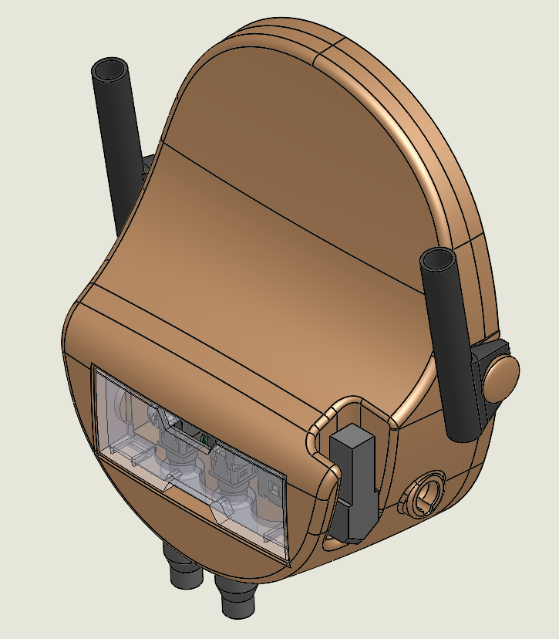 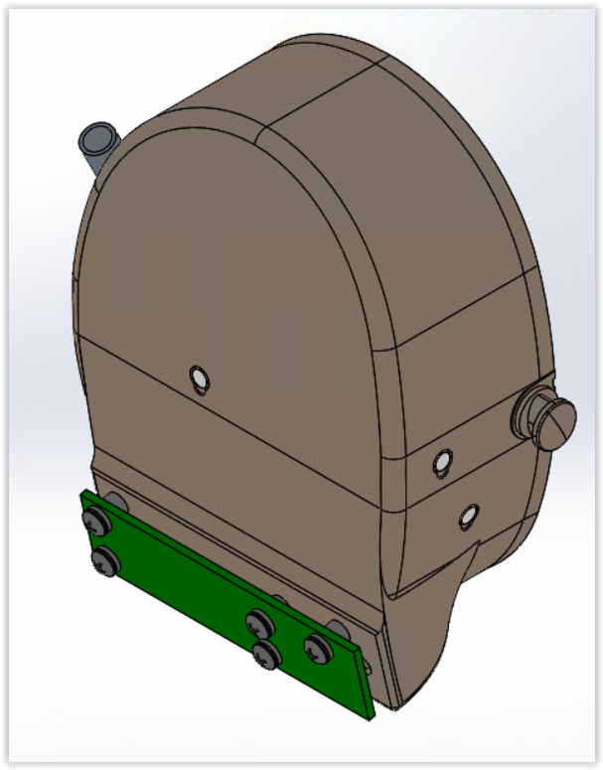

A B C

* 1. The audio for the headset is processed by the Tympan, which has an audio codec and an Arduino-compatible microcontroller. You can add 2 more additional channels using the AIC Shield, which stacks on top of the Tympan. Two enclosure designs are provide to encompass these boards.
* Tympan Enclosure: Enclosure for the Tympan PCB and battery
* Tympan Enclosure with AIC Shield: Enclosure for the Tympan PCB, battery, and AIC Shield
  1. The repository is organized by:
* Bill of Materials: List of components and subassemblies
* Mechanical: Solidworks CAD files and STP files for 3D printing
* Electronics: PCB design files and Gerber output files, along with a wiring diagram
* Firmware: Example Arduino sketches written specific for the OpenTact project. For basic sketches on audio processing, start with the Tympan wiki “[Getting Started](https://github.com/Tympan/Docs/wiki/Getting-Starting-with-Tympan).”

1. Fabricating the Headset Components (also refer to bill of materials)
   1. Mechanical: Most of the mechanical components are 3D-printed using SLS fiber-reinforced nylon (PA12), with the exception of the headband and ear seals, which are taken from a set of commercial ear muffs (3M X4A). The speaker mount accepts 40mm speakers and is compatible with all three earcup styles. If you need to modify the physical components, the CAD design files require Solidworks version 2018 SP4 or later. Otherwise, you can import the STL files and modify them from there.
   2. Electrical: The Tympan processing board can be purchased through [https://shop.tympan.org](https://shop.tympan.org/), or fabricated using the design files from this repository. A breakout board is mounted to each earcup to provide a place to solder the mic and speaker wires. The short breakout board is sufficient for projects involving a (1) mic and (1) speaker per side. For more complex projects, the long breakout board accommodates multiple components but requires external jumper wires.

*If using the long breakout board, refer to the wiring diagram in the Electrical folder*. *Note that the long breakout board is not compatible with the Low-Profile Headset.*

The short breakout board has two sides so that it can be used for both the left and right earcups. Solder (3) TRRS jacks onto the side of the breakout board labeled “J1” in the upper left, which will become the “left” breakout board. These pads correspond to “TRRS-1”, “TRRS-3”, and “TRRS -5”.

Solder (1) TRRS jack onto the side of the breakout board labeled “J3” in the upper left, which will become the “right” breakout board. These pads correspond to “TRRS-6.”

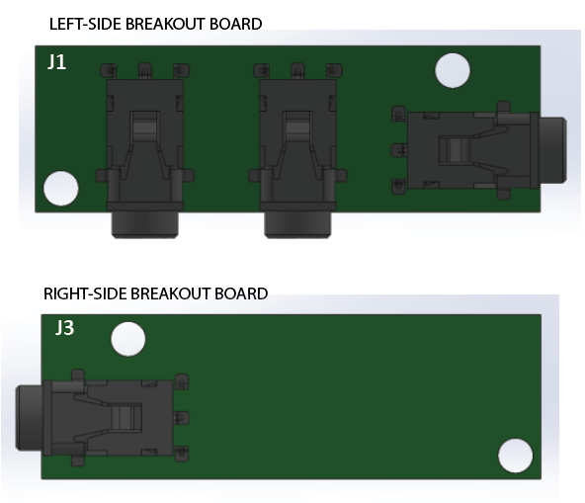

*Left and right sides of the Short Breakout Board, with TRRS jacks*

If you need to modify the PCBs, the breakout boards for the earcups were created in [Fritzing](http://fritzing.org/) and the Tympan PCB and AIC Shield were designed in [KiCad](http://kicad-pcb.org/).

1. Assembling the Headset
   1. Microphone: Solder wire leads to the 6mm mic, paying attention to the dot indicating polarity.

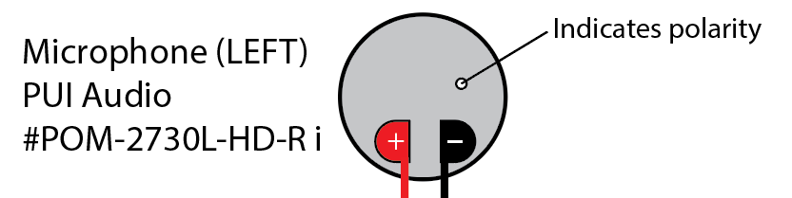

In the case of the Earcup with Pinna, the microphone is inserted into the ear canal from inside of the earcup. For the other external microphones, drill out the small pilot hole inside the opening where the microphone will sit to allow wires to be routed inside to the earcup.

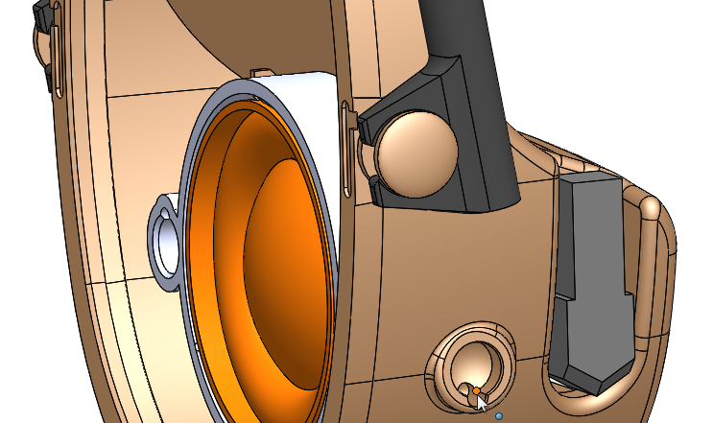

Drill out pilot hole before inserting the microphone

Seal the microphone with putty (see BOM) or adhesive, then run the microphone wires through a hole near the bottom of the earcup to the outside, where the breakout board will go. Leave more than 4” of wire outside the earcup to trim back later. Label the wires

* 1. Foam: Trim and insert foam inside the earcups to diffuse the resonating noise from the empty cavity.
  2. Speaker: If using the Low-Profile Earcup, trim back the bottom tab of the speaker mounting plate, as shown in the figure below. Drill a small hole in the middle of the mounting plate to pass wires through, then pass the speaker wires through the mounting plate, then thru the hole near the bottom of the earcup to the outside where the breakout board will go. Leave more than 4” of wire outside the earcup to trim back later. Label the wires. Apply putty (see BOM) to seal the hole in the earcup.

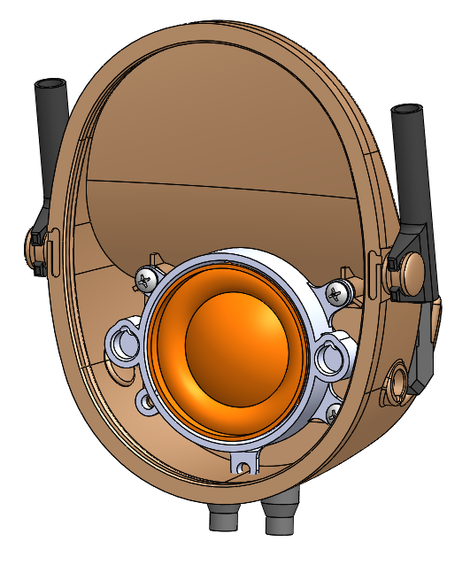

Trim tab of speaker mount

Press the speaker into the mounting plate then screw the mounting plate to the earcup. If the speaker is loose inside the mounting plate, apply putty or superglue to secure it.

* 1. Ear Seal: Remove the ear seals from the commercial earmuffs and install them onto the new earcups. Hold the earcups against your ears to determine if more foam is needed to diffuse the noise from the empty cavity. Press the ear seal against your face and blow to determine if there are any leaks. Fill any leaks with putty. If you need to remove a stubborn ear seal, use a small screwdriver to pry the ear seal away, inserting a second screwdriver along the gap that is created.
  2. Breakout Boards: Locate the breakout board for the right earcup. Cut the trace indicated in the figure below. Trim the microphone and speaker wires and solder them to the breakout boards. Shown is the outside face of the breakout boards, however, soldering the wires to the inner face provides a cleaner look.

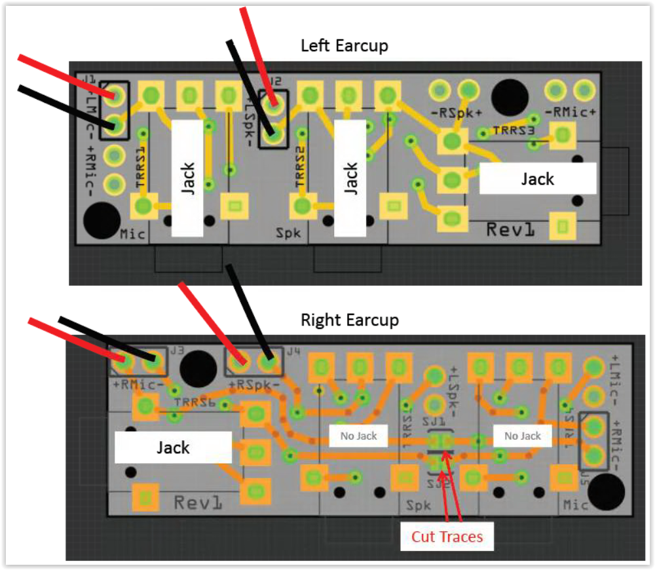

Screw the breakout board to the earcup, using washers on top of the board to prevent shorting. If using the long breakout board, place additional plastic washers under the board to provide clearance for the jumper wires.

* 1. Cables: The mic and speaker signals from the Tympan are routed to the left earcup using (2) audio cables (3-conductor; TRS). Note that the audio cable with right-angle plugs is 4-conductor (TRRS) and used to bridge the left and right breakout boards. This cable can be shortened (cut and spliced) to better fit the headband.

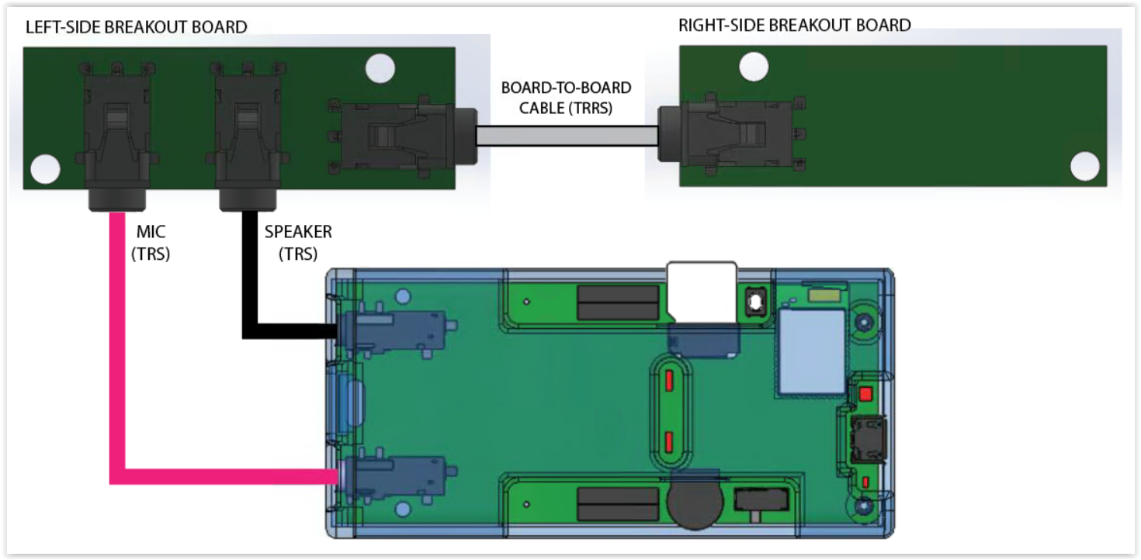

1. Software
   1. Once the components are assembled, follow the “[Getting Started](https://github.com/Tympan/Docs/wiki/Getting-Starting-with-Tympan)” guide on the Tympan wiki. This will direct you how to install the Arduino programming environment and the Tympan Audio library. Then move on to the more advanced programs in the Tympan library, or check out the OpenTact-specific programs included in this repository.