# T201 2022 World Cup Data Analysis

**SQL Queries**

**Task 1- Average ball faced by batsman**

* SELECT ROUND(AVG(balls), 2) avg_ball_faced FROM fact_bating_summary;

Output-

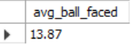

**Task 2- Batting average**

* SELECT ROUND(AVG(runs), 2) avg_bating_runs FROM fact_bating_summary

Output-



**Task 3- Total runs by batting position.**

* SELECT DISTINCT battingPos, SUM(runs) AS 'total_runs' FROM fact_bating_summary
* GROUP BY battingPos
* ORDER BY total_runs DESC;

Output-

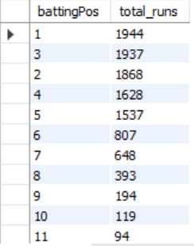

**Task 4- How many % of runs scored in boundary?**

* Alter TABLE fact_bating_summary 🡪 **added a new columns called 'runs_by_boundary'**
* ADD runs_by_boundary INT;
* UPDATE fact_bating_summary 🡪 **fill data sum of columns 4s(1 four = 4runs) and 6s(1 six = 6 runs) in runs_by_boundary**
* SET runs_by_boundary = 4s * 4 + 6s * 6;
* SELECT ROUND((SUM(runs_by_boundary) / SUM(runs)) * 100, 2) as 'boundary %' FROM fact_bating_summary;

Output-

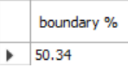

**Task 5- Top 5 batsman average strike rate who played more than 20 balls ?**

* SELECT DISTINCT batsmanName, ROUND(AVG(SR), 2) as 'avg_sr'
* FROM fact_bating_summary
* GROUP BY batsmanName
* HAVING SUM(balls) > 20
* ORDER BY avg_sr DESC LIMIT 5;

Output-

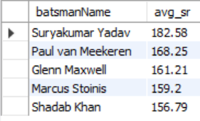

Task 6- Total ball faced

* SELECT SUM(balls) total_ball_faced FROM fact_bating_summary;

Output-



Task 7- Batting average

* SELECT ROUND(SUM(balls) / COUNT(match_id), 2) batting_average FROM fact_bating_summary;

Output-



Task 8- Total ball bowled.

* SELECT SUM(overs * 6) as balls from fact_bowling_summary;

Output- 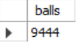

Task 9- Bowling average.

* SELECT ROUND(SUM(runs) / SUM(wickets), 2) AS 'bowling_average' FROM fact_bowling_summary;

Output-

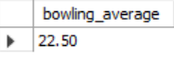

Task 10- Bowling strike rate.

* SELECT ROUND(SUM(overs * 6) / SUM(wickets), 2) AS 'bowling_strike_rate' FROM fact_bowling_summary;

Output-

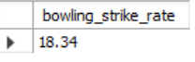

Task 11- Dot ball %.

* alter table fact_bowling_summary -> **created new column balls add data from overs multiply by 6**
* add balls int;
* update fact_bowling_summary
* set balls = overs * 6;
* SELECT ROUND((SUM(0s) / SUM(balls)) * 100, 2) as "dot_ball_%" FROM fact_bowling_summary

Output-

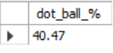

Task 12- Economy

* SELECT ROUND((SUM(runs) / SUM(balls)) * 6, 2) as "economy" FROM fact_bowling_summary;

Output-

