Future vs CompletableFuture

CompletableFuture is an extension to Java’s Future API which was introduced in Java 5.

A Future is used as a reference to the result of an asynchronous computation. It provides an isDone() method to check whether the computation is done or not, and a get() method to retrieve the result of the computation when it is done.

Future API was a good step towards asynchronous programming in Java but it lacked some important and useful features.

# 1, Maven

Types of Repositories

* local
* central
* remote

local repository

* ~/.m2

remote

life cycle

* validate
* compile
* test
* package
  + jar/ war
* verify
* install
* deploy

mvn clean

mvn test

mvn install

# 2, Git

git vs svn

intellji

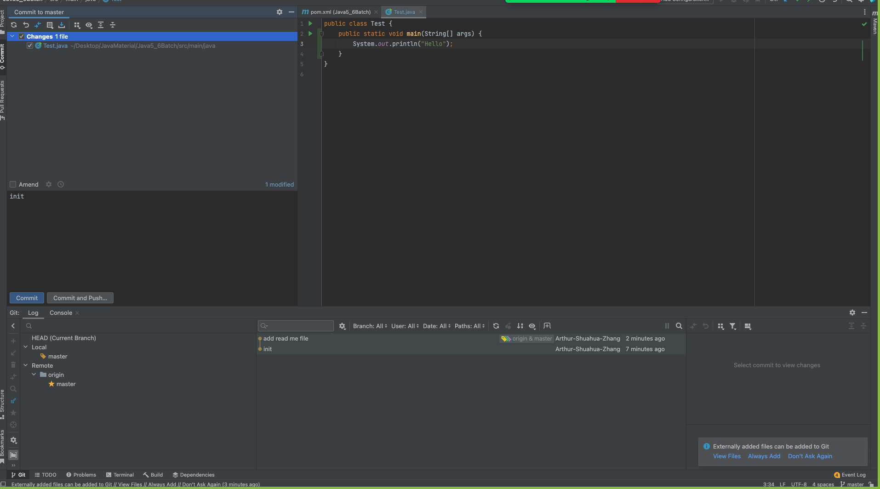

terminal

271 vi ReadMe.txt

272 ls

273 git brach

274 git branch

275 git add .

276 git commit -m "add read me file"

277 git push

# 3, Eight Basic Data Types

primitive type

* byte, short, int, long, float, double, char, boolean

wrapper class

* Byte, Short, Integer, Long, Float, Double, Character, Boolean

autoboxing and unboxing

# 4, String/StringBuilder/StringBuffer

String

* immutable
* thread safe

StringBuilder

* mutable
* not thread safe

StringBuffer

* mutable
* thread safe

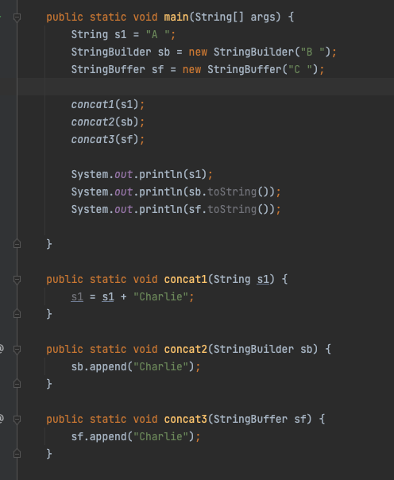

# 5, String/String constant pool

== vs equals()

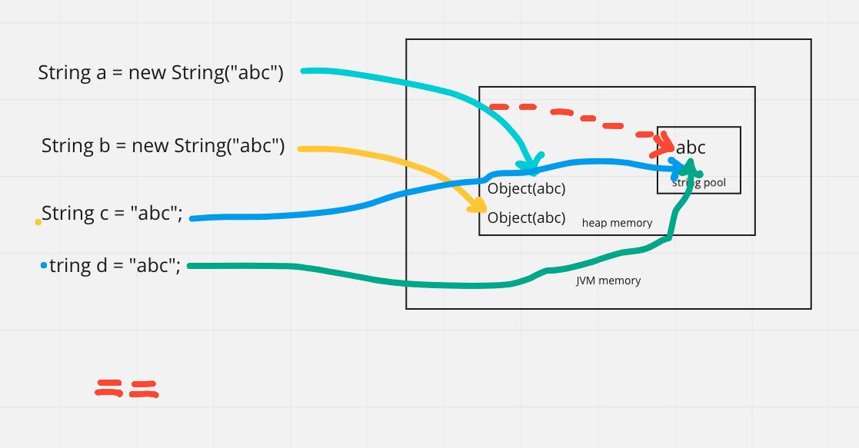

-128 -> 127

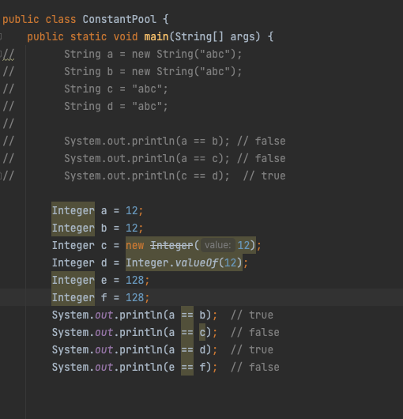

# 6, equals / hashcode

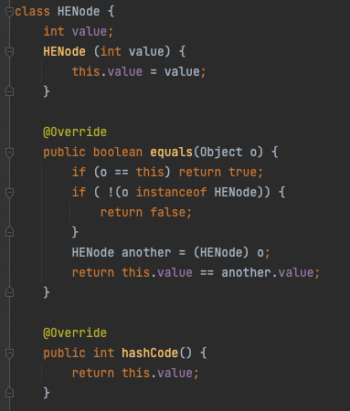

# 7, Collection

## **untitled (20).jpg**

List

* ArrayList

address 0

|  |  |  |  |  |  |
| --- | --- | --- | --- | --- | --- |
| data0 | data1 | data2 | data4 | data5 |  |

O(1)

* LinkedList

|  |  |  |  |  |
| --- | --- | --- | --- | --- |
| node1  data  next = node2 |  |  |  | node3  data  next node4 |
|  |  |  |  |  |
|  |  | node2  data  next = node3 |  |  |
|  |  |  |  |  |
|  |  |  |  |  |
|  |  |  |  |  |

O(n)

vector:

* thread safe

Stack

* thread safe,
* FILO
* push, pop

Deque: ArrayDeque

* first [ ] last
* replace Stack: deque.offerFirst(), deque.pollFirst();

Set

* HashSet
  + unique
  + don't’ keep insertion order
* TreeSet
  + unique
  + sorted
* LinkedHashSet
  + unique
  + keep insertion order

Map

* HashMap
* LinkedHashMap
* TreeMap
* HashTable
* ConcurrentHashMap

HashMap

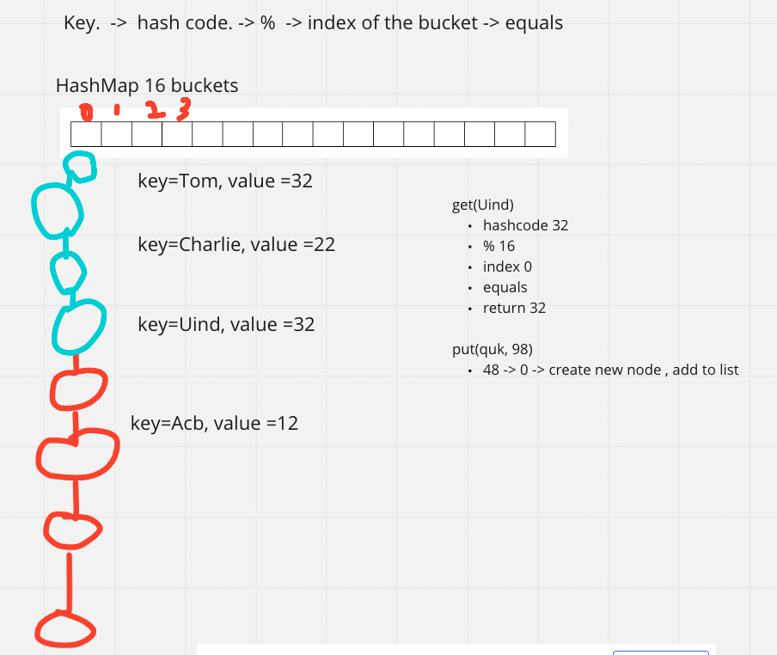

Queue

* FIFO

Heap

* PriorityQueue
* minHeap
* maxHeap

array

* int[] String[] Object[]
* int[][], char[][]

list vs set

HashMap vs HashTable vs ConcurrentHashMap

HashSet <- HashMap

# 8, Comparator vs Comparable

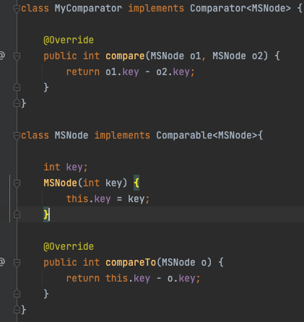

# 9, JVM

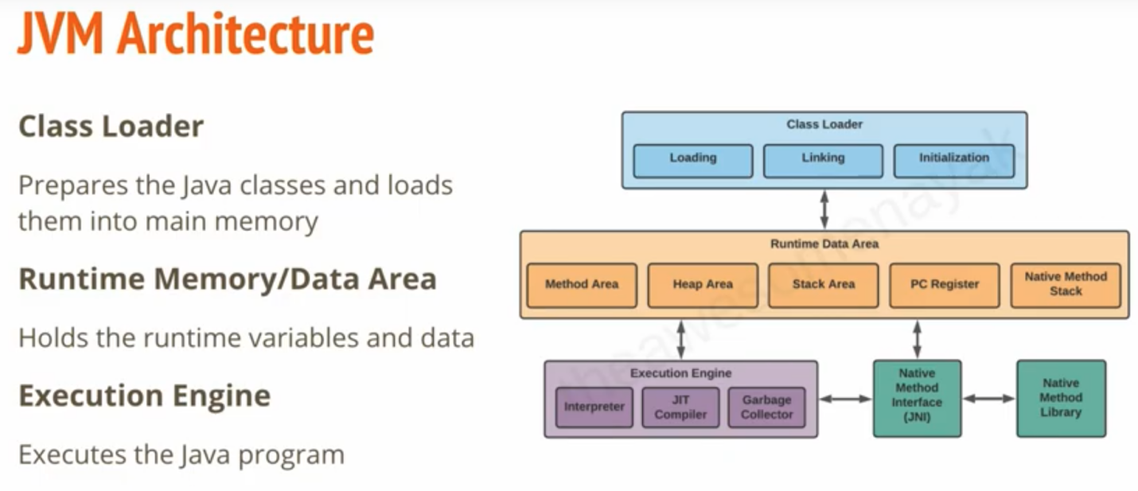

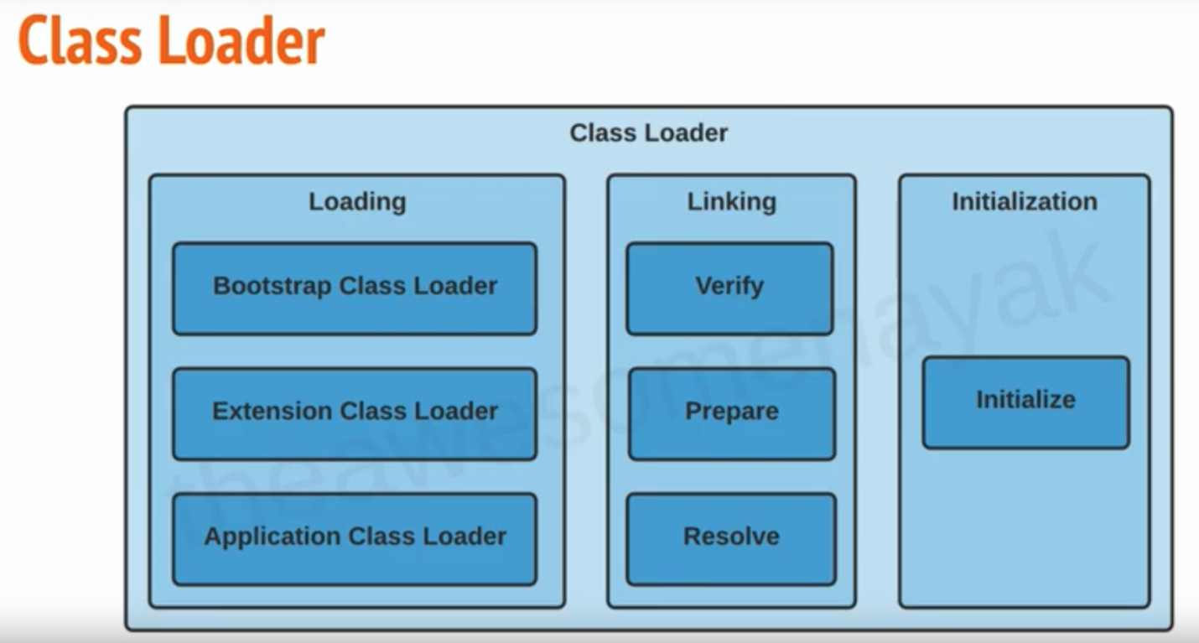

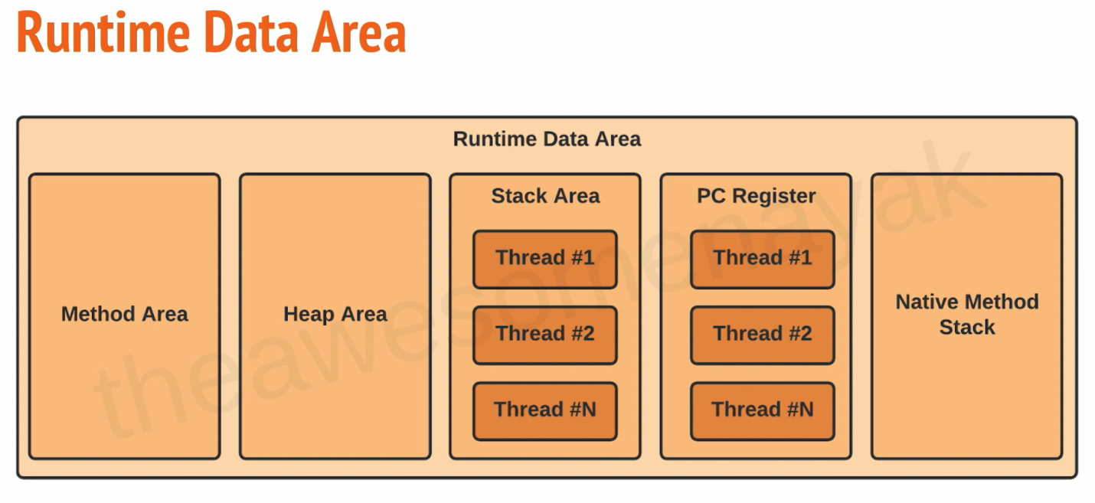

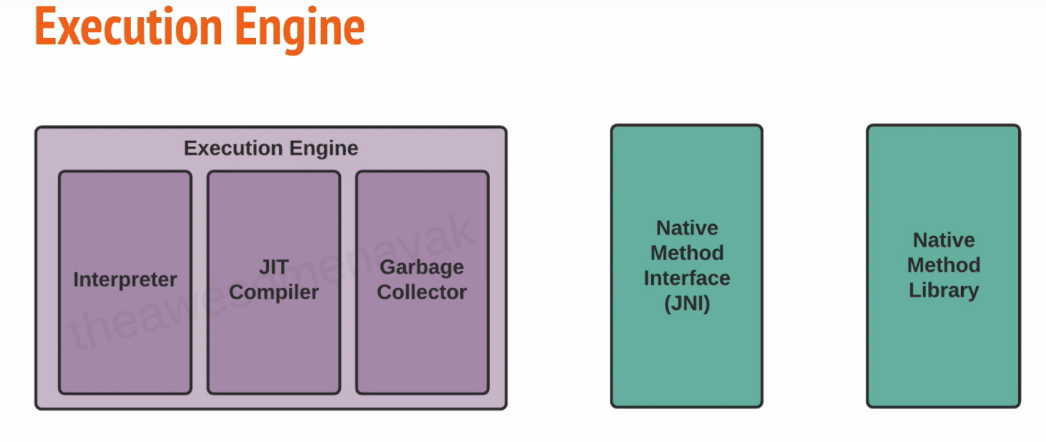

# 10, class Loader

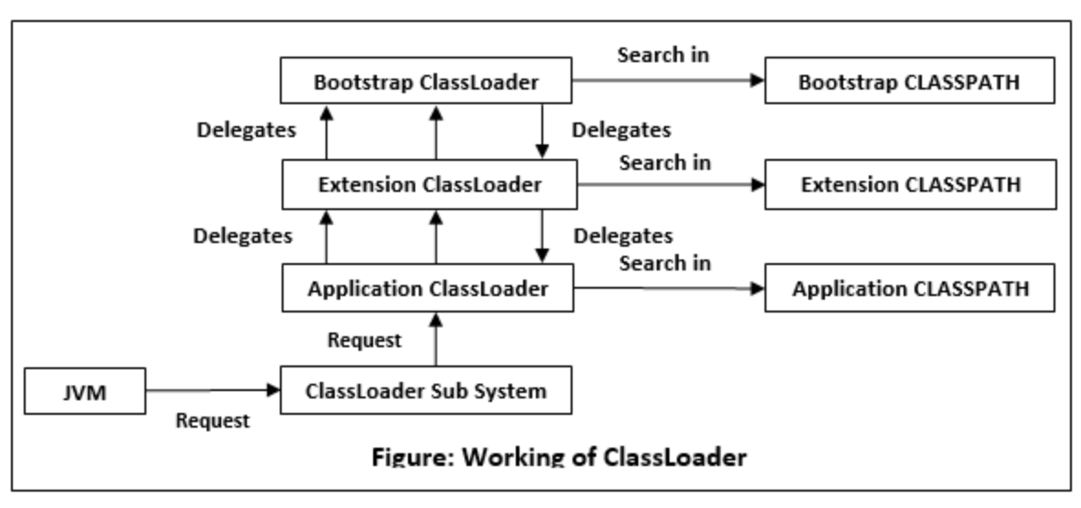

# 11, Garbage Collector

* serial GC
* parallel GC
* G1 GC

|  |  |  |  |
| --- | --- | --- | --- |
| chunk1  rank2 | chunk2  rank1 | chunk3  rank3 |  |
|  |  |  |  |
|  |  |  |  |
|  |  |  |  |

CMS GC(Concurrent Mark Sweep) G1

* deprecated since java 9
* completely removed in java 14

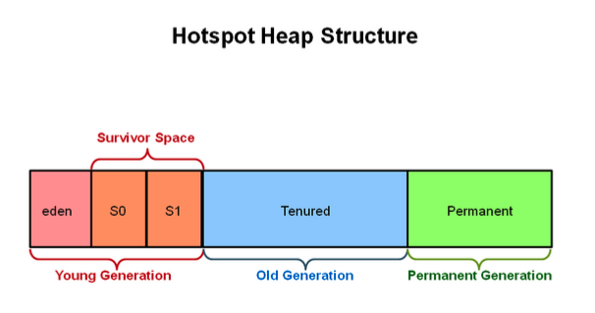

minor GC

major GC

# 12, Keywords

## keywords overview

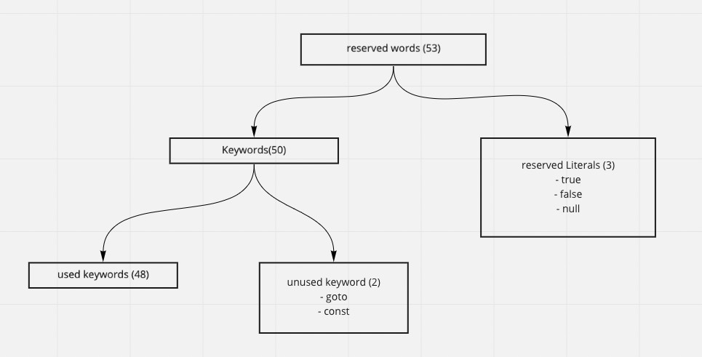

## Final

final variable

* create constant variable
* must be initialized

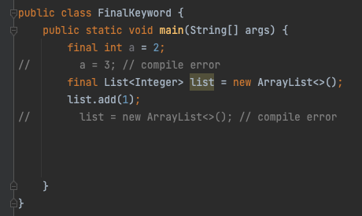

final method

* can’t be overridden

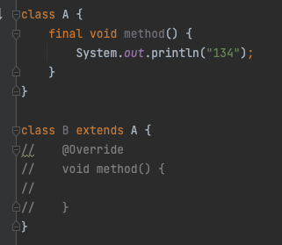

final class

* can’t be extended

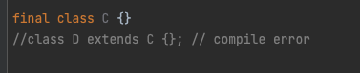

## immutable class

* final class
* private final fields
* no setter
* return deep copy of the collections for getter

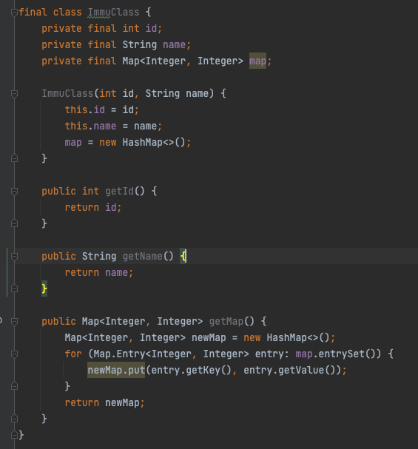

## static

* block
* variable
* methods
* classes

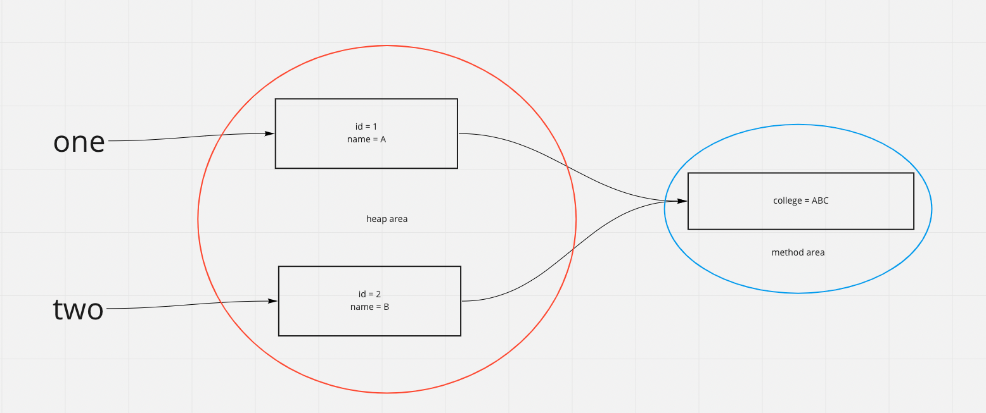

implements vs extends

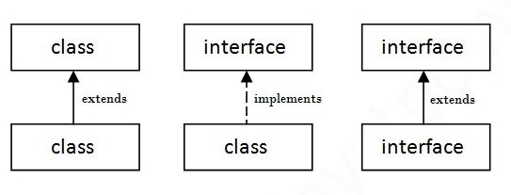

# 13, OOP

## Abstraction

* Abstract class
* interface

## Encapsulation

* declare all variables be private
* declare setter and getter

## Inheritance

* extends
* implements

## Polymorphism

* override
* overload

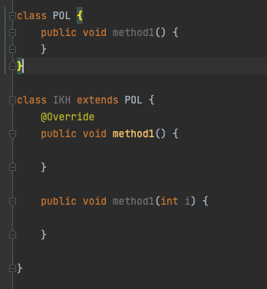

# 14, Exception

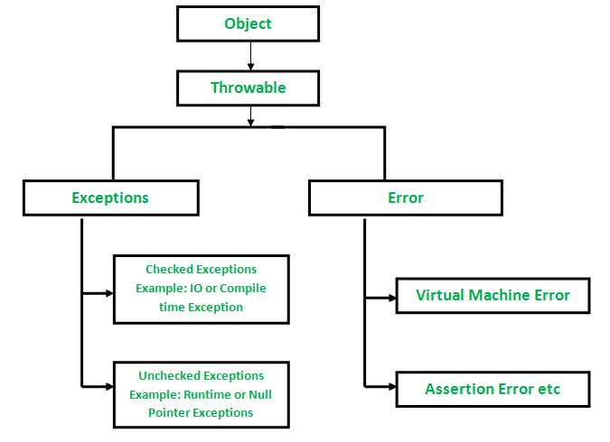

## checked exception vs unchecked exception

how to handle the exception

* try catch
* throws

## how to customize exception

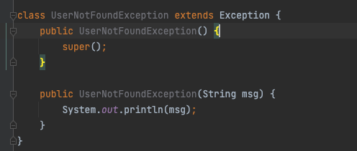

## how to handle multiple exception

try {

// business log

} catch (IOException ioe) {

} catch (SQLException sqle) {

} catch () {}

catch () {}

catch () {}

—------------------------------------------

try {

} catch (IOException | SQLException | …. ex) {

}

try {

Connection con = DataDreiver.getConnection();

} catch(IOException ioe) {

} catch (Exception ex) {

} finally {

if (con != null) con.close();

}

# 15, Generics

* easier and less error prone
* enforce type correctness at compile time
* without causing any extra overhead to your application

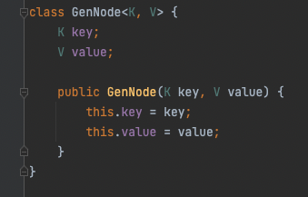

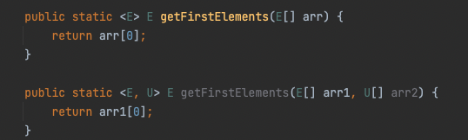

<? extends E>

<? super T>

<T extends E>

# 16, IO stream

Stream

* a continuous flow of data

Byte Stream

* InputSteam, OutputStream
* 1 byte = 8 bits

CharaterStream

* Reader, Writer
* 2 byte = 16 bits

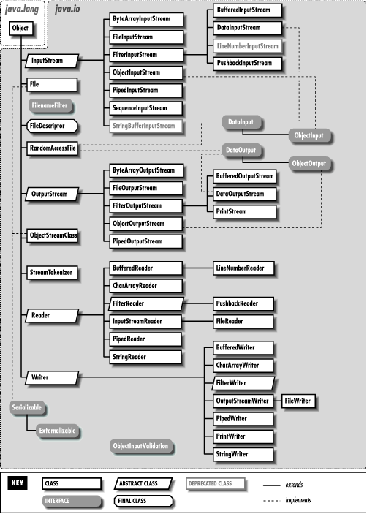

File

* the File class is part of java.io
* give you access to underlying file systems

# 17, Serialization and deserialization

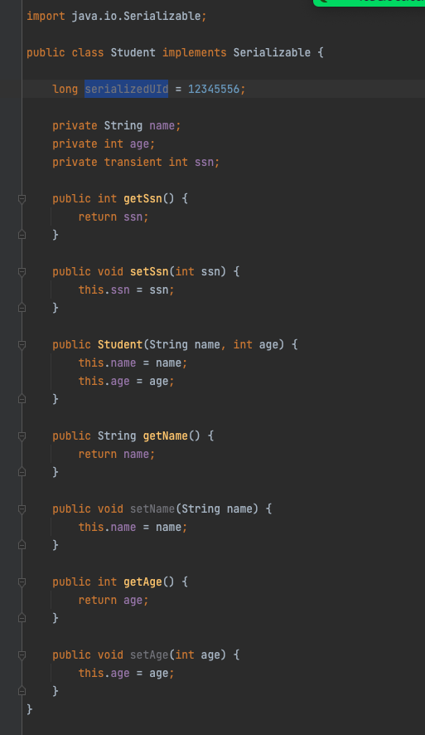

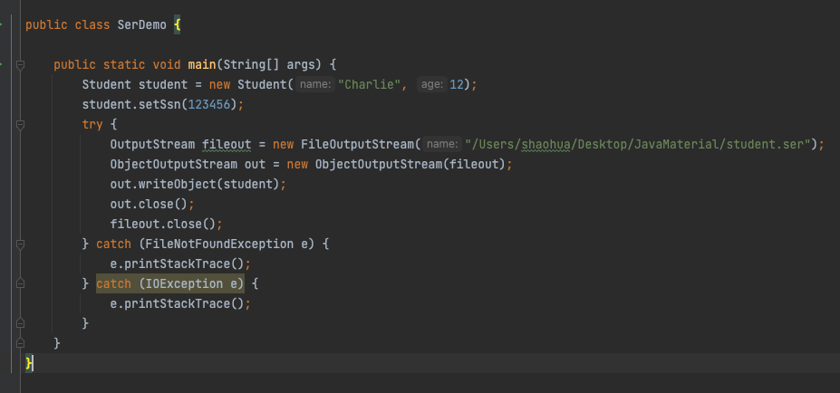

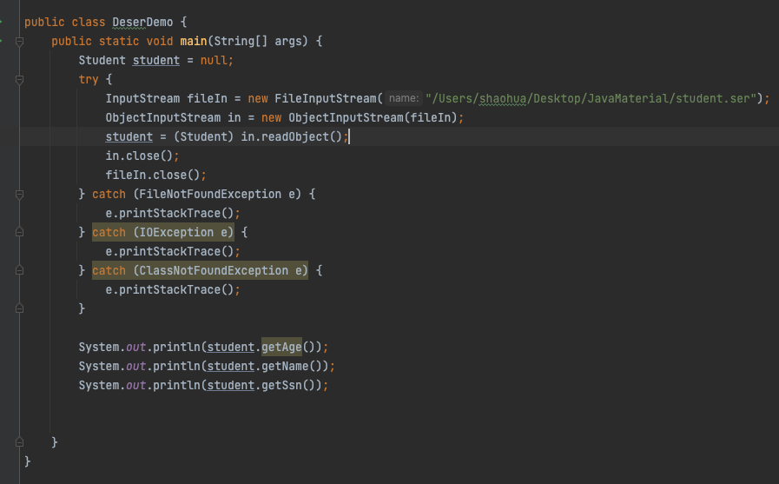

# 18, Java 8 features

## lambda

* functional programming
* less code

（arguments） -> {body}

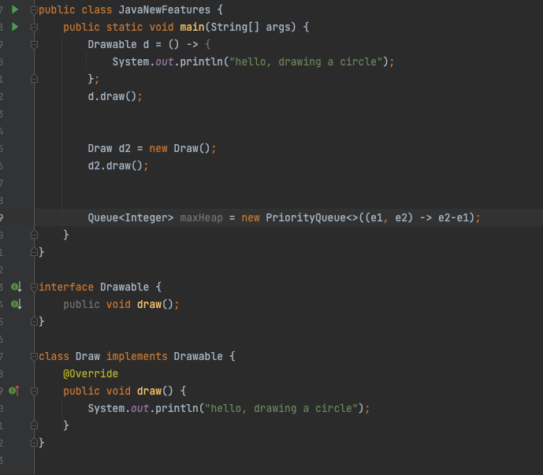

## Functional Interface

* Predicate
  + public boolean test(T t)
* Function
  + public R apply(T t)
* Consumer
  + public void accept(T t)
* Supplier
  + public R get()

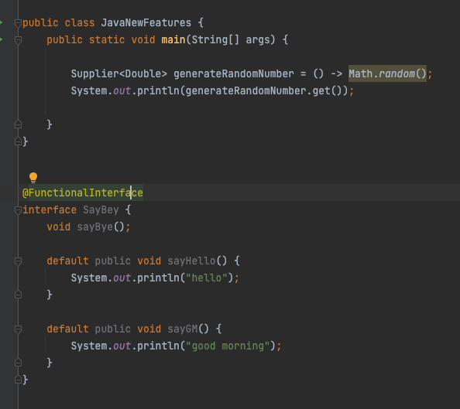

## Optional

if (obj == null) {

…

} else {

…

}

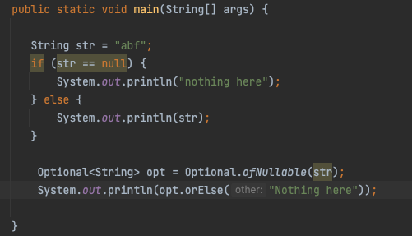

## Stream API

* intermediate operation: return a stream as result
  + map, flatmap, filter…
* terminal operation: return nun-stream
  + forEach, collect …

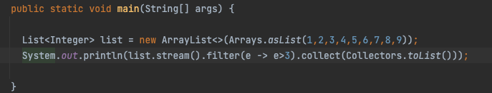

# 19, Mutli-threading

## thread vs process

* process
  + independent memory space, heap, OS resources
* thread
  + shared memory space
  + private stack, program counter, register

## Thread states

* new
  + thread create, not yet start
* runnable
  + executing in JVM
* blocked
  + wait for a monitor lock to enter synchronized block or method
* waiting
  + Object.wait with no timeout
  + Thread.join() with no timeout
  + park()
* timed_waiting
  + thread sleep
  + Object.wait() with timeout
  + thread.join with timeout
  + park
* terminated
  + thread has completed

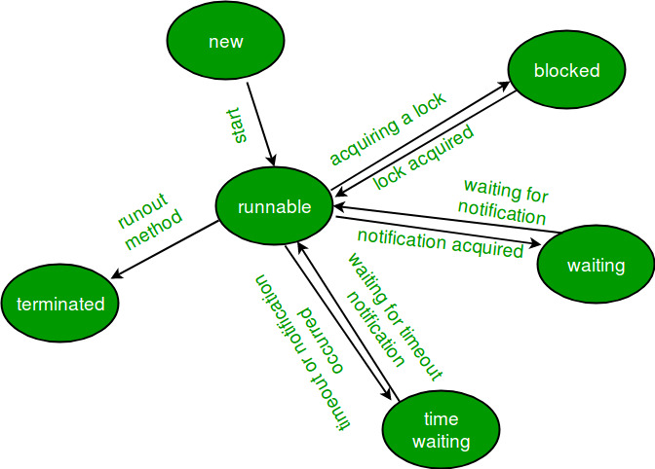

## thread creation

* extends Thread
* implements Runnable
* implements Callable
* thread pool

runnable vs callable

* no return / has
* no exception / has
* run() / call()

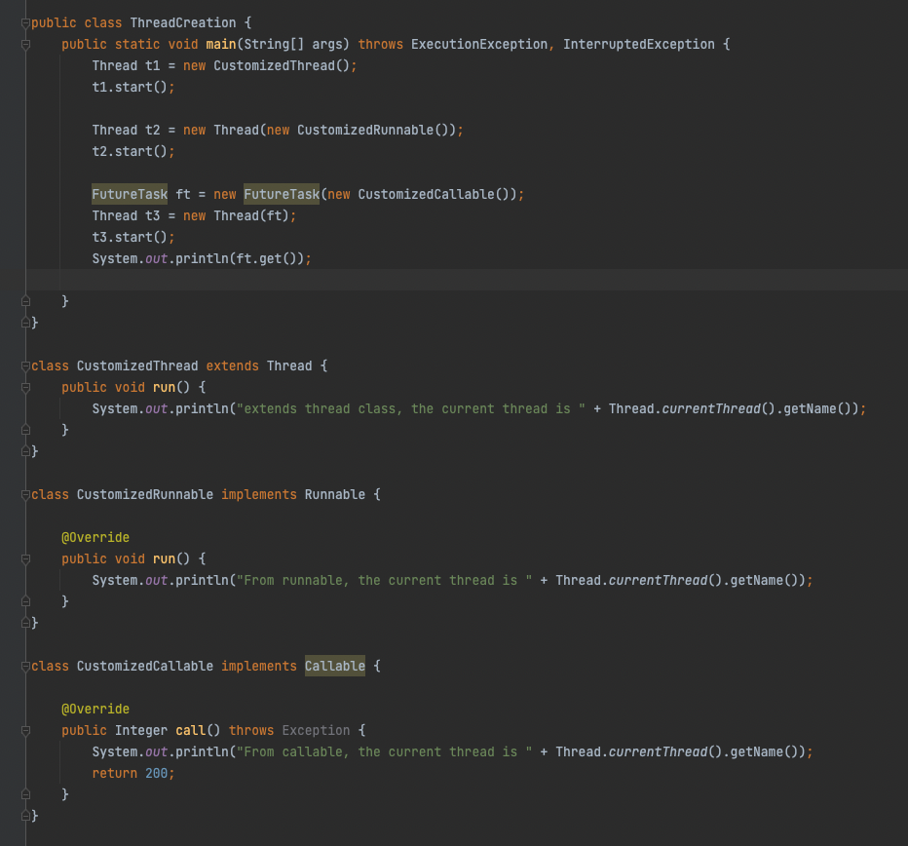

# Thread pool

## customized thread pool

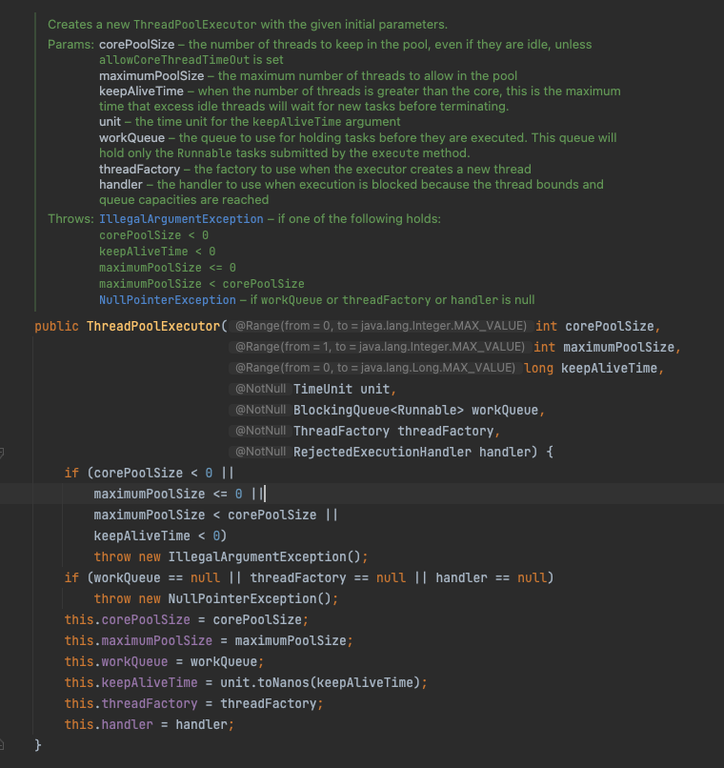

ThreadPoolExecutor

* corePoolSize
* maximumPoolSize
* KeepAliveTime
* Time unit
* work queue
* thread factory
* handler
  + abortPolicy
  + callerRunPolicy
  + discardPolicy
  + discardOldestPolicy

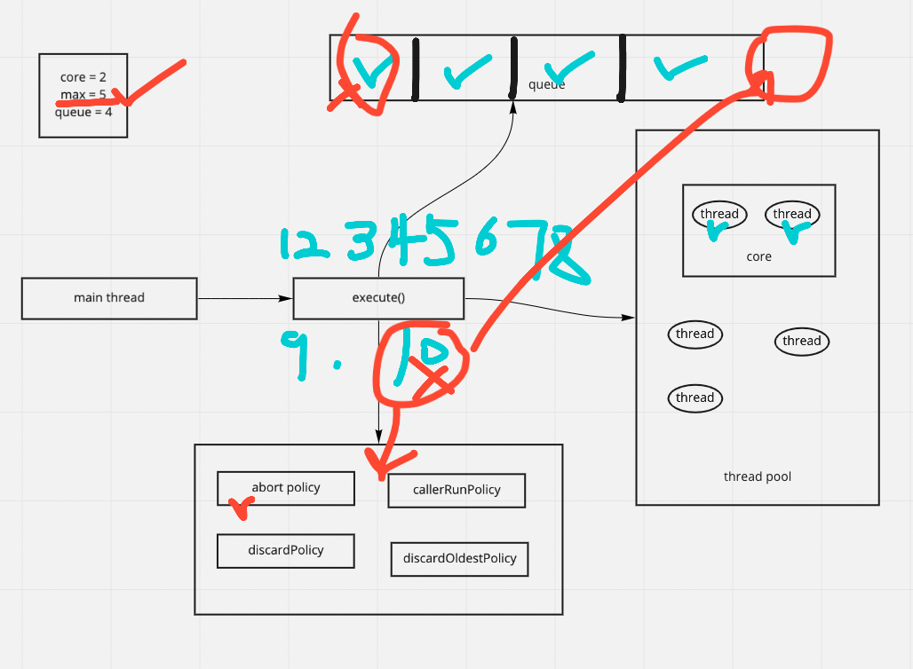

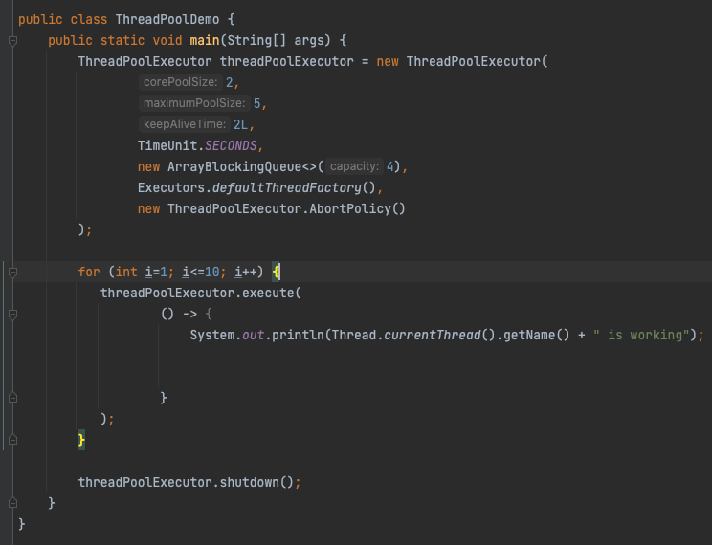

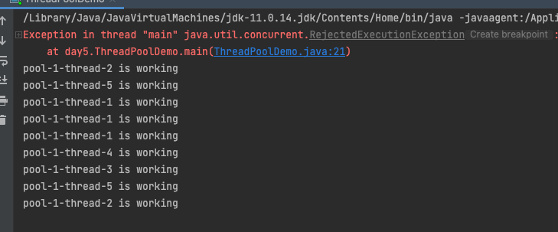

in-built thread pool

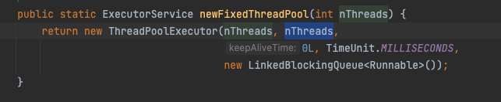

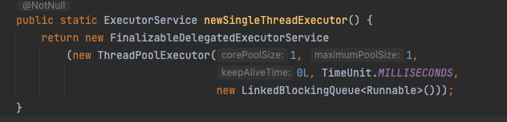

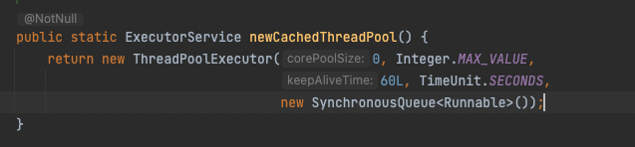

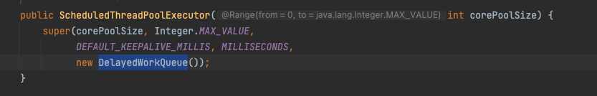

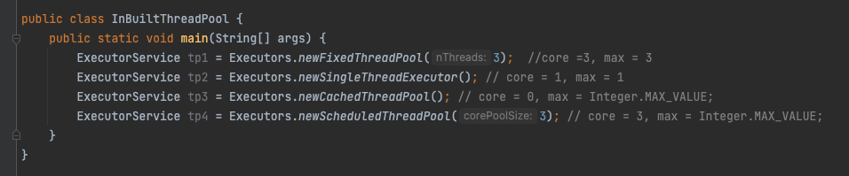

OutOfMemoryError

Lock

* synchronized
* Lock interface

synchronized

* block
* method
* static method
* class

class Demo {

public void method() {

synchronized(Demo.class) {

}

}

public synchronized void method() {

}

public synchronized static void method() {

}

public void method () {

synchronized(this) {

}

}

}

Lock interface

* lock(), unlock(), newCondition(), tryLock(), lockInterruptibly()
* ReentrantLock class

ReadWriteLock interface

* method
  + Lock readLock();
  + Lock writeLock();
* class
  + reentrantReadWriteLock

# 

# 

# 