|  |  |  |  |
| --- | --- | --- | --- |
| 교과목 | UI 아키텍쳐 설계 결과물 | 학습자명 | 김수빈 |

1. UI 아키텍쳐 설계

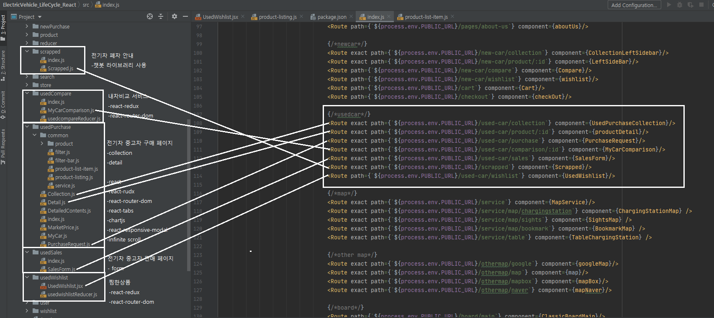

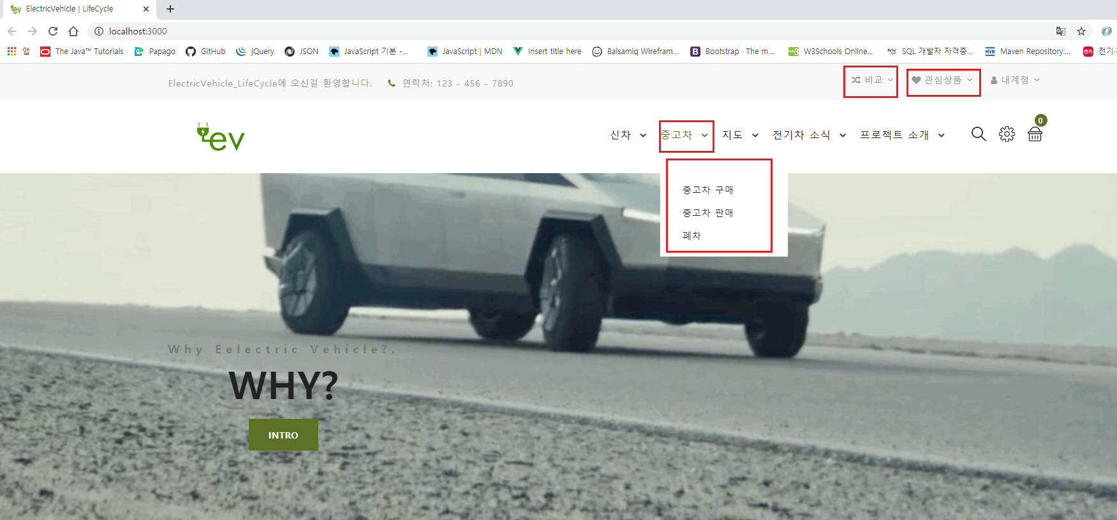

1. UI 템플릿 및 외부 라이브러리

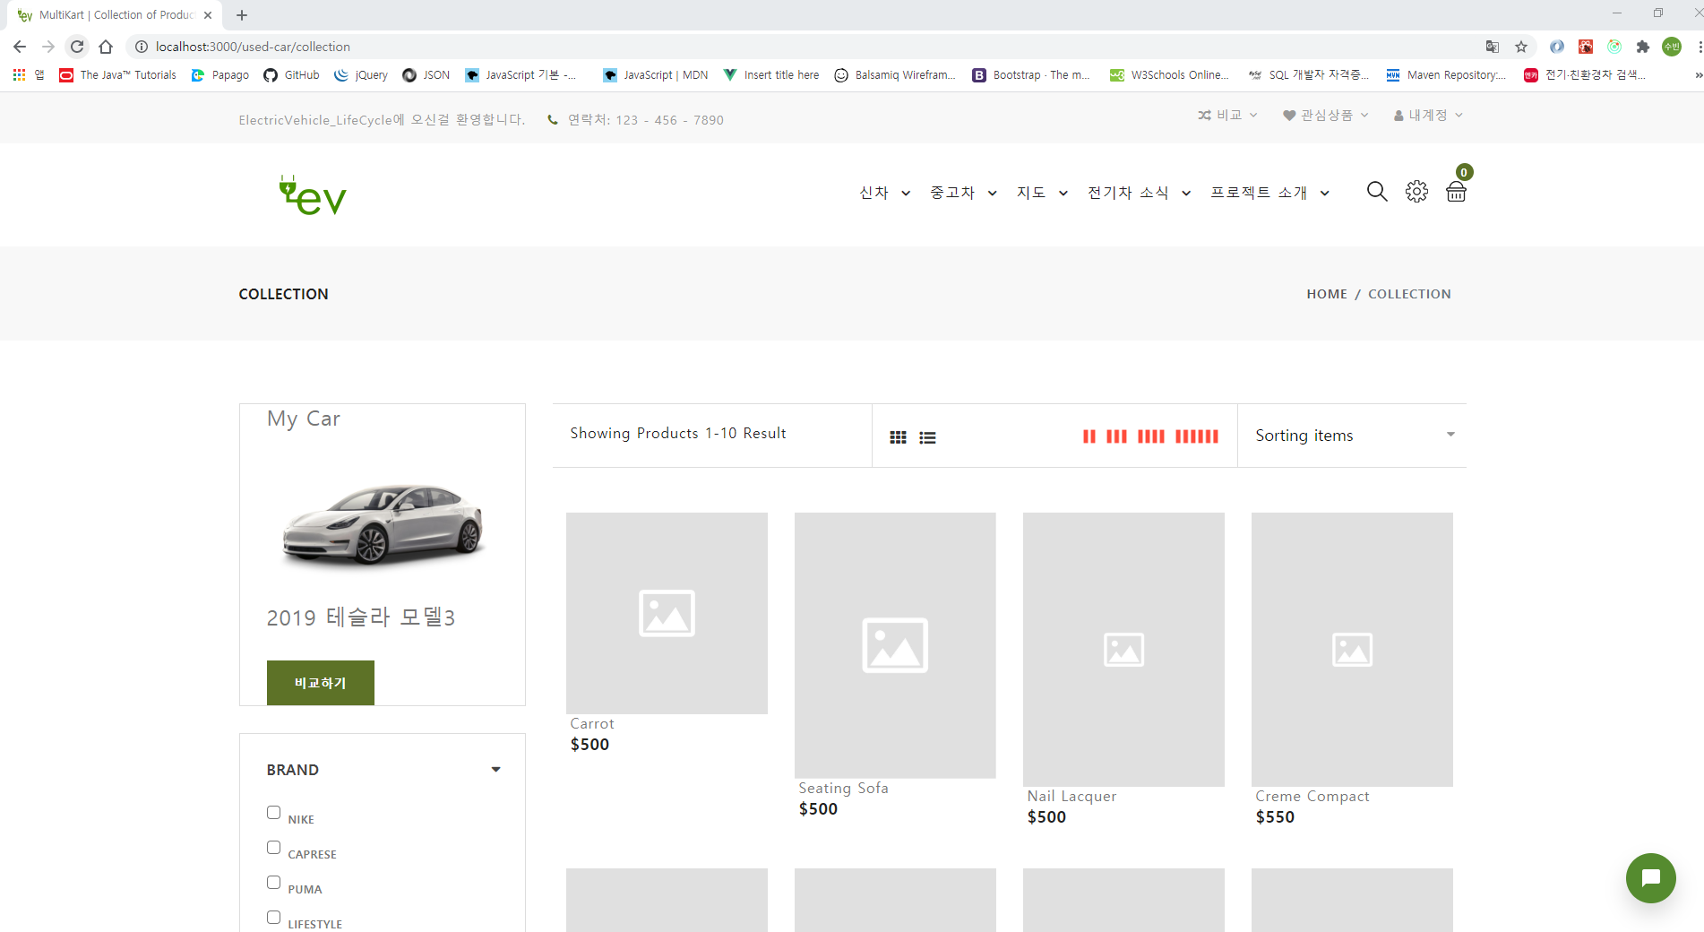

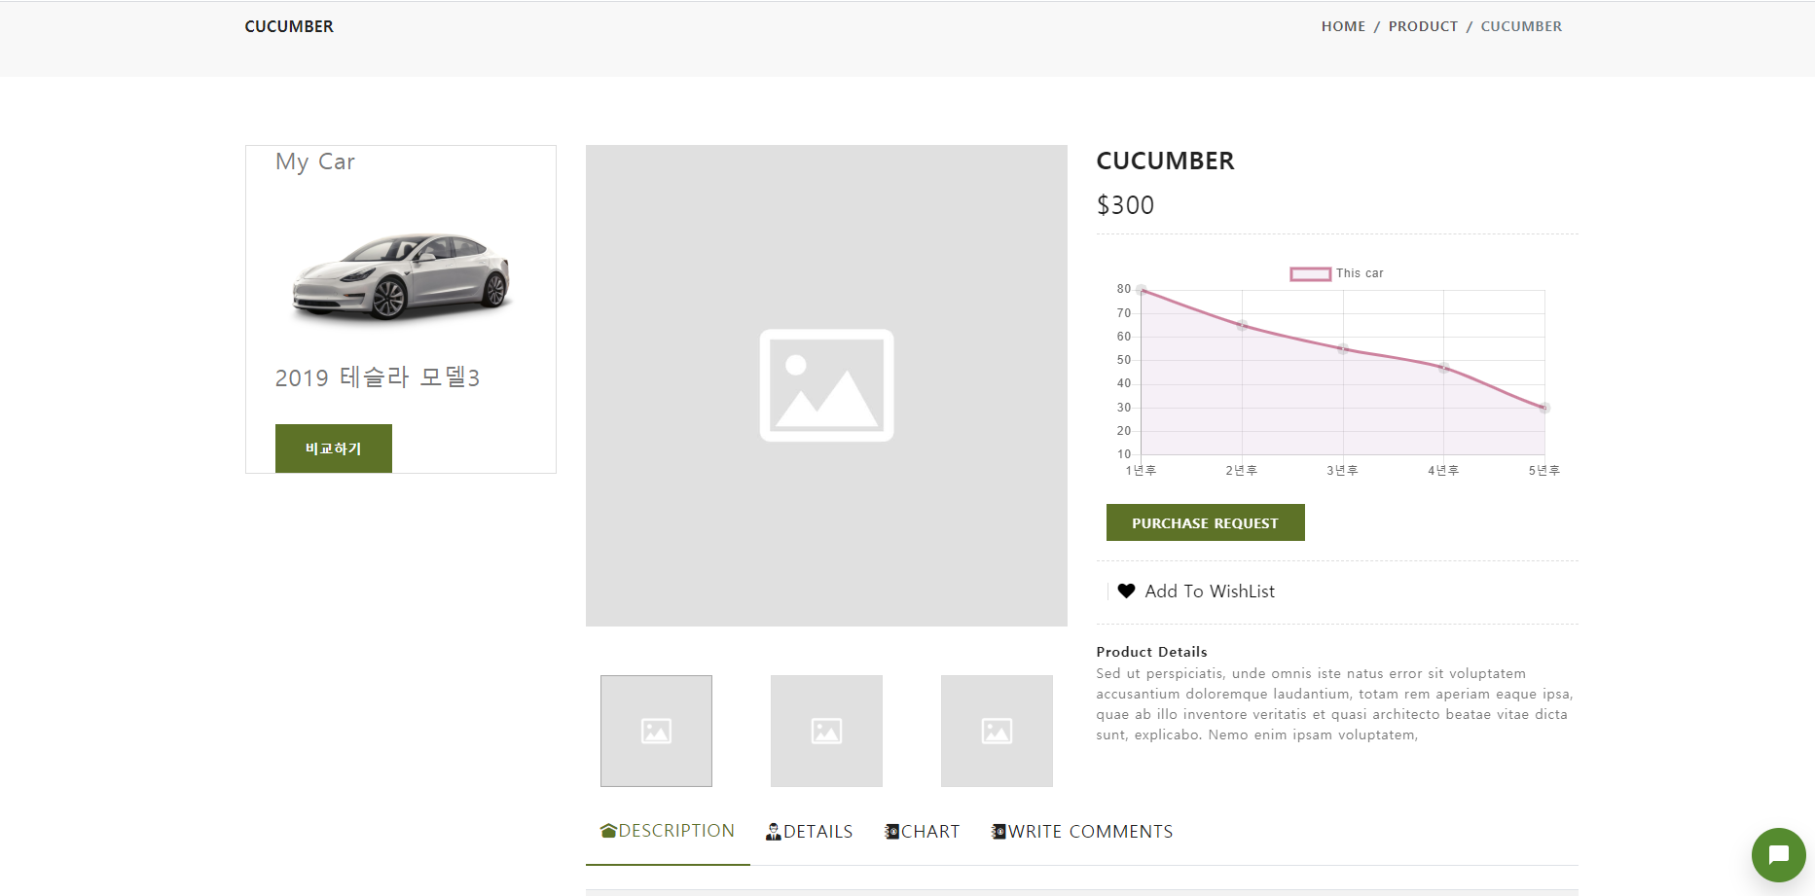

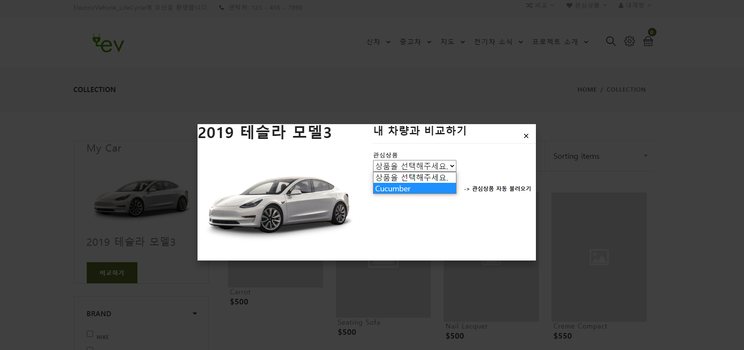

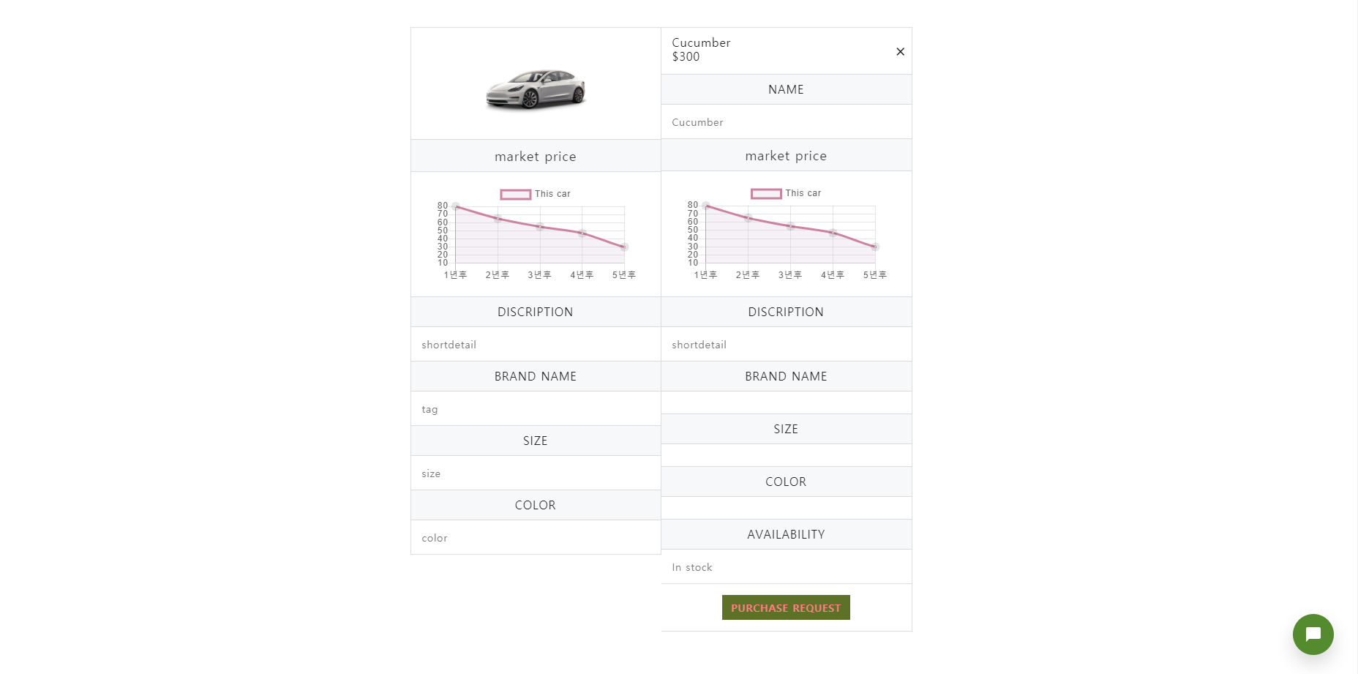

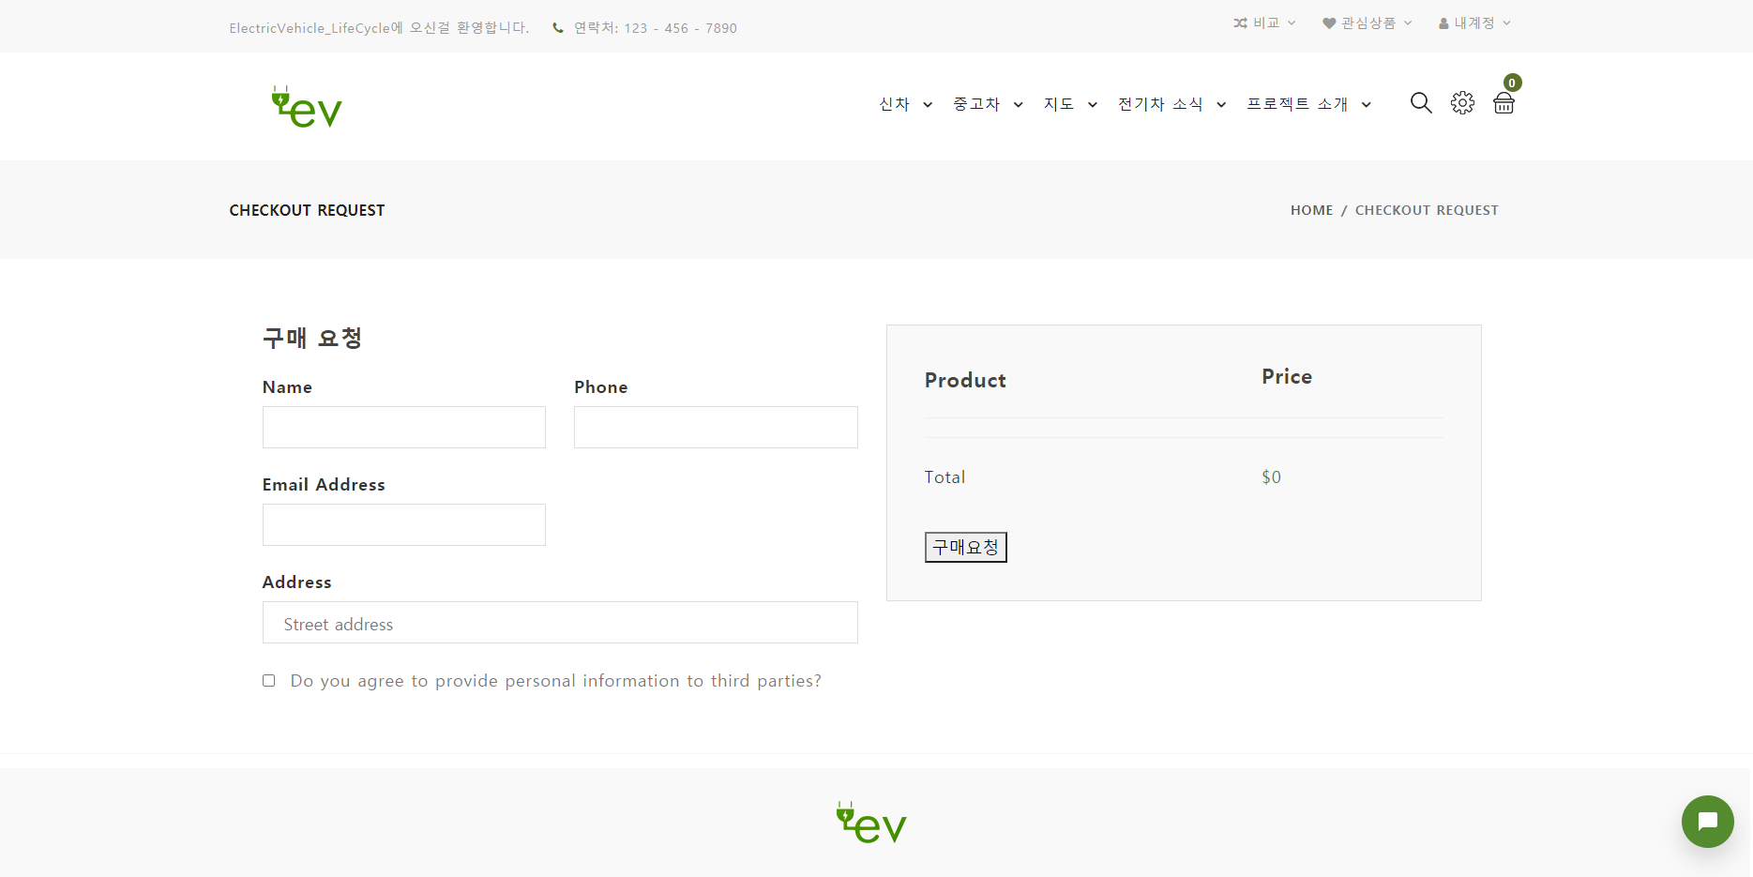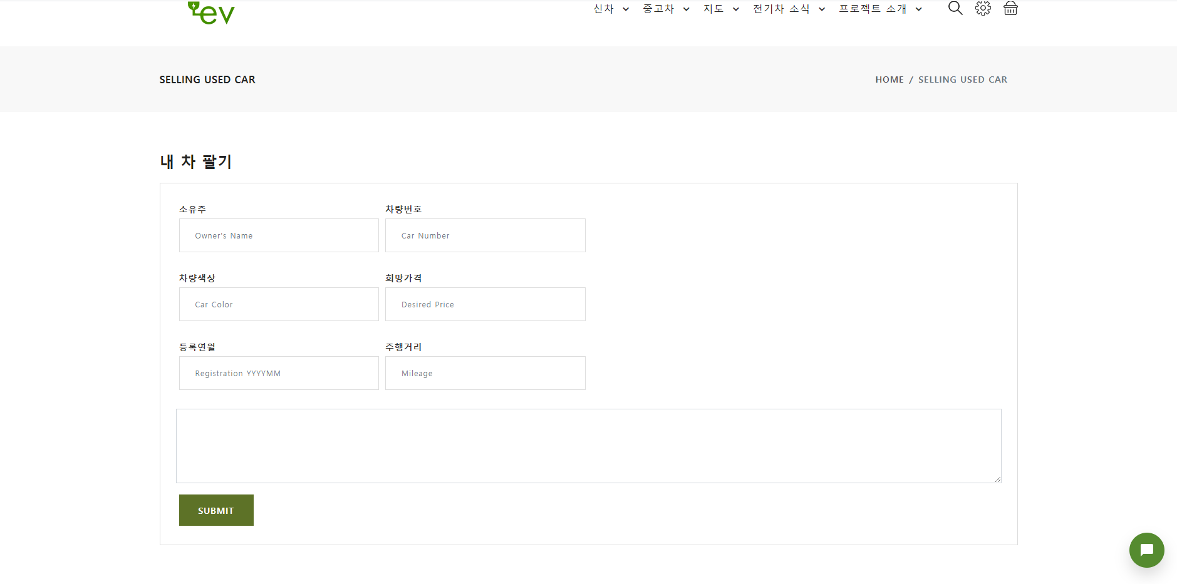

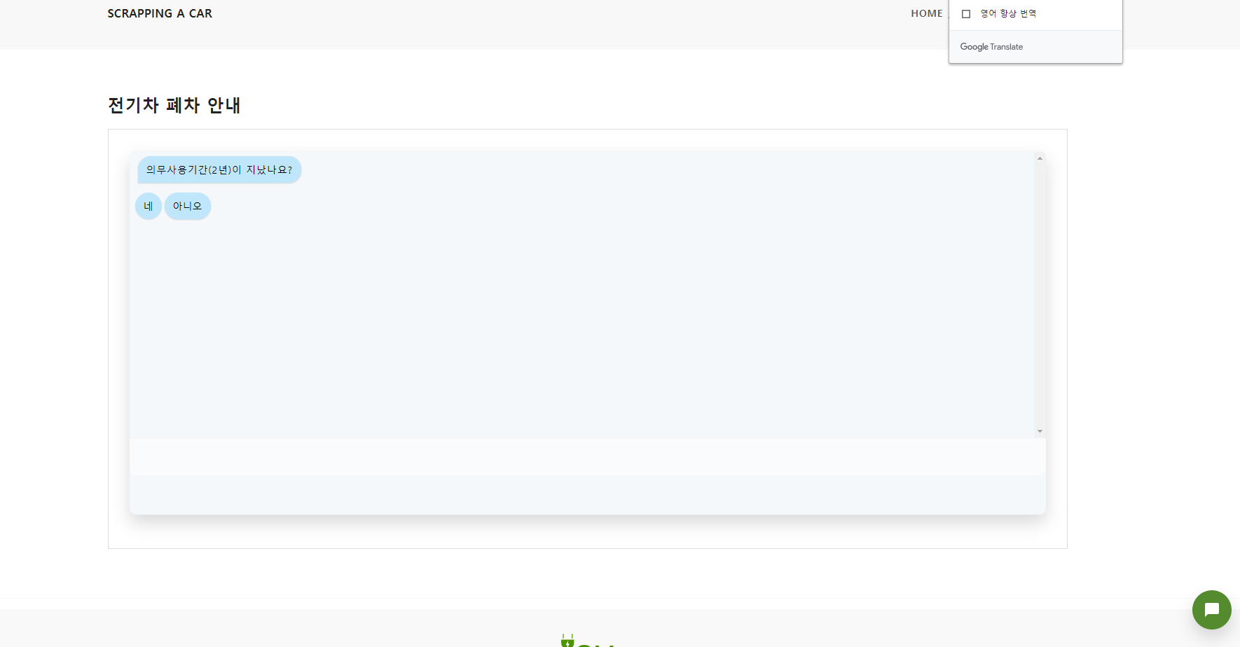

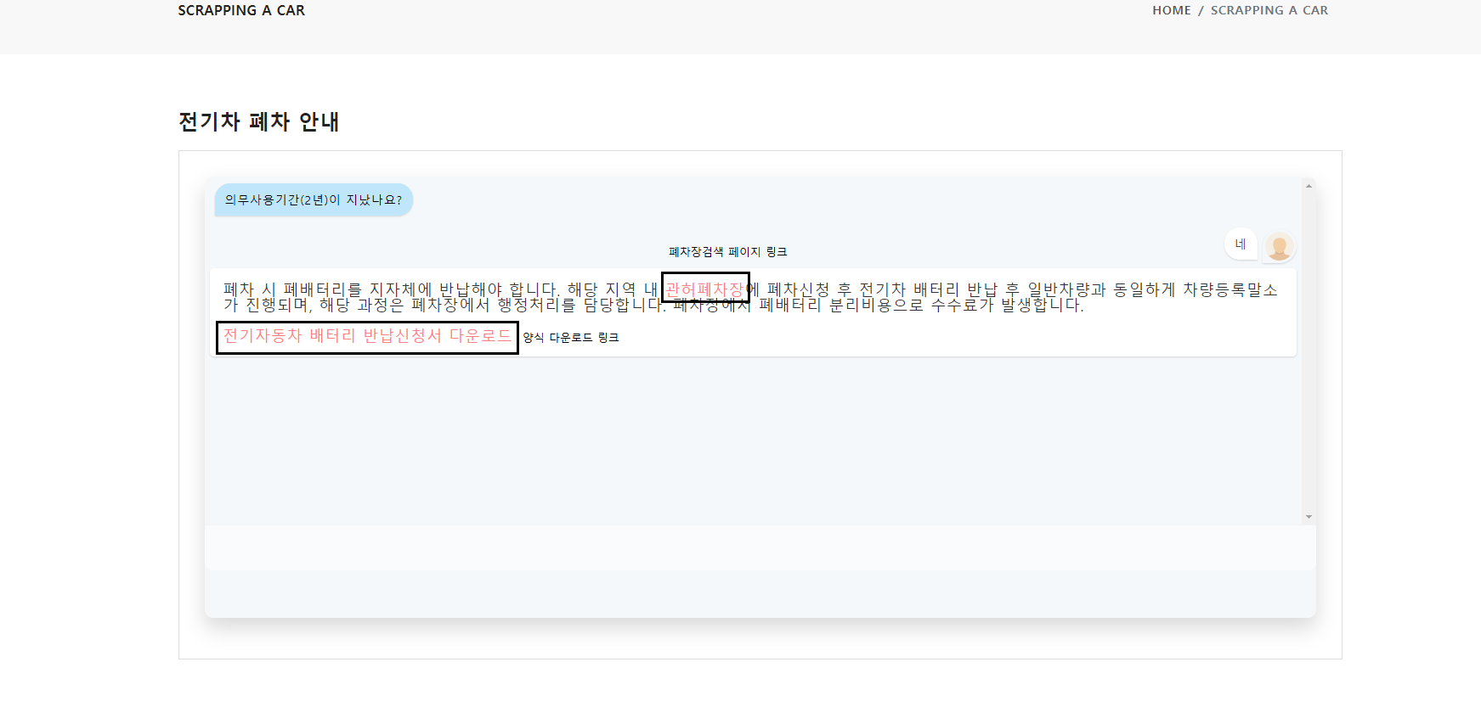

{

"name": "team_electric_vehicle_life_cycle_react",

"version": "0.1.0",

"private": true,

"dependencies": {

"@babel/core": "7.1.0",

"@mapbox/mapbox-gl-directions": "^4.0.3",

"@mapbox/mapbox-gl-geocoder": "^4.6.0",

"@mapbox/mapbox-gl-language": "^0.10.1",

"@material-ui/core": "^4.11.0",

"@reach/combobox": "^0.10.5",

"@react-google-maps/api": "^1.9.9",

"@svgr/webpack": "2.4.1",

"@testing-library/jest-dom": "^4.2.4",

"@testing-library/react": "^9.3.2",

"@testing-library/user-event": "^7.1.2",

"@types/jest": "^24.0.0",

"@types/node": "^12.12.51",

"@types/react": "^16.9.0",

"@types/react-dom": "^16.9.0",

"availity-reactstrap-validation": "^2.6.0",

"axios": "^0.19.2",

"babel-core": "7.0.0-bridge.0",

"babel-jest": "23.6.0",

"babel-loader": "8.0.4",

"babel-plugin-named-asset-import": "^0.2.3",

"babel-preset-react-app": "^6.1.0",

"bfj": "6.1.1",

"body-parser": "^1.19.0",

"bootstrap": "^4.3.1",

"case-sensitive-paths-webpack-plugin": "2.1.2",

"chalk": "^2.4.1",

"chart.js": "^2.8.0",

"component-will-mount-hook": "^1.0.2",

"cors": "^2.8.5",

"css-loader": "1.0.0",

"date-fns": "^2.15.0",

"dotenv": "6.0.0",

"dotenv-expand": "4.2.0",

"eslint": "5.6.0",

"eslint-config-react-app": "^3.0.8",

"eslint-loader": "2.1.1",

"eslint-plugin-flowtype": "2.50.1",

"eslint-plugin-import": "2.14.0",

"eslint-plugin-jsx-a11y": "6.1.2",

"eslint-plugin-react": "7.11.1",

"express": "^4.17.1",

"fetch-instagram": "^1.0.0-alpha.3",

"file-loader": "2.0.0",

"fork-ts-checker-webpack-plugin-alt": "0.4.14",

"fs-extra": "7.0.0",

"google-maps-react": "^2.0.6",

"html-webpack-plugin": "4.0.0-alpha.2",

"identity-obj-proxy": "3.0.0",

"instagram-api": "^1.0.3",

"jest": "23.6.0",

"jest-pnp-resolver": "1.0.1",

"jest-resolve": "23.6.0",

"mapbox-gl": "^1.11.1",

"mapbox-gl-directions": "^3.0.3",

"mdbreact": "^4.27.0",

"mini-css-extract-plugin": "0.4.3",

"optimize-css-assets-webpack-plugin": "5.0.1",

"pnp-webpack-plugin": "1.1.0",

"postcss-flexbugs-fixes": "4.1.0",

"postcss-loader": "3.0.0",

"postcss-preset-env": "6.0.6",

"postcss-safe-parser": "4.0.1",

"react": "^16.13.1",

"react-admin": "^3.7.1",

"react-anchor-link-smooth-scroll": "^1.0.12",

"react-app-polyfill": "^0.1.3",

"react-bootstrap": "^1.0.0-beta.9",

"react-chartjs": "^1.2.0",

"react-chartjs-2": "^2.7.6",

"react-ckeditor-component": "^1.1.0",

"react-countup": "^4.2.0",

"react-data-grid": "^6.1.0",

"react-datepicker": "^2.8.0",

"react-daum-postcode": "^1.9.0",

"react-dev-utils": "^6.1.1",

"react-dom": "^16.13.1",

"react-dropzone": "^10.1.6",

"react-dropzone-uploader": "^2.10.1",

"react-feather": "^2.0.3",

"react-fontawesome": "^1.6.1",

"react-geocode": "^0.2.1",

"react-google-charts": "^3.0.14",

"react-google-maps": "^9.4.5",

"react-helmet": "^5.2.1",

"react-image-lightbox": "^5.1.1",

"react-image-magnifiers": "^1.2.1",

"react-image-zoom": "^0.7.0",

"react-images-upload": "^1.2.7",

"react-infinite-scroll-component": "^4.5.3",

"react-input-range": "^1.3.0",

"react-instafeed": "^0.4.0",

"react-loading-bar": "0.0.7",

"react-magnific-popup": "^1.0.1",

"react-map-gl": "^5.2.7",

"react-map-gl-directions": "^1.0.4",

"react-map-gl-geocoder": "^2.0.11",

"react-masonry-css": "^1.0.14",

"react-modal": "^3.11.2",

"react-naver-maps": "^0.0.13",

"react-pace-progress": "^2.0.0",

"react-paypal-express-checkout": "^1.0.5",

"react-photo-gallery": "^8.0.0",

"react-redux": "^7.1.0",

"react-redux-loading-bar": "^4.5.0",

"react-redux-multilingual": "^2.0.4",

"react-responsive-modal": "^4.0.1",

"react-router-dom": "^5.0.1",

"react-router-scroll-4": "^1.0.0-beta.2",

"react-router-transition": "^2.0.0",

"react-scripts": "3.4.1",

"react-simple-chatbot": "^0.6.1",

"react-slick": "^0.24.0",

"react-slide-toggle": "^0.1.13",

"react-smart-data-table": "^0.7.1",

"react-star-rating-component": "^1.4.1",

"react-sticky-box": "^0.7.8",

"react-table": "^6.10.0",

"react-tabs": "^3.0.0",

"react-toastify": "^5.3.2",

"react-topbar-progress-indicator": "^2.0.0",

"reactstrap": "^8.0.1",

"redux": "^4.0.5",

"redux-devtools-extension": "^2.13.8",

"redux-infinite-scroll": "^1.0.9",

"redux-logger": "^3.0.6",

"redux-thunk": "^2.3.0",

"resolve": "1.8.1",

"scss": "^0.2.4",

"simple-react-validator": "^1.2.4",

"slick-carousel": "^1.8.1",

"smartmenus": "^1.1.0",

"socket.io": "^2.3.0",

"socket.io-client": "^2.3.0",

"style-loader": "0.23.0",

"styled-components": "^5.1.1",

"terser-webpack-plugin": "1.1.0",

"typescript": "~3.7.2",

"underscore": "^1.10.2",

"url-loader": "1.1.1",

"use-places-autocomplete": "^1.3.10",

"use-react-router": "^1.0.7",

"webpack-dev-server": "3.1.9",

"webpack-manifest-plugin": "2.0.4",

"workbox-webpack-plugin": "3.6.3"

},

"scripts": {

"start": "node scripts/start.js",

"build": "node scripts/build.js",

"test": "node scripts/test.js"

},

"eslintConfig": {

"extends": "react-app"

},

"browserslist": {

"production": [

">0.2%",

"not dead",

"not op_mini all"

],

"development": [

"last 1 chrome version",

"last 1 firefox version",

"last 1 safari version"

]

},

"jest": {

"collectCoverageFrom": [

"src/**/*.{js,jsx,ts,tsx}",

"!src/**/*.d.ts"

],

"resolver": "jest-pnp-resolver",

"setupFiles": [

"react-app-polyfill/jsdom"

],

"testMatch": [

"<rootDir>/src/**/__tests__/**/*.{js,jsx,ts,tsx}",

"<rootDir>/src/**/?(*.)(spec|test).{js,jsx,ts,tsx}"

],

"testEnvironment": "jsdom",

"testURL": "http://localhost",

"transform": {

"^.+\\.(js|jsx|ts|tsx)$": "<rootDir>/node_modules/babel-jest",

"^.+\\.css$": "<rootDir>/config/jest/cssTransform.js",

"^(?!.*\\.(js|jsx|ts|tsx|css|json)$)": "<rootDir>/config/jest/fileTransform.js"

},

"transformIgnorePatterns": [

"[/\\\\]node_modules[/\\\\].+\\.(js|jsx|ts|tsx)$",

"^.+\\.module\\.(css|sass|scss)$"

],

"moduleNameMapper": {

"^react-native$": "react-native-web",

"^.+\\.module\\.(css|sass|scss)$": "identity-obj-proxy"

},

"moduleFileExtensions": [

"web.js",

"js",

"web.ts",

"ts",

"web.tsx",

"tsx",

"json",

"web.jsx",

"jsx",

"node"

]

},

"babel": {

"presets": [

"react-app"

]

},

"devDependencies": {

"babel-eslint": "^9.0.0",

"node-sass": "^4.13.0",

"sass-loader": "^7.3.1",

"webpack": "^4.41.2"

}

}