|  |  |  |  |
| --- | --- | --- | --- |
| 교과목 | 프로그램언어 활용 개인 프로젝트 | 학습자명 | 김수빈 |

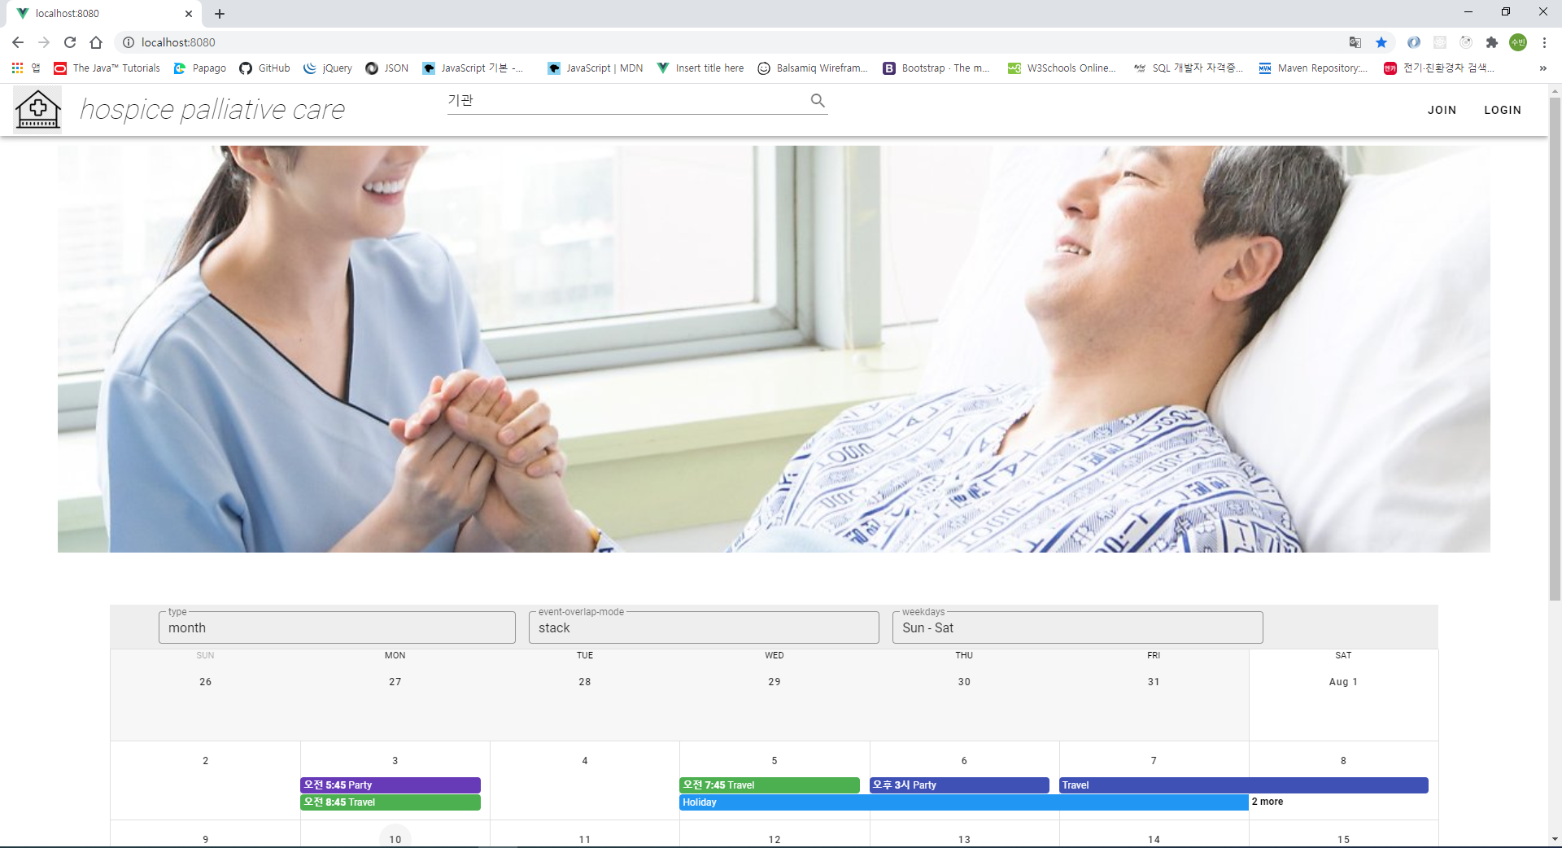

**App.vue**

<template>

<v-app>

<v-app-bar>

<div class="d-flex align-center">

<v-img />

<router-link to="/">

<h1 class="display-1 black--text font-weight-thin font-italic ml-5 mr-16">

hospice palliative care

</h1>

</router-link>

</div>

<v-flex sm3 class="ml-16">

<v-text-field

v-model="searchWord"

label="Search"

single-line

append-icon="search"

@keyup.enter="search"

></v-text-field>

</v-flex>

<v-spacer></v-spacer>

<router-link to="/join">

<v-btn>

<span class="black--text">Join</span>

<v-icon>mdi-open-in-new</v-icon>

</v-btn>

</router-link>

<router-link to="/login">

<v-btn>

<span class="black--text">Login</span>

<v-icon>mdi-open-in-new</v-icon>

</v-btn>

</router-link>

</v-app-bar>

<v-content>

<vue-page-transition name="fade">

<router-view/>

</vue-page-transition>

</v-content>

</v-app>

</template>

<script>

export default {

data() {

return {

searchWord: "기관"

};

},

created() {

},

methods: {

search() {

if(this.searchWord === '기관'){

alert('검색')

this.$store.dispatch("retriever/search", this.searchWord);

}

}

}

};

</script>

**Home.vue**

v-carousel

v-calendar

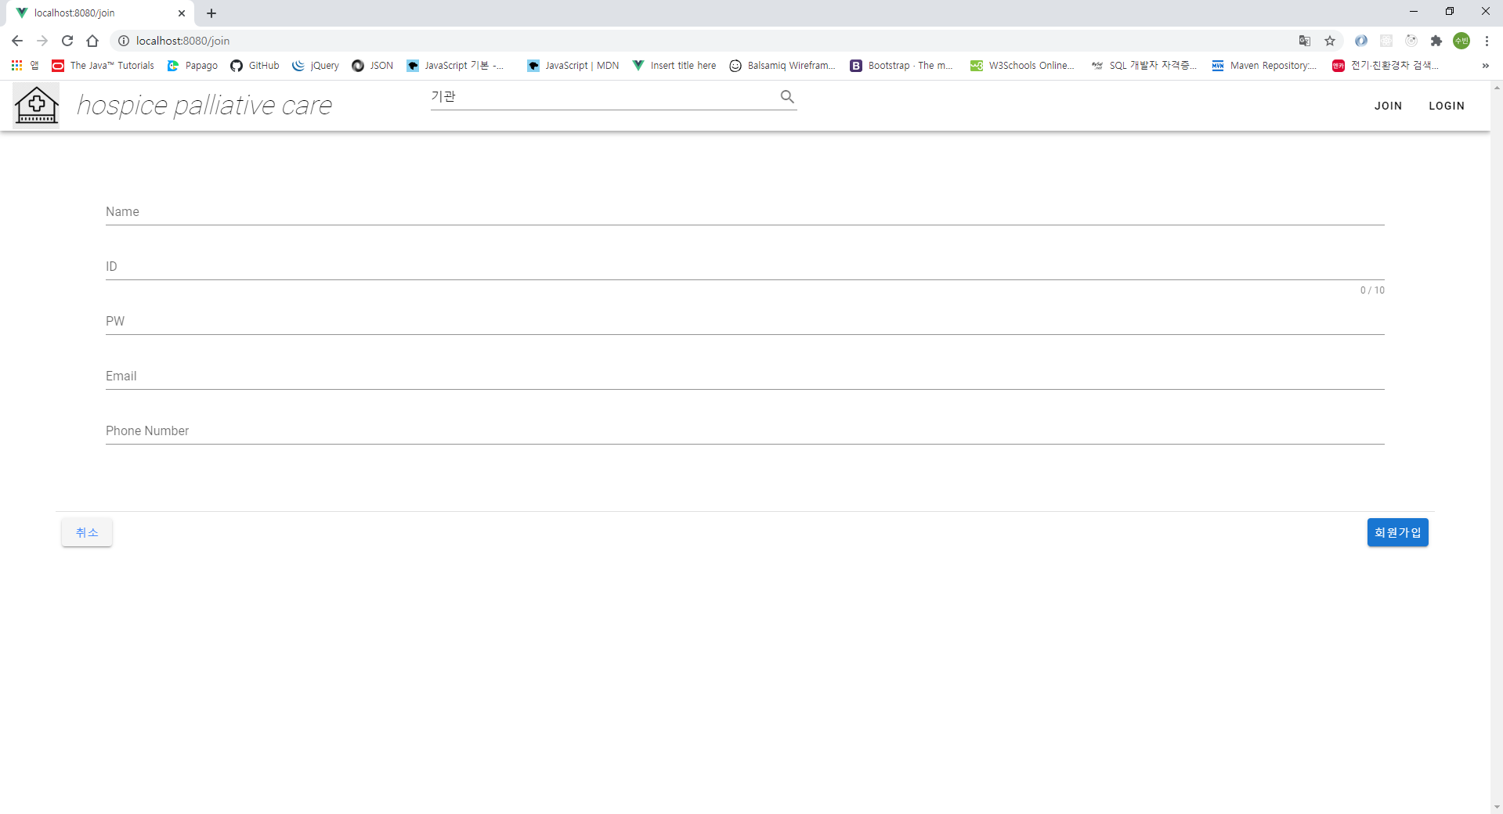

**Join.vue**

<template>

<v-container>

<v-form ref="form" v-model="valid" lazy-validation >

<v-text-field

v-model="name"

label="Name"

required

class="mt-16 mx-16"

></v-text-field>

<v-text-field

v-model="userid"

:counter="10"

label="ID"

required

class="mx-16"

></v-text-field>

<v-text-field

v-model="passwd"

label="PW"

required

class="mx-16"

></v-text-field>

<v-text-field

v-model="email"

label="Email"

required

class="mx-16"

></v-text-field>

<v-text-field

v-model="phoneNumber"

label="Phone Number"

required

class="mb-16 mx-16"

></v-text-field>

<v-divider></v-divider>

<v-card-actions>

<v-btn

to="/"

color="normal"

>

취소

</v-btn>

<v-spacer></v-spacer>

<v-btn

color="primary"

@click="join"

>

회원가입

</v-btn>

</v-card-actions>

</v-form>

</v-container>

</template>

<script>

export default {

data () {

return {

name: '',

userid: '',

passwd: '',

email: '',

phoneNumber: ''

}

},

methods: {

join () {

this.$store.dispatch('user/join', {name:'',userid:'',passwd:'',email:'',phoneNumber:''})

}

}

}

</script>

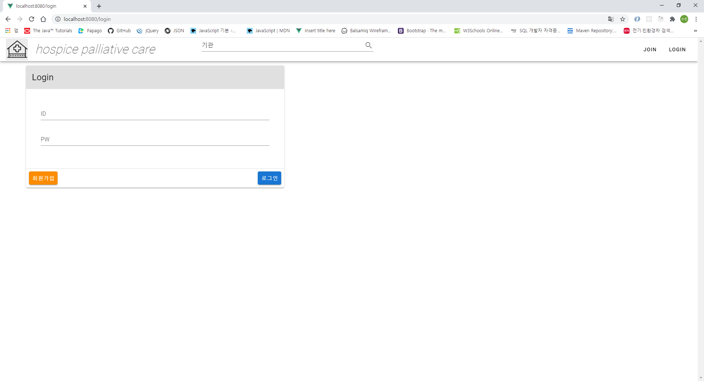

**Login.vue**

<template>

<v-container>

<v-card max-width="40%">

<v-card-title

class="headline grey lighten-2"

primary-title

>

Login

</v-card-title>

<v-form v-model="valid">

<v-text-field

v-model="userId"

label="ID"

required

class="mx-10 mt-10"

></v-text-field>

<v-text-field

v-model="passwd"

label="PW"

required

class="mx-10 mb-10"

></v-text-field>

</v-form>

<v-divider></v-divider>

<v-card-actions>

<v-btn

to="/join"

color="warning"

flat

>

회원가입

</v-btn>

<v-spacer></v-spacer>

<v-btn

color="primary"

flat

@click="login"

>

로그인

</v-btn>

</v-card-actions>

</v-card>

</v-container>

</template>

<script>

export default {

data () {

return {

userid: '',

passwd: ''

}

},

methods: {

login () {

this.$store.dispatch('user/login',{userid:'', passwd:''})

}

}

}

</script>