Date: 8/8/2023

Introduction to HTML: HTML stands for Hypertext Markup Language. Where hypertext refers to the text that can help us navigate from one document to another. While markup language stands for a language which helps us tell the text format, like the text will be bold, italic, underlined, etc. and this can be achieved using html tags. Following is the list of all html tags available.

And these all are not frequently used, we need a few of them for our day-to-day development, those few are as follows:

HTML Heading Elements: For using the headings in HTML, we use heading tags, these tags range from 1 to 6, i.e., from <h1></h1> to <h6></h6>. And its syntax is as follows:

<h1>My First Heading</h1>

Breaking down the syntax:

<h1> => this is the opening tag

</h1> => forward slash shows that a tag is a closing tag

My First Heading => this is the text that is to be displayed when this HTML page will be rendered

<tag> vs. Element: Tag is anything that has been enclosed with angular brackets <>, and the whole thing which is written along with tags and content is known as the element. Example: “<h1>Hello</h1>” this whole thing inside the quotation marks is the HTML element.

Purpose of Heading elements: Whenever we read a long document, we usually skim through the headings of the document to get an idea, what document is exactly about. Search engines use headings to index the structure and content of the web pages. To define the concept of headings and subheadings, we have a 6-level hierarchy of these headings, which looks like this:

<h1>Heading 1</h1>

<h2>Heading 2</h2>

<h3>Heading 3</h3>

<h4>Heading 4</h4>

<h5>Heading 5</h5>

<h6>Heading 6</h6>

When we use these heading elements, they will be rendered in following way:

Now since we know how we can use these heading elements, here’s an exercise to get hands-on on this. We need to achieve the following:

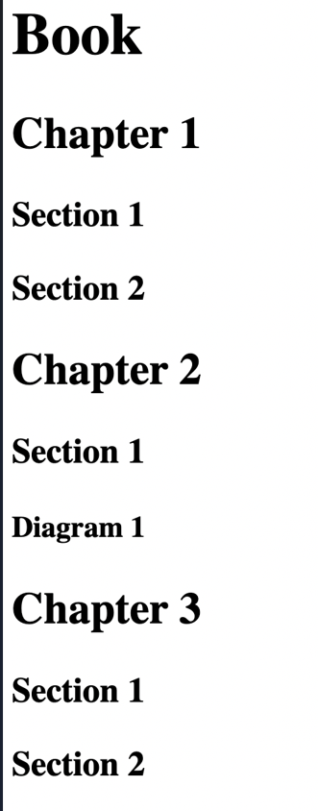

Here’s the solution:

Keep in mind: We need to remember that there could not be more than one <h1></h1> elements. It is not a good idea to have more than one top level heading element. As well as, if you have an opening tag as <h2> and you are closing it with </h6> so it won’t work the way you want it to work, because you aren’t sure with your requirements if you want to show second level heading element or sixth level heading element. The output will be the second level heading element in this case.

Also, always try to maintain order while using heading elements. Don’t skip the levels, i.e., if you are currently using h1 heading element, and then directly start using h3 heading element. So, this is not considered to be good practice. Instead go level by level.

Paragraph elements: When we write plain text in HTML, it is rendered, such that all the text written runs into each other, even if the text has been written in a new line or so. So, to differentiate between two or more paragraphs, we need to use the <p></p> (paragraph tags). This is also good practice for web accessibility, because if a user is blind, they still can skip from paragraph to paragraph and see what’s happening.

Syntax: <p>This is a paragraph</p>

Now that we are aware of what paragraph tag is, so we need to perform below exercise:

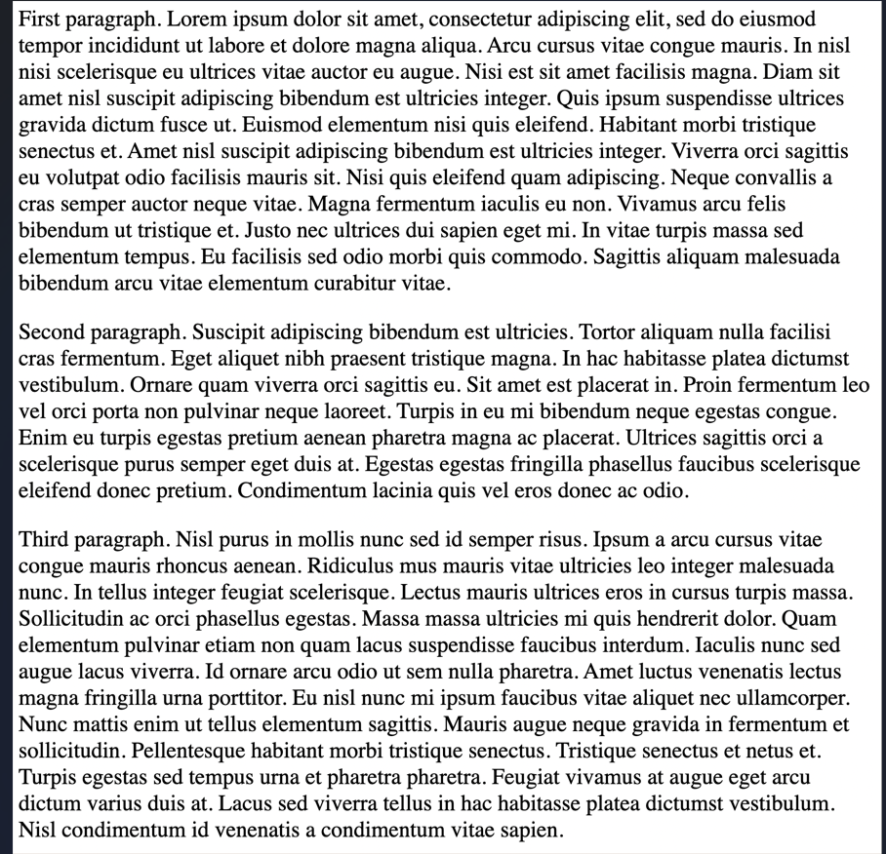

Here’s the way to achieve above thing:

Tip: you need not write this whole paragraph manually, just write “lorem” and after that, number of words you want in your paragraph. Example, I wanted my first paragraph to have 80 words, so I wrote, lorem80 and hit enter, and the text was autogenerated.

Self-closing tags: self-closing tags or void tags are the tags that do not need to be closed manually by its closing tag, which means they do not have a separate closing tag. Also, this implies that these tags do not contain the content in between the opening and closing tags.

Syntax: <tag_name />

Examples: <hr />, <br />, <img />, <input />, etc.

Now that we know about these void or self-closing tags, we need to use these tags to achieve the following:

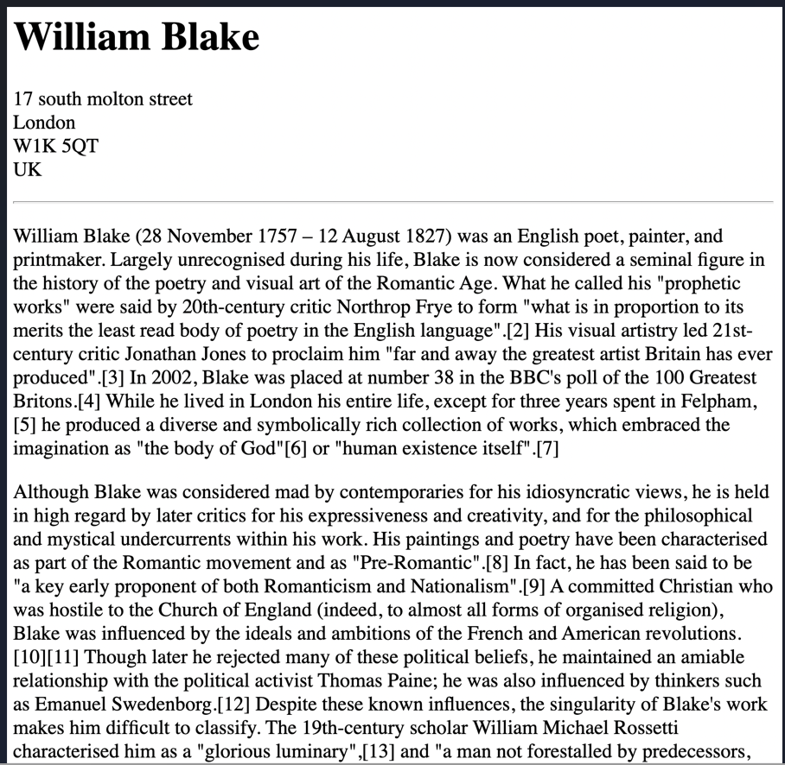

Here’s the text we need to use:

William Blake 17 south molton street London W1K 5QT UK William Blake (28 November 1757 – 12 August 1827) was an English poet, painter, and printmaker. Largely unrecognised during his life, Blake is now considered a seminal figure in the history of the poetry and visual art of the Romantic Age. What he called his "prophetic works" were said by 20th-century critic Northrop Frye to form "what is in proportion to its merits the least read body of poetry in the English language".[2] His visual artistry led 21st-century critic Jonathan Jones to proclaim him "far and away the greatest artist Britain has ever produced".[3] In 2002, Blake was placed at number 38 in the BBC's poll of the 100 Greatest Britons.[4] While he lived in London his entire life, except for three years spent in Felpham,[5] he produced a diverse and symbolically rich collection of works, which embraced the imagination as "the body of God"[6] or "human existence itself".[7] Although Blake was considered mad by contemporaries for his idiosyncratic views, he is held in high regard by later critics for his expressiveness and creativity, and for the philosophical and mystical undercurrents within his work. His paintings and poetry have been characterised as part of the Romantic movement and as "Pre-Romantic".[8] In fact, he has been said to be "a key early proponent of both Romanticism and Nationalism".[9] A committed Christian who was hostile to the Church of England (indeed, to almost all forms of organised religion), Blake was influenced by the ideals and ambitions of the French and American revolutions.[10][11] Though later he rejected many of these political beliefs, he maintained an amiable relationship with the political activist Thomas Paine; he was also influenced by thinkers such as Emanuel Swedenborg.[12] Despite these known influences, the singularity of Blake's work makes him difficult to classify. The 19th-century scholar William Michael Rossetti characterised him as a "glorious luminary",[13] and "a man not forestalled by predecessors, nor to be classed with contemporaries, nor to be replaced by known or readily surmisable successors".[14]

Solution:

Tip: we can skip using forward slash in self-closing or void tags.

Finally, we have covered the introduction part, and whatever we have learnt till now, let’s put everything together. So, we need to write an HTML code to achieve something like below:

Solution:

The List Elements: whenever we go through an article or a blog, we see that people mention their thoughts in points, these pointers can be numbered, as well as without numbers (just bullet points). These are called as the list items in HTML. To create these list items, we have two types of lists-

1. Unordered list.
2. Ordered list.

Unordered list does not have numbering, we can call it as bullet point list in layman terms. Syntax to write ordered lists is <ul></ul>. In between these tags, we need to write down the list items, and to do so, we have <li></li> tags.

Example:

<ul>

    <li>One</li>

    <li>Two</li>

    <li>Three</li>

</ul>

Output:

Ordered list contains numbering. Syntax to write ordered lists is <ol></ol>. In between these tags, we need to write down the list items, and to do so, we have <li></li> tags.

Example:

<ol>

    <li>One</li>

    <li>Two</li>

    <li>Three</li>

</ol>

Output:

Since we have understood and implemented the lists, so we can easily go for below exercise:

Solution:

<h1>Angela's Recipe for the Best Cinnamon Roll </h1>

<h2>Ingredients </h2>

<h3>For the dough: </h3>

<ul>

    <li>¾ cup warm milk </li>

    <li>2 ¼ teaspoons yeast </li>

    <li>¼ cup granulated sugar </li>

    <li>1 egg plus 1 egg yolk </li>

    <li>¼ cup butter </li>

    <li>3 cups bread flour </li>

</ul>

<h3>For the filling: </h3>

<ul>

    <li>2/3 cup dark brown sugar </li>

    <li>1 ½ tablespoons ground cinnamon </li>

    <li>¼ cup butter </li>

</ul>

<h2>Instructions </h2>

<ol>

    <li>Mix the milk with the yeast, sugar, eggs. </li>

    <li>Melt the butter and add to the mixture. </li>

    <li>Add in the flour and mix until combined into a dough. </li>

    <li>Knead the dough for 10 minuites. </li>

    <li>Transfer the dough into a large bowl and cover with plastic wrap. </li>

    <li>Leave it somewhere to rise for 2 hours. </li>

    <li>After the dough has doubled in size, roll it out into a large rectangle. </li>

    <li>Melt the butter for the filling and mix in the sugar and cinnamon. </li>

    <li>Spread the filling onto the dough then roll the dough into a swiss roll. </li>

    <li>Cut the roll into 3cm sections and place flat into a baking tray. </li>

    <li>Pre-heat the oven to 350F or 180C, then bake the rolls for 20-25min until lightly brown. </li>

</ol>

Nesting and Indentation (how to write good code): Indentation is necessary if we want to make our code easily readable so that anyone can navigate through the elements in the code. Now for example, we want to write code to achieve the following, then we need to nest the elements in the code, so to make that code readable and maintainable, we need to use indentation.

Solution:

<ul>

    <li>A</li>

    <li>B</li>

        <ol>

            <li>B1</li>

            <li>B2</li>

                <ul>

                    <li>B2a</li>

                        <ul>

                            <li>B2aa</li>

                            <li>B2ab</li>

                        </ul>

                    <li>B2b</li>

                    <li>B2c</li>

                </ul>

            <li>B3</li>

                <ol>

                    <li>B31</li>

                    <li>B32</li>

                </ol>

        </ol>

    <li>C</li>

</ul>

The Anchor element: