|  |
| --- |
| Creating Futures |
| Annual report for the year 2014 - 2015 |

|  |
| --- |
| Jimmy Cherian  Jimmy.cherian@creatingfutures.in |



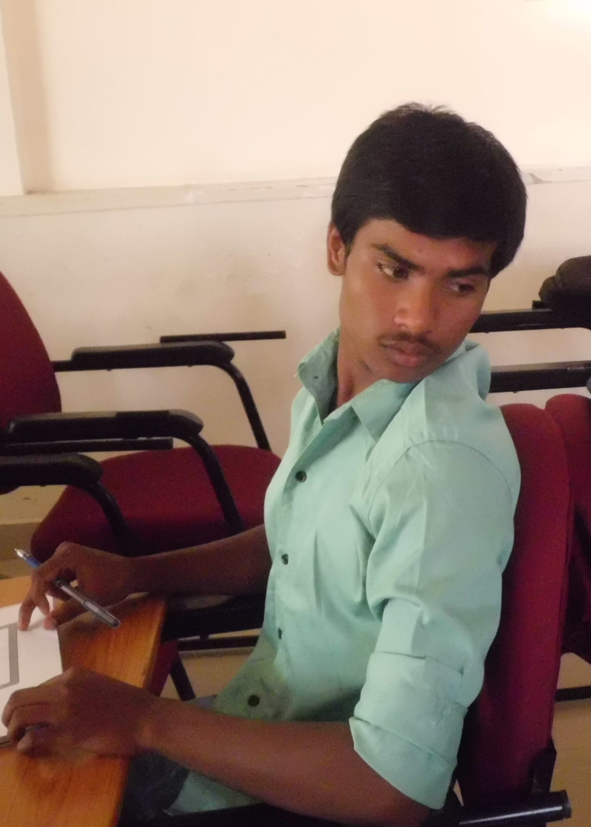

I AM CREATING FUTURES

Table of Contents

Letter from the President 4

About Creating Futures 6

Our Mission 6

Our Vision 6

Our Goals: 6

Objectives of Creating Futures 7

Spoken English 8

Life Skills 8

Education to Employability 8

Internship Program 8

Report for the year 8

Introduction 8

Skill Development. 9

Training Content Development. 10

Volunteers 11

Others 11

Summary 12

Testimonials 12

Financial statement 12

Acknowledgement 13

Our partners 14

Memories 15

Contact us 17

*T*he Capacity to learn is a gift; The ability to learn in a skill; the willingness to learn is a choice

* *Brian Herbert*

*I*f you think in terms of a year, plant a seed; if in terms of ten years, plant trees; if in terms of 100 years, teach the people

* *Confucius*

Consciously or unconsciously, every one of us does render some service or other. If we cultivate the habit of doing this service deliberately, our desire for service will steadily grow stronger, and will make, not only our own happiness, but that of the world at large.

* *Mahatma Gandhi*

# Letter from the President

Greetings

It is my pleasure to present the first annual report of Creating Futures. It has been a very eventful year, with a lot of accomplishments and a lot of learning. As we look back, I am sure we all can say that we did make a difference in some way or another

We started this organization with the belief that we can make a difference to the young people out there who need guidance and mentorship. We wanted to create futures for those students who did not have the exposure or the resources. And we did this with the help of volunteers, NGO’s, partner organizations, friends and family. Without this eco-system, I am not sure if we would have been able to achieve what we did. I take this opportunity to thank each one of them and show my gratitude to all of them for their service and support. End of the year, I feel honoured and humbled to be a part of other people’s lives, and to help them and guide them.

Every year, we see lakhs of students passing out of colleges. Many of these are “first generation” educated students. Our aim was to act as a catalyst to help these students achieve their dreams. Our aim was to enable them with the skills and capabilities which will ensure that they get the right job.

Starting this year, we focused on Workforce Devel­opment Program which we named as Education to Employability programs, to prepare students for new jobs or better jobs. We train our students not only with technical skills, but educate our students with job-seeking skills of resume writing, communication, effective interview techniques and so on.

In the coming year, we will continue to focus on the needs of all of our programs, with a special emphasis on Internship program, particu­larly for the Engineering students. Irrespective of the program, we feel that these students need guidance and supervision in developing socially, mentally, academically, and physically. We want to educate and motivate them to be successful, and to be positive leaders of our community. And we believe that we have the right platform, framework and the team to do this. We look forward to your contribution to make this happen for the coming year.

Happy reading

Jimmy Cherian

# About Creating Futures

Creating Futures is a non-profit and non-government organization in the field of IT and ITES. It aims to create employment opportunities for the educated rural and urban youth from economically under-privileged background by providing them with real-life experiences, building their capabilities as well as training them in various skills to make them highly capable corporate-ready resources. This initiative includes:

* Technology-based project experience and training
* Soft-skill training and development
* End-to-End software development lifecycle program
* Business and corporate-enabled programs

# Our Mission

* Facilitate and provide employment opportunities for under-privileged or marginalized educated youth.
* Creating a network of resource to reduce unemployment

# Our Vision

Creating Employment opportunities for the educated rural & urban poor and empowering them to be integrated into mainstream business environment thereby enabling them to earn a sustainable livelihood improving the overall standard of living

# Our Goals:

* Increase the career options of students by providing suitable training and experience that includes a rigorous real-life work environment.
* Help students develop technical skills and soft skills that meet industry standards.
* Provide students with hands-on learning.
* Provide students with the ability to make the connection between classroom instruction and real business environment by applying knowledge and skills to solve real-world problems.
* Create an eco-system of resources with focused skill development for students
* With more than 70% of our population living in rural areas or being a part of the urban poor population, focus will be on these groups of students.
* Enrol graduate students with the intention of giving them the necessary training and experience, thus enabling them to be employed.

# Objectives of Creating Futures

Creating Futures’ objectives are:

1. **Enable** employment among educated youth (Education to Employability)
2. **Ensure** interns are employed.

Creating Futures will work towards the achievement of these through two complementary programs:

* Value-Addition Program

This is a short-duration (approximately, 10 days) program, and focuses on honing skills, predominantly soft skills, that will enable under-privileged youth find employment, and aimed at educated youth, with minimum qualification of 12th standard.

* Practical, Real-Life Experience Program

This is a long-duration (approximately, 4-6 months) program, with primary focus on internship, and aimed at skills needed for the IT industry.

Both these programs are aimed at the educated rural and urban youth from economically weak background.

As our objective is to Identify and train under-privileged and needy youth, we aim to accomplish this through ***various complementary programs***

## Spoken English

* Primarily for the rural and non-English speaking youth and for those who may have dropped out of school / college
* This program is usually the 1st step and is followed by the other programs

## Life Skills

This program focuses on developing the following:

* Self Belief
* Social Skills
* Self Esteem
* Group Dynamics
* Teamwork
* Goal Setting

## Education to Employability

This program covers the following:

* Communication
* Resume Writing
* Interview Skills
* Presentation Skills
* Group Discussions
* Business English
* Analytical & Problem Solving

## Internship Program

* This is a long term program for 6 months or above and focuses on building the technical skills of the student.
* Real life experience will be provided to the students as part of this program

# Report for the year

## Introduction

This report details the various activities done by Creating Futures for the year 2014 – 2015. The activities are categorized into the following

* **Skill Development**. This section details the various trainings, workshops, mentoring done by Creating Futures for the students
* **Training** **Content** **Development**. This section highlights the various training content that was created as part of our various programs.
* **Volunteers**. Creating Futures as an organization depends heavily on its volunteers. This sections details the activities done in this area
* **Others**. This section include other organizational activities that were carried out during the year

## Skill Development.

Under this programme, we have focused on employability, life skills and Spoken English workshops for students who have passed out or were passing out during the year. This included conducting workshop at colleges, NGO organizations and our corporate partner premises. Below are the workshops which we conducted during the year.

1. 5 day Education to Employability Workshop conducted at Ciber

* Partnered with Ciber for the Education to Employability Program
* **22 students** registered for the workshop
* Workshop held at Ciber premises for the Volunteers. Many volunteers from Ciber

1. Partnered with St.Joseph’s Evening Collage for identifying and training students for the Workshop at Ciber

* Workshop held at St. Joseph's evening college.
* Education to Employability Workshop held with **20 students** registering for the program

1. Life Skills program done for rural students at Vellore

* **12 students** participated for this program which was held over the weekend

1. Workshop held at Davengere for “Education to Employability” program

* 29 students registered for the program
* Post-Workshop activities planned for the batch at Davengere. These include curriculum and approach

1. Workshop held at Shishu Mandir

* Partnered with Shishu Mandir for the workshop (NGO working for the upliftment of the children).
* Workshop held at Shishu Mandir premises for “Education to Employability” Program
* 19 students registered for the program

1. Post Workshop activities for Davengere Batch initiated
2. “Lifeksills” and “Spoken English” program held at Madurai

* **14 students** registered for the workshop

1. 2nd Workshop held at Davengere for “Education to Employability” program

* **60 students** registered for the program
* Two parallel workshops held

1. Workshop at Saama Wellness Center planned and conducted at the Saama premises.

* **16 students** participated in the workshop

1. Post Workshop activities held for the students of Shishu Mandir

* Multiple One day sessions held at Shishu Mandir

1. Workshop held at St. Joseph's evening college.

* 3rd workshop for the St. Joseph’s Evening School students
* Education to Employability Workshop held with **25 students** registering for the program

1. Workshop held at Dreams Foundation. (Dreams Foundation is a NGO working with the Under privileged children)

* Workshop held at Dream Foundation premises
* Education to Employability Workshop held with **17 students** registering for the program

## Training Content Development.

Creating Futures focuses on skill enhancement for the students, so that they are prepared for employment. Given this need of skill enhancement Creating Futures have invested lot of time and effort in defining the approach and methodology towards skill development. Based on this we have also focused on the curriculum needed for the employment, training path and learning map.

Below are the various activities, which we have accomplished during the year.

1. Approach and Methodology to training at Creating Futures defined.
2. Defined curriculum for education employability programme.
3. Identified the high level learning map for Creating Futures.
4. Following Training content created:
   * Communication Skills
   * Business English
   * Grooming and Presenting Skills
   * Resume Writing
   * Interviewing Skills
   * Group Discussions
   * Problem Solving
   * Analytical Skills
   * Aptitude Tests
   * Data Analysis and Interpretation
   * Presentation Skills
   * Email Etiquette

## Volunteers

Volunteers play a huge role in Creating Futures, as we are volunteer based organization.

Below are the various activities that we have done to attract, engage and retain volunteers.

1. Had an initial workshop with volunteers to understand the approach to Creating Futures.
2. Volunteers identified. Core Team formed. Roles and Responsibilities identified and allocated to the various volunteers
3. Defined Volunteer Database and recruiting of volunteers
4. Internal volunteer workshop held for the approach to training
5. 2nd Workshop with Volunteers held to plan for the various activities of Creating Futures
6. Couple of posters have been defined to solicit for more Volunteers.
7. Train the Trainer workshop held at Ciber to train 15 volunteers
8. 3rd Volunteer workshop and get together held to discuss the various activities around Creating Futures
9. Volunteer workshop held for all volunteers part of the Shishu Mandir Workshop

## Others

Listed below are the various other initiatives and activities done during the year.

* Purchased a domain and hosting environment for the website
* Created and released the website
* Email Ids created with Creating Futures Domain
* Engaged with legal representatives to register the NGO. Registered the NGO with the Registrar
* Partnered with Ogilvy to design the Logo, Theme and overall Visual branding for Creating Futures
* Standard Operating procedures defined for the Training activities
* Facebook, Linkedin and Twitter Profiles created
* Based on our overall goals, created an elevator pitch for creating Futures
* Partnered with iVolunteer for “Impact” projects. As part of this, iVolunteer will provide volunteers for 5 named projects. (*iVolunteer is an NGO that focuses on briding volunteers to the needed NGOs)*
* Marketing approach and Plan completed
* Partnered with Saama Wellness Centre as their CSR partner
* Newsletters published on a regular frequency

## Summary

To summarize, below are the highlights for the year.

* + Over 220 Students trained
  + Over 80 volunteers part of the Creating Futures Journey
  + Average of 8 volunteers per workshop
  + More than 13 Soft-skills modules created
  + Partnered with corporates, NGO’s and Colleges to meet the stated objectives
  + Continued Coaching and Mentoring students even after the workshops
  + Post Workshop sessions held after the initial workshop
  + Most of the students employed
  + Excellent feedback from the students

# Testimonials

* *This was the best training conducted for us.* ***Charan Kumar****. Student from St. Josephs*
* *I am feeling happy, really! The class was very good and I have been learning more skills. My request is to keep this workshop again. ~* ***Rupesh P****. Student from Dreams Foundation*
* *“As an individual, I got so much knowledge about resume writing, small talk, group discussion, do's and don'ts in every stage of interview. TOTALLY IT WAS THE BEST TRAINING I HAVE ATTENDED TILL NOW!” –Bhoomika, a student from Davengere*
* *It's been close to a year now since I have been associated with Creating Futures & I must admit, the journey thus far has been really very inspiring & satisfying. Volunteer Management & a Trainer: that's my role at Creating Futures.* ***Arjun Hebbar. Volunteer at Creating Futures***

# Financial statement

|  |  |  |  |  |  |
| --- | --- | --- | --- | --- | --- |
| BALANCE SHEET AS ON 31ST MARCH 2015 | | | | | |
| Liabilities | Amount | Amount | Assets | Amount | Amount |
| **Corpus Fund** |  | 10,001 | **Fixed Assets** |  |  |
|  |  |  | Furniture and Fixtures | 4,300 |  |
| **General Fund** |  |  | Less Depreciation | 430 | 3,870 |
| Opening Balance |  |  |  |  |  |
| Add: Excess of Income |  |  | **Current Assets** |  |  |
| Over Expenditure | 4,391 | 4,391 | cash in hand |  | 10,522 |
| **Total** |  | **14,392** | **Total** |  | **14,392** |

|  |  |  |  |
| --- | --- | --- | --- |
| RECEIPTS AND PAYMENTS AS ON 31ST MARCH 2015 | | | |
| **Receipts** | **Amount** | **Payments** | **Amount** |
| **To Opening Balances:** |  |  |  |
| Cash in hand |  | By Accounting Charges | 2,500 |
|  |  | By Audit Fee | 2,500 |
|  |  | By Internet & Website Charges | 8,171 |
| To Contribution Received | 95,097 | By Orientation Programme Expenses | 18,950 |
| To Other Income | 24,000 | By printing & Stationery | 7,406 |
| To Corpus Fund Received | 10,001 | By Professional Fee | 6,000 |
|  |  | By Registration Expenses | 2,305 |
|  |  | By salary & Wages | 15,000 |
|  |  | By Soft Skill Devpt Expenses | 20,664 |
|  |  | By Students Career Devpt Expenses | 25,490 |
|  |  | By Travelling & Conveyance | 5,290 |
|  |  | By Furniture Purchased | 4,300 |
|  |  |  |  |
|  |  | By Closing Balances: |  |
|  |  | Cash in hand | 10,522 |
|  |  |  |  |
| **Total** | **1,29,098** | **Total** | **1,29,098** |

# Acknowledgement

We like to acknowledge our volunteers and well-wishers for constantly helping, guiding and supporting us. Without their active involvement, achieving our goals wouldn’t have been possible.

Over the year around 65 + volunteers were involved in Creating Futures activities.

|  |  |
| --- | --- |
| Aakanksha Bhatnagar | Pooja |
| Amulya Shankar | Poornima Nandeesh |
| Andrew Alberts | Pushpalatha Annavi |
| Anitha Chari | R Ratchana |
| Arati Arunkumar | Rebecca Pragalathan |
| Arjun Hebbar | Rohini Joyappa |
| Avinash Aralaguppi | Roshan Priyadarshi |
| Bernadin B | Roshini K |
| Bindu Sundaresh | Rosine Jose |
| Chandrika rai | Rupak Rai |
| Divya Joyce | Sajana Shankaran |
| Emily Jyothi Golla | Sandeep Kumar |
| Girish Baliga | Sandhya Ramanujam |
| Hemant Negi | Sanila Nitin |
| Himanshu Pani | Sarath Mohan |
| Jayakrishna Reddy .G | Sharmela Pattabiraman |
| John Paul | Sheela M |
| Joyeeta Saha Chakravarty | Shirley T Verghese |
| Kiran Kokkeragadda | Shruthi Ponnappa |
| Lavanya G N | Sidarth Patra |
| Liz Poulose | Sitaram Sujir |
| Mahesh Ramegowda | Sobin George |
| Maithili | Sowmya Gopinath |
| Meenakshi | Suneetha Pusuluri |
| Meera Raman | Supritha |
| Monisha Devaiah | Sushrut K |
| Mridula Divakar | Thulasi Menon |
| Nakul Charekar | Vasumathi Arumugam |
| Nitin Vijayan | Vijay Chintada |
| Norton Cunningham | Vikram Raghavachari |
| Pallavi Mahesh | Vinay |
| Pavithra | Virupakshi B N |

We would also like to thank our trustees for guiding, mentoring, volunteering and contributing and supporting the cause of Creating Futures.

* Norton Cunningham
* Anitha Chari
* Andrew Alberts

# Our partners

A collaborative network is a key success factor for the Creating Futures. There is a need to have a eco system that works in a partnership mood to achieve our goals and objectives. During the year we have collaborated with NGOs, Corporate Organizations and collages to meet our objectives.

Creating Futures acknowledge and thank our partners for their support during the year. We are grateful for your involvement .

For the year we have partnered with the following corporate organisations.

* Ciber
* Saama Wellness Centre

We were supported by the following organization for our branding activities :

* Ogilivy

We collaborated with the following NGO organizations to reach our beneficiaries :

* iVolunteer
* Shishu Mandir
* Dream Foundation
* Breads

We also engage with the following collages for our out reach programmes:

* St.Joseph Evening Collage, Bangalore
* Jain Institute of Technology, Davengere

# Memories

Collage of some of the workshop conducted during the year at various occasions.

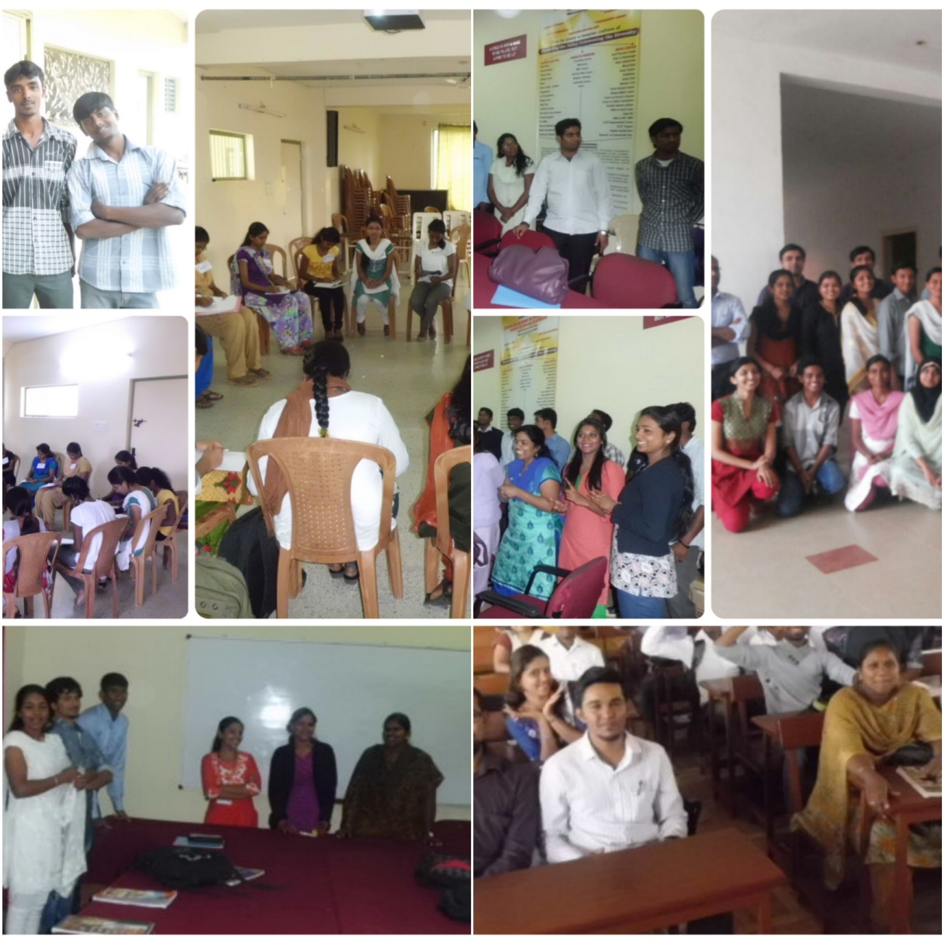

Collage of volunteers as they participated in various workshops.

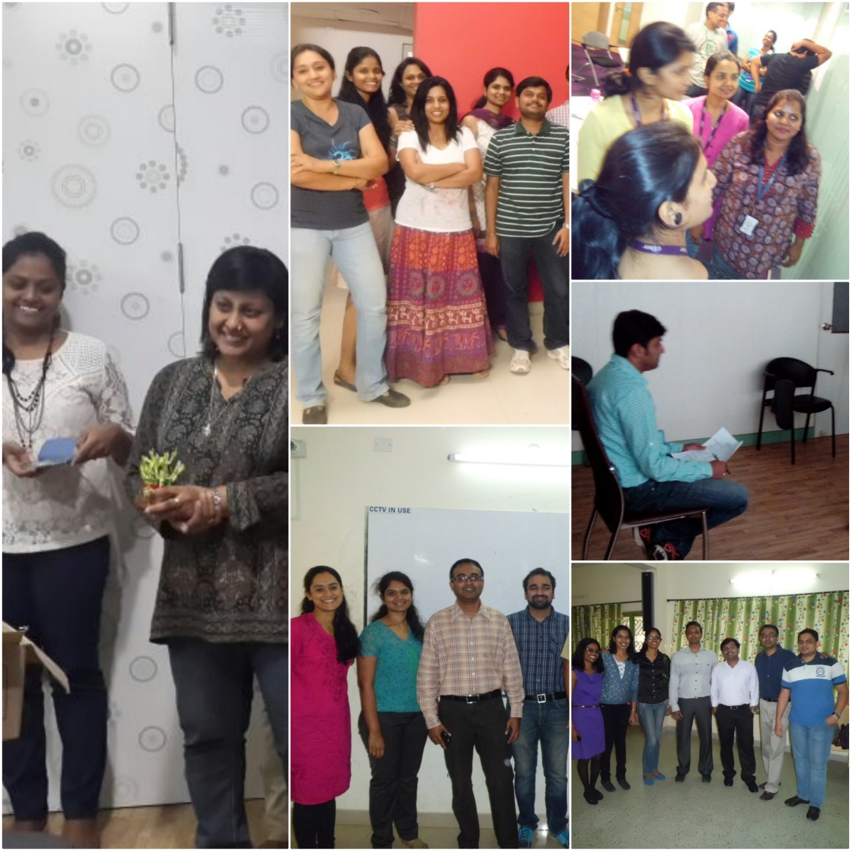

# Contact us

* Website: [www.creatingfutures.in](http://www.creatingfutures.in)
* Facebook: [www.facebook.com/educationtoemployability](http://www.facebook.com/educationtoemployability)
* Linkedin: <https://www.linkedin.com/company/creating-futures?trk=top_nav_home>
* Twitter: [www.twitter.com/cr8ingfutures](http://www.twitter.com/cr8ingfutures)
* Contact Person: Jimmy Cherian
* Contact Number: +91 9845132192
* Contact Email: [info@creatingfutures.in](mailto:info@creatingfutures.in)