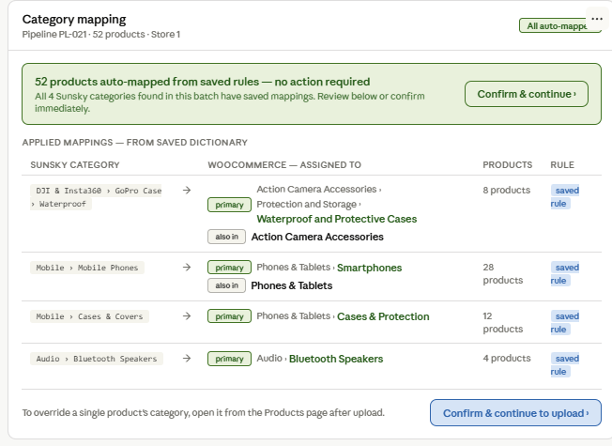

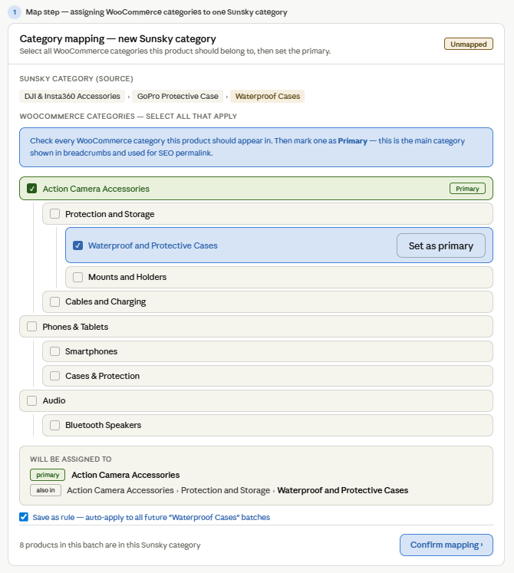
The tree is checkboxes, not a single dropdown. A dropdown forces you to pick one value. Checkboxes let you pick several levels simultaneously — the product gets assigned to both "Action Camera Accessories" (top) and "Waterproof and Protective Cases" (deep), which is exactly the WooCommerce multi-category behaviour you described. The hierarchy is visible so you never wonder which level a category sits at.
First selection automatically becomes primary. This matches the most common intent — you usually want the deepest, most specific category to be primary. But you can change it immediately with "Set as primary" on any other checked row. The primary is shown in green, everything else in blue, so the distinction is always visually clear.
The result box below the tree shows the final assignment in plain language. Before confirming, the user can read exactly: "Primary: Action Camera Accessories › Protection and Storage › Waterproof and Protective Cases. Also in: Action Camera Accessories." This is what gets sent to WooCommerce — no ambiguity.
The saved rule stores the full set, not just one category. As shown in the dictionary (Screen 2), each rule records every category in the assignment plus which one is primary. When this rule auto-applies on the next run, the product gets the full multi-category assignment automatically — not just the primary.
The depth difference between Sunsky and WooCommerce does not matter. Sunsky has 3 levels, WooCommerce has 3 levels but they are completely different. The mapping editor does not try to match levels — it just lets you check whatever WooCommerce categories are correct, regardless of how the Sunsky hierarchy was structured. This is the only approach that works when the two taxonomies have no structural relationship.

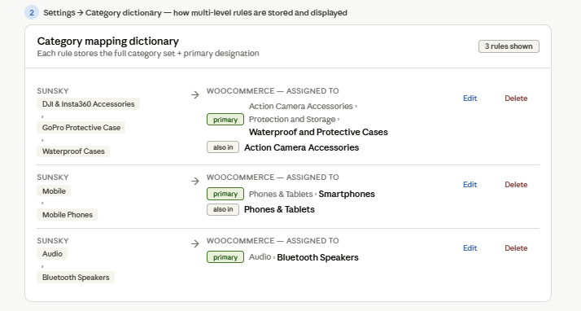

The system maintains a persistent mapping dictionary — a database table with rows of:
Sunsky category (full path)
→ WooCommerce category set (one or more full paths)
→ primary category designation
→ times used / last used
At the Map step, the pipeline checks every distinct Sunsky category in the current batch against this dictionary. Two outcomes:
- All found → auto-apply all rules, show State A, user confirms in one click
- Some not found → auto-apply known rules, surface only unknowns for manual assignment, show State B. Each manual assignment has "Save as rule" checked by default, so it enters the dictionary immediately and will never appear again.
The dictionary grows with every run. After covering your typical Sunsky category range — which for a focused supplier like Sunsky is finite — the Map step becomes permanently one-click.

UX Flow — the full lifecycle

Run 1 — building the dictionary from scratch:
All Sunsky categories are new
→ Map step shows State B for every category
→ User assigns WooCommerce category set + primary for each
→ Each assignment saved as rule automatically
→ Confirm → Upload
Time cost: 5–15 minutes depending on category count

Runs 2–N — routine batches, all known categories:
All Sunsky categories already in dictionary
→ Map step shows State A immediately
→ User reads the summary, confirms
→ Upload
Time cost: 5 seconds

Any run — new Sunsky category encountered:
Known categories auto-mapped
→ Map step shows State B, banner highlights only the new ones
→ User assigns only the new categories
→ Saved → next time it's automatic
→ Confirm → Upload
Time cost: 30 seconds per new category

Per-product exception — one product needs a different category:
Product already uploaded with correct batch category
→ User opens product from Products page
→ Mapping tab → edit WooCommerce category
→ Source badge changes to "manual"
→ This product is never touched by future batch rules

Where each action lives in the menu
Action | Where | When
Define WooCommerce category tree | Sync WooCommerce (existing) | Once, before first run. Sync pulls categories from WooCommerce into Pipeline Pro
Manage saved mapping rules | Settings → Category mapping dictionary | Anytime — add, edit, delete rules
Assign categories for new Sunsky categories | Map step inside Pipeline Runner | During pipeline run, only when new categories appear
Review auto-mapped categories | Map step inside Pipeline Runner | Every run — one-click confirm when all known
Override one product's category | Products page → Mapping tab | After upload, per-product exception

The steps in full pipeline order
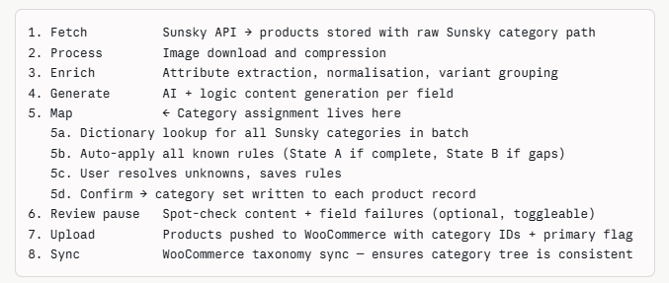

The Map step sits between Generate and Upload deliberately. Content generation does not depend on category assignment, so those two steps can run in any order — but Map must complete before Upload because the Upload API call needs the WooCommerce category IDs.

