Attribute mapping (attribute rule)

Summary
- Inventory field mapping (weight + dimensions → WooCommerce shipping fields)
- Global default attribute rules page
- AI extraction rules page
- Per-pipeline Map step showing predefined rules with editing
- WooCommerce as the source of truth for attributes, loaded dynamically
- Three-panel structure in the Map step: auto-applied defaults / unset / overrides — makes the user's job at the Map step immediately clear
- Value selector constrained to WooCommerce terms only — prevents bad data reaching WooCommerce
- Override badge and "Reset to default" action — makes exceptions visible and reversible
- Per-product navigation (Previous / Next) at the Map step — because only products with unset attributes surface here, not all 50+

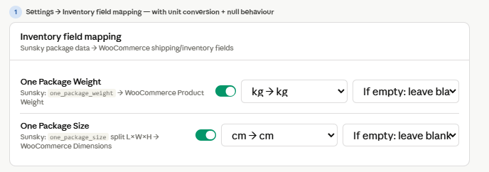
Screen 1 — Inventory mapping has a unit conversion dropdown (kg/lbs, cm/inches) and a null behaviour selector per field (leave blank / flag for review / use default). These are the two practical options the dev needs to implement.

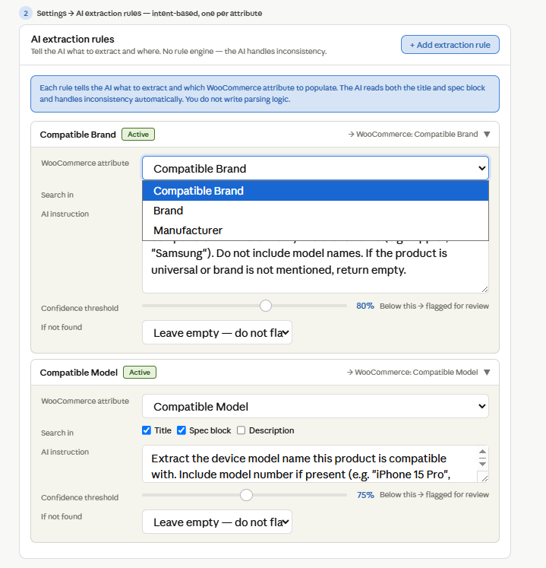
Screen 2 — AI extraction rules replaces the rule engine concept entirely. Each attribute gets one card with: which WooCommerce attribute to populate, which source fields to read, a natural language instruction for the AI, a confidence threshold slider, and a "if not found" behaviour. The instruction field is the key — this is where you write intent, not parsing logic. Try the slider — the threshold you set determines whether the AI's result is auto-accepted or flagged amber for human review at the Map step.

AI extraction with per-attribute configuration — not rules, but intent declarations. You tell the AI what each attribute means and where to look. The AI handles the inconsistency. Here is the difference:
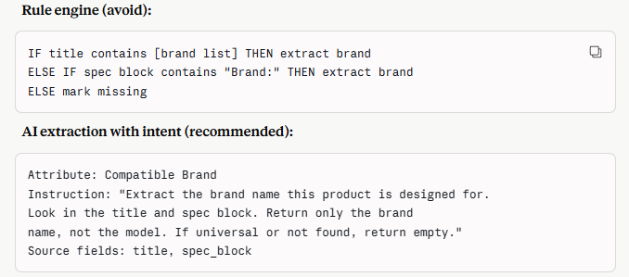
The AI reads the instruction, applies it intelligently across both title and spec block, handles the "universal product" case naturally, and returns a confidence score. You write one instruction per attribute, not a branching rule tree. This is maintainable at 6–15 attributes. A rule engine at that scale is not.
What is configurable per attribute:
- The natural language instruction for the AI
- Which source fields to search (title / spec block / both)
- Whether empty result is acceptable or flags for manual review
- Confidence threshold — below this, the result is flagged for human confirmation

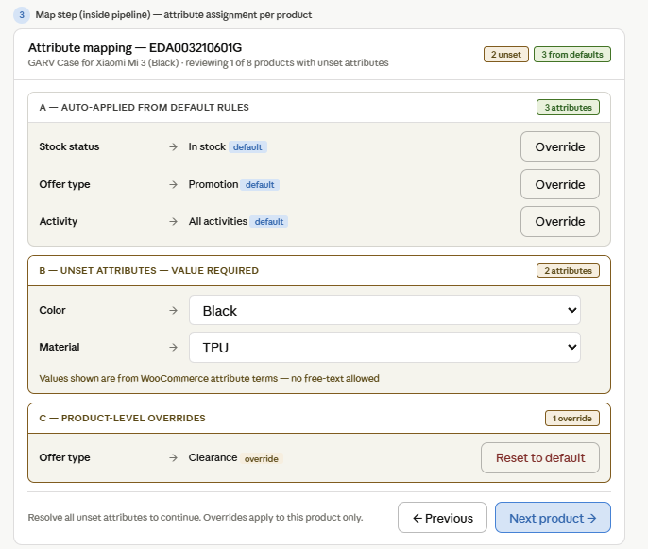
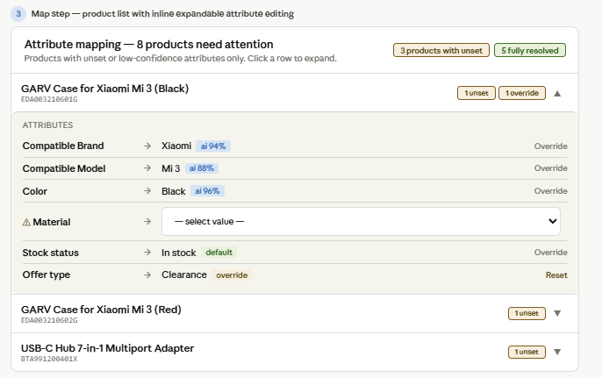
Where are Panel B attributes managed
Panel B shows attributes that belong to the product's attribute profile (assigned at the Map step) but have no value yet from any source. So the question of what appears in Panel B is answered by: which profile is assigned to this product.
You manage that in two places:
Settings → Attribute profiles — where you define which attributes belong to each profile. If "Compatible Brand" is in the Mobile Phone profile, every product with that profile will show it in Panel B if no value was extracted.
The Map step — where you assign a profile to a Sunsky category. That assignment determines which attributes every product in that category is expected to have.
UI
The right pattern is an inline expandable row in the product list. The user clicks a product row, it expands below showing only Panel B attributes — the ones that need values. They fill them in inline and collapse. No page navigation, no modal. Fast, scannable, recoverable.
The role of Panel C (product-level overrides)
Your default rule says: Offer type → Promotion for all products.
You run a pipeline with 50 products. 48 get Promotion from the default. But 2 products are clearance items — they need Offer type → Clearance specifically.
Panel C is where those 2 products show their exception. It answers the question: "what is different about this product compared to the defaults?" Panel C surfaces the diff automatically.
In practice Panel C is often empty — most products match their defaults. It only appears and shows entries when a product has been deliberately changed away from a default value. Its purpose is visibility, not data entry.

Map step product list shows only products that need attention — unset attributes or low-confidence extractions. Each row is expandable inline. No separate window, no navigation. The amber ⚠ icon on an attribute name means it is unset and requires a value before the product can proceed to upload. The source badges show where each value came from: ai 94% means AI extracted it with high confidence, default means it came from the global default rules, override means it was manually changed away from a default.

