Problem 1 — Extraction. Sunsky data is inconsistent. Some products have a spec block, some don't. You can't write one rule that reliably extracts "Color: Black" from all products.
Problem 2 — Normalisation. Even when you extract a value, Sunsky might say "black", "Black Color", "Noir", or "BK" for the same thing. WooCommerce needs a clean controlled value.
Problem 3 — Grouping. "GARV Case Black" and "GARV Case Red" are two Sunsky SKUs that need to become one WooCommerce variable product with two variations. You currently do this manually by eye.
Any system that tries to solve all three automatically will fail on edge cases constantly and create more work than it saves. The right approach is to be honest about what can be automated and what cannot, and design the UI around human judgment for the parts that can't.

My proposal: AI-assisted extraction + human confirmation
The pipeline gains one new step called Enrich, sitting between Process and Generate content. It has three substeps handled in sequence.

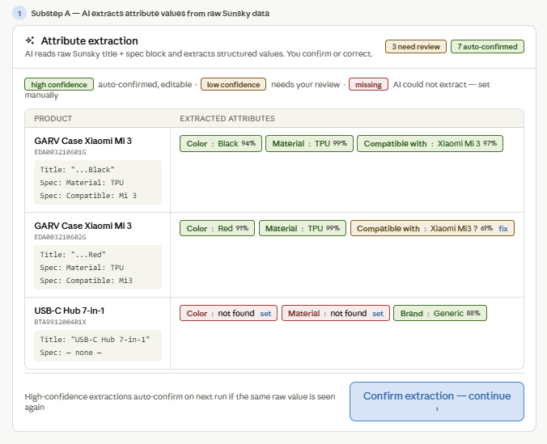
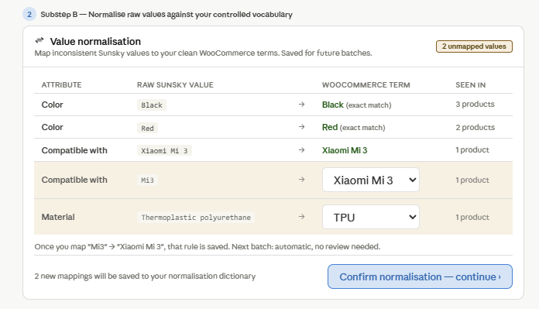
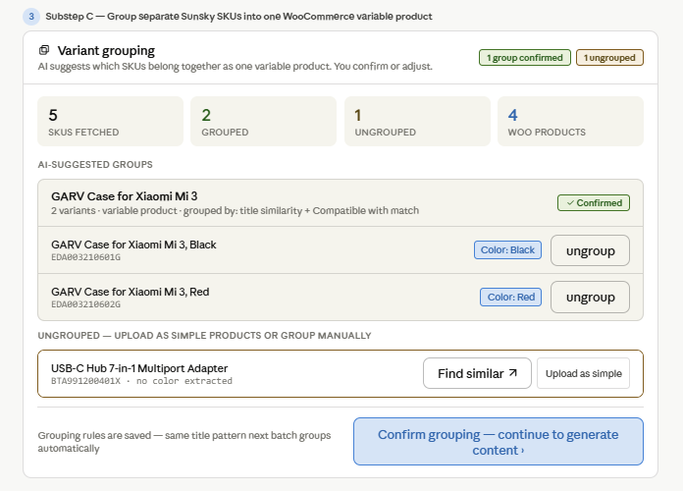

Substep A — AI extraction
The AI reads two sources per product simultaneously: the title and the spec block (when it exists). It outputs a confidence score per extracted value. High confidence (above ~85%) means the extraction is auto-confirmed and shown in green — the user can still edit it but doesn't have to. Low confidence means the AI is uncertain and flags the value in amber for review. Missing means the AI found nothing and shows a red "set" link for manual entry.
The confidence threshold is configurable in Settings. The reason this works better than writing extraction rules is that the AI handles the inconsistency naturally — it reads "...Black" in a title the same way it reads "Color: Black" in a spec block. You don't need separate rules for separate formats.
Substep B — Normalisation dictionary
Every raw Sunsky value that the AI extracts gets checked against your normalisation dictionary — a saved list of raw value → WooCommerce term mappings. "Black" → "Black" is an exact match, no action needed. "Mi3" → "Xiaomi Mi 3" is a mapping you set once and it is saved permanently. Next batch: "Mi3" is resolved automatically without appearing in the review list at all.
This is how the system gets faster over time. The first batch of a new product type requires the most normalisation work. By the fifth batch, most values have been seen before and the review list is nearly empty.
Substep C — Variant grouping
The AI suggests groups based on title similarity and matching attribute values (same "Compatible with" value is a strong grouping signal). You see the suggested groups, confirm them, and can ungroup or manually merge. Confirmed grouping patterns are saved — "GARV Case for Xiaomi Mi 3, {Color}" is remembered as a pattern, so next batch any title matching that pattern is auto-grouped.
The ungrouped product (USB-C Hub with no color) gets two options: "Find similar" searches other fetched SKUs for potential matches, and "Upload as simple" uploads it as a standard non-variable WooCommerce product. Both are valid choices depending on the product.

Where do you set attribute values? In Substep A you confirm what the AI extracted. In Substep B you normalise them to clean WooCommerce terms. By the time a product reaches Upload, its attribute values are already confirmed, clean, and linked.
How does "GARV Case Black" link to Color: Black in WooCommerce? Substep C groups the Black and Red SKUs into one variable product. Each SKU becomes one variation. The variation attribute is Color, the values are Black and Red. WooCommerce receives one variable product with two variations, each linked to its color value. The Upload step handles the WooCommerce API call structure — variable product + variation objects — based on the group definition produced in Substep C.

