The complete flow — no CSV, empty WooCommerce

Fetch → Process → Generate content → [MAP STEP] → Upload → Sync

The mapping step is the new piece. Here is what happens at each stage:

Stage 1 — Fetch (what gets stored)
You select Sunsky category "Mobile > Mobile Phones" and fetch 5 products. Pipeline Pro stores for each product exactly what Sunsky returns:
- Sunsky category: Mobile > Mobile Phones

No WooCommerce category yet — this field is blank

Stage 2 — The new Map step (between Generate content and Upload)
This is where two things happen before anything touches WooCommerce:
A — Category mapping You see which Sunsky categories appeared in this batch and you assign a WooCommerce category to each. Pipeline Pro will create the Woo category if it doesn't exist yet.
The allowed-list is configured once in Settings and reused across all batches — but you can still see and adjust it from within the map step.

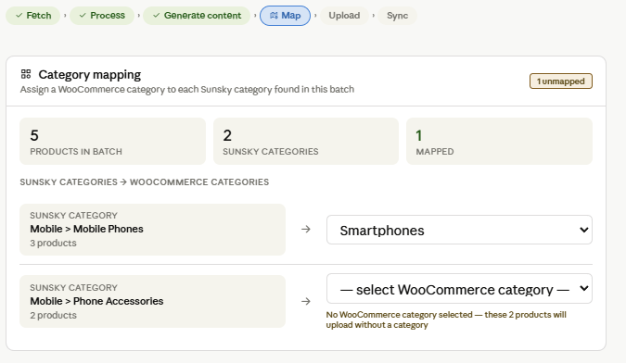

Category mapping panel
Pipeline Pro looks at all 5 fetched products and finds 2 distinct Sunsky categories in this batch: "Mobile > Mobile Phones" (3 products) and "Mobile > Phone Accessories" (2 products). It groups them and shows one mapping row per unique Sunsky category — not one per product. This is the key design decision: you map 2 categories instead of 5 products.
The WooCommerce category dropdown is populated from whatever categories already exist in WooCommerce from previous syncs. If none exist yet (first ever run), the dropdown only contains "+ Create new category…". Selecting that option shows a text input and a hint: "Will be created in WooCommerce on upload." The category gets created during the Upload step, not during Map — so if you cancel before confirming, nothing is created in WooCommerce.
If you leave a Sunsky category unmapped, a warning shows: "these 2 products will upload without a category." The Confirm button still works — unmapped is allowed, not blocked, because sometimes you genuinely don't want a WooCommerce category on certain products.

