Problem Statement:

Created an Android application to perform daily tasks of cataloging. Features include adding items along with their price and stock availability, updating existing items in the database, and also deleting the items that are not required. Items in the database can also be viewed.

Input and Output Diagram

Delete

Enter name: Enter email:___

Enter Course:

Enter Fee:

delete Courses

Select Courses

Item id 1: Item name 2: Item qty 1: Item type 1:

Item id 2: Item name 2: Item qty 2: Item type 2:

and so on ……

insert

Enter name:

Enter email:___

Enter Course:

Enter Fee:

Insert Courses

Course Registration

Application

View item

Select item

Update

Enter name: Enter email:___

Enter Course:

Enter Fee:

Enter Fee: d

Update Courses

Update item

Delete item

Insert item

View Courses

course id 1: : course name 2: Item qty 1: Item type 1:

email 3._______

course 4.____

course fee 5._______

activity_main.xml:

<?xml version="1.0" encoding="utf-8"?>

<androidx.constraintlayout.widget.ConstraintLayout xmlns:android="http://schemas.android.com/apk/res/android"

xmlns:app="http://schemas.android.com/apk/res-auto"

xmlns:tools="http://schemas.android.com/tools"

android:layout_width="match_parent"

android:layout_height="match_parent"

tools:context=".EditActivity">

<TextView

android:id="@+id/title"

android:layout_width="264dp"

android:layout_height="38dp"

android:layout_marginTop="124dp"

android:background="#6EE1AF"

android:text="@string/title"

android:textColor="#640AF6"

android:textSize="28sp"

android:textStyle="bold"

app:layout_constraintEnd_toEndOf="parent"

app:layout_constraintHorizontal_bias="0.387"

app:layout_constraintStart_toStartOf="parent"

app:layout_constraintTop_toTopOf="parent" />

<Button

android:id="@+id/btn_edit"

android:layout_width="190dp"

android:layout_height="55dp"

android:layout_marginTop="584dp"

android:text="@string/edit"

android:textAlignment="center"

android:textColor="#FFE500"

android:textColorHighlight="#912323"

app:layout_constraintEnd_toEndOf="parent"

app:layout_constraintStart_toStartOf="parent"

app:layout_constraintTop_toTopOf="parent" />

<Button

android:id="@+id/btn_delete"

android:layout_width="190dp"

android:layout_height="55dp"

android:layout_marginTop="636dp"

android:layout_marginEnd="108dp"

android:text="@string/delete"

android:textAlignment="center"

android:textColor="#FFE500"

android:textColorHighlight="#912323"

app:layout_constraintEnd_toEndOf="parent"

app:layout_constraintTop_toTopOf="parent" />

<Button

android:id="@+id/btn_back"

android:layout_width="190dp"

android:layout_height="55dp"

android:layout_marginTop="688dp"

android:layout_marginEnd="108dp"

android:text="@string/back"

android:textAlignment="center"

android:textColor="#FFE500"

android:textColorHighlight="#912323"

app:layout_constraintEnd_toEndOf="parent"

app:layout_constraintTop_toTopOf="parent" />

<EditText

android:id="@+id/id"

android:layout_width="wrap_content"

android:layout_height="wrap_content"

android:layout_marginTop="200dp"

android:layout_marginEnd="44dp"

android:ems="10"

android:inputType="textPersonName"

app:layout_constraintEnd_toEndOf="parent"

app:layout_constraintTop_toTopOf="parent" />

<EditText

android:id="@+id/name1"

android:layout_width="wrap_content"

android:layout_height="wrap_content"

android:layout_marginTop="275dp"

android:layout_marginEnd="44dp"

android:ems="10"

android:inputType="textPersonName"

app:layout_constraintEnd_toEndOf="parent"

app:layout_constraintTop_toTopOf="parent" />

<EditText

android:id="@+id/email1"

android:layout_width="wrap_content"

android:layout_height="wrap_content"

android:layout_marginTop="350dp"

android:layout_marginEnd="44dp"

android:ems="10"

android:inputType="textPersonName"

app:layout_constraintEnd_toEndOf="parent"

app:layout_constraintTop_toTopOf="parent" />

<EditText

android:id="@+id/course1"

android:layout_width="wrap_content"

android:layout_height="wrap_content"

android:layout_marginTop="425dp"

android:layout_marginEnd="44dp"

android:ems="10"

android:inputType="textPersonName"

app:layout_constraintEnd_toEndOf="parent"

app:layout_constraintTop_toTopOf="parent" />

<EditText

android:id="@+id/fee1"

android:layout_width="wrap_content"

android:layout_height="wrap_content"

android:layout_marginTop="500dp"

android:layout_marginEnd="44dp"

android:ems="10"

android:inputType="textPersonName"

app:layout_constraintEnd_toEndOf="parent"

app:layout_constraintTop_toTopOf="parent" />

<TextView

android:id="@+id/textView5"

android:layout_width="80dp"

android:layout_height="40dp"

android:layout_marginStart="24dp"

android:layout_marginTop="200dp"

android:background="#FFFFFF"

android:text="@string/id"

android:textAllCaps="true"

android:textColor="#F60303"

android:textSize="20sp"

android:textStyle="bold"

app:layout_constraintStart_toStartOf="parent"

app:layout_constraintTop_toTopOf="parent" />

<TextView

android:id="@+id/textView"

android:layout_width="80dp"

android:layout_height="40dp"

android:layout_marginStart="24dp"

android:layout_marginTop="275dp"

android:background="#FFFFFF"

android:text="@string/name"

android:textAllCaps="true"

android:textColor="#F60303"

android:textSize="20sp"

android:textStyle="bold"

app:layout_constraintStart_toStartOf="parent"

app:layout_constraintTop_toTopOf="parent" />

<TextView

android:id="@+id/textView4"

android:layout_width="81dp"

android:layout_height="40dp"

android:layout_marginStart="24dp"

android:layout_marginTop="350dp"

android:background="#FFFFFF"

android:text="@string/email"

android:textAllCaps="true"

android:textColor="#F60303"

android:textSize="20sp"

android:textStyle="bold"

app:layout_constraintStart_toStartOf="parent"

app:layout_constraintTop_toTopOf="parent" />

<TextView

android:id="@+id/textView2"

android:layout_width="80dp"

android:layout_height="40dp"

android:layout_marginStart="24dp"

android:layout_marginTop="425dp"

android:text="@string/courses"

android:textAllCaps="true"

android:textColor="#FF0000"

android:textSize="20sp"

android:textStyle="bold"

app:layout_constraintStart_toStartOf="parent"

app:layout_constraintTop_toTopOf="parent" />

<TextView

android:id="@+id/textView3"

android:layout_width="80dp"

android:layout_height="40dp"

android:layout_marginStart="24dp"

android:layout_marginTop="500dp"

android:text="@string/fee"

android:textColor="#FA0202"

android:textSize="20sp"

android:textStyle="bold"

app:layout_constraintStart_toStartOf="parent"

app:layout_constraintTop_toTopOf="parent" />

<ImageView

android:id="@+id/imageView"

android:layout_width="180dp"

android:layout_height="119dp"

android:layout_marginTop="8dp"

android:layout_marginEnd="124dp"

android:baselineAlignBottom="false"

android:textAlignment="center"

app:layout_constraintEnd_toEndOf="parent"

app:layout_constraintTop_toTopOf="parent"

app:srcCompat="@drawable/img" />

</androidx.constraintlayout.widget.ConstraintLayout>

activity_view.xml:

<?xml version="1.0" encoding="utf-8"?>

<androidx.appcompat.widget.LinearLayoutCompat xmlns:android="http://schemas.android.com/apk/res/android"

xmlns:app="http://schemas.android.com/apk/res-auto"

xmlns:tools="http://schemas.android.com/tools"

android:layout_width="match_parent"

android:layout_height="match_parent"

tools:context=".viewActivity">

<ListView

android:id="@+id/lst"

android:layout_width="match_parent"

android:layout_height="match_parent"

/>

</androidx.appcompat.widget.LinearLayoutCompat>

activity_edit.xml:

<?xml version="1.0" encoding="utf-8"?>

<androidx.constraintlayout.widget.ConstraintLayout xmlns:android="http://schemas.android.com/apk/res/android"

xmlns:app="http://schemas.android.com/apk/res-auto"

xmlns:tools="http://schemas.android.com/tools"

android:layout_width="match_parent"

android:layout_height="match_parent"

android:orientation="vertical"

android:gravity="center"

tools:context=".MainActivity">

<TextView

android:id="@+id/title"

android:layout_width="264dp"

android:layout_height="38dp"

android:layout_marginTop="200dp"

android:background="#6EE1AF"

android:text="@string/title"

android:textColor="#640AF6"

android:textSize="28sp"

android:textStyle="bold"

app:layout_constraintEnd_toEndOf="parent"

app:layout_constraintHorizontal_bias="0.387"

app:layout_constraintStart_toStartOf="parent"

app:layout_constraintTop_toTopOf="parent" />

<Button

android:id="@+id/btn_add"

android:layout_width="190dp"

android:layout_height="55dp"

android:layout_marginTop="584dp"

android:layout_marginEnd="128dp"

android:text="@string/add"

android:textAlignment="center"

android:textColor="#FFE500"

android:textColorHighlight="#912323"

app:layout_constraintEnd_toEndOf="parent"

app:layout_constraintTop_toTopOf="parent" />

<Button

android:id="@+id/btn_view"

android:layout_width="190dp"

android:layout_height="55dp"

android:layout_marginTop="636dp"

android:layout_marginEnd="128dp"

android:text="@string/view"

android:textAlignment="center"

android:textColor="#FFE500"

android:textColorHighlight="#912323"

app:layout_constraintEnd_toEndOf="parent"

app:layout_constraintTop_toTopOf="parent" />

<EditText

android:id="@+id/name"

android:layout_width="wrap_content"

android:layout_height="wrap_content"

android:layout_marginTop="275dp"

android:layout_marginEnd="44dp"

android:ems="10"

android:inputType="textPersonName"

app:layout_constraintEnd_toEndOf="parent"

app:layout_constraintTop_toTopOf="parent" />

<EditText

android:id="@+id/email"

android:layout_width="wrap_content"

android:layout_height="wrap_content"

android:layout_marginTop="350dp"

android:layout_marginEnd="44dp"

android:ems="10"

android:inputType="textPersonName"

app:layout_constraintEnd_toEndOf="parent"

app:layout_constraintTop_toTopOf="parent" />

<EditText

android:id="@+id/course"

android:layout_width="wrap_content"

android:layout_height="wrap_content"

android:layout_marginTop="425dp"

android:layout_marginEnd="44dp"

android:ems="10"

android:inputType="textPersonName"

app:layout_constraintEnd_toEndOf="parent"

app:layout_constraintTop_toTopOf="parent" />

<EditText

android:id="@+id/fee"

android:layout_width="wrap_content"

android:layout_height="wrap_content"

android:layout_marginTop="500dp"

android:layout_marginEnd="44dp"

android:ems="10"

android:inputType="textPersonName"

app:layout_constraintEnd_toEndOf="parent"

app:layout_constraintTop_toTopOf="parent" />

<TextView

android:id="@+id/textView"

android:layout_width="80dp"

android:layout_height="40dp"

android:layout_marginStart="24dp"

android:layout_marginTop="275dp"

android:background="#FFFFFF"

android:text="@string/name"

android:textAllCaps="true"

android:textColor="#F60303"

android:textSize="20sp"

android:textStyle="bold"

app:layout_constraintStart_toStartOf="parent"

app:layout_constraintTop_toTopOf="parent" />

<TextView

android:id="@+id/textView4"

android:layout_width="81dp"

android:layout_height="40dp"

android:layout_marginStart="24dp"

android:layout_marginTop="350dp"

android:background="#FFFFFF"

android:text="@string/email"

android:textAllCaps="true"

android:textColor="#F60303"

android:textSize="20sp"

android:textStyle="bold"

app:layout_constraintStart_toStartOf="parent"

app:layout_constraintTop_toTopOf="parent" />

<TextView

android:id="@+id/textView2"

android:layout_width="80dp"

android:layout_height="40dp"

android:layout_marginStart="24dp"

android:layout_marginTop="425dp"

android:text="@string/courses"

android:textAllCaps="true"

android:textColor="#FF0000"

android:textSize="20sp"

android:textStyle="bold"

app:layout_constraintStart_toStartOf="parent"

app:layout_constraintTop_toTopOf="parent" />

<TextView

android:id="@+id/textView3"

android:layout_width="80dp"

android:layout_height="40dp"

android:layout_marginStart="24dp"

android:layout_marginTop="500dp"

android:text="@string/fee"

android:textColor="#FA0202"

android:textSize="20sp"

android:textStyle="bold"

app:layout_constraintStart_toStartOf="parent"

app:layout_constraintTop_toTopOf="parent" />

<ImageView

android:id="@+id/imageView2"

android:layout_width="187dp"

android:layout_height="150dp"

android:layout_marginTop="24dp"

android:layout_marginEnd="128dp"

app:layout_constraintEnd_toEndOf="parent"

app:layout_constraintTop_toTopOf="parent"

app:srcCompat="@drawable/img" />

</androidx.constraintlayout.widget.ConstraintLayout>

MainActivity.java:

package com.example.courseregistration;

import androidx.appcompat.app.AppCompatActivity;

import android.content.Context;

import android.content.Intent;

import android.database.sqlite.SQLiteDatabase;

import android.database.sqlite.SQLiteStatement;

import android.os.Bundle;

import android.view.View;

import android.widget.Button;

import android.widget.EditText;

import android.widget.Toast;

public class MainActivity extends AppCompatActivity {

Button btn_add, btn_view;

EditText name, course,email, fee;

@Override

protected void onCreate(Bundle savedInstanceState) {

super.onCreate(savedInstanceState);

setContentView(R.layout.activity_main);

btn_add = findViewById(R.id.btn_add);

btn_view = findViewById(R.id.btn_view);

name=findViewById(R.id.name);

email=findViewById(R.id.email);

course=findViewById(R.id.course);

fee=findViewById(R.id.fee);

btn_view.setOnClickListener(new View.OnClickListener() {

@Override

public void onClick(View v)

{

Intent i = new Intent(getApplicationContext(),viewActivity.class);

startActivity(i);

}

});

btn_add.setOnClickListener(new View.OnClickListener() {

@Override

public void onClick(View v) {

insert();

}

});

}

public void onClick(View v) {

insert();

if (v.equals(btn_add)) {

Intent it = new Intent(this, viewActivity.class);

startActivity(it);

}

if (v.equals(btn_view)) {

Intent it = new Intent(this, viewActivity.class);

startActivity(it);

}

}

// insert operation of data

public void insert(){

try {

String n= name.getText().toString();

String e=email.getText().toString();

String c=course.getText().toString();

String f=fee.getText().toString();

// creating database

SQLiteDatabase db= openOrCreateDatabase("CourseDb", Context.MODE_PRIVATE,null);

db.execSQL("CREATE TABLE IF NOT EXISTS records(id INTEGER PRIMARY KEY AUTOINCREMENT,name VARCHAR,email VARCHAR,course VARCHAR,fee VARCHAR)");

String sql = "insert into records(name,email,course,fee)values(?,?,?,?)";

SQLiteStatement statement = db.compileStatement(sql);

statement.bindString(1,n);

statement.bindString(2,e);

statement.bindString(3,c);

statement.bindString(4,f);

statement.execute();

Toast.makeText(this,"Record Added Successfully",Toast.LENGTH_LONG).show();

name.setText("");

email.setText("");

course.setText("");

fee.setText("");

name.requestFocus();

}catch (Exception e ){

}

}

}

viewActivity.java:

package com.example.courseregistration;

import androidx.appcompat.app.AppCompatActivity;

import android.content.Context;

import android.content.Intent;

import android.database.Cursor;

import android.database.sqlite.SQLiteDatabase;

import android.os.Bundle;

import android.view.View;

import android.widget.AdapterView;

import android.widget.ArrayAdapter;

import android.widget.Button;

import android.widget.EditText;

import android.widget.ListView;

import java.util.ArrayList;

public class viewActivity extends AppCompatActivity {

ListView lst;

ArrayList<String> titles = new ArrayList<String>();

ArrayAdapter arrayAdapter;

@Override

protected void onCreate(Bundle savedInstanceState) {

super.onCreate(savedInstanceState);

setContentView(R.layout.activity_view);

// creation of database

SQLiteDatabase db = openOrCreateDatabase("CourseDb", Context.MODE_PRIVATE,null);

lst = findViewById(R.id.lst);

final Cursor c = db.rawQuery("select * from records",null);

int id = c.getColumnIndex("id");

int name = c.getColumnIndex("name");

int email =c.getColumnIndex("email");

int course = c.getColumnIndex("course");

int fee = c.getColumnIndex("fee");

titles.clear();

arrayAdapter=newArrayAdapter(this, androidx.appcompat.R.layout.support_simple_spinner_dropdown_item,titles);

lst.setAdapter(arrayAdapter);

final ArrayList<student> stud = new ArrayList<student>();

if(c.moveToFirst())

{

do{

student stu = new student();

stu.id = c.getString(id);

stu.name = c.getString(name);

stu.email=c.getString(email);

stu.course = c.getString(course);

stu.fee = c.getString(fee);

stud.add(stu);

titles.add(c.getString(id) + " \t " + c.getString(name) +" \t " + c.getString(email) + " \t " + c.getString(course) + " \t " + c.getString(fee) );

} while(c.moveToNext());

arrayAdapter.notifyDataSetChanged();

lst.invalidateViews();

}

lst.setOnItemClickListener(new AdapterView.OnItemClickListener() {

@Override

public void onItemClick(AdapterView<?> parent, View view, int position, long id) {

String aa = titles.get(position).toString();

student stu = stud.get(position);

Intent i = new Intent(getApplicationContext(),EditActivity.class);

i.putExtra("id",stu.id);

i.putExtra("name",stu.name);

i.putExtra("email",stu.email);

i.putExtra("course",stu.course);

i.putExtra("fee",stu.fee);

startActivity(i);

}

});

}

}

student.java:

package com.example.courseregistration;

public class student {

String id;

String name;

String email;

String course;

String fee;

String title;

public student (String id, String name, String email,String course,String fee, String title) {

this.id = id;

this.name = name;

this.email = email;

this.course=course;

this.fee=fee;

this.title=title;

}

public student() {

}

public void setId(String id) {

this.id = id;

}

public String getId() {

return id;

}

public void setName(String name) {

this.name = name;

}

public String getName() {

return name;

}

public void setEmail(String email) {

this.email = email;

}

public String getEmail() {

return email;

}

public void setCourse(String course) {

this.course = course;

}

public String getCourse() {

return course;

}

public void setFee(String fee) {

this.fee = fee;

}

public String getFee() {

return fee;

}

public void setTitle(String title) {

this.title = title;

}

public String getTitle() {

return title;

}

}

EditActivity.java:

package com.example.courseregistration;

import androidx.appcompat.app.AppCompatActivity;

import android.content.Context;

import android.content.Intent;

import android.database.sqlite.SQLiteDatabase;

import android.database.sqlite.SQLiteStatement;

import android.os.Bundle;

import android.view.View;

import android.widget.Button;

import android.widget.EditText;

import android.widget.Toast;

public class EditActivity extends AppCompatActivity {

Button btn_delete, btn_edit,btn_back;

EditText id,name1, course1,email1, fee1;

@Override

protected void onCreate(Bundle savedInstanceState) {

super.onCreate(savedInstanceState);

setContentView(R.layout.activity_edit);

btn_delete = findViewById(R.id.btn_delete);

btn_edit = findViewById(R.id.btn_edit);

btn_back = findViewById(R.id.btn_back);

id = findViewById(R.id.id);

name1 = findViewById(R.id.name1);

email1 = findViewById(R.id.email1);

course1 = findViewById(R.id.course1);

fee1 = findViewById(R.id.fee1);

Intent i = getIntent();

String t1=i.getStringExtra("id").toString();

String t2 =i.getStringExtra("name").toString();

String t3 = i.getStringExtra("email").toString();

String t4 = i.getStringExtra("course").toString();

String t5 = i.getStringExtra("fee").toString();

id.setText(t1);

name1.setText(t2);

email1.setText(t3);

course1.setText(t4);

fee1.setText(t5);

btn_delete.setOnClickListener(new View.OnClickListener() {

@Override

public void onClick(View v) {

Delete();

}

});

btn_back.setOnClickListener(new View.OnClickListener() {

@Override

public void onClick(View v) {

Intent i = new Intent(getApplicationContext(),viewActivity.class);

startActivity(i);

}

});

btn_edit.setOnClickListener(new View.OnClickListener() {

@Override

public void onClick(View v) {

Edit();

}

});

}

// delete the data

public void Delete()

{

try

{

String id1 = id.getText().toString();

// creating databases

SQLiteDatabase db = openOrCreateDatabase("CourseDb", Context.MODE_PRIVATE,null);

String sql = "delete from records where id = ?";

SQLiteStatement statement = db.compileStatement(sql);

statement.bindString(1,id1);

statement.execute();

Toast.makeText(this,"Record Deleted",Toast.LENGTH_LONG).show();

name1.setText("");

email1.setText("");

course1.setText("");

fee1.setText("");

name1.requestFocus();

}

catch (Exception e)

{

Toast.makeText(this,"Record Fail",Toast.LENGTH_LONG).show();

}

}

public void Edit()

{

try

{

String n= name1.getText().toString();

String e=email1.getText().toString();

String c=course1.getText().toString();

String f=fee1.getText().toString();

String i=id.getText().toString();

SQLiteDatabase db = openOrCreateDatabase("CourseDb",Context.MODE_PRIVATE,null);

String sql = "update records set name = ?,email = ?,course=?,fee=? where id= ?";

SQLiteStatement statement = db.compileStatement(sql);

statement.bindString(1,n);

statement.bindString(2,e);

statement.bindString(3,c);

statement.bindString(4,f);

statement.bindString(5,i);

statement.execute();

Toast.makeText(this,"Record Updated Successfully ",Toast.LENGTH_LONG).show();

name1.setText("");

email1.setText("");

course1.setText("");

fee1.setText("");

name1.requestFocus();

}

catch (Exception e)

{

Toast.makeText(this,"Record Fail",Toast.LENGTH_LONG).show();

}

}

}

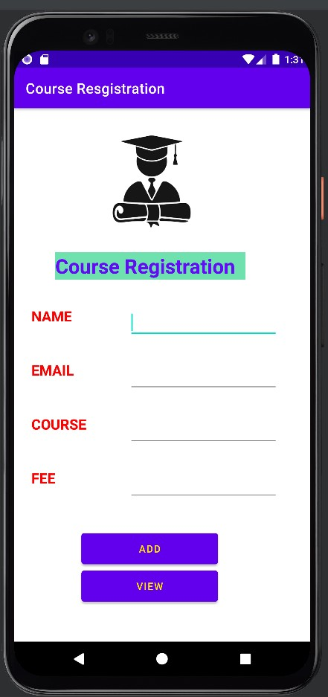

Taking Courses:

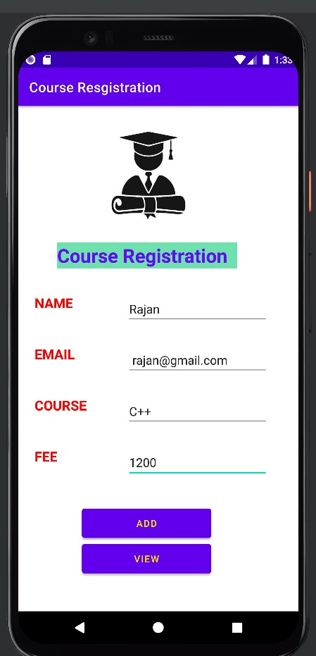

List of Courses Taken by Student:

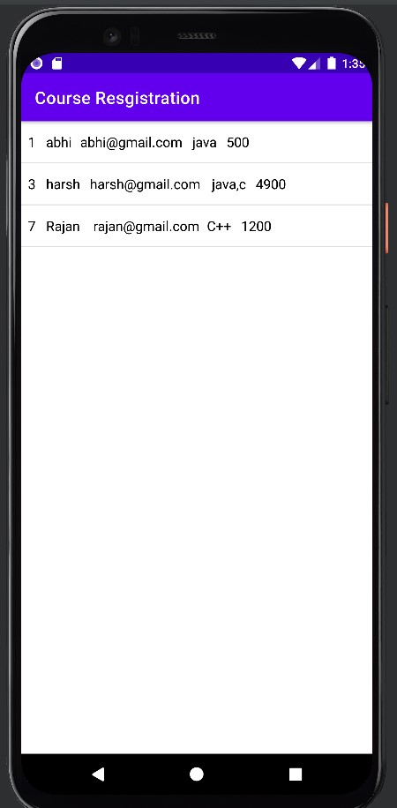

Update Courses by Student:

\

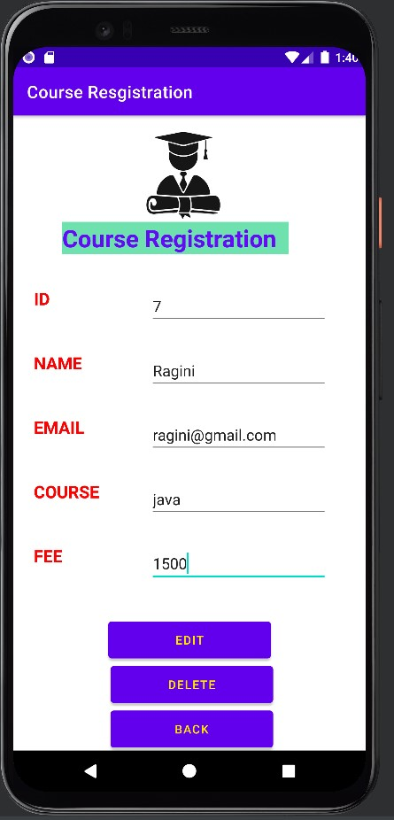

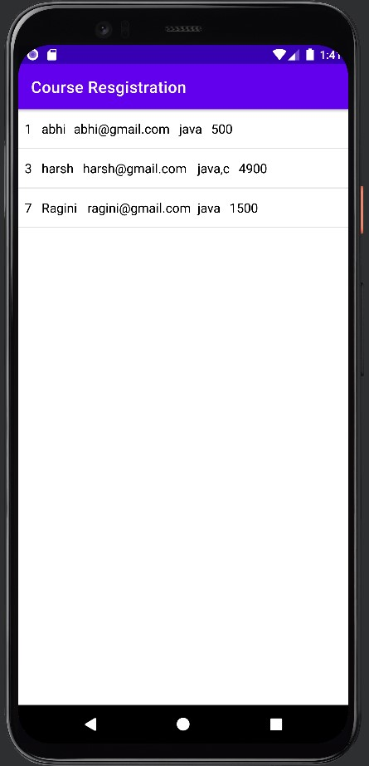

Deleted Courses by Student:



