**Visveswaraya Technological University**

**Belagavi – 590018, Karnataka**

A Mini Project Report on

**“Python Handcricket Game”**

Project Report submitted in partial fulfilment of the requirement for Application Development using Python [18CS55]

**Bachelor of Engineering**

**In**

**Computer Science and Engineering**

**Submitted By**

**Aditya Krishnan**

**1JT19CS004**

**Abhishek Kumar**

**1JT19CS002**

**Department of Computer Science and Engineering**

**Accredited by NBA, New Delhi**

**Jyothy Institute of Technology,**

**Tataguni, Bengaluru – 560082**

**ACKNOWLEDGEMENT**

Firstly, we are very grateful to this esteemed institution **“Jyothy Institute of Technology”** for providing us an opportunity to complete our mini project.

We express our sincere thanks to our **Principal Dr. Gopalakrishna K** for providing us with adequate facilities to undertake this mini project.

We would like to thank **Dr. Prabhanjan S**, **Professor and Head of Computer Science and Engineering Department** for providing for his valuable support.

We would like to thank our guides **Mr. Saravana MK, Assistant Professor** for their keen interest and guidance in preparing this mini project.

Finally, we would thank all our friends who have helped us directly or indirectly in this mini project.

**Aditya Krishnan [1JT19CS004]**

**Abhishek Kumar [1JT19CS002]**

**ABSTRACT**

The aim of this mini project is to play the “Handcricket” game against a computer as opponent. The game starts off with a toss, and the player can either choose heads or tails. If he chooses correctly, he can choose whether to bat or bowl first, otherwise the computer will pick one at random. After the toss has concluded, the player plays either batting or bowling, according to the choice. He selects a number from 1 to 6, and the computer does the same. If both the numbers are the same, the batsman is out. Then they swap sides and repeat the procedure. After both teams are out, the team with the higher score wins.

**JYOTHY INSTITUTE OF TECHNOLOGY**

**Department of Computer Science and Engineering**

**Accredited by NBA, New Delhi**

**Jyothy Institute of Technology,**

**Tataguni, Bengaluru – 560082**

**CERTIFICATE**

Certified that the mini project work entitled **“Python Handcricket Game”** carried out by **Aditya Krishnan [1JT19CS004] and Abhishek Kumar [1JT19CS002]** bonafide students of Jyothy Institute of Technology, in partial fulfilment for the award of **Bachelor of Engineering** in **Computer Science and Engineering** department of the **Visvesvaraya Technological University, Belagavi** during the year **2021-2022**. It is certified that all corrections/suggestions indicated for Internal Assessment have been incorporated in the Report deposited in the departmental library. The mini project report has been approved as it satisfies the academic requirements in respect of Project work prescribed for the said Degree

|  |  |  |
| --- | --- | --- |
| Signature of Guide |  | Signature of HoD |
| ........................................... |  | ................................ |
| **Mr. Saravana M. K** |  | **Dr. Prabhanjan. S.** |
| Assistant Professor |  | Prof & Head of Dept - CSE |
| Dept of CSE |  | JIT, Bengaluru |
| JIT, Bengaluru |  |  |

External Viva

External Viva Examiner Signature with Date:

1.

2.



# JYOTHY INSTITUTE OF TECHNOLOGY

### Department of Computer Science and Engineering Accredited by NBA, New Delhi

### Tataguni, Off. Kanakapura Road,

### Bengaluru - 560 082

# DEPARTMENT VISION AND MISSION

**Vison:**

To be a centre of excellence in Computer Science and Engineering education, focus on research, innovation and entrepreneurial skill development with professional competency.

# Mission:

M1: To provide state of the art ICT infrastructure and innovative, research-oriented teaching-learning environment and motivation for self-learning & problem-solving abilities by recruiting committed faculty.

M2: To encourage Industry Institute Interaction & multi-disciplinary approach for problem-solving and adapt to ever-changing global IT trends.

M3: To imbibe awareness of societal responsibility and leadership qualities with professional competency and ethics.

**TABLE OF CONTENTS**

|  |  |  |
| --- | --- | --- |
| **Sl No** | **Description** | **Page No** |
| 1 | INTRODUCTION | 1 |
| 2 | IMPLEMENTATION | 3 |
| 3 | RESULTS AND SCREENSHOTS | 11 |
| 4 | CONCLUSION | 15 |

**CHAPTER 1**

**INTRODUCTION**

**CHAPTER 1**

**1.1 Introduction to Python**

Python is an object-oriented high-level programming language with dynamic semantics. Its high-level built-in data structures, combined with dynamic typing and dynamic binding; make it very attractive for Rapid Application Development as well as for use as a scripting or glue language to connect existing components together. Python’s simple, easy to learn syntax emphasizes readability and therefore reduces the cost of program maintenance. Python supports modules and packages, which encourages program modularity and code reuse. The Python Interpreter and the extensive standard library are available in source or binary form without charge for all major platforms, and cam be freely distributed

**1.2 Introduction to Tkinter**

The Tkinter package the standard Python interface to the TCL/TK GUI toolkit. Both Tk and Tkinter are available on most Unix platforms, including macOS, as well as on Windows systems. Tkinter provides various controls, such as buttons, labels and text boxes used in a GUI application. These controls are commonly called widgets.

**1.3 Introduction to Handcricket**

Handcricket is a simple game where two players take turns batting and bowling against each other. Here, instead of a second player, we play against a computer. The computer randomly generates choices and compare it with the player choices. The score is tallied as the game goes on and the player with the highest score wins

**1.4 Scope and importance of work**

The scope of the project is to create an entertaining game that allows users to play Handcricket using their computer.

**CHAPTER 2**

**IMPLEMENTATION**

**CHAPTER 2**

**2.1 Modules**

1. **Tkinter:**

Tkinter module is used to create a GUI for the program, allowing user to press buttons to give input.

1. **Random:**

The random module is used to generate random numbers used in the toss and during batting and bowling

**2.2 Functions**

1. **Six():**

This function generates a number between 1 and 6 during batting and bowling for the computer

1. **Two():**

This function generates a number between 1 and 2 during the toss

1. **Bat():**

This function manages all the parts of batting for the player

1. **Bowl():**

This function manages all the parts of bowling for the player

1. **Game():**

This function controls the game, and decides what part of the game will be played next

1. **TossMenu():**

This function is used during the toss, and checks if the player has won or lost the toss

**2.3 SOURCE CODE**

from tkinter import *

import random

#Random Number

def six():

return random.randrange(1,7)

def two():

return random.randrange(0,2)

#Creating window for the game:

window = Tk()

window.title("Handcricket")

window.geometry("640x360")

window.resizable(width=False, height=False)

window.iconbitmap('E:\Github\handcricket\icon.ico')

bgframe = Frame(window)

bgframe.pack(side="top", expand=1)

bgframe.place(x= 0, y= 0)

bgimage = PhotoImage(file = 'E:\Github\handcricket\wallpaper.png')

bgwidget = Label(bgframe, image = bgimage)

bgwidget.pack()

buttonimage = PhotoImage(file = 'E:\Github\handcricket\\button.png')

#Starting Heading

Header = "MENU"

HeaderWidget = Label(window, text = "Handcricket",height = 1, width = 30, bg = 'gray', highlightthickness=2,highlightcolor= 'black')

HeaderWidget.pack(pady=10)

#Heading Change

def Heading(Header):

HeaderWidget.config(text=Header)

#The Game

def Game():

Play.destroy()

Exit.destroy()

result = TossMenu()

#Player won toss or not

if result == 1:

Match(BatBowl())

else:

Match(two())

#Batting

def Bat():

score = 0

rand = 0

choice = IntVar()

Heading("Batting")

ScoreWidget = Label(window, text = "Your Score: "+str(score), height = 1, width = 20,bg = 'gray', highlightthickness=2,highlightcolor= 'black')

PlayerWidget = Label(window, text = "Your Choice: "+str(choice.get()), height = 1, width = 20,bg = 'gray', highlightthickness=2,highlightcolor= 'black')

OpponentWidget = Label(window, text = "Opponent's Choice: "+str(rand), height = 1, width = 20,bg = 'gray', highlightthickness=2,highlightcolor= 'black')

ScoreWidget.pack()

PlayerWidget.pack()

OpponentWidget.pack()

c1 = Button(window, text='1',command=lambda: choice.set(1), height = 20, width = 190, image = buttonimage, compound=CENTER)

c2 = Button(window, text='2',command=lambda: choice.set(2), height = 20, width = 190, image = buttonimage, compound=CENTER)

c3 = Button(window, text='3',command=lambda: choice.set(3), height = 20, width = 190, image = buttonimage, compound=CENTER)

c4 = Button(window, text='4',command=lambda: choice.set(4), height = 20, width = 190, image = buttonimage, compound=CENTER)

c5 = Button(window, text='5',command=lambda: choice.set(5), height = 20, width = 190, image = buttonimage, compound=CENTER)

c6 = Button(window, text='6',command=lambda: choice.set(6), height = 20, width = 190, image = buttonimage, compound=CENTER)

c1.pack()

c2.pack()

c3.pack()

c4.pack()

c5.pack()

c6.pack()

while True:

ScoreWidget.config(text = "Your Score: "+str(score))

window.wait_variable(choice)

rand = six()

if choice.get() == rand:

break

else:

score += choice.get()

PlayerWidget.config(text = "Your Choice: "+str(choice.get()))

OpponentWidget.config(text = "Opponent's Choice: "+str(rand))

ResultWidget = Label(window, text = "You are out", height = 1, width = 20,bg = 'gray', highlightthickness=2,highlightcolor= 'black')

ResultWidget.pack(pady=1)

ContinueButton = Button(window, text='Continue',command=lambda: choice.set(0), height = 20, width = 190, image = buttonimage, compound=CENTER)

ContinueButton.pack(pady=1)

window.wait_variable(choice)

c1.destroy()

c2.destroy()

c3.destroy()

c4.destroy()

c5.destroy()

c6.destroy()

PlayerWidget.destroy()

OpponentWidget.destroy()

ResultWidget.destroy()

ContinueButton.destroy()

return score

#Bowling

def Bowl():

score = 0

rand = 0

choice = IntVar()

Heading("Bowling")

ScoreWidget = Label(window, text = "Computer's Score: "+str(score), height = 1, width = 20,bg = 'gray', highlightthickness=2,highlightcolor= 'black')

PlayerWidget = Label(window, text = "Your Choice: "+str(choice.get()), height = 1, width = 20,bg = 'gray', highlightthickness=2,highlightcolor= 'black')

OpponentWidget = Label(window, text = "Opponent's Choice: "+str(rand), height = 1, width = 20,bg = 'gray', highlightthickness=2,highlightcolor= 'black')

ScoreWidget.pack()

PlayerWidget.pack()

OpponentWidget.pack()

c1 = Button(window, text='1',command=lambda: choice.set(1), height = 20, width = 190, image = buttonimage, compound=CENTER)

c2 = Button(window, text='2',command=lambda: choice.set(2), height = 20, width = 190, image = buttonimage, compound=CENTER)

c3 = Button(window, text='3',command=lambda: choice.set(3), height = 20, width = 190, image = buttonimage, compound=CENTER)

c4 = Button(window, text='4',command=lambda: choice.set(4), height = 20, width = 190, image = buttonimage, compound=CENTER)

c5 = Button(window, text='5',command=lambda: choice.set(5), height = 20, width = 190, image = buttonimage, compound=CENTER)

c6 = Button(window, text='6',command=lambda: choice.set(6), height = 20, width = 190, image = buttonimage, compound=CENTER)

c1.pack()

c2.pack()

c3.pack()

c4.pack()

c5.pack()

c6.pack()

while True:

ScoreWidget.config(text = "Computer's Score: "+str(score))

window.wait_variable(choice)

rand = six()

if choice.get() == rand:

break

else:

score += rand

PlayerWidget.config(text = "Your Choice: "+str(choice.get()))

OpponentWidget.config(text = "Opponent's Choice: "+str(rand))

ResultWidget = Label(window, text = "Computer is out", height = 1, width = 20,bg = 'gray', highlightthickness=2,highlightcolor= 'black')

ResultWidget.pack(pady=1)

ContinueButton = Button(window, text='Continue',command=lambda: choice.set(0), height = 20, width = 190, image = buttonimage, compound=CENTER)

ContinueButton.pack(pady=1)

window.wait_variable(choice)

c1.destroy()

c2.destroy()

c3.destroy()

c4.destroy()

c5.destroy()

c6.destroy()

PlayerWidget.destroy()

OpponentWidget.destroy()

ResultWidget.destroy()

ContinueButton.destroy()

return score

def Match(myplay):

playerscore = 0

opponentscore = 0

if myplay == 0:

playerscore = Bat()

opponentscore = Bowl()

else:

opponentscore = Bowl()

playerscore = Bat()

Heading("Game Over")

if playerscore == opponentscore:

ResultWidget = Label(window, text = "Draw!", height = 1, width = 20,bg = 'gray', highlightthickness=2,highlightcolor= 'black')

ResultWidget.pack(pady=15)

elif playerscore>opponentscore:

ResultWidget = Label(window, text = "You Win!", height = 1, width = 20,bg = 'gray', highlightthickness=2,highlightcolor= 'black')

ResultWidget.pack(pady=15)

else:

ResultWidget = Label(window, text = "Computer Wins!", height = 1, width = 20,bg = 'gray', highlightthickness=2,highlightcolor= 'black')

ResultWidget.pack(pady=15)

#Toss Menu

def TossMenu():

choice = IntVar()

Heading("Heads or Tails?")

Heads = Button(window, text='Heads',command=lambda: choice.set(0), height = 20, width = 190, image = buttonimage, compound=CENTER)

Tails = Button(window, text='Tails',command=lambda: choice.set(1), height = 20, width = 190, image = buttonimage, compound=CENTER)

Heads.pack(pady=2)

Tails.pack(pady=2)

window.wait_variable(choice)

Heads.destroy()

Tails.destroy()

if choice.get() == two():

#Player wins the toss

return 1

else:

#Player loses the toss

return 0

#Player chooses whether to start with bowling or batting

def BatBowl():

choice = IntVar()

Heading("Do you choose to bat or bowl?")

Bat = Button(window, text='Bat',command=lambda: choice.set(0), height = 20, width = 190, image = buttonimage, compound=CENTER)

Bowl = Button(window, text='Bowl',command=lambda: choice.set(1), height = 20, width = 190, image = buttonimage, compound=CENTER)

Bat.pack(pady=2)

Bowl.pack(pady=2)

window.wait_variable(choice)

Bat.destroy()

Bowl.destroy()

return choice.get()

#Main Menu

Play = Button(window, text='Play',command=lambda: Game(), height = 20, width = 190, image = buttonimage, compound=CENTER)

Play.pack(pady=2)

Exit = Button(window, text='Exit',command=exit, height = 20, width = 190, image = buttonimage, compound=CENTER)

Exit.pack(pady=2)

window.mainloop()

**CHAPTER 3**

**SNAPSHOTS**

**CHAPTER 3**

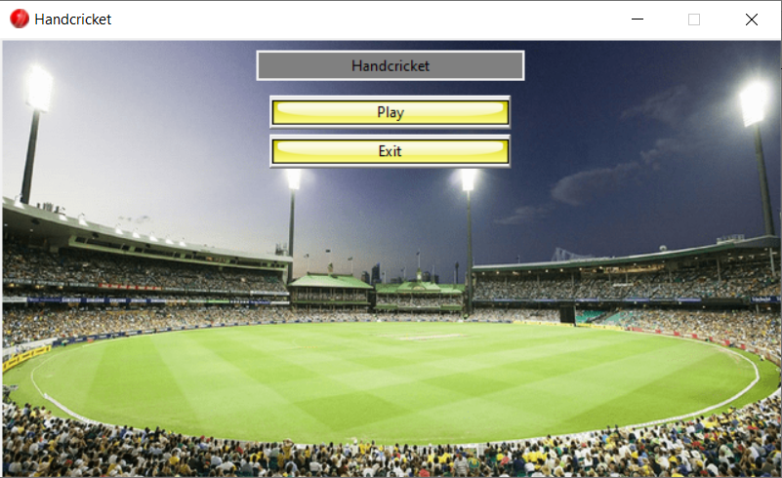

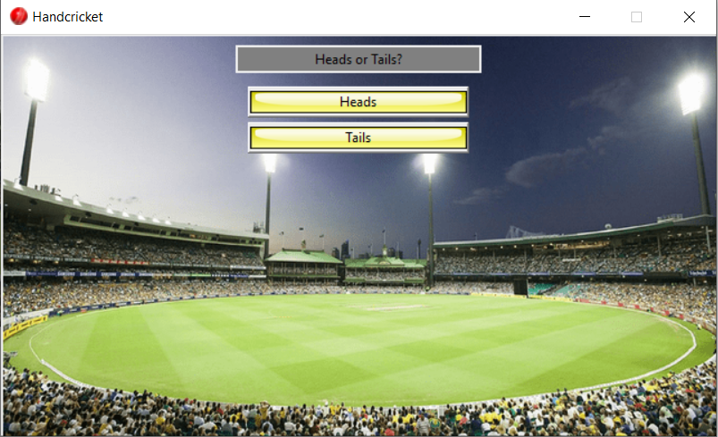

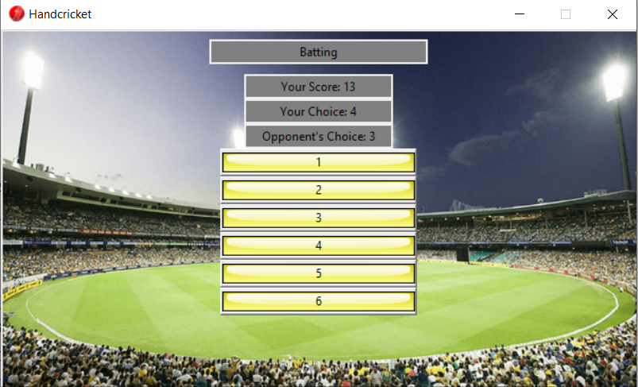

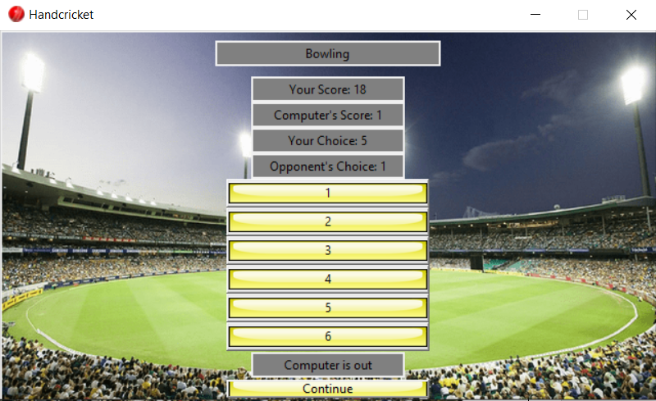

**CHAPTER 4**

**CONCLUSION**

**CONCLUSION**

We have successfully implemented the Handcricket game in python and demonstrated the functionality of the Tkinter module in a neat and presentable GUI. Buttons are used to take input from the user instead of manually typing their choices. Using random function ensures that no game will be the same.

Features:

1.Interactive GUI program

2.Fun and entertaining game built with Python

3.Behind the scenes randomization and widget placement

**REFERENCES**

**[1]** <https://www.python.org/doc/>

**[2]** <https://docs.python.org/3/library/tkinter.html>

**[3]** <https://docs.python.org/3/library/random.html>

**[4]** Introduction to Python Programming by Gowrishankar S