Dealzme22

1. Search result

The search result shows deal and also discussion subject, but when clicking on discussion, nothing is display, even if he founds 1 discussion subject.

Here below we can see 1 discussion is found, but if we want to check it is showing page not found.

Search for ace, 2 deals found, 1 discussion



Clicking on discussion, will bring page not found, or it should display the result of the search

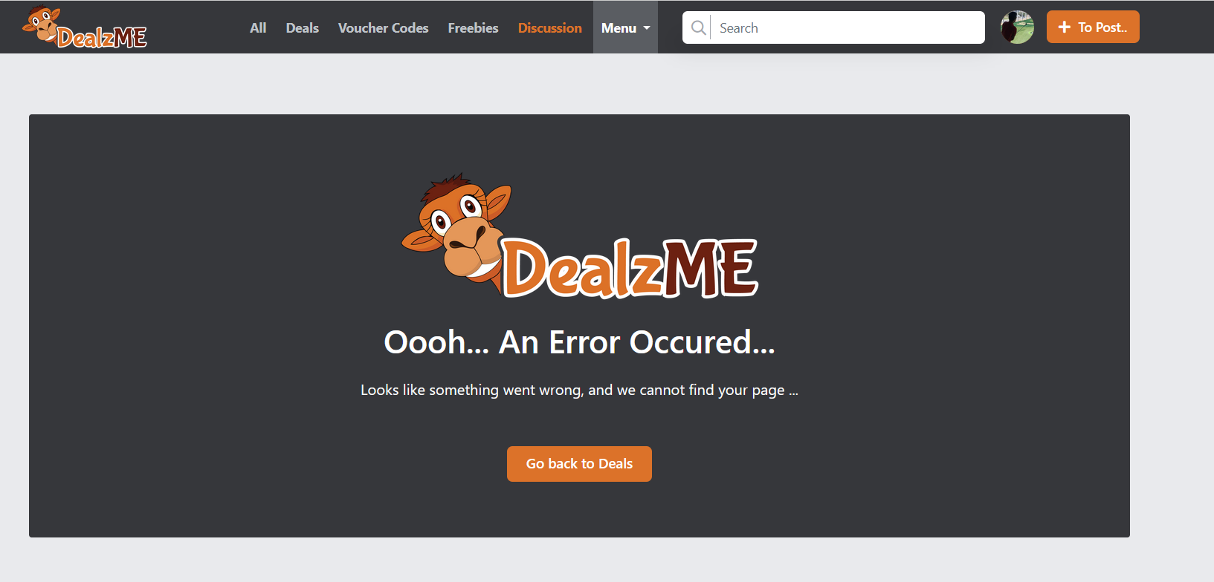

Maybe a link to the Db that is not properly done. Check the implementation with the common-view and all_discussion files done by the person who implemented the search function.

1. Search result display for desktop, mobile, iPad

When the enter key is triggered to execute the search, we will have the name of the shop that will be display if it is existing. Then we could have the related group displayed

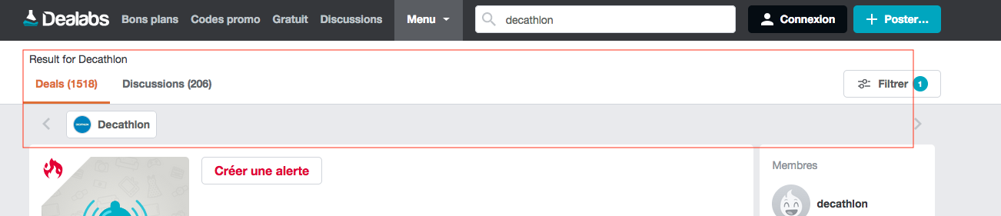

Example here we have the shop 1st then the related group

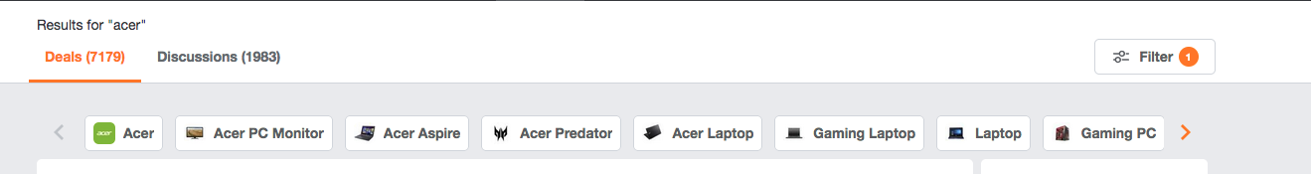

On mobile display for deals and discussion should be as follow

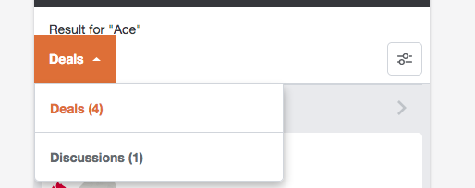

On mobile and iPad merchant result will be display as follow



1. Search bar mobile and iPad

After finishing the keyboarding in the search bar, and not pressing enter, we have a list of different elements that comes up.

In mobile and iPad version nothing is showed, but it should. Try on desktop version to see the result.

Here as it should be

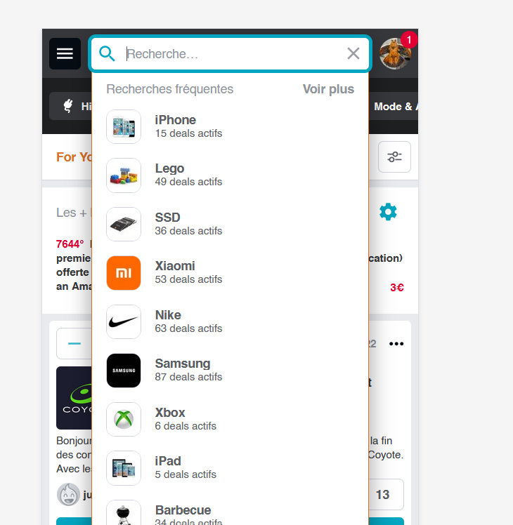

It should execute the Js as per the desktop version.

1. Pagination

We have a pagination system, with our infinite scroll down, but the solution found looks very complex, if we apply some design modification to the common-view it is not following on the pagination, as it is completely independent.

Also I believe it might be a cause of slowing the website down.

We should see to redo this part, here a website that has a flowless pagination and infinite scrolling <https://ernio.lv/>

<https://hotukdeals.com/>

Pagination for deal, coupon code, freebies, discussion, as well as in merchant, group, user profile....

1. OWL carousel / slick

I see that we are using slick and owl carousel2, is there a way to have everything under slick?

To remove owl carousel

It will give us more sense to have only 1 type of slider and not 2.

It is used for Hottest deal right side column, group display in single deal

1. Update new sign in with google (optional for now)

Google sign evolved and will soon be obsolete, so we need to migrate to the new version

[**https://developers.google.com/identity/gsi/web/guides/migration**](https://developers.google.com/identity/gsi/web/guides/migration)

[**https://developers.google.com/identity/gsi/web?hl=en**](https://developers.google.com/identity/gsi/web?hl=en)

1. Better display for mobile

Reorganize from this

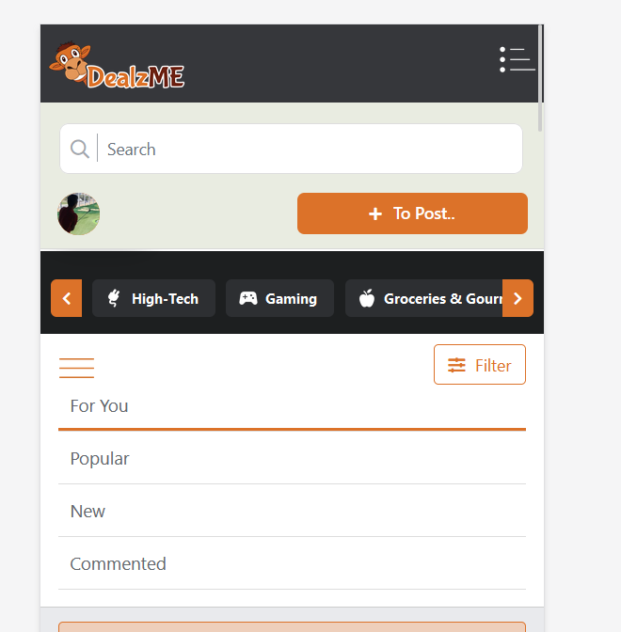

To this

* menu in a square box, with “far fa-bars” icon,
* square orange box for the deal + menu,
* square box for the search button,
* round for the profile picture, if not connected black square with “far fa-user” icon.

All should have the same height.

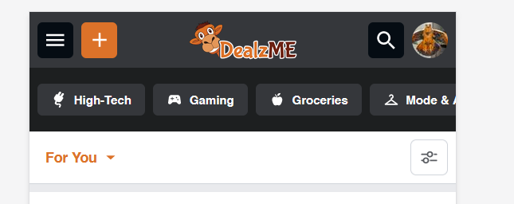

Open menu give this

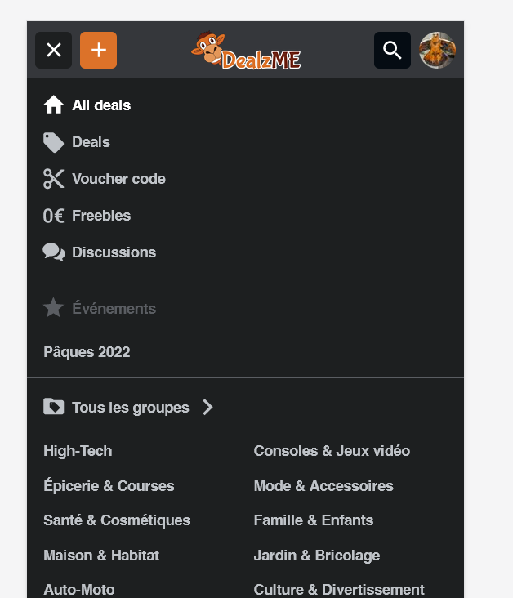

+ menu should give this

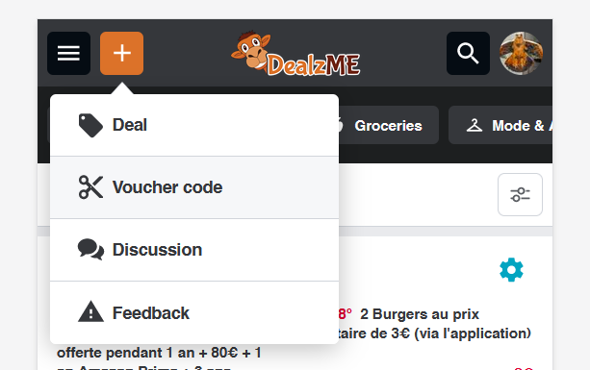

Extend of the search bar when clicking on the search logo

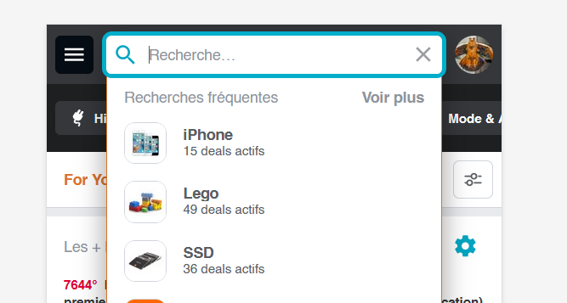

Reorganize this

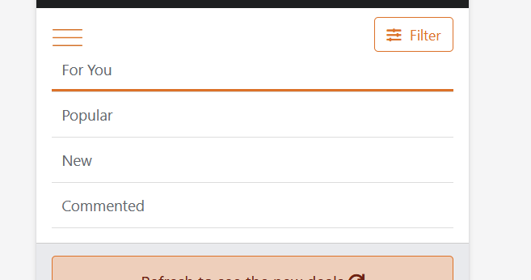

Into this, display of the selected item on the bar, either for you, popular, new or commented

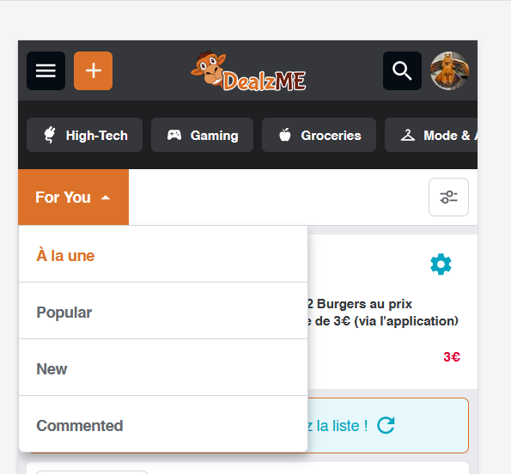

The active one is having the text in orange

Make sure that all the open menus are display perfectly

When removing the current search bar position check that it doesn’t have impact on the other pages, like merchant, group.... like an empty space