T

This set of resources is for learning about Creative Commons (CC) and for delivering information sessions and presentations which inform the use of CC licences in the Galleries, Libraries, Archives and Museum (GLAM) sector, particularly with regard to developing digital collections.

**Introduction**

On the web, huge amounts of graphic materials, photos or audio materials are available. But we should remember that every photo, picture, graphic, audio recording or video is someone’s property, and such person may object to his or her work or property being broadly distributed and used.

1Pyramid of levels of openness. The figure shows different levels of access and use rights that are most commonly encountered

**In order to make these uses legal within the scope of copyright, they are made available using** so-called open licenses. Alternatively, the resources might be in the public domain (when their intellectual property rights already expired, or when no copyright exists for other reasons.

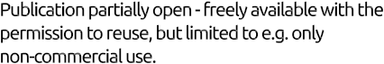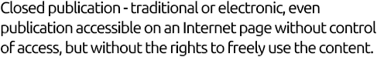

Materials that are openly licensed or in the public do- main can be easily used as open resources. The most popular open licenses, such as *Creative Commons Attribution (CC BY)* and *Creative Commons Share-alike (CC BY-SA)*, allow for free use of licensed materials. Users can change and revise, transform or remix, adapt and reuse, and redistribute them according to their needs. Content can be for example freely translated to foreign languages or texts and audio materials can be remixed into multimedia content. Some open resources can be used with limitations, e.g. cannot be used commercially, and other open resources can be used only within the limits of fair use (they cannot be modified and shared outside classroom). This depends on a particular definition of openness adapted in a given project.

Open Resources are freely accessible resources available with the right to copy, reuse and adapt them



In practice, it means that the resources are released under

open license or reside in public domain

**Creative Commons**



**Attribution** **Creative Commons Attribution- Share-alike** **Public domain**

**Boundless.com digital textbooks** **Saylor.org** **digital textbooks**

**Wikipedia and Wikimedia** **Commons collegeopentextbooks.org**

**Europeana.eu Arvchive.**

**GLAM Examples**

[**Europeana**](http://www.europeana.eu/portal/) – an online catalog of Europe’s heritage collec- tions.

**How does Creative Commons work? (CC licenses and the public domain)**

For a review of Australian copyright law, see

Copyright- a general overview

<http://www.smartcopying.edu.au/copyright-guidelines/copyright---a-general-overview>

In the traditional copyright model, represented by the typical “All rights reserved” statement, to use (modify, circulate, adapt etc.) someone’s work, a permission from the author must be obtained. The procedure can be burdensome and discouraging, especially that in many cases authors are willing to share their works.

Creative Commons licenses make it easier to share creative works based on the principle “Some rights reserved”. When publishing a work, lesson scenario, photo, novel or song, its author can indicate how other people may use such works, by choosing an appropriate license. Creative Commons provides ready-to-use licenses that offer different sets of license clauses: permissions and limitations. In this way, creators can define in a flexible manner their own rules for sharing their creative works with other people. License conditions are like modules: two or three of them can be combined to create a single license.

All Creative Commons licenses combine some common features (respect for moral rights) with particular conditions chosen by the licensor (i.e. the creator herself or the institution which bought copy- right, e.g. publishing house). The creator offering the license always retains intellectual property rights, but at the same time allows other people to use his or her work. In addition, the creator can decide whether to limit commercial uses or the possibility to create derivative works.

The licenses are built out of four elements called conditions - BY (Attribution), NC (Non-commercial use), ND (No derivative works), SA (Share-alike). Mixing and matching these conditions produces different licenses. Every license requires information about the author (to avoid mistakes or plagiarisms), and thus contains the Attribution condition.

**Attribution**

Attribution means that licensees may copy, distribute, display and perform the work covered by copyright and make derivative works based on it only if they give the author the credits.

**Non-commercial use**

Non-commercial use means that licensees may copy, distribute, display and perform the work covered by copyright and make derivative works based on it only for non-commercial purposes.

**Share-alike**

The condition means that licensees may distribute derivative works only under a license identical to the license that governs the original work.

**No Derivative Works**

The condition means that licensees may copy, distribute, display and perform only verbatim copies of the work, not derivative works based on it.

CC licensees are different combinations of the above conditions.

**Licenses**

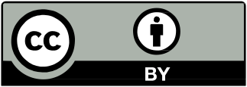**Attribution.** The license allows users to copy, modify, distribute, display and perform the work only if the author is given the credits. Under the license, licensees have the broadest scope of freedom.

*This is a popular license for publicly funded content. Used by the World Bank, the White House and the Polish Open e-Textbooks project.*

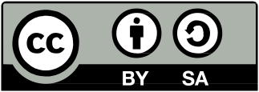**Attribution - Share-alike.** The license allows users to copy, modify, distribute, display and perform the work only if derivative works are covered by a license identical to the license that governs the original work.

*The license is used by Wikipedia and all similar projects.*

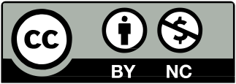**Attribution - Non-commercial.** The license allows users to copy, modify, re-mix, distribute,display and perform the work only for non-commercial purposes. However, the derivative works are not covered by the condition (they can be covered by different license, e.g. allowing their commercial use).

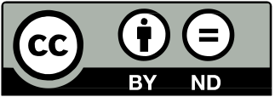**Attribution - No derivatives.** This license allows distribution, presentation and execution of work in both the commercial and non-commercial purposes, provided that it in its original form (not to create derivative works).

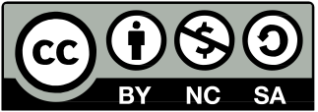**Attribution - Non-commercial - Share-alike.** The license allows users to distribute, display andperform the work only for non-commercial pur- poses and only if derivative works are covered by a license identical to the license that governs the original work.

*The license was used by the band Nine Inch Nails to publish their best-selling album Ghosts I-IV.*

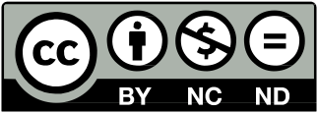**Attribution - Non-com- mercial - No derivatives.** The license allows users

to distribute, display and perform the work only for non-commercial purposes and only verbatim copies of the work, not derivative works based on it. It is the most restrictive license.

**This work was inspired by and is a derivative of “Open Lesson” by**

Monika Koblak, Aleksandra Kozubska,

Izabela Meyza, Adam Rębacz, Krzysztof Sikora, Anna

Stokowska, Kamil Śliwowski.

Translation from Polish: Jan Popowski

The publication is available under a Creative Com- mons Attribution

3.0 Poland license. [creativecommons.org/licenses/by/3.0/pl](http://creativecommons.org/licenses/by/3.0/pl).