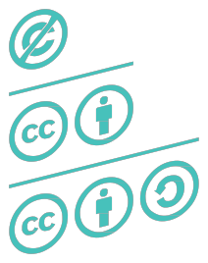

**This work is a derivative of “Open Lesson” by**

Monika Koblak, Aleksandra Kozubska,

Izabela Meyza, Adam Rębacz, Krzysztof Sikora, Anna

Stokowska, Kamil Śliwowski.

The publication is available under a Creative Com- mons Attribution 3.0 Poland license. creativecommons.org/licenses/by/3.0/pl