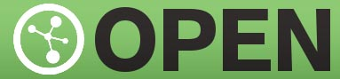
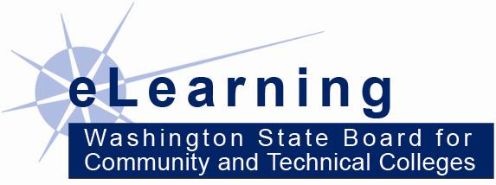
Open Course Library Content Development

The Open Course Library is a collection of expertly developed educational materials – including textbooks, syllabi, course activities, readings, and assessments – for 81 high-enrollment college courses. There are three main goals:
- Lower textbook costs for students (no more than $30 materials cost to student)
- Provide new resources for faculty to use in their courses
- Fully engage in the global open educational resources discussion

Timeline:
- Phase 1 course available October 31, 2011 (see http://opencourselibrary.org)
- Phase 2 available Spring 2013
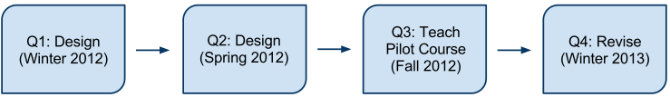
  - Phase 2 Development Timeline:
ART
100
81 Course Collections Being Developed:
http://opencourselibrary.org

Course Teams:
Faculty Developer(s)
Librarian
Instructional designer

OCL Support Personnel:
Subject Matter Experts
SME Coordinator
Accessibility Specialist
Global Education Specialist

Initial Impact of the Open Course Library:
- 42 courses developed in Phase 1 were released in fall 2011 and are available to all
- Over 30,000 visits to opencourselibrary.org from 125 different countries in the first 6 months
- Student textbooks savings in year 1 ($1.26 M) exceeds cost of phase 1 development ($1.1 M)
- No significant difference in completion rates (OCL pilots vs. courses with traditional materials)

Three Things You Should Know About the Open Course Library
http://opencourselibrary.org

What is the Open Course Library?
The Open Course Library is a collection of expertly developed educational materials designed by faculty and openly shared with the world. It includes textbooks, syllabi, course activities, readings, and assessments for 81 high-enrollment college courses. 42 courses have been completed so far, providing faculty with a high-quality, affordable option that will cost students no more than $30 for course materials.

The Open Course Library is:
- High Quality – Course materials go through an extensive series of quality checks.
  - All course materials are pilot-tested in a college classroom and then further refined.
  - Quality checks include peer reviews, instructional designer reviews, and expert reviews by universal design, accessibility, and global education specialists.
- Affordable – Students pay no more than $30 for Open Course Library materials, including textbooks. Most courses use 100% free materials.
  - Students spend $1000 or more on textbooks annually, in addition to tuition.
  - Some students even attempt courses without purchasing the textbooks, which affects completion rates.
  - Using Open Course Library materials allows students to spend less per course and afford more courses per term so they can graduate faster and get better paying jobs sooner.
- Adaptable – Faculty can modify and build on some or all of the course materials.
  - Faculty adopters can use as much of the course materials as they choose.
  - There are no strings attached. We only ask that faculty cite the Open Course Library in their course and fill out our short adoption form.

Please visit http://opencourselibrary.org for more information, including the first 42 courses.
Contact: Tom Caswell, SBCTC Open Education Policy Associate, tcaswell@sbctc.edu

