


OER-friendly Tools and Resources

Where to find OER
- Open License Search: http://search.creativecommons.org
- OER Search: http://www.oerglue.com/courses
- OCW Search: http://www.ocwconsortium.org/en/courses
- Curated Repositories:
  - http://oercommons.org
  - http://www.merlot.org/merlot/index.htm
- Open Textbooks: http://www.collegeopentextbooks.org/
- More OER: http://www.scoop.it/t/finding-oer

Where to create or adapt OER

OER Sharing Platforms
- Connexions –
  - Pros: Lots of visibility; allows others to easily make copies/adaptations from within Connexions
  - Cons: Hard to add content as collections, limits on file size
- Google Sites –
  - Pros: Free, Simple to edit and organize
  - Cons: limits on # of pages and files. Internal permissions can get complicated.
- eduCommons –
  - Pros: Designed based on MIT Open Courseware; supports open content licensing; supports metadata; built with open source software
  - Cons: Difficult to self-host and/or customize ; recommend using enPraxis for hosting

Print-on-demand Tools
- Lulu –
  - Pros: Supports Creative Commons licensing and Google’s Cloud Drive; no up-front costs; Integrates with Kindle
  - Cons: Downloading even free books is not instantaneous (requires about 30 minutes of waiting for confirmation email)
- Create Space –
  - Pros: Least expensive of all other providers; no up-front costs; Integrates with Kindle format
  - Cons: Requires bank info to set up an account
- Coop –
  - Pros: High quality; integrates well with Connexions content
  - Cons: More expensive than other options

Creating eBooks with Lulu & Google Drive
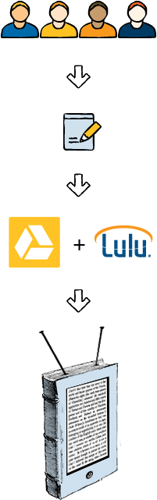
What is Google Drive?
Google Drive is a cloud storage and collaboration service from Google that allows people to create, edit, and share files with one another. Drive also allows people to store their files online and access them from any device: in desktop folders on Mac or PC computers, in mobile apps on Android or iOS devices, or from any web browser by visiting drive.google.com. It’s a simple way for people to open files from Drive, make changes or edits in the application, and then save the updated file in Drive.
What is the Lulu One-Click Publishing App?
The Lulu One-Click Publishing app lets creators collaborate with anyone on Google Drive, then easily publish content as a PDF eBook that can be sold or converted to a print book on Lulu.com. The app supports multiple file formats including PDF, DOC, DOCX, and TXT and can accept multiple files simultaneously for creators who choose to upload individually saved chapters. Creators keep full creative and copyright control and Lulu support Creative Commons licensing.

How does it all work?
- Install the Lulu One-Click Publishing App. (This app requires Google Chrome.)
- Upload your PDF, DOC, DOCX, or TXT file to Google Drive.
- Open the Lulu One-Click Publishing App and follow the wizard.

