SBTCTC, Open Technology Handout
May, 2012
Download this handout: http://goo.gl/Vb8QP

Design Overview…………………………………………………..………………………………………………………… 2.

Creating a Google Account……………………………………………………………………….……………………… 3.

Uploading to a Google Docs Collection…………………………………………………….……………………… 3.

Organizing Google Docs…………………………………………………………….……………………………………… 4.

Working Collaboratively in Google Docs…………………………………………………………………………… 5.

Downloading from Google Docs………………………………………………………………………..……………… 6.

Adding Google Docs to ANGEL, Blackboard, Canvas or Moodle………………………………………… 6.

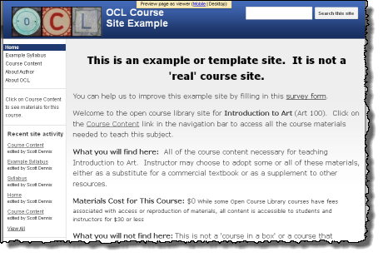

Design Overview

The Open Course Library grant project is an ongoing course content development project with similar goals to many of the DOL grant projects. We hope that what we have learned as we have worked on this project will benefit many of the DOL grantees.

The Goal of the OCL project

The goal of the Open Course Library (OCL) project is to create fully developed course content for 81 high enrollment courses in the Washington State Community and Technical College system, and then share those materials with an open license. Faculty members, instructional designers, librarians and other staff members are working in teams to locate and build the content for each course. Our goal is for instructors in WA colleges and around the world to adopt high quality OCL content and teach courses using it, whether as a whole course or in bits and pieces, to enhance teaching and improve learning.

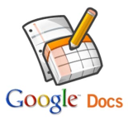
Based on what we learned in the first development phase, in Phase Two developers are adding course content to Google Docs collections that is linked to a course pages at opencourselibrary.org (a Google Site). There is a separate set of site pages and docs collection for each course development project. When the project is complete anyone will be able to visit the site and search all courses, browse course pages and the docs collections. Wherever possible, developers uploading course content to the Google docs collections and converting the content to Google docs format. Having the content in Google docs format will allow visitors to download some or all course documents in the format that works best for them (Word, PDF, etc). All project video content are being added to a common YouTube account and then linked or embedded back to the course content in the docs collection. This will make it easier to add closed captioning as well as reducing the size of course docs collection (making them easier to download), and making it easier to find and update video content as needed in the future.

Creating a Google Account

If you don't already have one, or if you want a separate account for your development project, creating a Google account should be a quick and easy process.
Point your browser to: https://accounts.Google.com/NewAccount
You will need a current email address and to agree to certain terms of service.
You will use your Google account to upload or create content online in Google docs and possibly to youtube if you have videos to add to your course. You will probably also use a Google account to collaborate and communicate with your OCL team members.

Uploading to a Google Docs Collection

There are two ways to upload files to Google Docs:
Dragging files directly into your Documents List or collection
One big advantage of dragging and dropping is that you can drop directly onto collections and sub-collections. When using the upload button, on the other hand, you will upload to your documents list and can then drag and drop onto collections and sub-collections. This feature is available only in the latest versions of Chrome and Firefox. If you aren’t working in the latest version of Chrome or Firefox, you can click the Upload button and select Files... from the drop-down menu.

Clicking the Upload button and selecting Files...
To manually select files from your computer to upload to Google Docs, follow these steps:
In your Documents List, click the Upload button and select Files... from the drop-down menu.
Select the file you'd like to upload to Google Docs. To select multiple files, press Shift or Ctrl and click all the files to upload.

Once you drag and drop or upload a file, the settings you select will be applied to all files you upload. You can adjust these preferences in the Settings section of the Upload drop-down menu.

When you upload a file, a box that indicates the progress of the upload appears in the bottom right of your screen. You can minimize the box, move it to the left or right of the screen, or share directly from the box by clicking the Share link. When you’re done, you can click the document title to open the uploaded file or close the box by clicking the x in the upper right of the box.

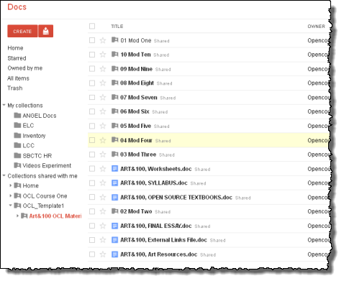
Organizing Google Docs
In Google Docs there are collections, which are like folders (if you convert to Google Drive, docs collections become folders). a collection behaves like a folder in that it is a separate container for organizing files. Collections can have sub-collections.

Working Collaboratively in Google Docs
About real-time collaboration in Google Docs:

Docs (like Microsoft Word):
If you and another collaborator are editing or commenting upon the same document at the same time, a box with the name of the collaborator appears at the top of the screen. If other people are editing or commenting upon a document simultaneously with you, you’ll see their edits and comments in real time. You can also see their names listed at the top. Click the arrow to the right of the names to open a tab where you can chat with other collaborators within the document.

Fifty people can edit a document at the same time. You can share a document with up to 200 people.

Spreadsheets (like Microsoft Excel):
If multiple people are editing or viewing your spreadsheet at the same time, you'll see their names listed at the top. Click the arrow to the right of the names to open a tab where you can chat with other viewers and collaborators about changes being made to the spreadsheet.

Presentations (like Microsoft PowerPoint):
If other people are editing a presentation simultaneously with you, you'll see their names at the top of the page. You'll also be able to chat with other viewers and collaborators in View presentation mode (available in the upper-right corner of the edit page).

10 people can edit a presentation at the same time. However, you can share a presentation with up to 200 people (whether you add collaborators or viewers, the total cannot exceed 200 people).

Drawings:
If other people are editing a drawing simultaneously with you, you'll see their edits in real time. You can also see their names listed at the top. Click the arrow to the right of the names to open a tab where you can chat with other editors from within Google drawings.

Other editors see your changes as you complete them, like when you finish moving or entering text in a shape. If you cancel an edit before completing it, the change isn't saved and collaborators don't see it.Up to 50 people can edit and view a drawing at the same time.

Looking for a quick way to share? Change the visibility option of your doc so that anyone with the link can view it (or edit it -- your choice). Docs set to “Anyone with the link” can be viewed by anyone who has a link to the doc, so it can be a convenient way to share a non-private doc with a big group.

Downloading from Google Docs
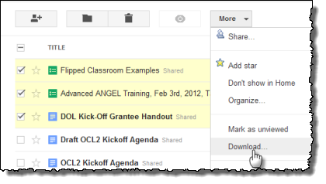
While logged into Google and looking at your own Documents view or looking at a docs collection that someone has shared with you, you will see selection boxes to the left of each individual docs file. Select the docs that you want to download. Next, click the “More” button and then Download.

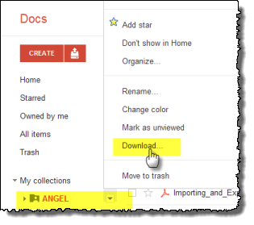

You can download your own collections by moving your mouse over them and choosing from the available options.

Within a collection, you can choose to select all or select a sub-set of items for download. If the docs files were originally created in Google or were converted to Google format when uploaded, you will be given a range of file formats to choose from for download. If the files were not converted to Google formats you will be able to download them in the format originally uploaded.

Please note that if you download a copy of a Google doc and edit it offline you will not get further edits that your collaborators may make online and they will not get yours. This is why many people choose to edit completely online.

Adding Google Docs to ANGEL, Blackboard, Canvas or Moodle
One feature of Google Docs collections that is very handy for people who use a learning management system such as Blackboard, ANGEL, or Moodle is that it is possible to download Google docs content is a format that is easy to import to the learning management system. For example:

Steps for Adding Google Content to ANGEL
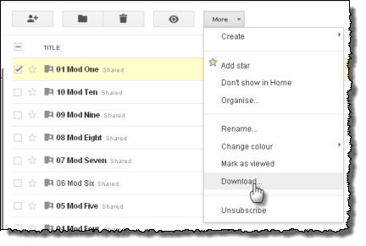
- While logged into a Google account, find the Google docs collection or individual docs that you want to download.
1.

- Select the content and then choose Download under More options:

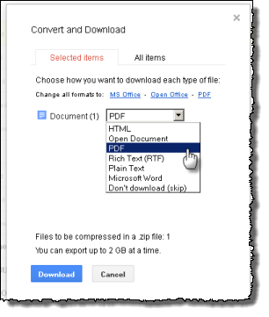
- Choose the format that you want included doc files to be exported at. PDF is a format that seems to work well with most systems and browsers.
2.

- Download the .zip file.

- Log into ANGEL, and go to the Manage tab in the course where you will import the content.
- Click on the Import Console
- Choose Content Package
- Browse to find the zip file you downloaded from Google Docs
- ANGEL will upload the file and then ask you whether you’d like to put all of its contents in a new lessons content folder, and existing folder or the root lessons area

Watch a video, detailing the step-by-step process of uploading to ANGEL:
http://youtu.be/KLSK-F_prpg

Watch a video, detailing the step-by-step process of uploading to Canvas:
http://youtu.be/rF3o865OtsU

