Best Practice in Creating and Managing Open Educational Resources: Examples and Samples
Introduction to this document
The following materials were used in the development of the Open Course Library, managed by the Washington State Board for Community and Technical Colleges (SBCTC). These materials provide an example of how an institution or project can manage the development and delivery of open educational content.

Index
Sample creative commons logo on the content page………….Page 2
Sample copyright statement………….Page 2
Sample Email to request permission………….Page 3
Sample Resource Clearinghouse (Materials Audit)………….Page 4
Sample Video list………….Page 5
Sample Templates for Course Guide, Objectives, Course Map, Learning activities, Assessment, Syllabus………….Page 6
Sample Project Guidelines and Deliverables………….Page 7

Sample Deliverables Tracking………….Page 10

Sample creative commons logo on the content page

Unless otherwise specified, this work by the Washington State Colleges is licensed under a Creative Commons Attribution 3.0 Unported License. The Open Course Library is funded by the Bill & Melinda Gates Foundation and the Washington State Legislature.

Sample copyright statement
The course materials you are viewing were created as part of the Open Course Library (OCL) project. The OCL is a collection of courses designed by a cooperative of faculty members in Washington State starting in 2011. The courses, and our maintenance of them, are complete as of March 2013.
All of our work is available for use and adoption by anyone at any time. We release materials created by our team using a Creative Commons (CC By) license.
Some materials associated with this course might have be made available through cooperation of the original copyright holder. In these cases please follow the distribution restrictions as defined by the specific material.
To attribute this course please use the names of our faculty designer(s): Rebecca Engel
To cite this course please use the following citation example:
Engel, Rebecca. Open Course Library: ASL&121: American Sign Language I. The Open Course Library. Washington State Board for Community & Technical Colleges, xx March, 2013. Web. Date of access.
Sample Email to request permission
Hello Dr. Dumbledore,
I am a faculty with the Washington State Open Course Library project. The purpose of this project is to design openly licensed courses that can be taught face-to-face, hybrid and/or online. These courses will be freely available on the internet for anyone to copy, modify and use. One of the purposes of this project is to offer educational resources to regions where formal educational opportunities are scarce or expensive.
I am creating a course entitled “Advanced potion” and I would like to use a post from you blog entitled “Why poly juice potion?” from February 2005.
I am seeking your permission to distribute this material as part of our course. You will maintain your copyrights, but will be giving us permission to distribute this material for reuse as part of the teaching of this course. We will mostly likely copy the text of your post into a Google document, attribute you and include a note that the work should be used for educational purposes. A full citation for the work will accompany it, as will a statement of copyright ownership and notice that the work cannot be distributed for reasons other than education.
Please contact me at xxxx@hogwarts.edu or by telephone at 253-xxx-xxxx with information about this request.
Thank you for your time and attention.
Regards,
Boyoung

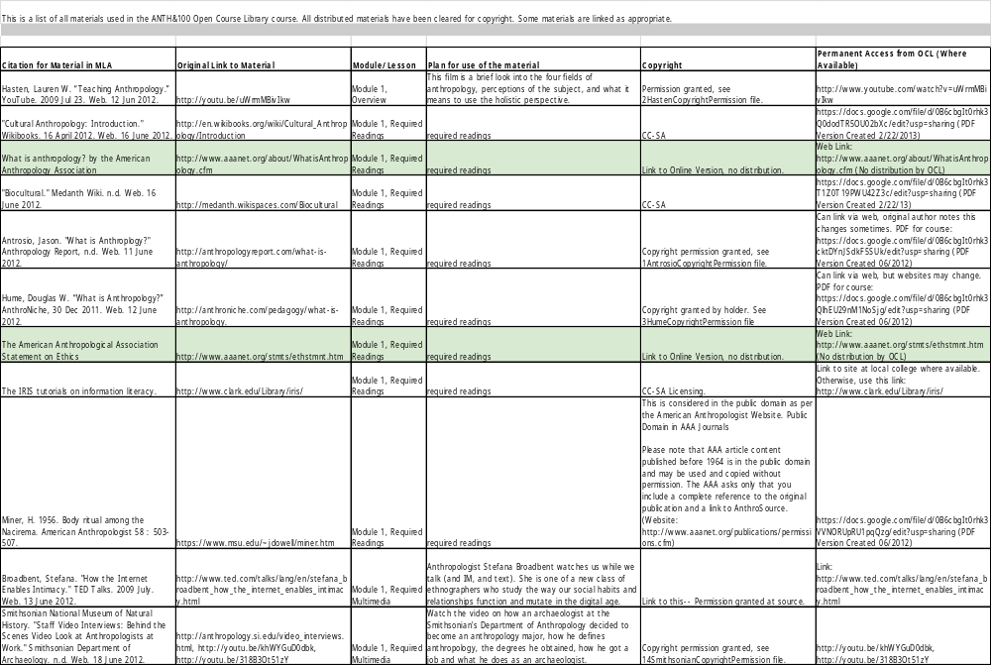
Sample Resource Clearinghouse
Sample Video list
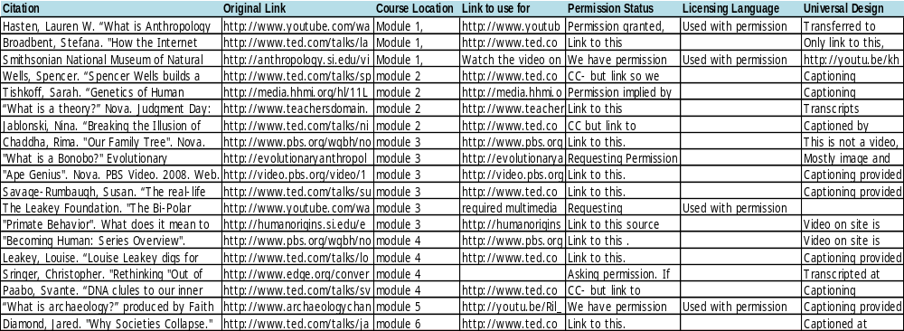

Sample Course Templates for Course Guide, Objectives, Course Map, Learning activities, Assessment, Syllabus

Please find the templates at http://goo.gl/wCSLA

Sample Project Guidelines and Deliverables

Washington State Student Completion Initiative
Open Course Library (OCL)
Phase 2 – Beginning January 2012
Guidelines & Deliverables

Unified Quarter Schedule

We will us the following schedule to define quarters for the Open Course Library project across all colleges. Open Course Library participants agree to follow this schedule during the project:
January 9, 2012 | Start Winter OCL work – Plan, outline, and develop course
March 23, 2012 | End Winter OCL work
April 2, 2012 | Start Spring OCL work – Course development, course reviews
June 14, 2012 | End Spring OCL work
Summer 2012 | Summer Break
Fall 2012 | Faculty course designers pilot teach OCL course at their colleges (Fall Quarter)
January 7, 2013 | Start Winter OCL work – Final revisions
March 22, 2013 | End Winter OCL work – All OCL work due

Project Deliverables and Timeline
In phase 2 we are providing a much more specific set of deliverables and deadlines for two reasons:
(1) the funds we are using require monthly deliverables from all participants, and (2) many of the phase 1 courses were completed late, resulting in additional expense. In phase 2 grant payments will be contingent on completion of monthly deliverables. By participating in the project you agree to meet the following deliverables and deadlines:

Winter 2012 Deliverables (as of 2/14/12)
Winter 2012 Deliverables | Faculty Course Designer | Instructional Designer (ID) | Other (specify who) | Final Deadline
Kickoff planning for Support Staff (Meet online via Collaborate) |  | TBA | All Support Staff TBA
Course preview sheet, including draft of course-level objectives | Bring digital file to kickoff | Review at kickoff |  | January 26, 2012
All: Attend OCL phase 2 kickoff (mandatory) | January 24-26, 2012
Course-level objectives | Submitted by February 3, 2012 | Reviewed by February 10, 2012 |  | February 17, 2012
Module-level objectives | Submitted by February 10, 2012 | Reviewed by February 17, 2012 |  | February 24, 2012
Course Content Map / Outline | Submitted by February 17, 2012 | Reviewed by February 24, 2012 | Sent to 2 Subject Matter Experts on March 16, 2012 | April 2, 2012
Learning Activities | Submitted by March 9, 2012 | Reviewed by March 16, 2012 |  | March 23, 2012
SME Peer Reviews | Faculty sends SME nomination with criteria to ID by 2/17 | ID approves by 3/1 | QA (Ellen B.) sends all SMEs confirmation e-mail by 3/5 | SMEs given full course map and learning activities by 3/16; reviews due to QA by 4/2 (then sent to IDs & faculty)
Brief OCL Project Report/Online Survey (Tom will send link) | Submitted by ALL project participants by June 14 | Submitted by ALL project participants by June 14, 2012 | Submitted by ALL project participants by June 14, 2012
System to track copyright clearance and tracking of all materials used in each course |  |  | Organized by librarians by February 24, 2012 | In place by February 24, 2012
Webinar on identifying copyright of educational materials |  |  | Librarians lead webinar in mid-February, 2012
END WINTER QUARTER 2012 Colleges invoice SBCTC for winter | Quarter ends March 23

Spring 2012 Deliverables
Spring 2012 Deliverables | Faculty Course Des. | Instructional Designer (ID) | Other (specify who) | Final Deadline
Syllabus and Exams/Assessments with answer keys or grading rubrics (note: answers will be openly shared) | Submitted by April 20, 2012 | Reviewed by April 27, 2012 |  | May 4, 2012
All external materials indexed and copyright cleared (author, copyright license, URL, short description) |  |  | Librarians, Spring 2012 | June 1, 2012
All materials complete and ready for faculty reports & expert reviews | Ready by May 4, 2012 or sooner
Subject Matter Expert Review of course materials x 2 |  |  | Reviewed by 2 Subject Matter Experts by May 18 (content review)
Global Education Report – submitted by faculty course designers | Submit report June 22, 2012 or sooner |  | Reviewed by Global Ed Specialist. All reviews completed by May 25, 2012 | Final Global Ed approval in winter 2013
Information Literacy Report – submitted by faculty course designers | Submit report June 22, 2012 or sooner |  | Reviewed by Librarian All reviews completed by May 25, 2012 | Final changes by June 22, 2012
Accessibility / Universal Design Report | Submit report June 22, 2012 or sooner |  | Reviewed by Accessibility/UD Specialist & DSSC in summer 2012 | Final Accessibility/UD approval in winter 2013
Instructional Design Review of course materials -- ready to pilot? |  | Reviewed by June 29, 2012 |  | Final ID approval in winter 2013
Course Development Complete! Prep for pilot by moving OCL materials to LMS, as needed (work with local eLearning staff for help)
Brief OCL Project Report/Online Survey (ALL OCL2 participants) | Submitted by June 27, 2012 | Submitted by June 27, 2012 | Submitted by librarians by June 27, 2012
END SPRING QUARTER 2012 Colleges invoice SBCTC for spring quarter work. | Spring OCL2 Quarter ends June 16, 2012 | Colleges submit invoices by July | All expenses for fiscal year 2011-12 must be submitted to SBCTC

Sample Deliverables Tracking
