**Fractional Investment Service Platform**

Business and Technical Summary

Initiated May 2022

Sudhakar Krishnamachari

version 0.1

**Summary:**

*CRE is booming and evergreen business segment. Middle class with excess investible income is also increasing and searching for medium risk opportunities to invest in. This coming together of increase and viability of growth for both the borrower and investor base, is an opportunity for fintechs to leverage. There is already a mildly crowded market of ~20+ platforms for retail shares in real estate market over and above the REIT capital sourcing. But nearly all of these platforms seem profitable and have healthy funding.*

*Yet another fractional investment platform with eventual growth to other industries as it evolves can leverage a late entrant strategy of learning in depth from the existing players, market scope, capabilities and top it up with the frontier technologies to differentiate massively with AI/ML, Blockchain/NFT, connected/cloud strategies, metaverse.*

*Refer* [*https://www.ibef.org/industry/real-estate-india*](https://www.ibef.org/industry/real-estate-india) *for market scope and opportunities from a real estate growth perspective and extrapolate on fractional investment service platform growth.*

**Discussion:**

**Proposal for fintech technology platform for enterprises to obtain capital funding through crowd sourcing from serious retail investors**

The new way of sourcing capital from a crowd sourced approach to fund large projects of values ranging 250,000 USD and above. The intent is to provide a medium risk instrument to the retail (and institutional investors if interested) backed preferably with a tangible collateral. While P2P crowd sourcing has worked in a limited sense for lower ticket lending, this is a little more complex product that involves onboarding shareholders/ co-owners to the venture, servicing of the returns on the venture through its asset utilization. Also have a secondary market to trade the units of shares for liquidity for the co-owners.

*With about 1% of the indian employed class having disposable income and risk apetite, it can be the right timing to bring together investors and borrowers in a common platform for medium to high risk and high returns investments.*

The potential use cases as already developing in the market are:

**\* Commercial Real Estate :**

An CRE enterprise obtains the requisite land, permissions, plan sanctions and then floats the offer to crowd source the funds for the execution of the project to the retail investors. This can be through public advertisements or through private placements. Typical float about 1000 to 10000 units to be sold through call for investment with ticket size of approx 25 – 50 K USD each.

On subscription, the project kicks off and on completion is put on a commercial rent, which fetches say average of 1 – 3% returns annually for the share holders.

Through the years ahead, the potential for secondary investors who can buy the shares off from the primary at mutually agreed values facilitated by market rate indicators for par value.

*The real estate market as a whole in india has a* ***100 – 200 billion USD loan book with an annual borrowing of 10 – 20 billion USD****. CRE in India is about* ***5 billion USD with a CAGR of 13% yoy*** *expected in the decade ahead. The market is cyclical and with its troughs and highs keeps an average return of 12 – 18% return in any region for resale value alone. CRE rental returns can be in the 8 – 12 % rate optimistically, though downturns as in recent pandemic can crash to low or negative retuns post expenses. CRE crowd sourcing can take a sizable share away from traditional CRE lending by FI of all categories.*

The similar flow for financial implications and similar actors in the venture can be implemented for any venture ranging from:

**\* Industrial ventures**

**\* Retail businesses**

**\* Schools, teaching institutes**

Any business that has a notion of well managed execution costs, time bound plan to completion, fixed and known source of income generation for servicing of returns generated and eventually a market for trading the shares of the investment.

While all of this can be potentially managed by the enterprise on its own with in house systems and processes, there is a huge opportunity for providing a specialized multi-tenanted solution on per region/jurisdiction basis.

**References:**

<https://www.propertyshare.in/faqs>

<https://www.cbinsights.com/company/property-share/financials>

2MM USD

<https://compstak.com/data-api>

<https://myrecapital.com/>

<https://www.crunchbase.com/organization/myre-capital/investor_financials>

5B USD valuation ??

<https://bhive.fund/fractional-real-estate>

<https://www.cbinsights.com/company/bhive-workspace/financials>

3.5 MM USD funding

<https://strataprop.com/>

<https://www.crunchbase.com/organization/strata-f0fe>

7.5MM USD funding

<https://www.gripinvest.in/>

<https://thelanding.in/>

<https://fincity.com/>

<https://hbits.co/>

<https://www.magicbricks.com/mbinvest/>

<https://www.winvesta.in/>

<https://www.nobroker.in/>

<https://www.propreturns.com/>

**Services Modules:**

**1. Co-ownership Onboarding** : that involves prospecting, finalizing the unit shares with investors, legal documentation. This will have a large component for front end ui customization to provide for portal to book prospective investors and provide the continued functionality through other phases ahead.

**2. Servicing** : This involves the asset utilization action that initiates stable income generation, accounting for cost management, per unit share amortization returns for shareholders. Reports and other features will round of the capability with mostly automated functionality

**3. Secondary market :** Initiate, develop and manage the secondary trading of the unit shares for the co-owners to liquidate their holding as and when required. Maintain or obtain a par value assessment to facilitate easy fixation of trade value per unit with premium or discount based on the demand/availability of units.

Many other common capabilities, base features will need to be included to make this a complete product that can service multiple enterprises to float their venture and obtain the capital

**Technology Architecture:**

Micro or modular services based with customizable front UI on a multi layer layout

Containerized and orchestrated with industry standard common services for identity, authorization and other capabilities as sidecars

Potential for blockchain based architecture or technology components can be implemented viz for identity, non fungible tokens for shares etc. AI – ML can be incrementally integrated through the entire lifecycle of the services

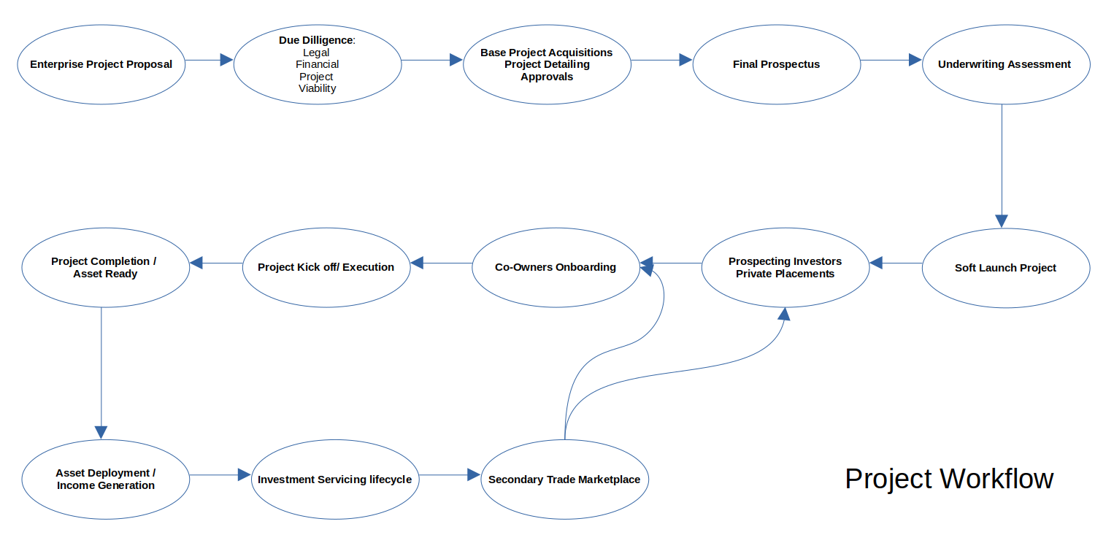

**Fractional Investment Platform**

**Co–Owning Onboarding**

**Servicing Investment**

**Secondary Trade Marketplace**

**Actors / Entities**

* Primary Venture Enterprise
* Shareholders / Co-Owners
* Broker / Advisor
* Underwriter

**Financial Accounting**

* General / Sub ledgers
* Cashflows / Cash Xfer Interface
* Taxation

**Services:**

* Market Rate Service
* Audit / Validation Service
* Risk Assessment Service
* Asset Deployment Management

**Regulatory Constraints**

* Domain Specific
* Fractional Service driven

**Legal Documentations**

* Jurisdiction bound co-ownership docs, trade/transfer of ownership documentation

**Reports**

**Solution Modules:**

* **Project / Venture Portal**
  + Final Prospectus / Details
  + Models : 3D Virtual Reality / Pics
  + Financial Worksheet for the Investors
* **Facilitating Prospecting Co-Owners**
  + Basic Registration of Interest form / Initial prospect registration
  + Demo / Copy of documents / other artifacts
  + Lead prospects through the entire project, financial returns, risks
* **Co-Owner Onboarding**
  + Conversion of Prospect to Co-Owner / Shareholder
  + Booking of Shares
    - Cashflows
    - Legal Doc Generation
    - Unique NFT generation ( blockchain )
    - Digital Locker linked
  + Progress page till Project Completion
    - Show project status
    - Onsite progress artifacts
    - Shareholder AGM notification / minutes
    - Virtual Meetings / Virtual Meeting Platform
* **Asset Deployment**
  + Facilitate Asset deployment for income generation
  + Tracking and monitoring asset deployment
  + Budget / expense / income monitoring et als..
* **Investment Servicing**
  + Asset deployment income/expense statement
  + Regulatory management including tax documents et als
  + Per shareholder income distribution / cashflows
  + Investor statement generation

* **Secondary Trade Marketplace**
  + Buyer and Seller marketplace facilitation
  + Provide a market rate baseline
  + facilitate trade / buy-sell between parties
  + generate legal documentation and record NFT/blockchain ownership of shares
* **Reports**
* **Accounting Management and Statements**
* **Interfaces**