**Fractional Investment Service Platform**

Software Design Document

Initiated June 2022

Sudhakar Krishnamachari

version 0.1

**Summary:**

CRE is booming and evergreen business segment. Middle class with excess investible income is also increasing and searching for medium risk opportunities to invest in. This coming together of increase and viability of growth for both the borrower and investor base, is an opportunity for fintechs to leverage. There is already a mildly crowded market of ~20+ platforms for retail shares in real estate market over and above the REIT capital sourcing. But nearly all of these platforms seem profitable and have healthy funding.

**Models**:

**Users**

Enterprise : EnterpriseFinancials : EnterpriseLocation : EnterpriseContact : EnterpriseAddress :

Investor : InvestorProfile : InvestorContact : InvestorAddress : ...

Advisor/Broker : AdvisorProfile : AdvisorContact : AdvisorAddress : AdvisorDetails

Admin/Super/Tech....

**Project**:

Project Master : Project : ProjectDetails : ...

**Transactions**:

ProjectShare : ProjectShareBuyTransaction / ProjectShareSellTransaction : ProjectShareNFT / BlockchainInfo

ProjectAssetEarningShares ?

**Accounting**:

Account: GeneralLedger : SubLedger : VirtualGL : ...?

Cashflows : Incoming / Outgoing ? OR subsume this in transaction itself.. ??

**Workflows**:

Onboarding (create) : PrimaryTrade / SecondaryTrade : AssetEarnings

Authorization/Authentication

***********************************************

**AI/ML:**

* Location Specific Property Rent Value prediction

* Default Risk / Rating for properties and enterprise/venture

* Investor ownership pattern, predict property fit

* Investor earning projections

....

**Metaverse / 3D virtual worlds:**

* Property walkthroughs virtual with avatars

* Advisor / Robo Advisor / Enterprise connects virtual

....

**Drone / GIS Tech Integration:**

* GIS overlayed information / images

* Drone image/videos/progress information updates

Requests driven when critical % of investors are interested

**Design Approaches for Investor Portal:**

The different stages of investors, landing pages, user experience depends on the type / stage of the investors:

* Initial / First time prospects
* Registered initial investors / one or few investment(s)
* Experienced investors / multiple investments
  + conservative
  + medium risk/ aggressive
  + high risk / aggressive investor
* Pivot / sub categorizing I:
  + low value/volume investor
  + medium value / volume investor
  + high volume/value investor
* Pivot / sub categorizing II:
  + investing medium risk on multiple platforms / asset classes
  + investing only on this platform

Example for Design Thinking for UI Experience:

https://tykeinvest.com/

|  |  |
| --- | --- |
|  |  |
|  |  |

Another:

|  |  |
| --- | --- |
|  |  |
|  |  |

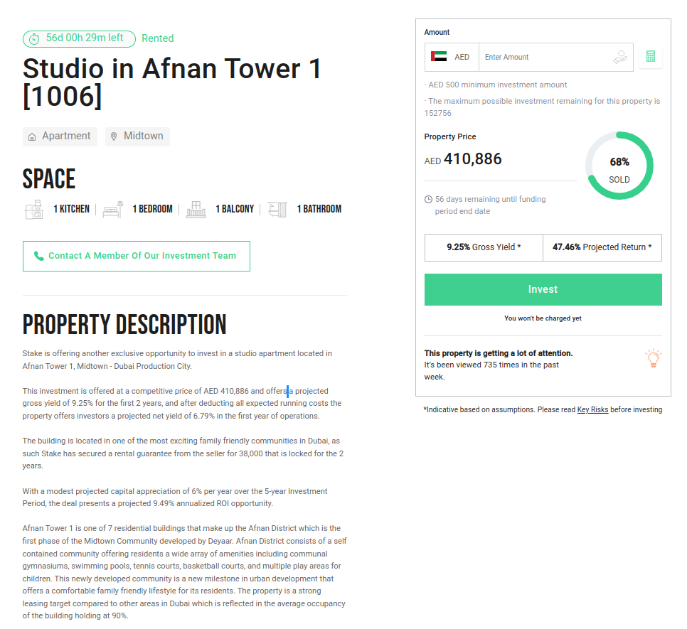

**API Endpoints Listing for UI Experience for Investor Portal :**

* Investor Registration and Profile creation
  + Minimal : POST
  + Full : PUT
* Authentication & Authorization : POST
* Dashboard Data : Summary and investment cards : GET
* Likes / Interest markers update : POST / DELETE
* History / Listing of Likes : GET
* Project / Investment proposal details, deal / financial worksheet : GET
* Investment booking, workflow to complete investment and cashflow : GET + POST + PUT
* Summary of Investments / Cashflows : GET GraphQL query ?
* Tax Summary / docs : GET GraphQL ?

**API Endpoints Listing for UI Experience for Enterprise Portal :**

* Enterprise Registration and Profile creation
  + Minimal : POST
  + Full : PUT
* Authentication & Authorization : POST
* Dashboard Data : Summary and investment cards : GET
* Project / Investment proposal details, deal / financial worksheet : POST
* Summary of Investments across investors: GET GraphQL query ?

**API Endpoints Listing for UI Experience for Advisors:**

* Advisor Registration and Profile creation
  + Minimal : POST
  + Full : PUT
* Authentication & Authorization : POST
* Dashboard Data : Summary and investment cards : GET
* Tag per investor Likes / Interest markers update : POST / DELETE
* Tag per investor History / Listing of Likes : GET
* Project / Investment proposal details, deal / financial worksheet : GET
* On behalf of investor Investment booking, workflow to partially fill in investment and cashflow : GET + POST + PUT
* Summary of Investments across investors: GET GraphQL query ?

**Gamification**:

Ref FISP_FSD for requirements description.

Alternate and comprehensive experience of the platform to be provided in this interface