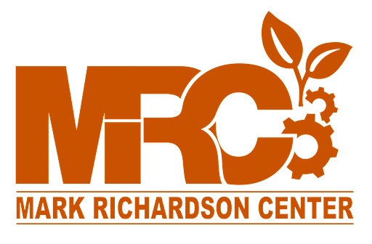
Panorama Project Reflection
DIGITAL ARTS 1A • MARK RICHARDSON CENTER
Name: ___________________________________ Date: ____________________
Answer each question in complete sentences.
1. What worked well in your panoramas? What are you proud of?

2. What did not work, or what was tricky during shooting or merging?

3. What would you do differently next time to make a better panorama?

4. What did you like most about this project? And if you could shoot a panorama of anywhere in the world, where would it be, and why?

