CREDIT SCORING MODEL
End-to-End Machine Learning Project
Predicting creditworthiness using applicant financial and credit-history characteristics.

1. Executive Summary
This project develops an end-to-end machine-learning credit scoring system using the UCI Statlog German Credit dataset. The objective is to classify applicants as good or bad credit risks while emphasizing model interpretability, cost-sensitive evaluation and professional visualization.

2. Dataset
The dataset contains 1,000 applicants and 20 predictor variables. Variables describe checking accounts, credit history, loan duration, credit amount, savings, employment, installment burden, property, housing, existing credits and other applicant characteristics.
Important limitation: the dataset does not contain a literal annual-income field. Therefore, income is not invented. Financial capacity is represented using the available credit amount, installment rate, checking/savings status and related variables.

3. Model Performance
model | accuracy | precision | recall | f1 | roc_auc | pr_auc
Random Forest | 0.7750 | 0.6190 | 0.6500 | 0.6341 | 0.8107 | 0.6761
Logistic Regression | 0.7350 | 0.5402 | 0.7833 | 0.6395 | 0.7944 | 0.6194
Extra Trees | 0.7750 | 0.6923 | 0.4500 | 0.5455 | 0.7937 | 0.6105
Hist Gradient Boosting | 0.7650 | 0.6182 | 0.5667 | 0.5913 | 0.7731 | 0.6311

4. Exploratory Analysis
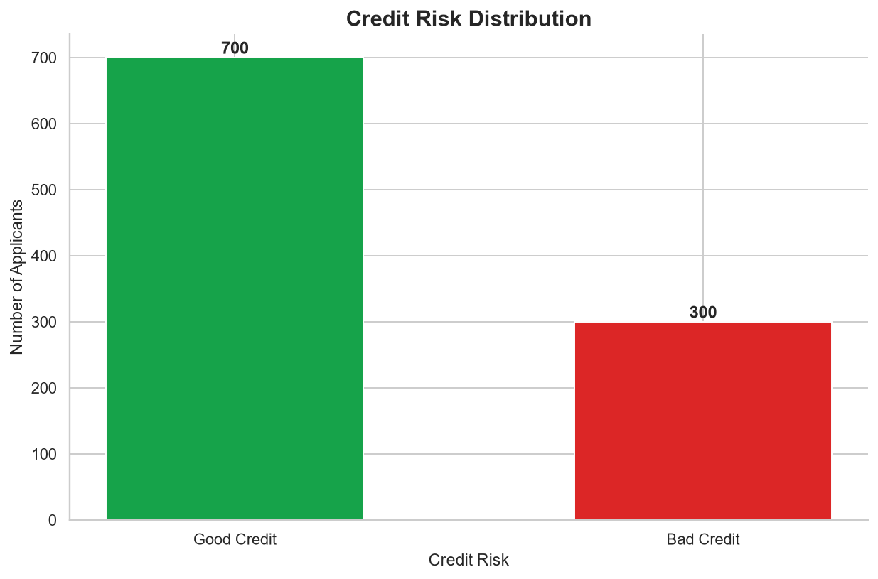
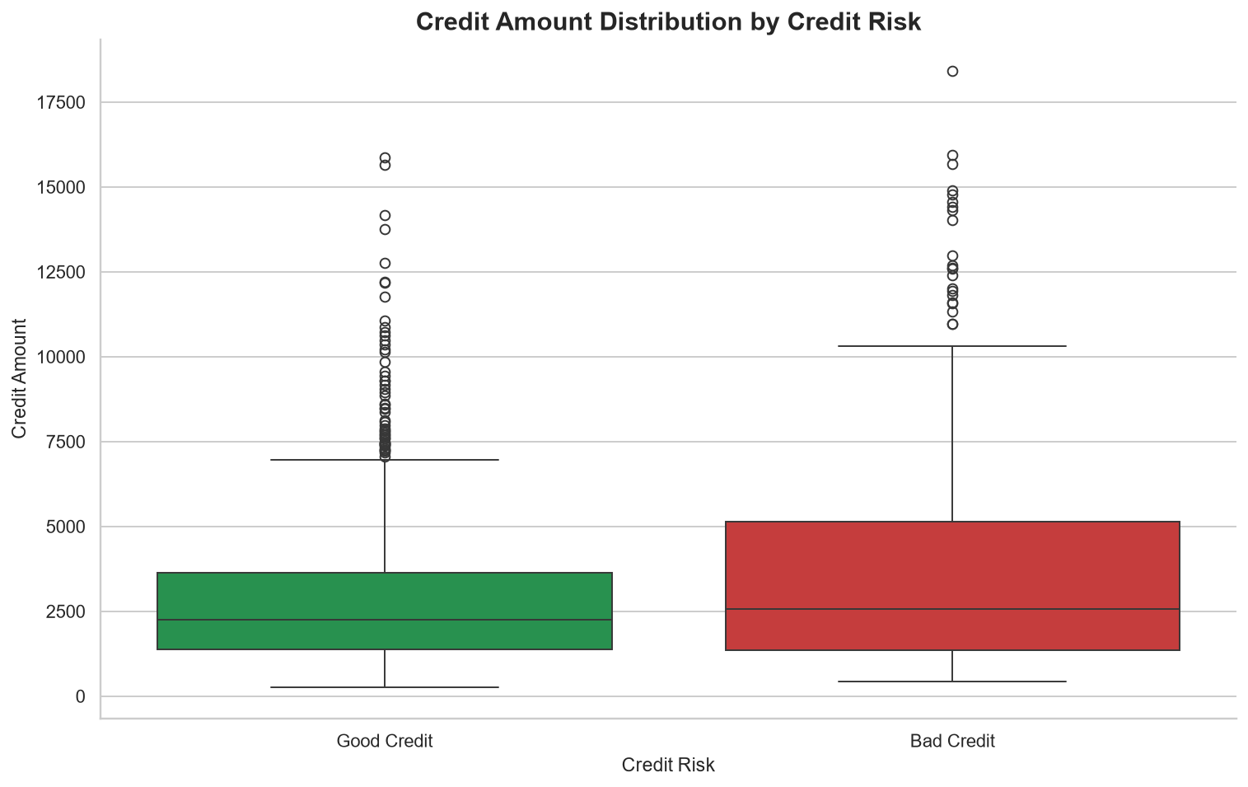
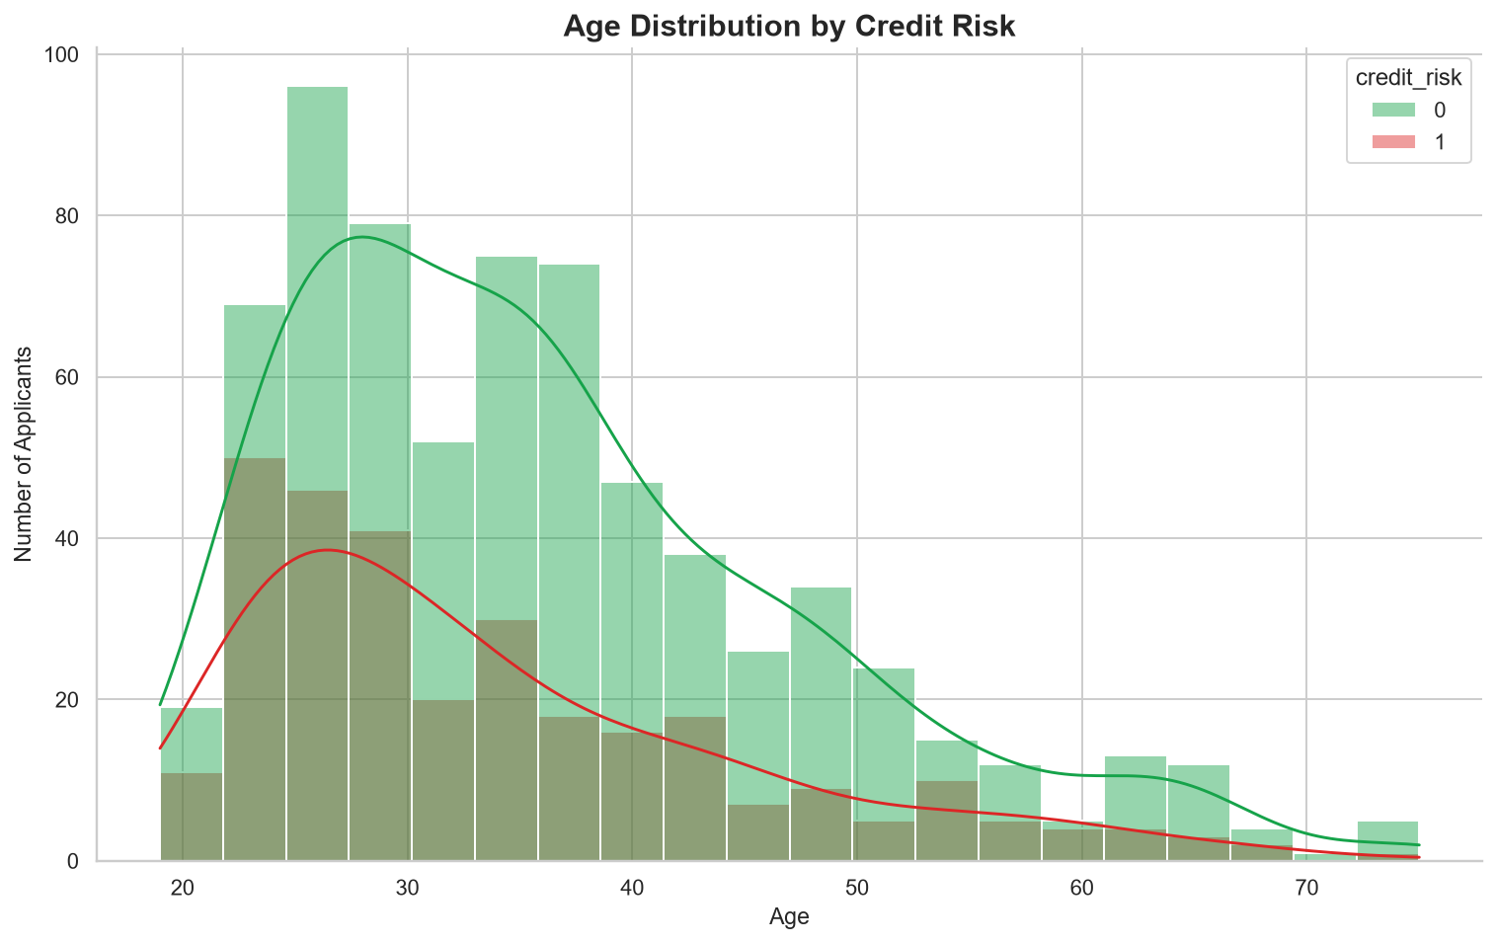
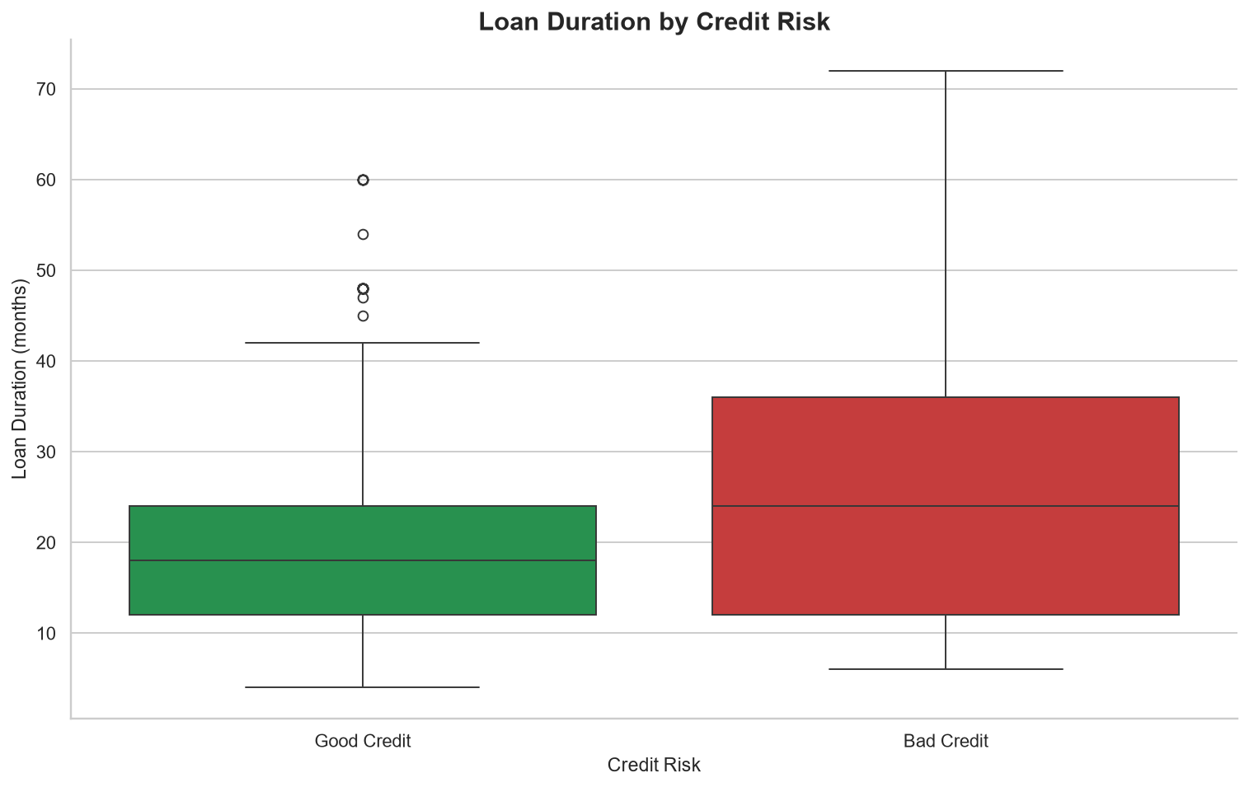
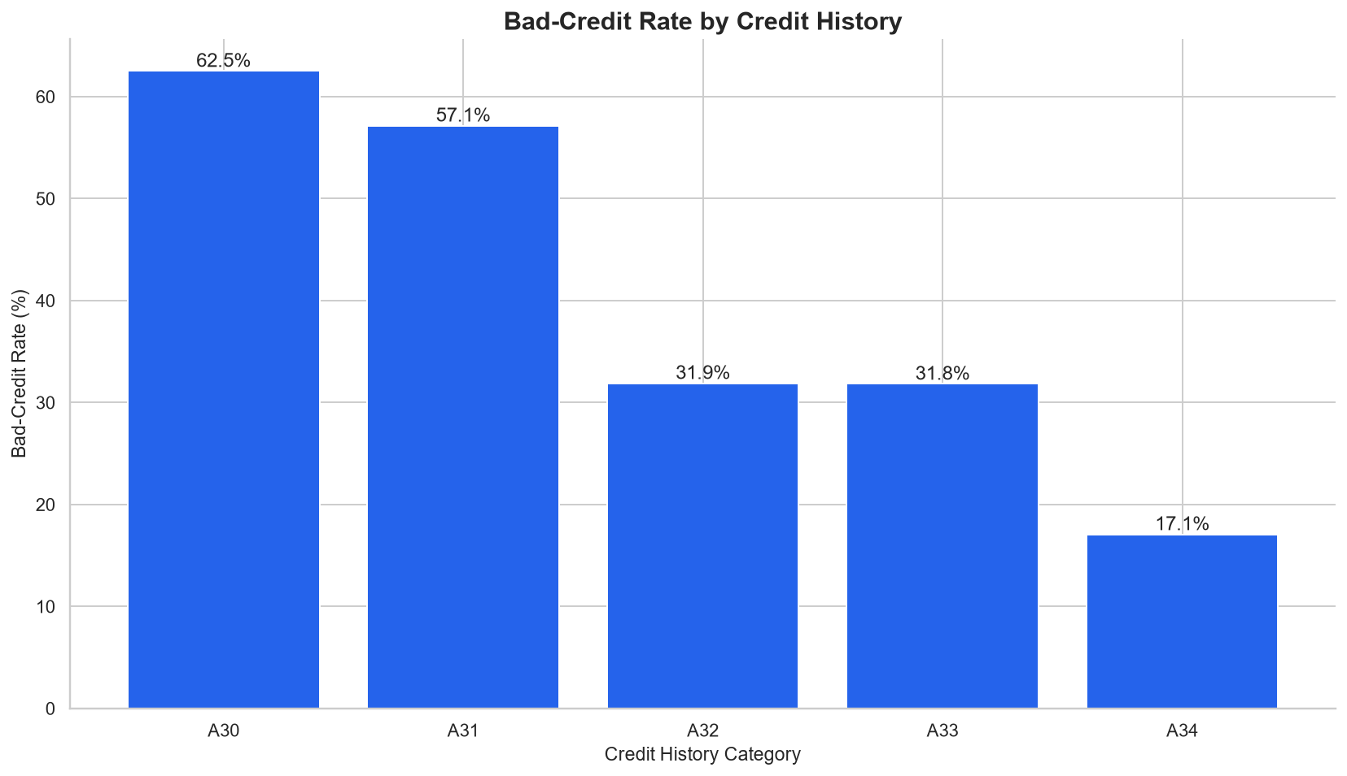
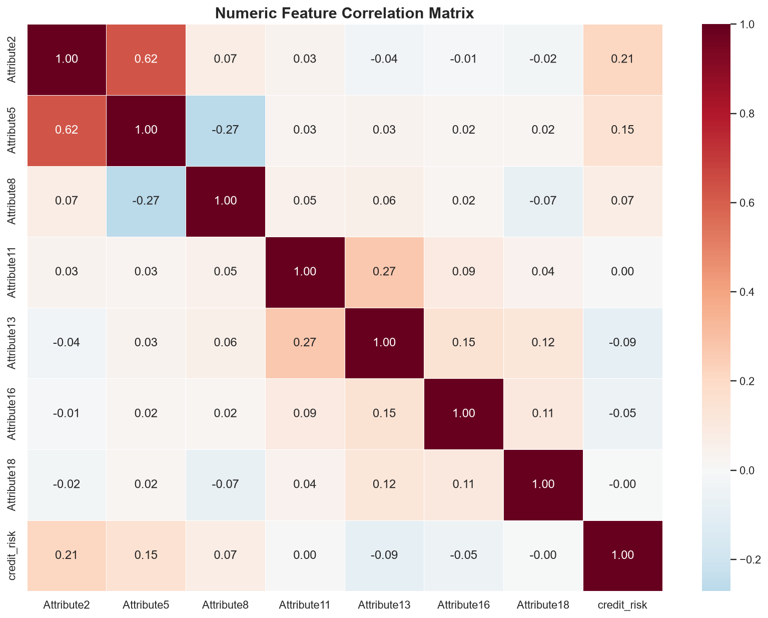
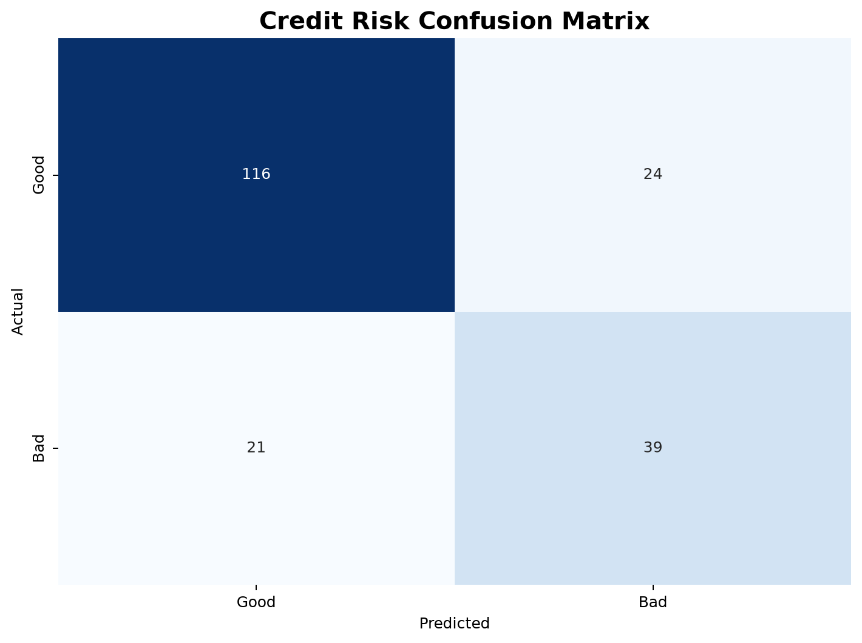
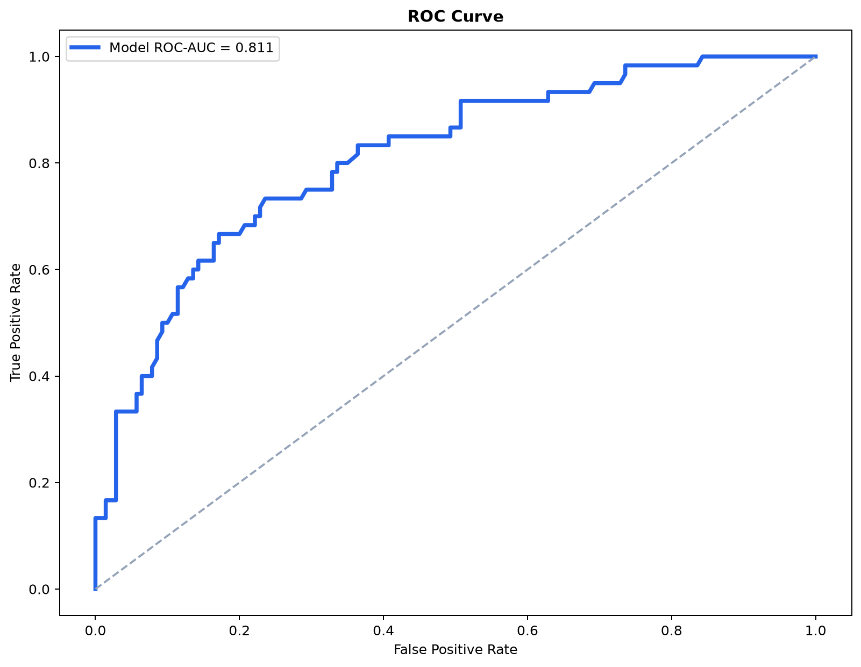
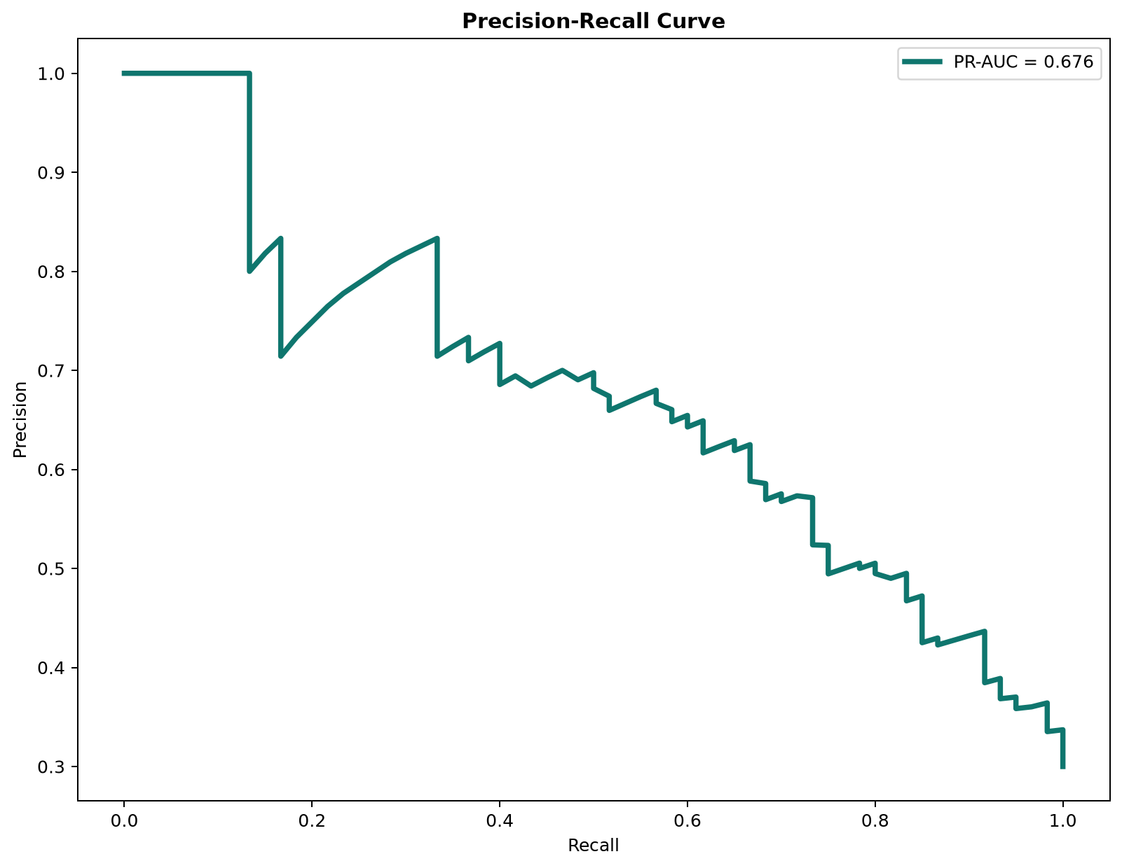
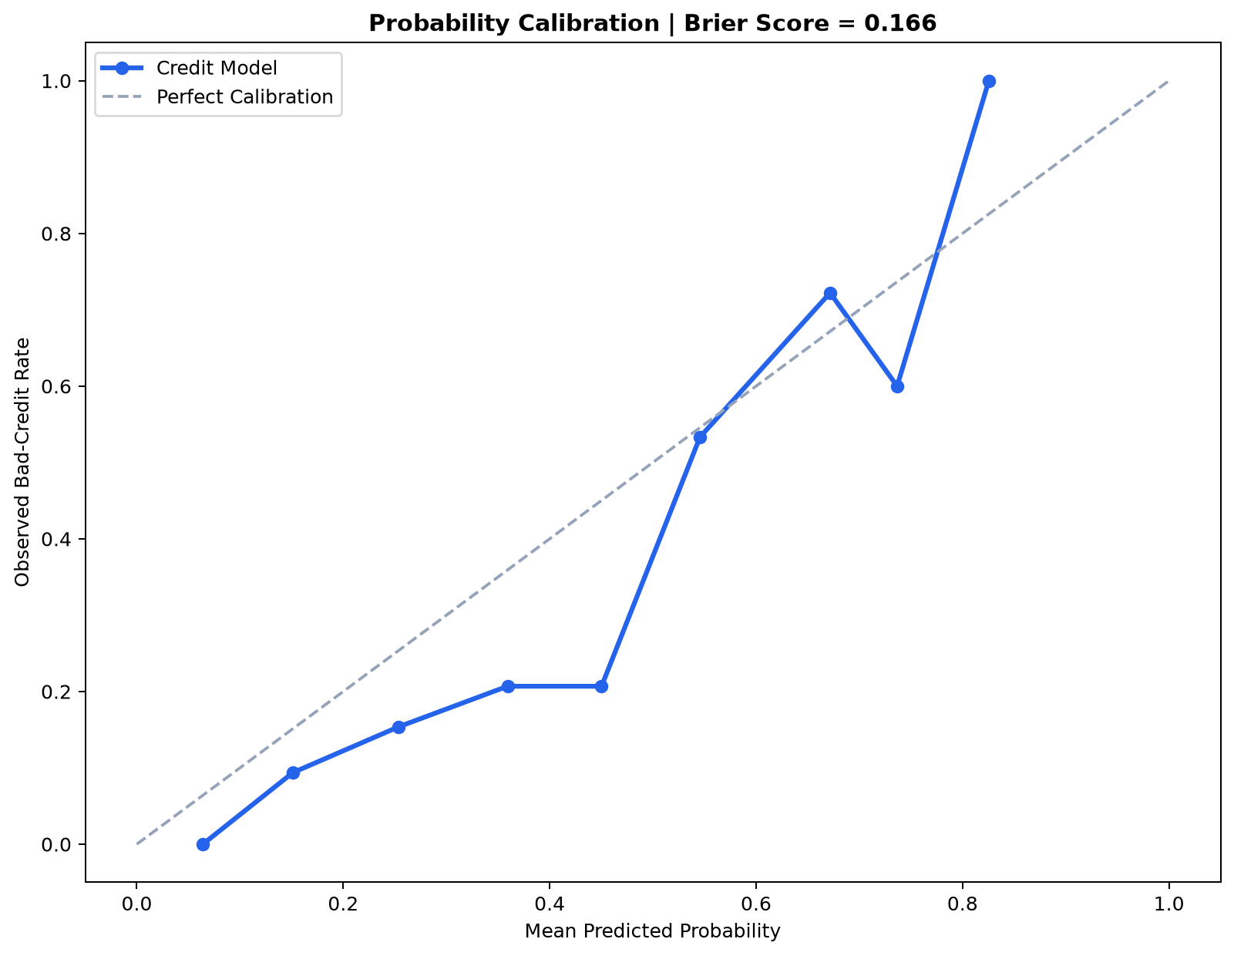
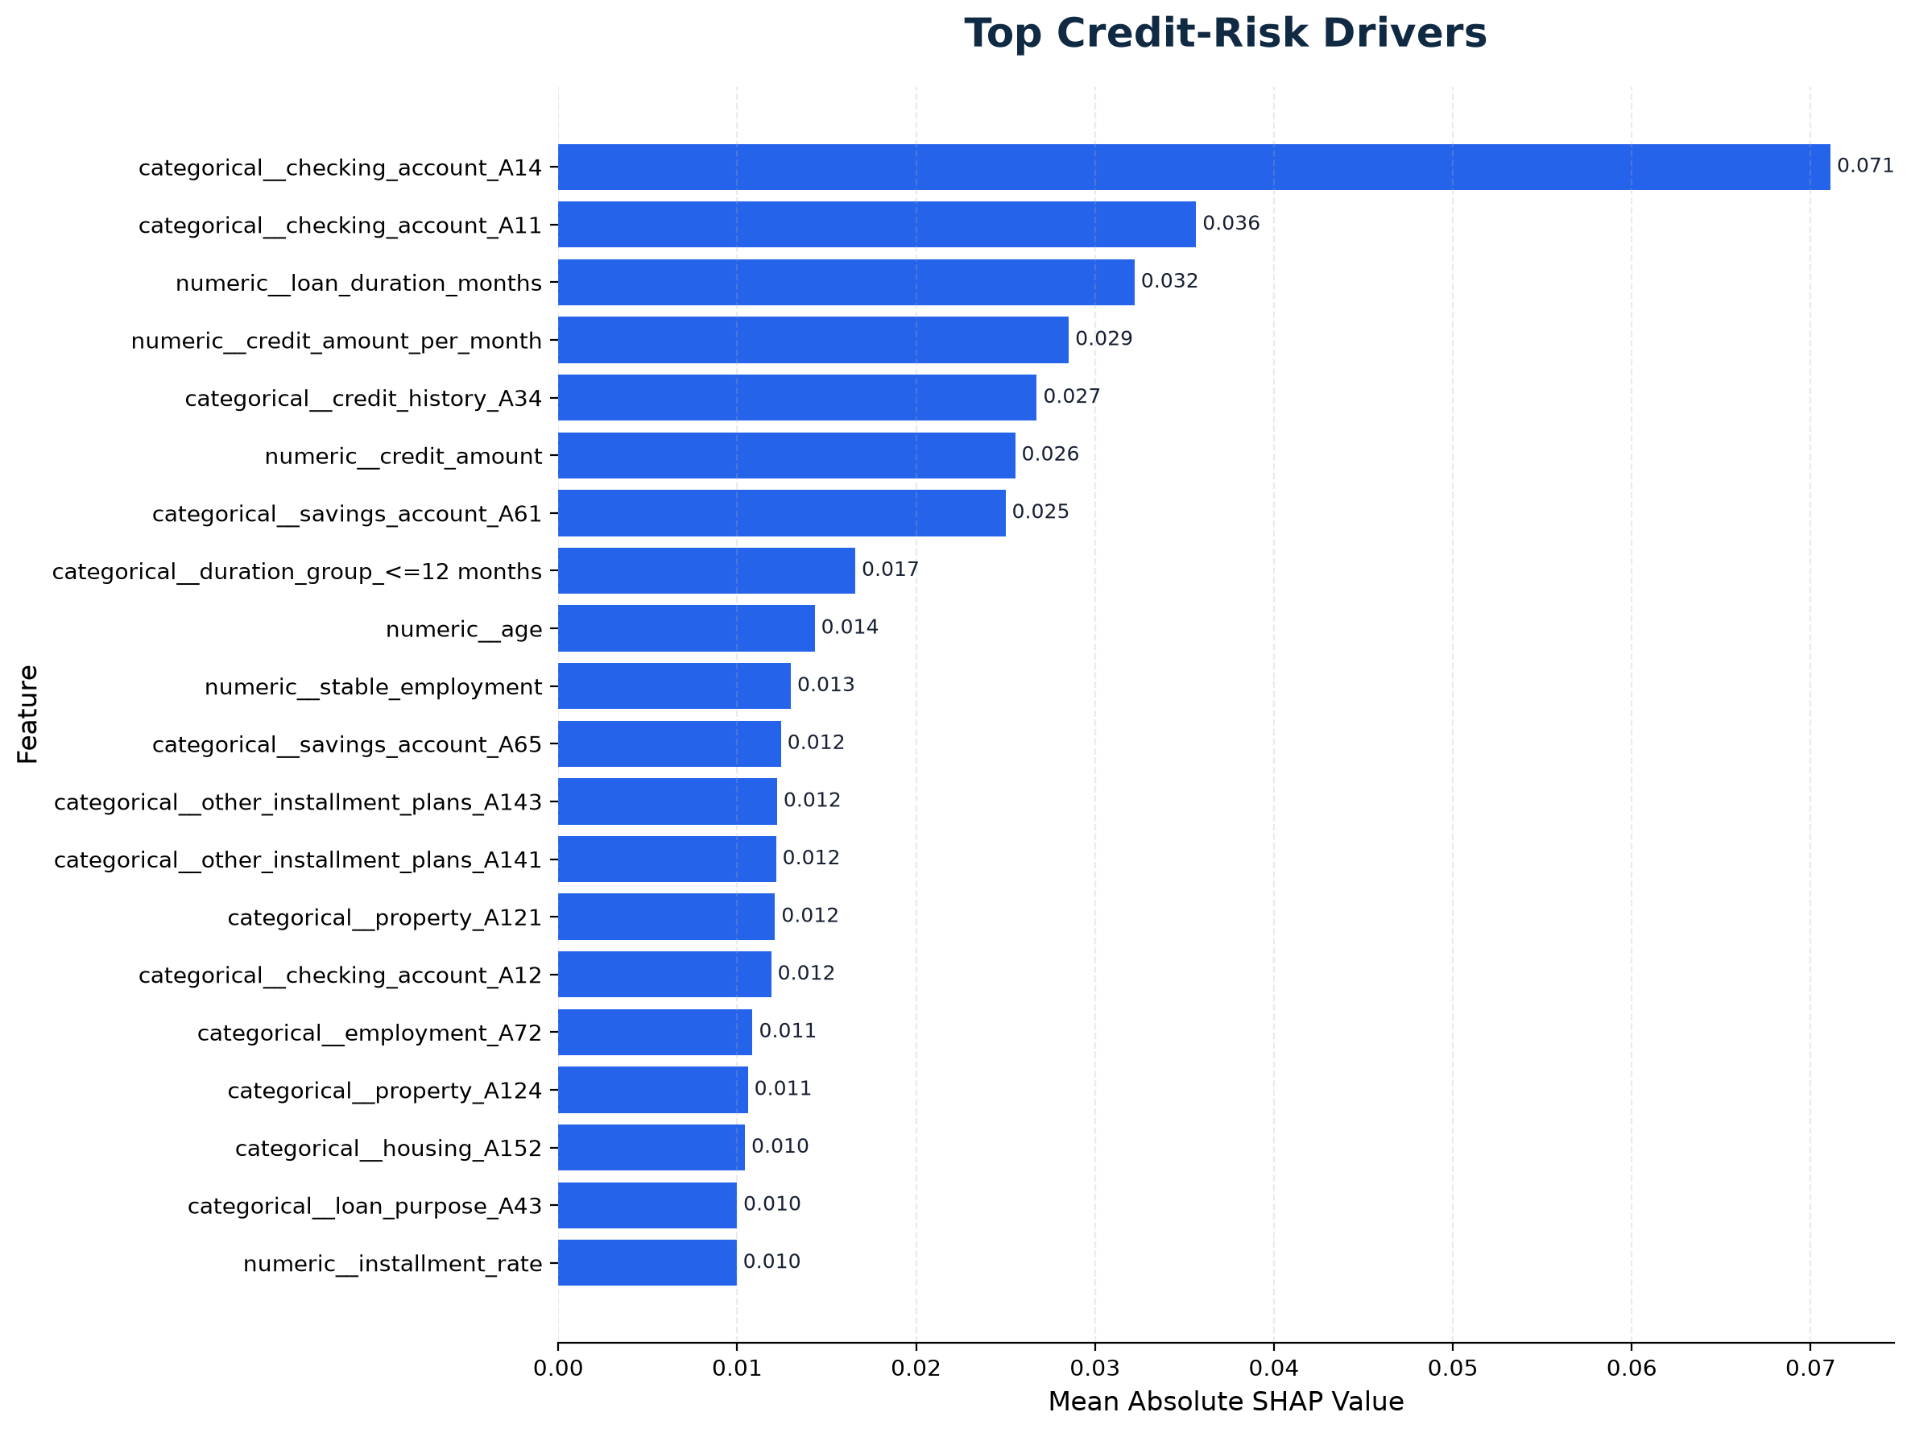

5. Conclusion
The resulting system provides a complete credit-risk workflow covering data acquisition, validation, exploratory analysis, feature engineering, model development, evaluation, threshold optimization, explainability and applicant-level prediction.
For production deployment, additional validation on recent institution-specific data, monitoring for population drift, probability calibration, fairness assessment, governance review and regulatory compliance would be required.

