Creativity Works’ Mental Health Creative Support Service
Report April 2012 – March 2013
Project Manager Philippa Forsey

Contents

Introduction Page 2
Outcome 1: Access to Services and activities Page 3
Satisfaction to activities Page 4
New Creative projects in B&NES Page 5
Evidence of Impact on Wellbeing and Health Page 6
Participant’s feedback on benefits of creative courses Page 7
Celebration and Events Outputs Page 8
Outcome 2: New Peer Support Groups Page 9
Summary of New Group Development Page 10 – 12
Feedback on individual and group progress Page 13
Feedback on group progress Page 14
Creativity Works Progression Process Page 15
Stages of Progression Page 16
Outcome 3: Signposting facilities Page 17
Outcome 4: Volunteering opportunities Page 18
Further Outcomes: Project Partnerships, Referrals
Community Venues and Digital Development Page 19
Additional Funding, Monitoring and Evaluation Page 20
Creativity Works monitoring and evaluation procedures Page 21
Creativity Works Artists and Summary Page 22
Recommendations Page 23
List of Appendices Page 24

Creativity Works’ Mental Health Creative Support Service Report
April 2012 – March 2013
Project Manager Philippa Forsey

The Mental Health Creative Support Service [MHCSS] provides a person-centred process of engagement and progression, which supports people with mental health needs in B&NES to take up opportunities in the community and support their transition from using mental health services to community, based activities.
The project is currently being delivered by Creativity Works in Bath and North East Somerset (B&NES) on behalf of B&NES Adult Social Care and Housing. The project is part of the Building Bridges to Well-being Commission, which is about to enter its third year of operation in partnership with St. Mungo’s and Sirona
The success of the service depends upon:
- Creativity Works’ innovative Creative Progression Process developed from 8 years of participant-led delivery and evaluation of the service and which involves and includes participants in developing direct involvement in service provision and in developing a ‘voice’ which helps to inform and shape services
- Provides participants with access to meaningful and inspiring creative activities which assist them to develop a sense of purpose, gain new skills and move towards independent living
- Strong delivery partnerships with St. Mungo’s and Sirona
- Strong links with statutory mental health services, community and culture which explore the extension of the service to address prevention initiatives

Creativity Works delivers creative projects to address three main areas:

- Wellbeing and Health
- Development and Progression
- Community Engagement

Outcome 1
Increased numbers of people with mental health problems have better access to community services and activities, which meet their needs and improve their health and wellbeing
Indicators
- Evidence of service user involvement in socially engaged activities across B&NES, which meet their needs, in which they express satisfaction.
- Evidence of service users experiencing improved quality of life, defined through their general health, contentment with life and subjective wellbeing
- Evidence of increase in community services and activities related to service users needs

Creative Project Delivery

Creativity Works delivers a range of creative taster workshops, engagement courses and projects throughout BANES. Taking part inspires people to develop their creative ideas, enhance their self-esteem, and improve their health and well-being through engagement with socially inclusive creative activity. Participants / mental health service users are supported to attend tasters and engagement courses managed by Creativity Works in partnership with organisations such as: AWP, St. Mungo’s; New Hope; Genesis; Sirona Re-ablement Service, Floating Support, Supported Living Services; Personal Support Workers etc.

Project Outputs
- 13 new creative projects across Bath & North East Somerset
- 125 sessions April 2012 – March 2013
- 107 total enrolments, 760 total attendances
- 3 projects attracted further funding through partnerships with 3 local Children’s Centre Services to support vulnerable families living with postnatal depression
- Participants voices and needs influence the delivery of the MHCSS through regular monitoring and evaluation sessions.
- 5 new creative community peer support groups supported

Project manager devises projects in partnership with other organisations, artists and people with lived experience of mental health needs aim to devise projects based on feedback and advice from people with lived experience of mental health and participants who have been on courses. Course facilitators are chosen because of their ability to be flexible and responsive to defining outcomes of the projects with participants and so meet the needs of people they work with. The socially engaged approach of Creativity Works artists is a major factor in enabling participants to reach their goals and to make wider links with community and culture.
The projects positively affect:
- Increased learning of new skills in creative thinking and creative arts inspire wider aspirations and motivation.
- A social prescribing approach to the projects to address early intervention and includes support for severe & enduring mental health.
- Participants feedback very satisfactory involvement in activities appropriate to their interests and needs

Satisfaction of the service  - 121 people say they are very satisfied with their experience of the service  - 96% of participants very satisfied and satisfied with their experience of the service  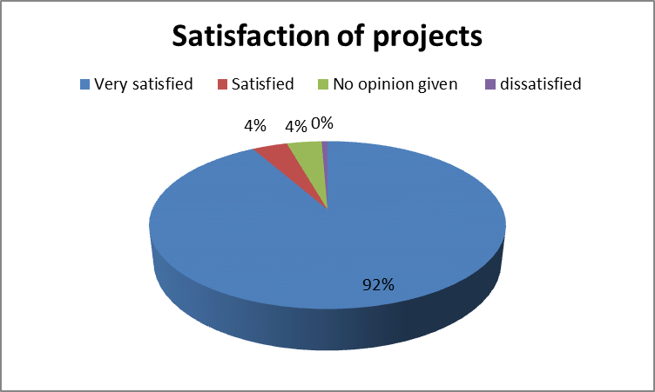 | Participants’ feedback on their satisfaction with the creative courses  Happiness and relaxation and friendship  When depressed provided something positive to do with my time.  Good to meet other people.  Don’t feel so down, have something to look forward to  Nice atmosphere. The statement to try not to criticise your work and have positivity makes a huge difference  Made me more relaxed. Don’t feel so tense here using my mind, imagination and thinking of new ideas.  Something to look forward to  Made me feel better in myself  It has been run very well, very friendly, welcoming and supportive tutor  A truly satisfying feeling of moving forward into a new way of life due to building of confidence. Opened my eyes to life completely with a mixture of creative writing and creativity
Appendix 2. Full project evaluations in attached document ‘MHCSS Course Evaluations 2012 - 2013’
New creative projects in Bath and North East Somerset (Mental Health Creative Support Service)
      - Healing Words - Creative writing and storytelling to explore the inner well of the imagination and life experiences
Town Hall, Midsomer Norton Library (7 enrolments, 12 sessions)
      - Wellbeing for Words - using the creative medium of words to support people on their journey towards greater wellbeing
Midsomer Norton Library (9 enrolments, 8 sessions)
      - Breathing Space - an art project designed to help people who have found themselves feeling lonely or disconnected and are having problems with anxiety and depression
Keynsham (12 enrolments, 7 sessions)
      - Looking Out – a creative course taking inspiration from local surroundings
Radstock (9 enrolments, 8 sessions)
      - Soul Dances - A fun movement class for everyone that relaxes and nourishes mind and body
Central Bath (6 enrolments, 8 sessions)
      - My Time My Space – a project for women experiencing low mood or postnatal depression and Saturday family sessions
Radstock (8 enrolments, 10 sessions)
      - Singing - an opportunity to sing in different styles, meet new people, gain confidence and develop the voice
Central Bath (17 enrolments, 43 sessions)
      - Tiny Monuments - a mixed media, collaborative arts project for individuals to express opinions about their life experiences in a positive way
Holborn Museum and Percy Centre, Bath (21 enrolments, 21 sessions)
      - Journal and Poetry Writing - exploring reading and writing poetry to develop and support your writing
Bath City College (9 enrolments, 4 sessions)
      - Creative Individuals - develop their creative writing skills, promoting wellbeing and confidence
Bath central Library (9 enrolments, 2 sessions)
Further successful funding from 3 B&NES Children’s Centres enabled:
      - My Time My Space – a project for women experiencing low mood or postnatal depression and Saturday family sessions
Radstock (7 enrolments, 12 sessions)
      - My Time My Space – a project for women experiencing low mood or postnatal depression and Saturday family sessions
Keynsham (9 enrolments, 11 sessions)
      - My Time My Space – a project for women experiencing low mood or postnatal depression
South Bath (10 enrolments, 5 sessions)
Evidence of Impact on Well-being and Health, Development and Progression and Community Engagement

Wellbeing and Health | Development and Progression | Community Engagement
Mental Wellbeing  Aspirations  Optimism  Relaxation  Confidence  Self Determination | Creative Potential (new ways of expressing communicating)  Interest in others  Dealing with problems  Trying new things  Motivation | Ability to get on with group members  Meaning and purpose  Interest in others  Closeness to others – feeling part of a group/ community
Participant feedback  Good to do something creative and meet other people.  Don’t feel so down, have something to look forward to.  Would feel more willing to have a go. I wouldn’t have come down here a few months ago. You feel relaxed here.  Knowing that I’m not alone with my mental illness  Brought me out of the house. Given me more confidence to go places gradually  Happiness and relaxation and friendship  A great deal of peace of mind  Has made me a happier person and more confident  ‘It’s made more of a contribution to my medical condition than anything else in years’ | I’ve made friends and I enjoy having space to relax, chat and be creative  Gives me something to look forward to knowing one day I get out.  I wouldn’t have thought about doing some of the projects.  This group is close in friendship and a lot of ideas flow’  More of an ability to express myself  Time to be creative in a very supportive atmosphere  Encouragement and support  Openness – open to exploring creatively – open to share emotions and concerns | Gave me a target to attend each week  ‘First thing I’ve come to in years’  ‘It’s good to know I’m not the only one. With depression and anxiety you feel alone’  You didn’t have to say why you were here, you’re just accepted for being here’  This group is special because of the social group’  It helped me in my understanding of other people  Pride in your work. Achievement – however small everybody is learning and growing  The set of new creative self-support groups helps provide services that meet the needs of people with lived experience of mental health.

Good to do something creative and meet other people * Gave me a target to attend each week * Good to meet other people * Doing something with your hands takes off the pressure. It’s therapeutic without feeling like therapy * It introduces you to something different you haven’t done before. Builds your confidence up which is a big thing * It took me 3 weeks to pluck up the courage to come. Now I look forward to it each week * Knowing that I’m not alone with my mental illness * We’re getting value for money rather than paying for care coordinators * I wouldn’t go to a group where there was a specific label of mental health. I don’t want to be labelled * I come to this group because it’s an art group not because I want to be labelled * I’m proud to be who I am and what I’ve been through * Helped give a structure to my week and a place to meet people * I do more exercise at home because of this * It has helped letting go of the cognitive and thoughts and coming back to sensations and feelings * Finding myself again and developing after being institutionalises and long hospital admission

Participant feedback on the benefits of attending creative courses

Celebration and Event Outputs

Creativity Works believes that the work produced by participants in our creative projects needs to be celebrated and we encourage them to work towards developing exhibition, publications, [including digital media] and performances which can reach a wider audience, raise awareness and help to reduce stigma.

Outputs  - 7 events delivered  - 26 sessions delivered at events  - 26 participant volunteers had roles at events  - Delivered to an audience of 577 people over the 7 events | Events  - The Black Dog Dinner Debate. A Co-created event led by participants, volunteers and artists involving to an audience about the links between creativity and mental well-being (May 2012).  - Creativity Works Co Create event ‘What is Socially engaged arts’ (June ‘12)  - Artists and participants evaluation review to influence future delivery of MHCSS (July 2012, 6 participants, 6 artists)  World Mental Health Day Guildhall, Bath – 8 creative sessions, some run by participants. 127 people sign in, 23 people running stands, 11 workshops. 33 people left comments overwhelmingly positive (Oct’ 12)  - Arts and Health South West AGM and member’s conference. Delivered a session on ‘What is patient/ service user involvement’, 4 volunteers from Tiny Monuments ran a creative evaluation and their model of working (Nov 2012).  - Health professionals’ event to promote the value of creativity and wellbeing and help promote referrals, Southdown, Bath. Attended by 8 heath visitors. (January ’13)  - Bath Literature Festival The Tiny Monuments self-run progression group develop and run a group exhibition of their work at Bath Library. A public opening and delivered 2 thought provoking ‘Meet the artist’ sessions in the week long event (March ‘12).

Outcome 2

Increase in peer support groups available, which assist service users to become self-supporting.
Communities develop initiatives that address local issues, providing local solutions to local needs.
Indicator
- Evidence of the set up of self support groups, networks, or social enterprises which are supported where required, and appropriate training, mentoring and advice offered.

Outcomes in progression and development of new peer support groups
- 5 new creative peer support groups start up
- 43 people involved in the set and management of 6 creative peer support groups
- 7 groups supported to apply for new funding through the St. Mungo’s fund and Quartet
- 6 successful fundraising bids by new peer support groups
- 1 person supported to enable a personal development course in ‘Speaking Circles’ for 6 individuals
- Creativity Works successful in a Quartet bid to support a network and on-going creative development for volunteers
- The reduction of use in Community Mental Health Services
- Rise in number of participants who access education, training, employment and volunteering
- The developments of networks of social support, where people with lived experience of mental health problems become experts in self-care and provide peer support.
- Creative projects have impact on individuals and their families as peer support groups strengthen positive experiences and social support networks

Creative Progression Process

Creativity Works has supported the development of 6 Progression Groups during 2012/13. These groups have evolved through a process of engagement, support and training to develop as community groups with a vibrant and inspiring focus around creativity and skills development rather than on their health problems. Participants experience varied means of expressing their issues through preferred art form choices and they are facilitated to develop and celebrate their ‘voice’. The Creative Progression Process treats people as individuals, as more than their illness and by working with real people/artists and working from venues based in the community they experience a tangible link with culture and mainstream community activities and services.
Summary of New Peer Group Development

Groups | Progress to date
Writing Space (previously Creative Individuals)  Bath library  Tuesdays 1 – 4pm | - MHCSS funding for Creative Writing group progress from Hay Hill to Bath Library Oct 2011 – April 2012  - Free use of Bath City College to plan May – August 2012 and support worker from St. Mungo’s  - St. Mungo's funding successful August 2012  - Group name themselves ‘Creative Individuals’  - Link with B&NES Quest project artist in residence  - Successful St. Mungo’s bid Sept 2012  - Hire of library space for 14 sessions Oct – Feb 2013  - Democratic approach to planning sessions and future group planning  - Facilitated sessions by D Davies  - Successful application to Quartet Feb 2013 for £1k  - Group renames as ‘Writing Space’  - Group member self publishes an anthology of poetry
Tiny Monuments Bath  Percy Community Centre  Wednesdays 10 – 1pm | - MHCSS funding for sessions during August – Sept 2012 including MHCSS and Arts Council funding  - Link with Holborn Museum during August 2012 for the delivery of 4 day long sessions involve 22 people, 4 volunteers and 2 facilitating artists.  - Successful funding from St. Mungo's £1.5k August 2012 enables group to continue with 1 facilitating artist  - Link with Somerset Film to make group film of work produced  - Hire of Percy Community Centre 14 sessions Sept – Dec 2012  - Group exhibition and presentation at World Mental Health Day Oct ‘12  - Group presentation and workshop at A&HSW Nov 2012  - Link with Bath Literature Festival and acceptance into programme  - Application to Quartet successful £2k November 2012  - Hire of PCC space for 20 sessions Dec – March 2013  - Democratic approach to planning sessions and future group planning  - Facilitation by D Davies and Jenny Thomas visual artist and curator  - Link made with B&NES Victoria Art Gallery for session on curation  - Exhibition and 3 events part of Bath Literature Festival March 2013  - 2 ‘Meet the artist’ sessions and Sale of artworks  - Application to Quartet Feb 2013 unsuccessful  - New application to St. Mungo’s fund £1.5k March 2013
Sing and Smile Bath  United Reform Church  Mondays 1 – 3pm | - MHCSS funding for Singing group enables progress from Hay Hill to United Reform Church Jan – Dec 2012  - 2 volunteers support group March – Dec 2012  - Link with Bath Church for Xmas concert Dec 2012  - Group members apply for St. Mungo’s funding Jan 2013  - United Reform Church grant free use of their venue Jan – March 2013  - Facilitation by artist Indigo Craig  - St. Mungo's funding successful Dec 2012 £1.3k  - New volunteer March 2013
Breathing Space Keynsham  Fridays 2 – 4pm | - MHCSS funding for group 8 sessions Oct – Dec 2012  - Referrals through CW and New Routes  - St. Mungo's funding successful Dec 2012 £1.2k  - Free use of St. Johns Church for planning meetings Jan – Feb 2013  - Link with B&NES Victoria Art Gallery for session on William Scott  - Democratic approach to planning sessions and future group planning  - Facilitated by G Huntley and B Dickson
Speaking Circles Bath  Nov – Dec 2012 | - St. Mungo’s support a service user to make a funding bid to run a personal development course in B&NES  - Creativity Works support the service user and delivery of the course in central Bath  - Course is evaluated and reported to St. Mungo’s
Hillview Art Project | - A Service user identifies the need for a creative project that improves Hillview psychiatric service accommodation.  - A steering group formed to support the development of a funding bid  - First funding bid unsuccessful Feb 2013
Inspirational Arts and Crafts Group | - Group supported to action plan short term and long term aims of the group  - Funding application written for Quartet  - Southdown Methodist church value the service the group brings to the community and agree to free venue hire
My Time My Space  Radstock  Mondays 10 - 12  My Time My Space Keynsham  Fridays 10 - 12 | - Funding attracted from Children’s Services and support from Sirona Health Visitors to support a 10 week courses May – July 2012 (Radstock) Jan – March (Keynsham)  - Women value the time and space and evaluation shows impacts on women’s mental health and family improving relationships  - Women from both courses continue to meet beyond the group for friendship and support in local community venues  - Keynsham group considering applying for funding Autumn 2013  - Funding attracted from Creativity Works and the project is profiled at the National Health Visiting Conference, Brighton Nov 2012. Interest from around the country.  - Project profiled in Community Health Practitioner April 2013
- Would be good to build on what we’ve done and try new activities.
Participants’ aspirations progress as result of taking part in the creative project
Participants and artists help shape a creative service and new volunteer roles
- Would like to continue here. Like these things, new ideas
- We could show work by the council offices. Would like to have an exhibition’
- Look at other things to help with chronic pain like relaxation, gentle exercise
- Getting myself out and about and meeting people
- Day by day. Love to do textile pattern making course
- Going to try and learn I.T. skills
- To do more creative activities again at home
- To do more art
- I’d like the group to continue
- Sing in the park. Sing to an audience
- Link with other art forms
- Follow through the development of your work – progressing ideas
- Having review meetings with everybody – very good

Creativity Works supports progression groups by encouraging them to work alongside volunteers, and some of our participants go on to provide volunteer and mentoring support and peer co-delivery. We work with other organisations to ensure that volunteers are properly recruited and receive the appropriate training and support to enable them to work effectively and safely in sometimes challenging community situations.
- Recruitment procedures and resources
- Mentoring, facilitation, safeguarding, mental health training etc.
- On-going support for volunteers and mentors to work alongside developing groups
Taking part in peer support groups results in:
- The reduction of use in Community Mental Health Services
- Rise in number of participants who access education, training, employment and volunteering
- The development of networks of social support, where people with lived experience of mental health problems become experts in self-care and provide peer support.

Feedback on progression groups  - Hearing each other has been really interesting. It has turned us into a really nice group. We have got on well and talk to each other about our group.  - Encouragement, feedback and picking out areas that are strongest in our work  - Encouragement helps you proceed with something. I’d like to write a story and pull something together. I would need some support. Perhaps a kid’s book or a story book.  - Endings can be perceived as beginnings – the desire to continue – build, grow, this energy creates something new  - Use end of sessions to reflect, draw together and what next? What else is available? | Participants’ feedback on how projects could be improved  - Don’t think it can. Always something different each week. Not pushy. Makes you relaxed  - ‘More numbers would mean it would make it more viable, yes that would be good. Some people might find it difficult to join a large group. If it was too big it would be difficult’  - Ability to recruit more participants – advertising, marketing of the courses  - Make more people aware of the courses, in local ‘freebie‘ paper. More flyers; Publicity in GP Surgeries, Swallows, NHS House, Community Options Team; who is not being reached?  - ‘My MH support worker didn’t know about it – lots of GP’s don’t know. They have bookmarks that could link on their computers they could use but they don’t’  - More sessions  - Mental health groups have a poor profile within the community – ideas need to change this profile  - Improve Visibility of the projects  - Case studies, blogs, exhibitions, live events, pop up gallery events  - Communicating with other groups / networking /sharing  - Develop an audience – a dialogue – INFLUENCE  - Everybody has to feel ownership – confidence – willingness to be seen by a wider public audience = image/ films/ performances/ works = bigger platforms – Internet  - EXPOSURE – people are interested in mental health issues – need to challenge the ‘hidden’

Creativity Works
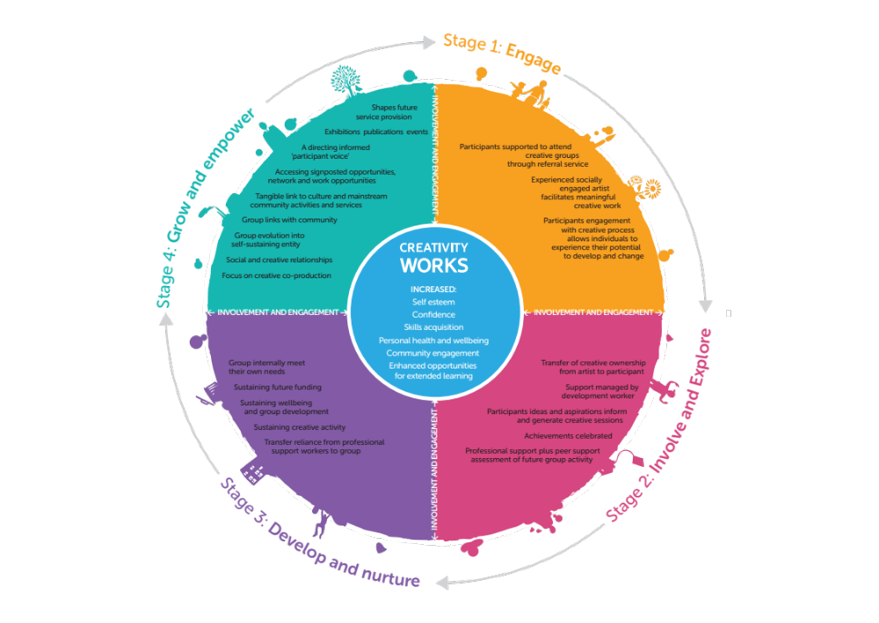

Creative Progression Process

Creativity Works has identified that participant’s progress through a minimum of 4 different stages on their journey to recovery and independence, and that they need different levels of support at each stage.
Here is a breakdown of each stage

Stages of Progression

Stage 1: Engagement and involvement is started by a structured course based around an art form, with participants supported to attend by a referral service e.g. the Re-ablement Service; Supported Living Services; Personal Support Workers, mental health support organisations etc. Participants gain confidence and self-esteem, which provide a springboard to continuing involvement.

Stage 2: The group, which continues to meet around a focus of creative activity, require carefully managed support. The lead artist and the Creativity Works Project Manager provide this. The group are supported to consider the benefits they have achieved and assess the potential for on-going creatively focused group activity led by their interests and based on their achievements so far. The group experience a growing sense of purpose and begin to develop a peer support structure. They are also made aware of and supported to take advantage of other courses offered through other organisations and community networks.

Stage 3: Moving on towards independent living is made possible as the group recognises that it wants to stay together and has a vibrant, inspiring shared identity and focus, based on their creative co-production. They are beginning to take greater responsibility and learn how to meet the needs of the group in terms of mental health, future funding, creative activity and ethos. They are making increasing use of community networks and training opportunities, and considering their future together as a group. They are increasingly interested in sharing their work through exhibition, publication or event and are able to voice and celebrate their achievements. Community Mentors, Personal Support Workers and Peer Support Networks support mental health needs.

The group continue to benefit from Creativity Works’ support when they are facilitated by Creativity Works artist support to gain learning and social outcomes through joint creative activity. Creativity Works’ Project Manager works with the group to note their achievements, plan for the future and complete funding applications to the Quartet Foundation, St Mungo’s and other sources. Participants are gaining confidence and skills and are able to support one another. Some members of the group are keen to deliver elements of project delivery themselves and others are taking on specific roles within the group. Again Community Mentors, Personal Support Workers and Peer Support Networks support mental health needs. Some groups may at this stage benefit from working with Social Enterprise and Work Development Services.

Stage 4: Independence is achieved and the group is able to manage their own needs within the community. The group feel supported by the roles required to keep the group going. They are confident in applying for funding from trusts and funding bodies. They are connected to community through tangible links with local community resources and other organisations.

Outcome 3
Evidence of the number of people aware of Wellaware (and other signposting facilities), and
Indicator
Increase in accurate and appropriate entries.

Outputs
Mapping of Creative Activity in B&NES
- Mapping of creative art forms in B&NES informs furthers community opportunities for participants.
- Project proposal of a B&NES wide Arts and Health project developed for a bid to ‘Time To Change’
- Mapping knowledge shared with St. Mungo’s to help update a local website built by volunteers
- Extra funding attracted from Arts and Health South West to enable a B&NES wide mapping of creative organisations
- Number of people who said they have heard of Wellaware = 1, not heard of Wellaware = 12
(See full report Appendix 1. A Research Report on Arts and Wellbeing Practice within Bath and North East Somerset September 2012)
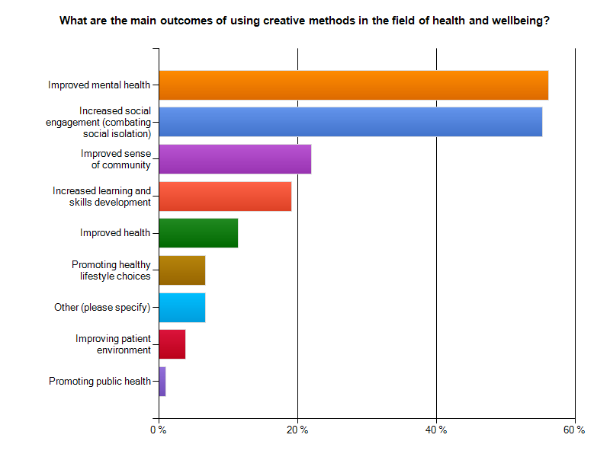
It is clear from the Mapping research that practitioners in B&NES predominantly aim to address mental health and emotional wellbeing through working with arts and creativity. When asked about the main outcomes of working in this way, improved mental health and wellbeing and increased social engagement were nearly equally rated as the key outcomes. This indicates social isolation is a major benefit derived through arts and creative approaches, although it may not have been the original driver for the activity. Social and community aspects are integral to the arts and wellbeing approach to improving the mental and emotional health of individuals
Outcome 4
People are supported and encouraged to take up volunteering opportunities in a social context
Indicator
Increased number of volunteers

Outputs
- 32 people become involved in running volunteering their time to run their own new peer support groups
- 10 people are supported in volunteering roles to organise World Mental Health Day
- Programme of training devised with St. Mungo’s for artists, participants and volunteers

Training and Development  In partnership with St. Mungo’s a programme of training was devised to support artists and participants/ service users. St. Mungo’s delivered free training for artist facilitators and participants of courses, which supported their personal and professional development.  This year’s training included:  - St. Mungo’s Training  - Recovery Training – 6 tutors 6 participants  - Boundaries Training 6 tutors, 6 participants  - Peer Facilitation Training – 1 tutor, 3 volunteers  - Creativity Works Co-Create events  - What is socially engaged art?  - What is development and progression?  - Mind Mental Health First Aid – 6 tutors | Creativity Works Co|Create Programme  Creativity Works depends upon the quality of the artists that we work with to help us to achieve the outcomes that support our partner’s work. We work with artists who are skilled and experienced in their art form and also in working in community and health settings.  - Provision of Jointly delivered Networking/mentoring session for artists, volunteers and support workers.  - Increased work opportunities for artists  - Year round programme of training and professional development in partnership with St. Mungo’s and other organisations for artists who deliver social, health community engagement and learning outcomes  - Pool of artists trained and supported in delivering agreed outcomes  - Artists benefit from Creativity Work’s comprehensive support systems which facilitate the delivery of socially engaged arts project  - Set of toolkits and resources to support artists professional development to deliver stated outcomes  - Participants benefit from artists improved facilitation skills
Further Outcomes

Project Partnerships
New partnerships have supported the referrals into the creative projects and the delivery of projects and events across B&NES
Partnerships have been formed with the following organisations to support creative project delivery, referral processes, attendance at creative projects, advertising, progression and development opportunities beyond initial creative courses to community events and activity:

Partnership Organisations  AWP Older People Liaison Team  AWP Older People Therapies Team  AWP Recovery Teams  Bath Library  Bath Literature Festival  Bath College Community Learning Service  First Steps Children’s Centre  Keynsham Children’s Centre  New Routes, The Care Forum  Radstock Children’s Centre  Sirona, Community Options Team  Sirona Health Visiting Teams  St. Mungo’s Building Bridges Service | Referrals  Creativity Works (9)  Through my GP (2)  New Routes (7)  Word of mouth (6)  Hay Hill (1)  Psychological Therapies Service (1)  Through social worker (1)  Sirona Health Visitors (18)  Community Options Team (6)  AWP (6)  Genesis (6)  DHI (1)  Julian House (1) | Community Venues Used  Bath Artists’ Studios  Bath Library  Keynsham Children’s Centre  Guildhall, Bath  Hay Hill Church Hall  Holborn Museum  Manvers Street Baptist Church  Midsomer Norton Library  Percy Community Centre, Bath  Radstock Children’s Centre  Southdown Methodist Church  St. Johns Baptist Church, Keynsham  St. Nicholas Church Meeting Room, Radstock  United Reform Church
Digital Development
Creative projects include the following Blogs:
- My Time My Space Keynsham blog - http://elementalanita.wordpress.com a private review of the project process made by the artist and shared with participants
- My Time My Space Radstock blog - http://mytimemyspaceradstock.blogspot.co.uk/ a private review of the project process made by the artist and shared with participants
- Black Dog: www.theblackdogresidency.tumblr.com
Additional Funding
This year delivery has been had an extensive range of courses due to extra funding of £3,300 brought forward from last year in to this years budget. Three Children’s Centres commissioned work with families experiencing mental health issues and enabled the My Time My Space project to run across times for 4 projects. Also additional funding from Arts and Health South west enabled the B&NES Mapping project. Creativity Works has been successful in attracting National Portfolio Status (NPO) from Arts Council England as one of only 120 organisations in the UK in recognition of the charities work to meet social need. This funding has enabled capacity building support that will enable Creativity Works to continue and flourish. Bath Council Arts Development continues to support Creativity Works although due to Council cutbacks this funding has had to be reduced.

Monitoring and Evaluation
In recent years Creativity Works has undertaken research into social impact, working with partners to develop a research initiative, which was published as a Report in 2011. The Social Impact Research Report and Evaluation Framework was produced by The University of Bath, Dept. of Social Policy in partnership with Creativity Works and the Cultural Forum for the Bath Area. We developed a comprehensive Outcomes Framework, garnered from a variety of National and Regional sources. More recently we have revised this method and want to simplify how we evaluate and how we tell people about what is important to us to evaluate, and are developing a toolkit.
Evaluation Procedures | Tools and Guidelines | Research
- Creativity Works Handbook/toolkit  - methods  - tools  - reporting  - advocacy  - Creativity Works Project Management Guidelines and template  - Handbook and tools for artists  - Artist, co-ordinator and support worker training  - Artist project management support guidelines | - Tools  - Participant and Artist observation journals or diaries  - Creative Conversations and Focus Groups  - Individual Development/Learning Plans/Tools  - Questionnaires  - Other imaginative/playful tools | - Creativity Works will lead on the development of a long term research project with regional university/s, including a participative research element and wider community, cultural and health and social care delivery organisations, partners and commissioners  - Social Return on Investment and Cost Benefit Analysis

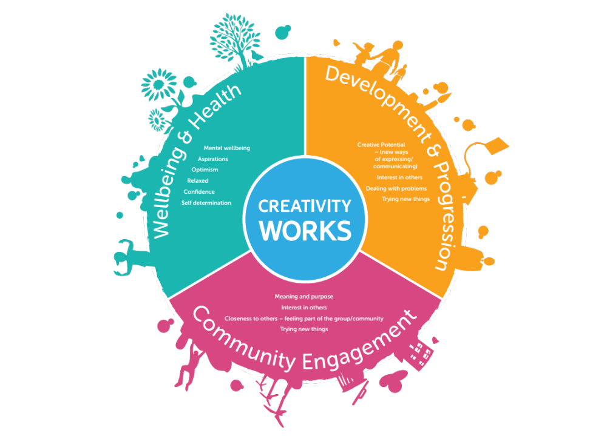 | - Creativity Works monitoring and evaluation is integrated within project delivery  - We evaluate wellbeing indicators [social and health], economic impact, audience development [arts and cultural engagement] and organisational performance  - Methodology is clear and comprehensive  - Policy includes academic rigour, general evaluation tools and methods of analysis [using consistent indicators develops strong evidence base over time], opportunities to provide advocacy to support increased delivery in key areas  - Policy and procedures are currently built around the Edinburgh Warwick Mental Well-being Scale and refer to/reference NEF Wellbeing indicators, the Mental Wellbeing Impact Assessment tools, Creativity Works' Outcomes Framework, NICE Guidelines and the EPDS (Edinburgh Post Natal Depression Scale). We also refer to the recommendations from the Social Impact Research Report from Dr. Barbra Teater and Dr. Mark Baldwin of University of Bath.  - Policy and procedures relate also to Clinical Commissioner Groups' need to provide Quality, Innovation, Productivity and Prevention and demonstrates how Creativity Works can help commissioners to meet their priorities and outcomes  - Where appropriate the use of Likert type scales to measure change  - Established process of collation and analysis of data, including thematic and statistical analysis  - Analysis feeds back into project development and provides evidence and advocacy to secure increased and improved delivery  - Data presented in imaginative ways, using reporting, charts, tables, case studies and visualisations  - Variety of tools support creative engagement and evaluation

With thanks to Creativity Works Artist Facilitators
The success of the Mental Health Creative Support Service would not have been possible without the knowledge and expertise of the artists on this programme. These socially engaged artists bring skills in listening, responding to the needs of their participants and providing inspiring and supportive sessions that link with the community and culture of B&NES and further afield. These skills have made these courses unique and bespoke and unlike anything else being delivered locally.
We are very grateful to: Anita MacCallum, Ben Dickson, David Davies, Georgia Huntley, Helen Moore, Itta Howie, Indigo Craig, Jenny Thomas, Jill Carter, Jo Plimmer, Marina Sossi, Paula Tew, Philippa Forsey

Summary

The Mental Health Creative Support Service delivered 10 creative projects across B&NES to over 100 people and 7 events, which reached an audience of over 570 people. Support of 6 creative peer-support groups, 5 of which developed this year has involved 43 people in volunteer roles and promoted greater connections with community and culture. Participants on the creative courses said they were very satisfied with the service and that it had helped them make connections with community and culture and develop social networks.

Working with 13 experienced artist facilitators in a wide variety of art forms from creative writing, to visual arts and dance has enabled people to express themselves in different ways and feedback shows that taking part has increased participants confidence, self esteem and promoted positive identity. Increased learning of new skills in creative thinking and creative arts has inspired wider aspirations and motivation and as a result outcomes have included people taking up new leisure interests, volunteering opportunities, returning to work and starting up businesses. With opportunities to share and profile work through celebrations, exhibitions and events at community and cultural events a sense of pride has been developed amongst participants and has helped reduce stigma around mental health issues promoting personal and encouraging stories in a positive light. These events have given the wider public opportunities to share their feelings about mental health and offered them a sense of support and inspiration.

The effectiveness of creative mental health support is shown through the 6 creative peer support groups that have continued to develop. Benefits to individuals include supporting each other’s creative aspirations and plans for the future, teamwork and shared decisions, enabling support through difficult times and helping to move ideas on. The groups help address social isolation and bring a new sense of purpose, which boosts motivation and aspirations. Participant volunteers in new creative groups have taken on roles such as fundraising, planning and booking venues to enable their networks to establish and keep connected.

There are greater connections with statutory, community and cultural organisations as a result of the creative groups and they are greatly valued by those that attend and other community organisations. The ‘voices’ of people with lived experience of mental health are enabling and influencing the design of new groups and services so helping to meet the requirements of local people with mental health issues.

Recommendations
- Continue to deliver creative projects across Bath and North East Somerset for people with lived experience of mental health
- Continue to integrate sustainable progression and development options within all creative course delivery
- Work with volunteer participants in the management of new group set-up and social enterprise
- Work with a Volunteer support worker to support the new progression creative art groups in their development.
- Progress and develop a volunteer policy and programme to support volunteers within creative groups
- Support training and development of artists, volunteers and participants as part of the Co|Create programme and in partnership with St. Mungo’s and other training providers
- Deliver the Supporting Employability and Personal Effectiveness accredited course (SEPE) which supports the development of employability skills through creativity
- Research other accreditation potential
- Continue to develop partnerships with statutory and community organisations to reach targeted areas of work and address early intervention and prevention
- Implement a PR and advocacy programme to raise the profile the MHCSS and support the referral of new clients to the service from health & social care professionals, GP commissioners and statutory and community services.
- Continue to support mapping of new information for signposting including Creativity Works fact sheets of creative groups, Wellaware and St. Mungo’s website
- Develop evidence of wider impacts and outcomes
- Celebrate outcomes and achievements

Appendices
Appendix 1. A Research Report on Arts and Wellbeing Practice within Bath and North East Somerset September 2012
Appendix 2. MHCSS Course Evaluation and Feedback 2012_13
Appendix 3. MHCSS Monitoring April 2012_13
Appendix 4. Report for B&NES evaluation April 2013

Creativity Works’ Mental Health Creative Support Service Report April 2012 – March 2013
Philippa Forsey, Creativity Works Wellbeing and Arts Project Manager, April 2013
philippa@creativityworksforeveryone.co.uk 01761 438852
www.creativityworks.org.uk

