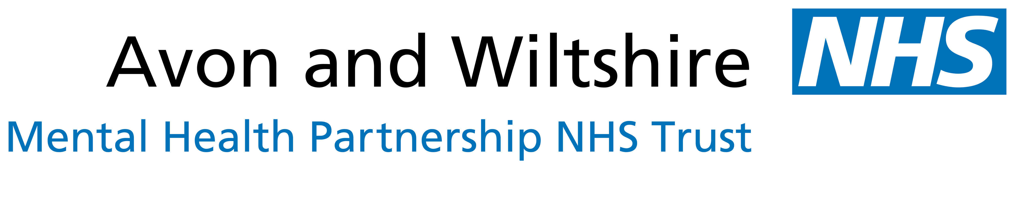

JOB DESCRIPTION

Title of post: Fresh Art@ worker (BANES)
Responsible to: Creativity Works Manager
Base: Hillview Lodge, Royal United Hospital, Bath, BA1 3NG
Time limit: One year – Pilot
Hours: 22.5 per week over 3 days

Job Summary:

This is a time-limited post to support the ‘Fresh Art @’ project. The post will be based at Hillview Lodge and working across 3 different clinical sites - Hillview Lodge, Bath NHS House & Ward 4, St. Martins Hospital. The Post holder will also attend meetings at Creativity Works in Radstock.
The job includes:

- Working with project partners to enable artists, service users and staff in enlivening the mental health clinical environments with fresh art
- Supporting the development of ‘Fresh Art@’ to stated venues
- Liaising with creative groups in the community, including BANES Museums, to promote social inclusion for AWP service users, friends & family.

Responsible to: Creativity Works Manager
Appraisal: Joint – Creativity Works and AWP

Line manager and supervision within AWP BANES: Lead Art Psychotherapist:

Other supporting staff to include:
- Involvement Coordinator
- Modern Matron
- Ward teams (Sycamore & Ward 4)
- Early Intervention / Recovery Managers
- R&D

Working with:
- AWP service users and carers
- AWP staff, both inpatient and community
- Volunteer artists and participants within creative projects
- Creativity Works
- Bath Museums
- Sirona
- Fringe Arts Bath

Job purpose:
- To support the planning, delivery, publicity and fundraising of Fresh Art@.
- To help enable AWP service users to access creative groups in their community
- To support quality engagement by participants and volunteers on projects
- To work within project timescales required by Fresh Art@ projects
- To support events and the curating of exhibitions in relation to the Fresh Art@ projects
- To undertake evaluation and documentation relevant to Fresh Art@
- To assist artists, volunteers, museum and mental health workers in designing and delivering workshops in AWP and community settings as appropriate

Management:
- To work in collaboration with project partners
- To support and motivate AWP service users and project participants
- To support creative activity and project planning with volunteers and participants
- To support the production and presentation of events and small exhibitions in relation to Fresh Art@
- Ensure health and safety requirements are addressed on all projects

Finance:
- Work with the Manager of Creativity Works and Fresh Art@ participants to ensure that the projects are delivered within the budget

Monitoring and Evaluation:
- Work with Manager of Creativity Works and AWP to implement effective monitoring and evaluation processes for the projects
- Contribute to the final report/s in collaboration with partners and steering group

Marketing and PR:
- Advocate for Fresh Art @ projects locally as appropriate
- Contribute to the marketing of Fresh Art @, working with the creative groups and participants

Governance:
- To undertake AWP induction and on-going mandatory training

Planning and General Duties:
- To undertake administrative duties connected with Fresh Art as required, including filing, photocopying, email correspondence, report writing
- To represent and promote Fresh Art@ and creative projects where appropriate

Conditions of Service (Summary):
- Timescale: 1 Year pilot
- Salary: £18,500.00 pro rata
- Special Conditions: The hours worked may require evenings and weekends
- Probationary period: 1 month
- The contract may be terminated by either party giving two week’s notice in writing

