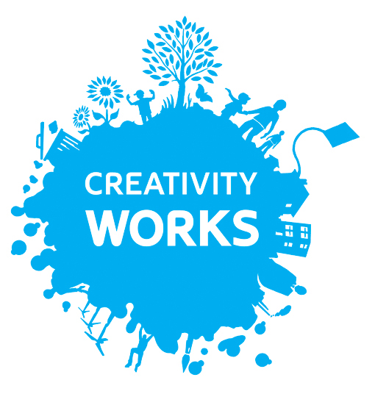

**Creativity Works Job Description**

Office and Project Assistant

Part time: 22.5 hours per week

Responsible to: The Director of Creativity Works

**Job Purpose:**

To work with the Staff Team to assist in the administration, management, and promotion of Creativity Works projects and events, and to be responsible for data collection and input

**Key Duties:**

* Manage promotion, bookings and other arrangements for Creativity Works’ co|Create programme of artists training, support and development
* To be responsible for the management of the new database including inputting data and creating reports
* To take a lead on the management of IT/media installation

**Key Tasks:**

* Assisting the staff team to implement, maintain and manage the new database
* To collate, input and disseminate monitoring and evaluation data from projects and events
* Assist in the management and production of marketing materials, including invitations, art work, posters, leaflets etc.
* To assist Staff Team with internal and external communications
* To co-ordinate the co|Create programme including making bookings, liaising with artists and participants alike, and implementing the marketing and comms strategy for the programme in collaboration with the Marketing and Admin Co-ordinator
* To manage all of the internal and external IT arrangements including use of email, computers and other equipment
* Attend and support staff meetings
* Attend and support Project Meetings – where appropriate
* Maintaining a specific Artists database

**General**

* To act in the best interests of Creativity Works
* To work within Creativity Works’ policy framework
* General administrative support
* To undertake any other duties and responsibilities commensurate with the post

|  |  |
| --- | --- |
| **Essential** | **Desirable** |
| **Availability on key dates** | |
| Interview: Fri 21st September 2018 |  |
| **Qualifications** | |
|  | Relevant qualification in administration and/or arts project management. |
| **Experience** | |
| Experience of general project administration | Experience of working as part of a team to co-ordinate events. |
| Production and management of marketing materials |  |
| Experience of using and maintaining a database | Experience of co-ordinating complex programmes of work |
| Organising and distributing marketing and PR material, both web-based and postal. |  |
| **Knowledge and skills** | |
| Knowledge of installation and maintenance of IT/media equipment and presentations on site | A thorough understanding of Office 365 |
| Commitment to and understanding of equality and diversity |  |
| Good Computer skills |  |
| Good communication skills both written and verbal, including the ability to speak on behalf of an organisation |  |
| Ability to develop and work within good health and safety and equality policies and practice | Ability to undertake risk assessments |
| **Personal Qualities** | |
| Ability to work well as part of a team |  |
| Strong self-motivation and ability to manage own time effectively with minimum supervision |  |
| The ability to respond positively/creatively to challenges and changes |  |
| A commitment to the aims and ethos of Creativity Works |  |
| Ability to work flexibly including some evenings and weekends |  |

**Conditions of Service (Summary)**

**Grade / Salary:** £21,500 pro rata

**Hours:** 22.5 hours per week (6 months initially with the ambition of rising to 30 hours thereafter)

# Special Conditions: The hours worked may require evenings and weekends.

**Pension:** Eligible to join **Creativity Works**’ stakeholder pension scheme to which the Board of Trustees make a 5% of salary level contribution.

**Based at:** Creativity Works, Leigh House, 1 Wells Road, Radstock BA3 3RN

**Overtime**: Overtime payments are not made. Time off in lieu is provided

**Expenses:** Travel during the course of Creativity Works business will be reimbursed and mileage paid at the current Creativity Works rate.

**Probationary period:** 12 weeks

**Notice period**: 4 weeks (by negotiation)