OOP LAB

Assignment – 01

**Q1. Write a java program to implement the following. Create two user defined arrays with different sizes (unsorted) then sort these arrays and finally merge them.**

**Solu.**

/*  
 * Copyright (c) 2021.  
 * Divyanshu Tyagi  
 * NIT Warangal  
 * 207919  
*/  
  
package Assignment1;  
import java.util.Scanner;  
  
/*  
Write a java program to implement the following. Create two user defined arrays  
with different sizes (unsorted) then sort these arrays and finally merge them  
*/  
public class sol1 {  
 public static void Sort(int a[]) {  
 for(int i = 1; i < a.length; i++) {  
 int j = i-1;  
 int ele = a[i];  
 while(j >= 0) {  
 if(a[j] > ele) {  
 a[j+1] = a[j];  
 }else {  
 break;  
 }  
 j--;  
 }  
 a[j+1] = ele;  
 }  
 }  
 public static void Print(int a[]) {  
 for(int i = 0; i < a.length; i++) {  
 System.*out*.print(a[i] + " ");  
 }  
 System.*out*.println();  
 }  
 public static void Input(int a[]) {  
 Scanner sc = new Scanner(System.*in*);  
 for(int i = 0; i < a.length; i++) {  
 a[i] = sc.nextInt();  
 }  
 }  
 public static void main(String[] args) {  
 Scanner sc = new Scanner(System.*in*);  
 System.*out*.print("Enter Size of first Array : ");  
 int n = sc.nextInt();  
 int a[] = new int[n];  
 *Input*(a);  
  
 System.*out*.print("Enter Size of second Array : ");  
 int m = sc.nextInt();  
 int b[] = new int[m];  
 *Input*(b);  
  
 *Sort*(a);  
 *Sort*(b);  
 System.*out*.println("Sorted Array 1 : ");  
 *Print*(a);  
 System.*out*.println("Sorted Array 2 : ");  
 *Print*(b);  
  
 // Merging of arrays  
 int r[] = new int[n+m];  
 int i = 0, j = 0, k = 0;  
 while(i < n && j < m) {  
 if(a[i] < b[j]) {  
 r[k++] = a[i++];  
 }else {  
 r[k++] = b[j++];  
 }  
 }  
 while(i < n) {  
 r[k++] = a[i++];  
 }  
 while(j < m) {  
 r[k++] = b[j++];  
 }  
 System.*out*.println("Final Merged Sorted Array : ");  
 *Print*(r);  
 }  
}

**OUTPUT:**

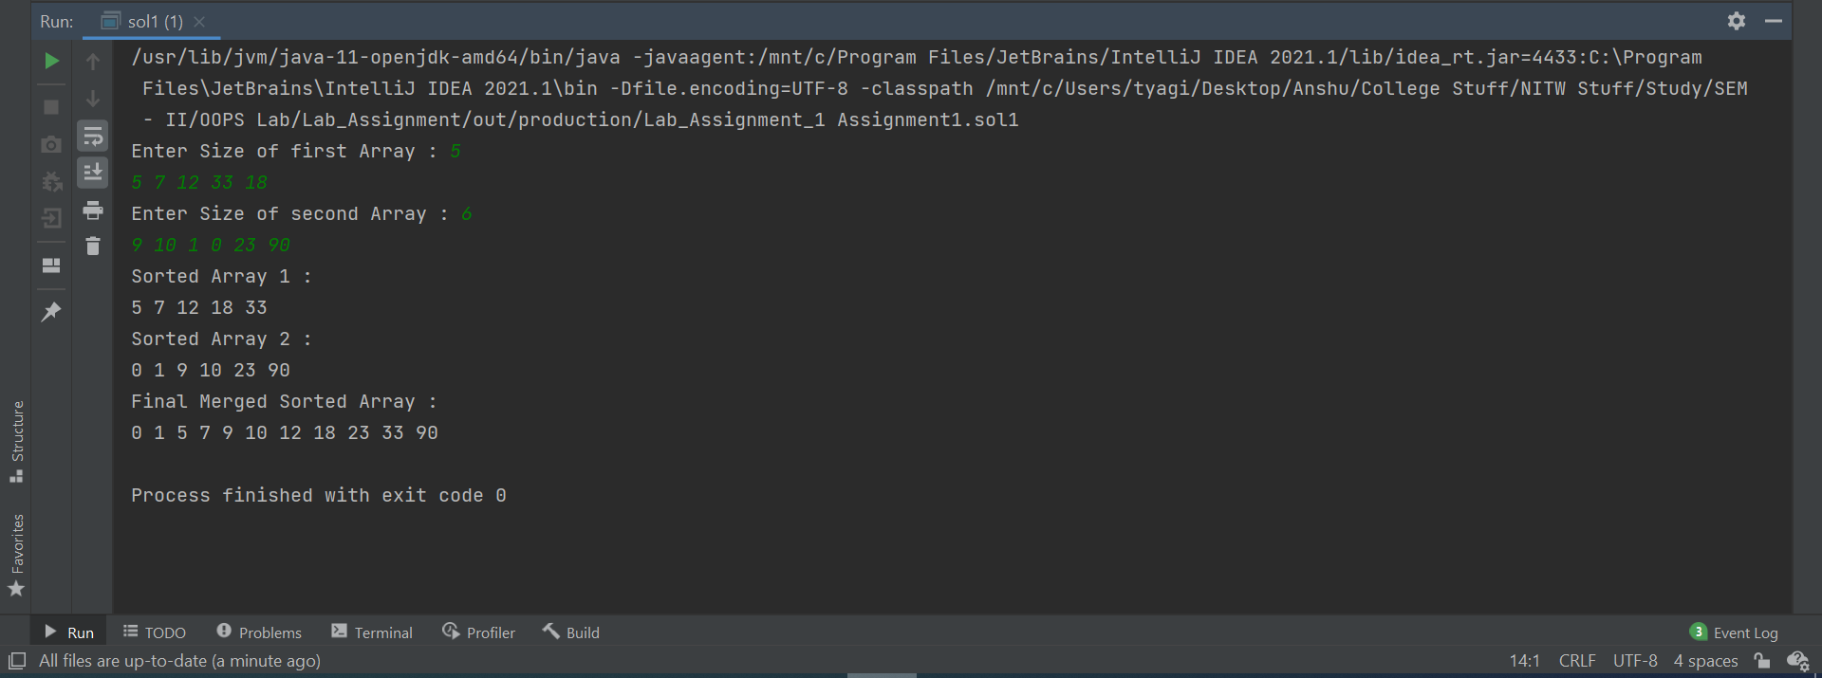

**Q2. Write a java program to determine whether a given matrix is sparse matrix or not. (Matrix should be user defined.)**

**Solu.**

/*  
 * Copyright (c) 2021.  
 * Divyanshu Tyagi  
 * NIT Warangal  
 * 207919  
 */  
  
package Assignment1;  
  
import java.util.Scanner;  
  
// Write a java program to determine whether a given matrix is sparse matrix or not.  
// Sparse Matrix condition : no. of zeroes should exceed (r*c)/2  
public class sol2 {  
 public static void Input(int[][] mat) {  
 Scanner sc = new Scanner(System.*in*);  
 for(int i = 0; i < mat.length; i++) {  
 for(int j = 0; j < mat[i].length; j++) {  
 mat[i][j] = sc.nextInt();  
 }  
 }  
 }  
 public static void Print(int[][] mat) {  
 Scanner sc = new Scanner(System.*in*);  
 for(int i = 0; i < mat.length; i++) {  
 for(int j = 0; j < mat[i].length; j++) {  
 System.*out*.print(mat[i][j] + " ");  
 }  
 System.*out*.println();  
 }  
 System.*out*.println();  
 }  
 public static boolean SparseCheck(int[][] mat,int r, int c) {  
 int zeros = 0;  
 for(int i = 0; i < r; i++) {  
 for(int j = 0; j < c; j++) {  
 if(mat[i][j] == 0) zeros++;  
 }  
 }  
 return (zeros >= (r*c)/2 ? true : false);  
 }  
 public static void main(String[] args) {  
 Scanner sc = new Scanner(System.*in*);  
 System.*out*.print("Enter number of rows of matrix : ");  
 int r = sc.nextInt();  
 System.*out*.print("Enter number of columns of matrix : ");  
 int c = sc.nextInt();  
  
 int mat[][] = new int[r][c];  
 *Input*(mat);  
 System.*out*.println("Matrix : ");  
 *Print*(mat);  
  
 if(*SparseCheck*(mat,r,c)) {  
 System.*out*.println("This is a sparse matrix");  
 }else {  
 System.*out*.println("This is not a sparse matrix");  
 }  
  
 }  
}

**OUTPUT:**

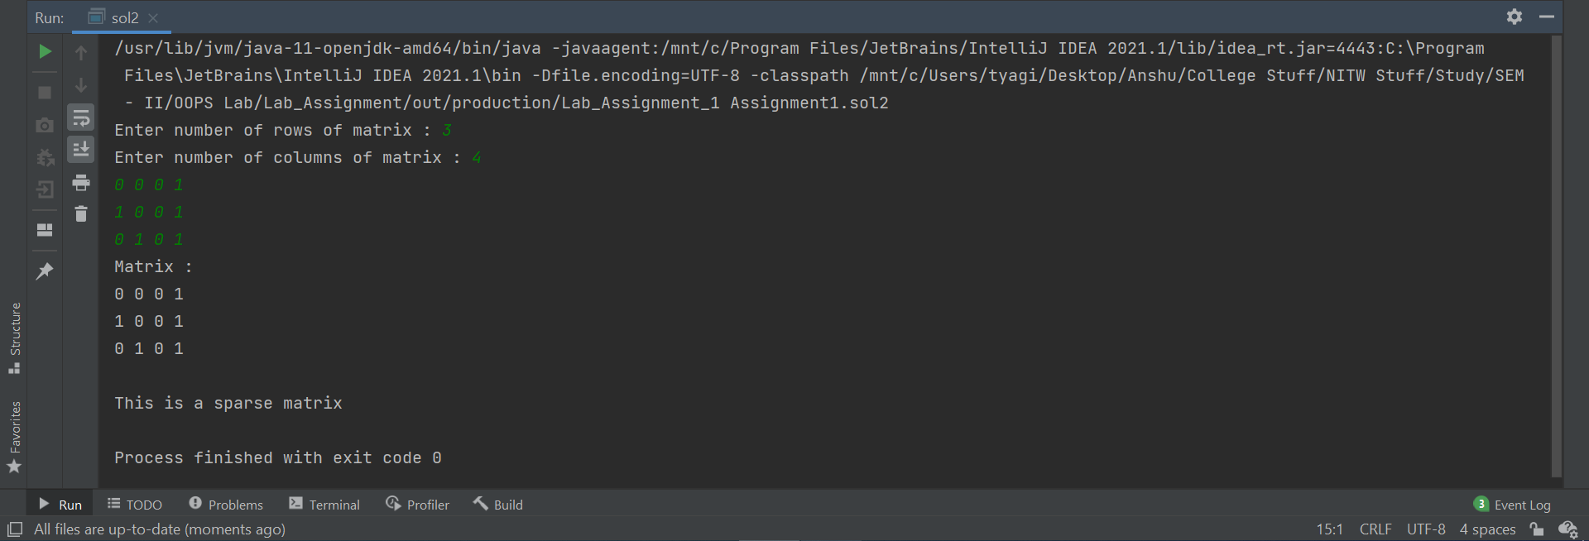

**Q3. Write a java program to left and right rotate the array by a given number of positions. (Number of positions to shift must be read from the console.)**

**Testcases:**

**Array: 9 5 7 2 6 3 8**

**Positions: 3**

**Output:**

**Left rotate: 2 6 3 8 9 5 7**

**Right rotate: 6 3 8 9 5 7 2**

**Solu.**

/*  
 * Copyright (c) 2021.  
 * Divyanshu Tyagi  
 * NIT Warangal  
 * 207919  
 */  
  
package Assignment1;  
import java.util.Scanner;  
/*  
Write a java program to left and right rotate the array by a given number of positions.  
(Number of positions to shift must be read from the console.)  
Testcases:  
 1) Array: 9 5 7 2 6 3 8 Positions: 3  
 Output:  
 Left rotate: 2 6 3 8 9 5 7  
 Right rotate: 6 3 8 9 5 7 2  
*/  
public class sol3 {  
 public static void Print(int[] a) {  
 for (int j : a) {  
 System.*out*.print(j + " ");  
 }  
 System.*out*.println();  
 }  
 public static void Input(int[] a) {  
 Scanner sc = new Scanner(System.*in*);  
 for(int i = 0; i < a.length; i++) {  
 a[i] = sc.nextInt();  
 }  
 }  
 public static void LeftRotate(int[] a, int pos) {  
 int n = a.length;  
 int[] aux = new int[n];  
 pos %= n;  
 for(int i = 0; i < n; i++) {  
 if(pos+i < n)  
 aux[i] = a[pos+i];  
 else  
 aux[i] = a[pos+i-n];  
 }  
 for(int i = 0; i < n; i++)  
 a[i] = aux[i];  
 }  
 public static void rightRotate(int[] a, int pos) {  
 int n = a.length;  
 int[] aux = new int[n];  
 pos %= n;  
 for(int i = 0; i < n; i++) {  
 if(n-(pos-i) < n)  
 aux[i] = a[n-(pos-i)];  
 else  
 aux[i] = a[n-(pos-i)-n];  
 }  
 for(int i = 0; i < n; i++)  
 a[i] = aux[i];  
 }  
 public static void main(String[] args) {  
 Scanner sc = new Scanner(System.*in*);  
 System.*out*.print("Enter Size of Array : ");  
 int n = sc.nextInt();  
 int[] a = new int[n];  
 *Input*(a);  
  
 System.*out*.print("Enter rotation amount : ");  
 int RT = sc.nextInt();  
  
 System.*out*.println("Left Rotated Array : ");  
 *LeftRotate*(a,RT);  
 *Print*(a);  
  
 System.*out*.println("Right Rotated Array : ");  
 *rightRotate*(a,2*RT);  
 *Print*(a);  
 }  
}

**OUTPUT:**

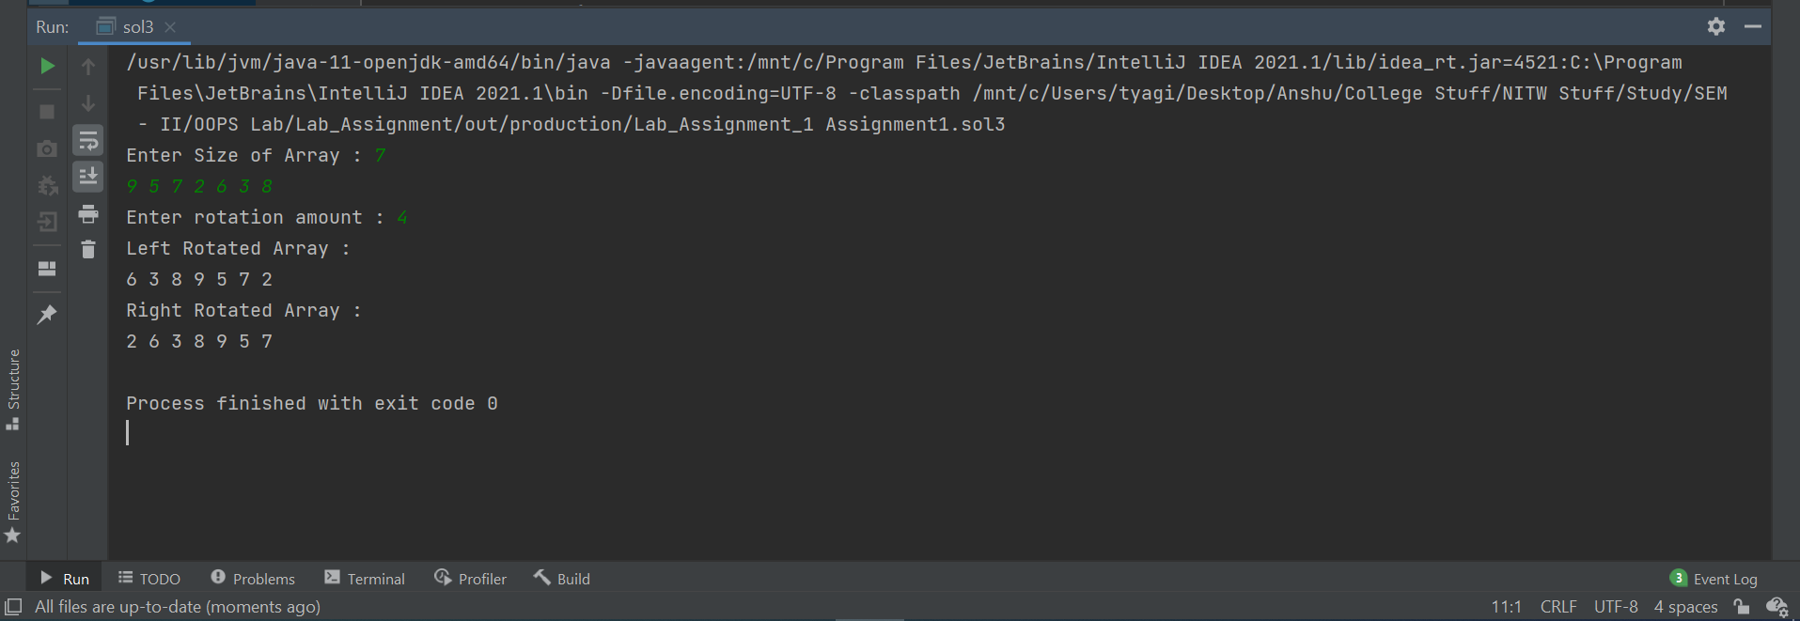

**Q4. Write a java program to implement the following Create a class called as Department, inside this create an instance variable called as course name and static variable called as department name and now one function for course details inside this function local variables for number of students enrolled, faculty name, and credits of that course. Now from another class create object for department class and print the relevant data specified above.**

**Solu.**

/*  
 * Copyright (c) 2021.  
 * Divyanshu Tyagi  
 * NIT Warangal  
 * 207919  
 */  
  
package Assignment1;  
/*  
Write a java program to implement the following :  
 Create a class called as Department, inside this create an instance variable  
called as course name and static variable called as department name and now one  
function for course details inside this function local variables for number of students  
enrolled, faculty name, and credits of that course. Now from another class create  
object for department class and print the relevant data specified above.  
*/  
class Department {  
 public String course_name;  
 public static String *department_name*;  
  
 Department(String cn) {  
 course_name = cn;  
 *department_name* = "CSE : MCA";  
 }  
  
 public void course_details() {  
 int num_of_studs = 56;  
 int credit = 26;  
 String faculty_name = "Sai Santosh Ambati";  
 System.*out*.println(num_of_studs + " " + faculty_name + " " + credit);  
 }  
};  
public class sol4 {  
 public static void main(String[] args) {  
 Department myDept = new Department("OOPS Programing Using Java");  
 System.*out*.println(myDept.course_name);  
 System.*out*.println(Department.*department_name*);  
 myDept.course_details();  
 }  
}

**OUTPUT:**

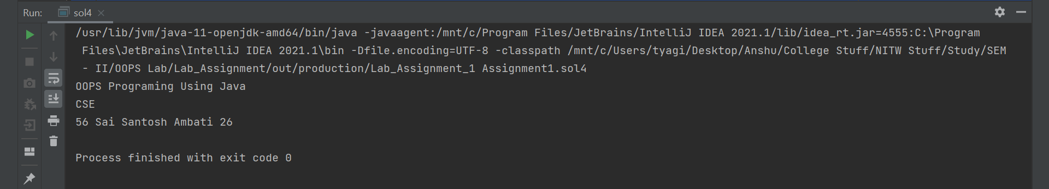

**Q5. Write a java program to implement the following. Create a base class Shape containing name as field. Class Shape will have a public method called getName() that returns the name of the shape. Create a class Circle deriving Shape having radius as field and calculate () method to calculate the area. Then, create a class Cylinder deriving Circle having height as field and calculate () method. Take the radius and height values from user as input and calculate areas of circle and cylinder as output.**

**Test Case:**

**Input:**

**Radius: 4**

**Height: 5**

**Output:**

**Area of Circle: 50.27**

**Area of Cylinder: 226.1**

**Solu.**

/*  
 * Copyright (c) 2021.  
 * Divyanshu Tyagi  
 * NIT Warangal  
 * 207919  
 */  
  
package Assignment1;  
  
import java.util.Scanner;  
  
class Shape {  
 public String name;  
 public String getName() {  
 return name;  
 }  
};  
  
class Circle extends Shape{  
 public Double radius;  
 Circle () {  
 name = "Circle";  
 }  
 public void calculate() {  
 Double area = Math.*PI*\*Math.*pow*(radius,2);  
 System.*out*.println("Area of " + new Circle().getName() + ": " + String.*format*("%.2f",area));  
 }  
};  
  
class Cylinder extends Circle {  
 private Double height;  
 Cylinder (Double radius, Double height) {  
 name = "Cylinder";  
 this.radius = radius;  
 this.height = height;  
 }  
 public void calculate() {  
 super.calculate();  
 Double area = 2*Math.*PI*\*radius*(height+radius);  
 System.*out*.println("Area of " + this.getName() + ": " + String.*format*("%.2f", area  
 ));  
 }  
};  
  
public class sol5 {  
 public static void main(String[] args) {  
 Scanner sc = new Scanner(System.*in*);  
 System.*out*.print("Radius: ");  
 Double r = sc.nextDouble();  
 System.*out*.print("Height: ");  
 Double h = sc.nextDouble();  
 Cylinder C = new Cylinder(r,h);  
 C.calculate();  
 }  
}

**OUTPUT:**

