OOP LAB

Assignment – 04

**Q1. Write a java program to create an attractive registration form for students admission into our institution which should contain Email id, password and confirm password, sex, Higher education qualification (this is pop up menu contains B.Tech, M.tech etc.), username, and date of birth, course (java, Data structures, Unix tool programming, Machine learning) choose one among them (java, Data structures, Unix tool programming, Machine learning). And each component should be specified with a label on top of it. For example, on top of email id component write label “enter email id”. Now all components should be properly aligned. At the end add a submit button, upon clicking this button, if password and confirm password are matched then save the total information into a file otherwise show an error message in a label just below the button.**

**Solu.**

/*  
 * Copyright (c) 2021.  
 * Divyanshu Tyagi  
 * NIT Warangal  
 * 207919  
 */  
  
package Assignment4;  
  
import javax.swing.*;  
import static javax.swing.JOptionPane.*showMessageDialog*;  
import java.awt.event.ActionEvent;  
import java.awt.event.ActionListener;  
import java.awt.*;  
import java.io.FileWriter;  
import java.io.IOException;  
  
class MyFrame extends JFrame implements ActionListener {  
 private Container c;  
 private JLabel title;  
 private JLabel email;  
 private JTextField temail;  
 private JLabel password;  
 private JTextArea tpassword;  
 private JLabel confirmPassword;  
 private JTextArea tconfirmPassword;  
 private JLabel quali;  
 private JComboBox cquali;  
 private JLabel course;  
 private JComboBox ccourse;  
 private JButton sub;  
 private JButton reset;  
  
 private String qualification[] = {  
 "B.tech",  
 "M.tech",  
 "MCA",  
 "MSC"  
 };  
  
 private String Course[] = {  
 "Java",  
 "Data Structure",  
 "Unix tool programming",  
 "Machine Learning"  
 };  
  
 public MyFrame() {  
 setTitle("Registeration Form");  
 setBounds(300, 90, 900, 500);  
 setDefaultCloseOperation(*EXIT_ON_CLOSE*);  
 setResizable(false);  
  
  
 c = getContentPane();  
 c.setLayout(null);  
  
 title = new JLabel("Registration Form");  
 title.setFont(new Font("Arial", Font.*PLAIN*, 30));  
 title.setSize(300, 30);  
 title.setLocation(300, 30);  
 c.add(title);  
  
 email = new JLabel("Email");  
 email.setFont(new Font("Arial", Font.*PLAIN*, 20));  
 email.setSize(100, 20);  
 email.setLocation(100, 100);  
 c.add(email);  
  
 temail = new JTextField();  
 temail.setFont(new Font("Arial", Font.*PLAIN*, 15));  
 temail.setSize(150, 20);  
 temail.setLocation(350, 100);  
 c.add(temail);  
  
 password = new JLabel("Password");  
 password.setFont(new Font("Arial", Font.*PLAIN*, 20));  
 password.setSize(100, 20);  
 password.setLocation(100, 150);  
 c.add(password);  
  
 tpassword = new JTextArea();  
 tpassword.setFont(new Font("Arial", Font.*PLAIN*, 15));  
 tpassword.setSize(100, 20);  
 tpassword.setLocation(350, 150);  
 c.add(tpassword);  
  
 confirmPassword = new JLabel("Confirm Password");  
 confirmPassword.setFont(new Font("Arial", Font.*PLAIN*, 20));  
 confirmPassword.setSize(200, 20);  
 confirmPassword.setLocation(100, 200);  
 c.add(confirmPassword);  
  
 tconfirmPassword= new JTextArea();  
 tconfirmPassword.setFont(new Font("Arial", Font.*PLAIN*, 15));  
 tconfirmPassword.setSize(200, 20);  
 tconfirmPassword.setLocation(350, 200);  
 c.add(tconfirmPassword);  
  
 quali = new JLabel("Qualification");  
 quali.setFont(new Font("Arial", Font.*PLAIN*, 20));  
 quali.setSize(200, 20);  
 quali.setLocation(100, 250);  
 c.add(quali);  
  
 cquali = new JComboBox(qualification);  
 cquali.setFont(new Font("Arial", Font.*PLAIN*, 20));  
 cquali.setSize(200, 25);  
 cquali.setLocation(350, 250);  
 c.add(cquali);  
  
 course = new JLabel("Course");  
 course.setFont(new Font("Arial", Font.*PLAIN*, 20));  
 course.setSize(150, 20);  
 course.setLocation(100, 300);  
 c.add(course);  
  
 ccourse = new JComboBox(Course);  
 ccourse.setFont(new Font("Arial", Font.*PLAIN*, 20));  
 ccourse.setSize(200, 25);  
 ccourse.setLocation(350, 300);  
 c.add(ccourse);  
  
 sub = new JButton("Submit");  
 sub.setFont(new Font("Arial", Font.*PLAIN*, 15));  
 sub.setSize(100, 20);  
 sub.setLocation(100, 400);  
 sub.addActionListener(this);  
 c.add(sub);  
  
 reset = new JButton("Reset");  
 reset.setFont(new Font("Arial", Font.*PLAIN*, 15));  
 reset.setSize(100, 20);  
 reset.setLocation(250, 400);  
 reset.addActionListener(this);  
 c.add(reset);  
  
 setVisible(true);  
 }  
  
 @Override  
 public void actionPerformed(ActionEvent e) {  
 if(e.getSource() == reset) {  
 String def = "";  
 temail.setText(def);  
 tpassword.setText(def);  
 tconfirmPassword.setText(def);  
 cquali.setSelectedIndex(0);  
 ccourse.setSelectedIndex(0);  
 }  
 else if (e.getSource() == sub) {  
 if(tpassword.getText().equals(tconfirmPassword.getText())) {  
 try {  
 FileWriter writer = new FileWriter("formInfo.txt");  
 writer.write(temail.getText() + "\n");  
 writer.write(tpassword.getText() + "\n");  
 writer.write(cquali.getSelectedItem() + "\n");  
 writer.write(ccourse.getSelectedItem() + "\n");  
 writer.close();  
 } catch (IOException ioException) {  
 ioException.printStackTrace();  
 }  
  
 *showMessageDialog*(null, "Data Successfully submitted to file");  
 }else {  
 *showMessageDialog*(null, "Password and confirm password are not same");  
 }  
 }  
 }  
}  
  
public class sol1 {  
 public static void main(String[] args) {  
 MyFrame frame = new MyFrame();  
 }  
}

**OUTPUT:**

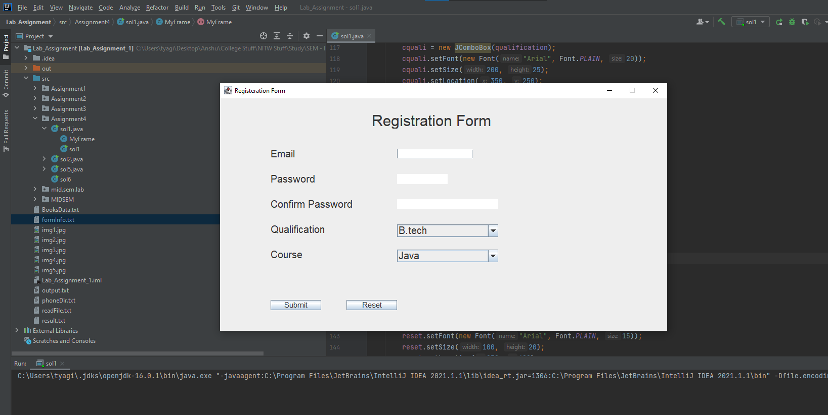

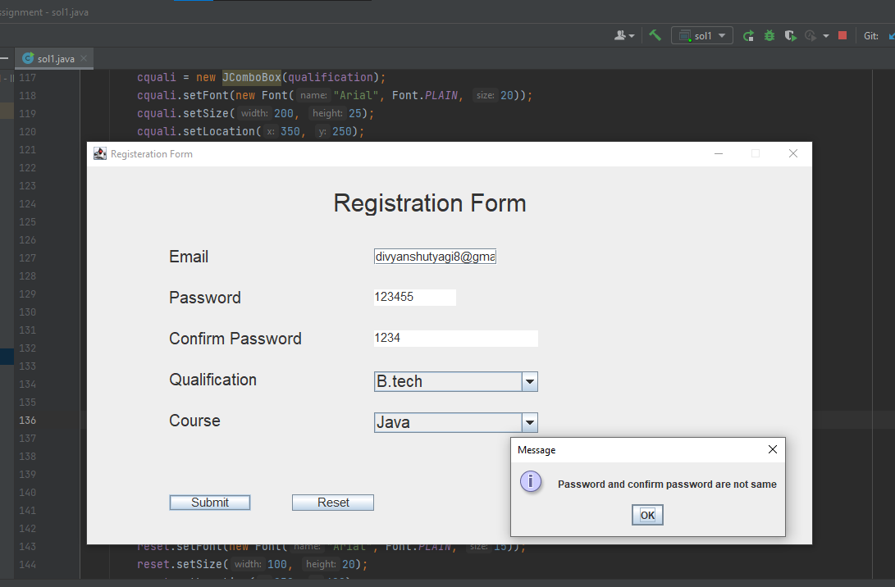

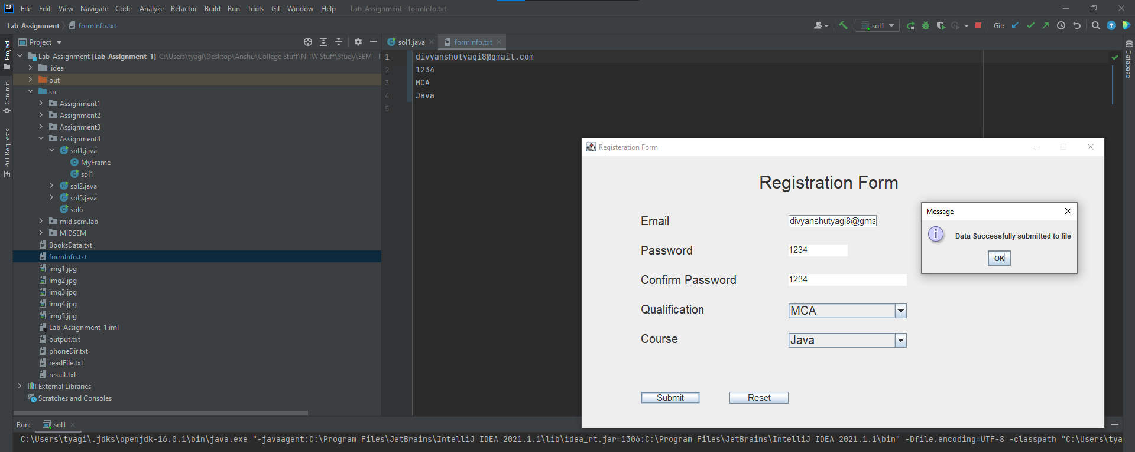

**Q2. Write a java program to implement a simple calculator having buttons for individual operations +, -, *, /, % and one clear button and along with them two text Fields one for first input, one for second input and one label for result. Arrange these buttons in a grid layout. Handle the possible exceptions like divisible by zero. Output Frame should be like below.**

**Solu.**

/*  
 * Copyright (c) 2021.  
 * Divyanshu Tyagi  
 * NIT Warangal  
 * 207919  
 */  
  
package Assignment4;  
  
  
import javax.swing.*;  
import java.awt.*;  
import java.awt.event.ActionEvent;  
import java.awt.event.ActionListener;  
import java.awt.event.KeyAdapter;  
import java.awt.event.KeyEvent;  
  
import static javax.swing.JOptionPane.*showMessageDialog*;  
  
class EmptyInputException extends Exception {  
 public EmptyInputException(String str) {  
 super(str);  
  
 }  
}  
  
class DivByZero extends Exception {  
 public DivByZero(String str) {  
 super(str);  
  
 }  
}  
  
class IntegerOverflowException extends Exception {  
 public IntegerOverflowException(String str) {  
 super(str);  
  
 }  
}  
  
class MyCalculatorFrame extends JFrame implements ActionListener {  
 private Container c;  
 private JLabel firstNum;  
 private JTextArea tfirstNum;  
 private JLabel secondNum;  
 private JTextArea tsecondNum;  
 private JButton add;  
 private JButton sub;  
 private JButton mul;  
 private JButton div;  
 private JButton mod;  
 private JButton clear;  
 private JLabel result;  
 private JTextArea tresult;  
  
  
  
 public MyCalculatorFrame() {  
 setTitle("Calculator");  
 setBounds(300, 90, 400, 280);  
 setDefaultCloseOperation(*EXIT_ON_CLOSE*);  
 setResizable(false);  
  
 c = getContentPane();  
 c.setLayout(null);  
  
 firstNum = new JLabel("First Number");  
 firstNum.setFont(new Font("Arial", Font.*PLAIN*, 20));  
 firstNum.setSize(200, 20);  
 firstNum.setLocation(1, 1);  
 c.add(firstNum);  
  
 tfirstNum = new JTextArea();  
 tfirstNum.setFont(new Font("Arial", Font.*PLAIN*, 15));  
 tfirstNum.setSize(200, 20);  
 tfirstNum.setLocation(202, 1);  
 c.add(tfirstNum);  
  
  
 secondNum = new JLabel("Second Number");  
 secondNum.setFont(new Font("Arial", Font.*PLAIN*, 20));  
 secondNum.setSize(200, 20);  
 secondNum.setLocation(1, 25);  
 c.add(secondNum);  
  
  
 tsecondNum = new JTextArea();  
 tsecondNum.setFont(new Font("Arial", Font.*PLAIN*, 15));  
 tsecondNum.setSize(200, 20);  
 tsecondNum.setLocation(202, 25);  
 c.add(tsecondNum);  
  
 result = new JLabel("Result");  
 result.setFont(new Font("Arial", Font.*PLAIN*, 20));  
 result.setSize(200,20);  
 result.setLocation(1,50);  
 c.add(result);  
  
 tresult = new JTextArea();  
 tresult.setFont(new Font("Arial", Font.*PLAIN*, 17));  
 tresult.setSize(200,20);  
 tresult.setLocation(202,50);  
 tresult.setEditable(false);  
 c.add(tresult);  
  
 add = new JButton("+");  
 add.setFont(new Font("Arial", Font.*PLAIN*, 15));  
 add.setSize(185,40);  
 add.setLocation(1,90);  
 add.addActionListener(this);  
 c.add(add);  
  
 sub = new JButton("-");  
 sub.setFont(new Font("Arial", Font.*PLAIN*, 15));  
 sub.setSize(185,40);  
 sub.setLocation(190,90);  
 sub.addActionListener(this);  
 c.add(sub);  
  
 mul = new JButton("*");  
 mul.setFont(new Font("Arial", Font.*PLAIN*, 15));  
 mul.setSize(185,40);  
 mul.setLocation(1,140);  
 mul.addActionListener(this);  
 c.add(mul);  
  
 div = new JButton("/");  
 div.setFont(new Font("Arial", Font.*PLAIN*, 15));  
 div.setSize(185,40);  
 div.setLocation(190,140);  
 div.addActionListener(this);  
 c.add(div);  
  
  
 mod = new JButton("%");  
 mod.setFont(new Font("Arial", Font.*PLAIN*, 15));  
 mod.setSize(185,40);  
 mod.setLocation(1,190);  
 mod.addActionListener(this);  
 c.add(mod);  
  
 clear = new JButton("Clear");  
 clear.setFont(new Font("Arial", Font.*PLAIN*, 15));  
 clear.setSize(185,40);  
 clear.setLocation(190,190);  
 clear.addActionListener(this);  
 c.add(clear);  
  
 // making event listener to not let user enter anything other than number in txt area  
 // associated for numbers  
 tfirstNum.addKeyListener(new KeyAdapter() {  
 public void keyPressed(KeyEvent ke) {  
 String value = firstNum.getText();  
 int l = value.length();  
 if ((ke.getKeyChar() >= '0' && ke.getKeyChar() <= '9' ) || ke.getKeyChar() == KeyEvent.*VK_BACK_SPACE*) {  
 tfirstNum.setEditable(true);  
 } else {  
 tfirstNum.setEditable(false);  
 }  
 }  
 });  
  
 tsecondNum.addKeyListener(new KeyAdapter() {  
 public void keyPressed(KeyEvent ke) {  
 String value = tsecondNum.getText();  
 int l = value.length();  
 if ((ke.getKeyChar() >= '0' && ke.getKeyChar() <= '9') || ke.getKeyChar() == KeyEvent.*VK_BACK_SPACE*) {  
 tsecondNum.setEditable(true);  
 } else {  
 tsecondNum.setEditable(false);  
 }  
 }  
 });  
 setVisible(true);  
 }  
  
 @Override  
 public void actionPerformed(ActionEvent e) {  
 Object source = e.getSource();  
 try {  
  
 if (tfirstNum.getText().length() == 0 || tsecondNum.getText().length() == 0) {  
 throw new EmptyInputException("Either of the two numbers is not entered");  
 }  
 if (source == clear) {  
 System.*out*.println("in clear");  
 String def = "";  
 tfirstNum.setText(def);  
 tsecondNum.setText(def);  
 tresult.setEditable(true);  
 tresult.setText(def);  
 tresult.setEditable(false);  
 }else {  
 Integer number_1 = Integer.*parseInt*(tfirstNum.getText());  
 Integer number_2 = Integer.*parseInt*(tsecondNum.getText());  
 long res = 0;  
 if(number_1 > Integer.*MAX_VALUE* || number_2 > Integer.*MAX_VALUE*) {  
 throw new IntegerOverflowException("Integer Overflow");  
 }  
 if (add.equals(source)) {  
 res = (number_1 + number_2);  
 }else if (sub.equals(source)) {  
 res = number_1 - number_2;  
 }else if (mul.equals(source)) {  
 res = number_1 * number_2;  
 }else if (div.equals(source)) {  
 if(number_2 == 0) {  
 throw new DivByZero("Divided by zero");  
 }  
 res = number_1 / number_2;  
 }else if (mod.equals(source)) {  
 res = number_1 % number_2;  
 }  
 if(res > Long.*MAX_VALUE*) {  
 throw new IntegerOverflowException("Integer Overflow");  
 }  
 tresult.setEditable(true);  
 tresult.setText(res + "");  
 tresult.setEditable(false);  
 }  
 }catch (Exception exp) {  
 *showMessageDialog*(null, "!! ERROR : " + exp.getMessage() + " !!");  
 exp.printStackTrace();  
 }  
 }  
}  
  
public class sol2 {  
 public static void main(String[] args) {  
 MyCalculatorFrame frame = new MyCalculatorFrame();  
 }  
}

**OUTPUT:**

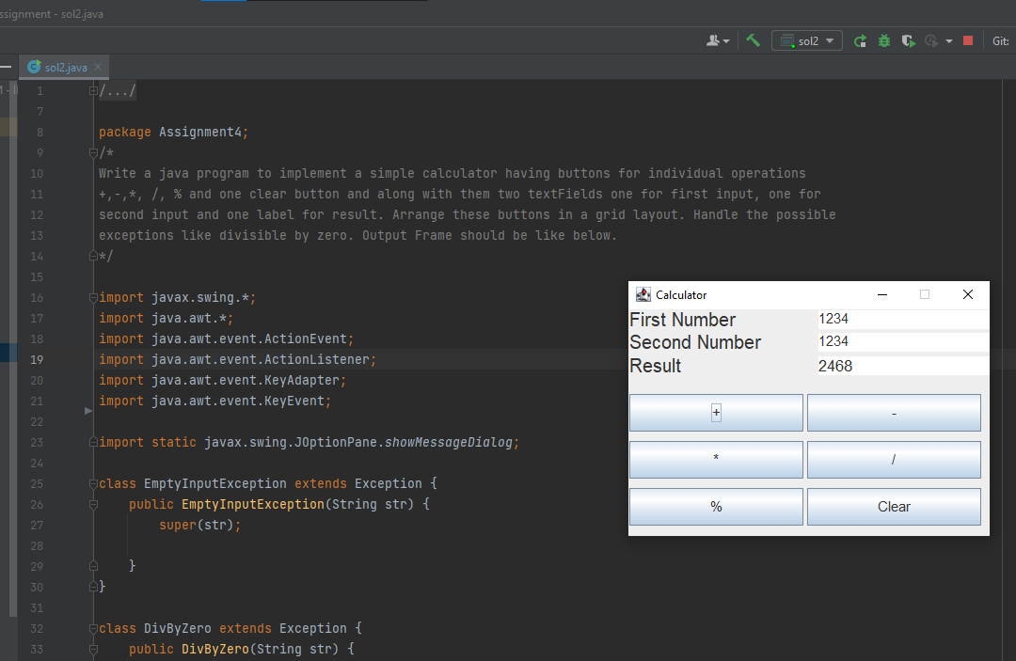

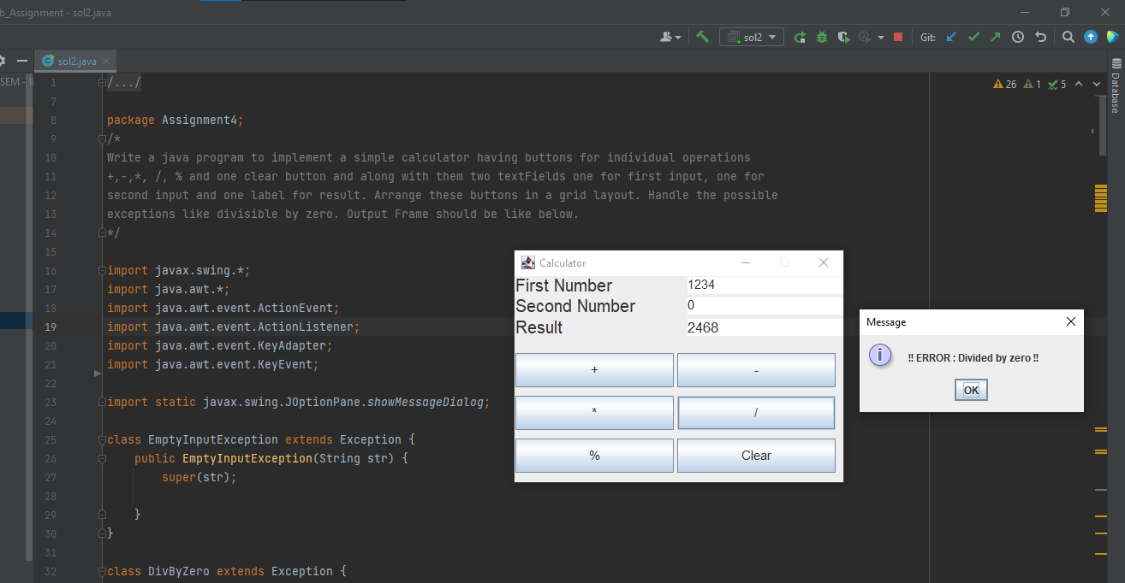

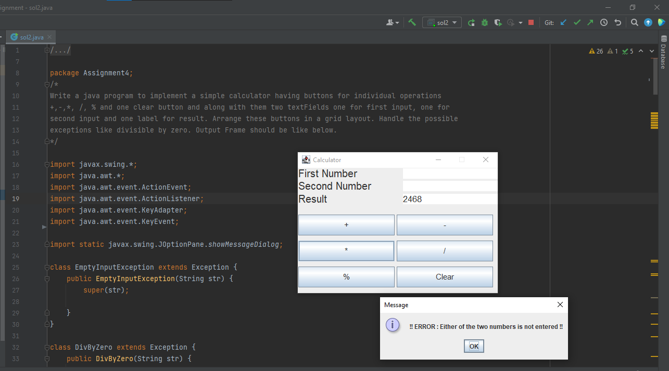

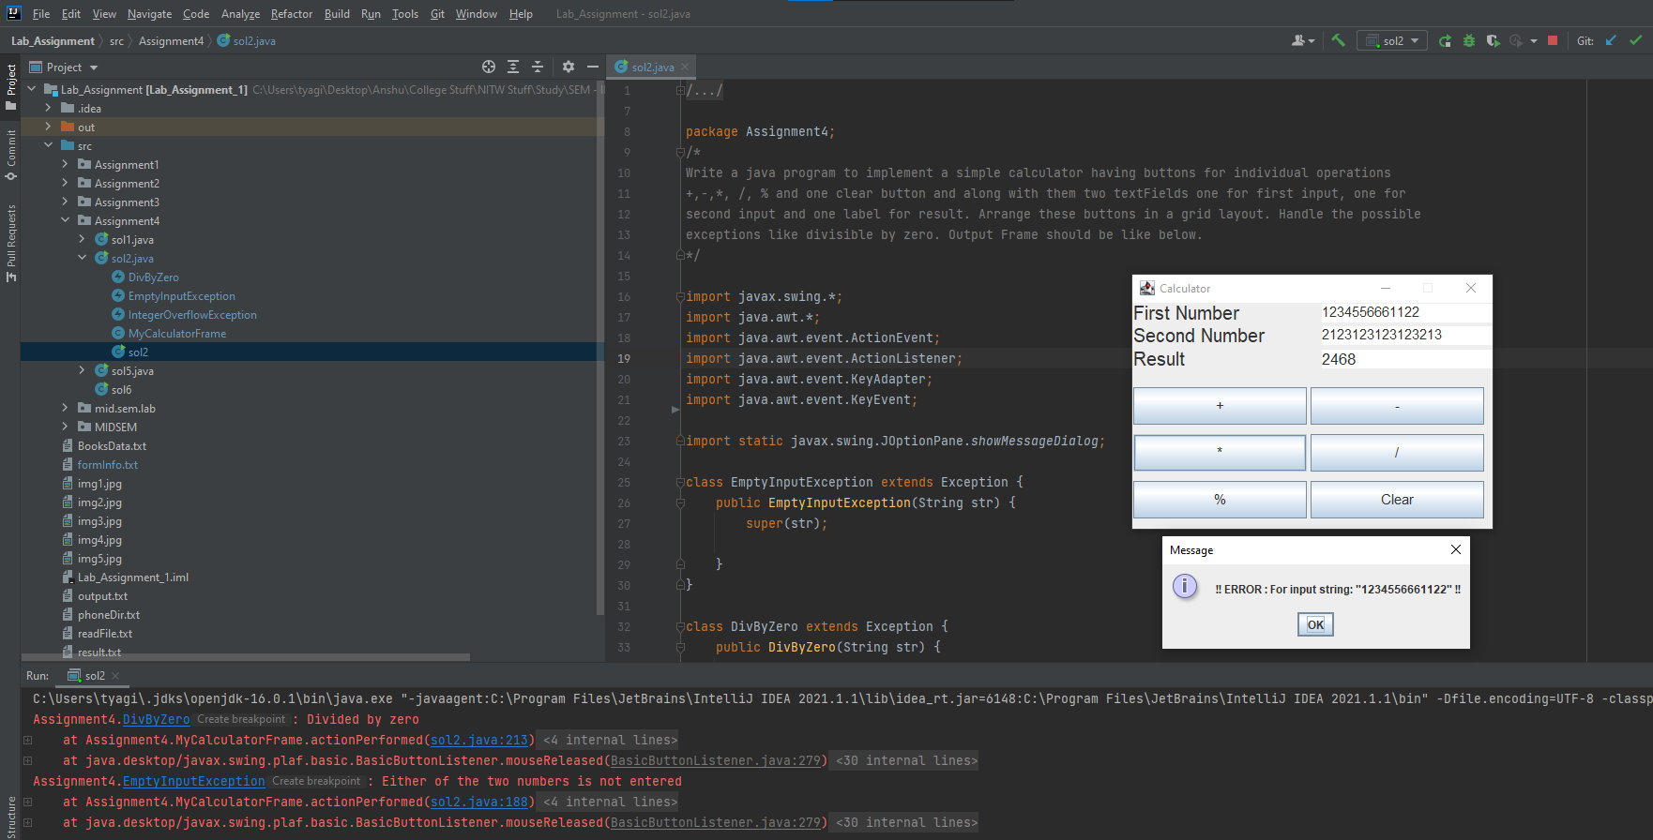

**Q3. Write a java program to implement the following. Create a frame and add a Textarea, label, Button inside it. Now, create a file called Biodata. Now, after clicking the button the data which we typed inside the textarea should be saved inside the file and the constraint is that the Minimum number of words in text Area should be 30, if this constraint is not followed then after clicking the button the label should be set to “Minimum number of words should be 30”. If constraint is followed properly the label should be set to “successfully copied data into the file”.**

**Solu.**

/*  
 * Copyright (c) 2021.  
 * Divyanshu Tyagi  
 * NIT Warangal  
 * 207919  
 */  
  
package Assignment4;  
  
import java.awt.*;  
import java.awt.event.ActionEvent;  
import java.awt.event.ActionListener;  
import java.awt.event.WindowAdapter;  
import java.awt.event.WindowEvent;  
import java.io.BufferedWriter;  
import java.io.FileWriter;  
import java.io.IOException;  
  
public class sol3 extends Frame implements ActionListener {  
 private Label label;  
 private Button button;  
 private TextArea textArea;  
 private FileWriter writer;  
 private BufferedWriter bufferWriter;  
  
 sol3() {  
 super("Sol 3");  
 setSize(800, 600);  
  
 textArea = new TextArea();  
 textArea.setBounds(10, 80, 500, 100);  
 add(textArea);  
  
 label = new Label();  
 label.setBounds(10, 200, 500, 30);  
 add(label);  
  
 button = new Button("Submit");  
 button.setBounds(10, 240, 100, 30);  
 button.addActionListener(this);  
 add(button);  
  
  
 addWindowListener(new WindowAdapter() {  
 public void windowClosing(WindowEvent e) {  
 System.*exit*(0);  
 }  
 });  
  
 setLayout(null);  
 setVisible(true);  
 }  
  
 @Override  
 public void actionPerformed(ActionEvent e) {  
 String tex = textArea.getText();  
 if (tex.split(" ").length < 30) {  
 label.setForeground(Color.*RED*);  
 label.setText("Minimum number of words should be 30.");  
 return;  
 }  
 try {  
 writer = new FileWriter("biodata.txt");  
 bufferWriter = new BufferedWriter(writer);  
 bufferWriter.write(tex);  
 bufferWriter.close();  
 writer.close();  
 label.setForeground(Color.*GREEN*);  
 label.setText("Successfully copied to the file!");  
 } catch (IOException ex) {  
 ex.printStackTrace();  
 }  
  
 }  
  
 public static void main(String[] args) {  
 new sol3();  
 }  
}

**OUTPUT:**

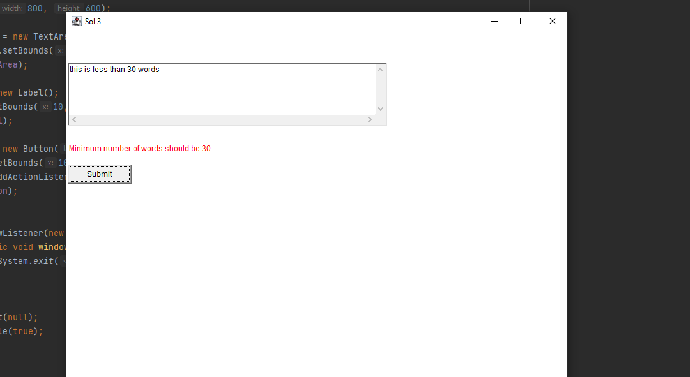

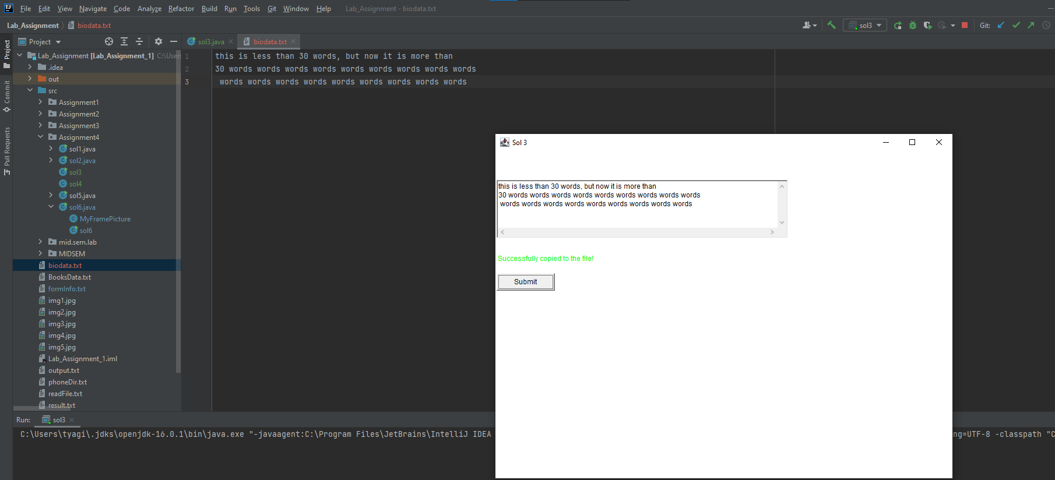

**Q4. Write a java program to illustrate all mouse events which are available in MouseListener interface**

**Solu.**

/*  
 * Copyright (c) 2021.  
 * Divyanshu Tyagi  
 * NIT Warangal  
 * 207919  
 */  
  
package Assignment4;  
  
import javax.swing.*;  
import java.awt.*;  
import java.awt.event.MouseEvent;  
import java.awt.event.MouseListener;  
import java.awt.event.WindowAdapter;  
import java.awt.event.WindowEvent;  
  
public class sol4 extends Frame implements MouseListener {  
 private Label label_1;  
 private JLabel log_label;  
  
 sol4() {  
 label_1 = new Label("All MOUSE actions will be logged here.");  
 label_1.setBounds(30, 80, 400, 30);  
 add(label_1);  
  
 log_label = new JLabel("");  
 log_label.setFont(new Font("Arial", Font.*BOLD*, 20));  
 log_label.setBounds(50, 50, 100, 30);  
 add(log_label);  
  
 setSize(600, 600);  
 setVisible(true);  
 addMouseListener(this);  
 setLayout(null);  
 addWindowListener(new WindowAdapter() {  
 public void windowClosing(WindowEvent e) {  
 System.*exit*(0);  
 }  
 });  
 }  
  
 public void log(String msg) {  
 this.log_label.setText(msg);  
 }  
  
 public void mouseClicked(MouseEvent e) {  
 log("Mouse Clicked.");  
 }  
  
 public void mouseEntered(MouseEvent e) {  
 log("Mouse Entered");  
 }  
  
 public void mousePressed(MouseEvent e) {  
 log("Mouse Pressed");  
 }  
  
 public void mouseReleased(MouseEvent e) {  
 log("Mouse Released");  
 }  
  
 public void mouseExited(MouseEvent e) {  
 log("Mouse Exit");  
 }  
  
 public static void main(String[] args) {  
 new sol4();  
 }  
}

**OUTPUT:**

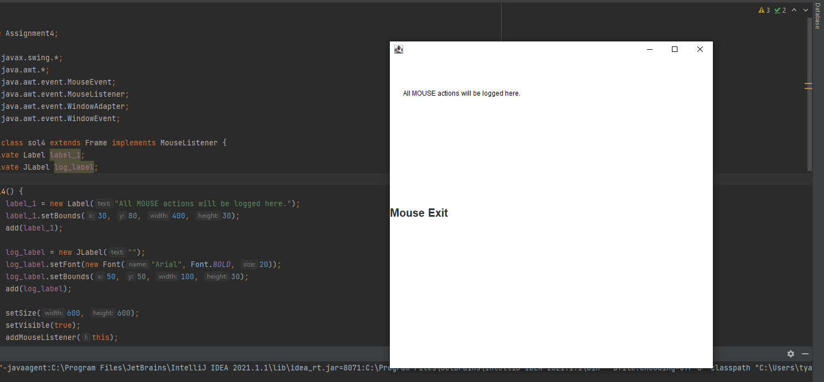

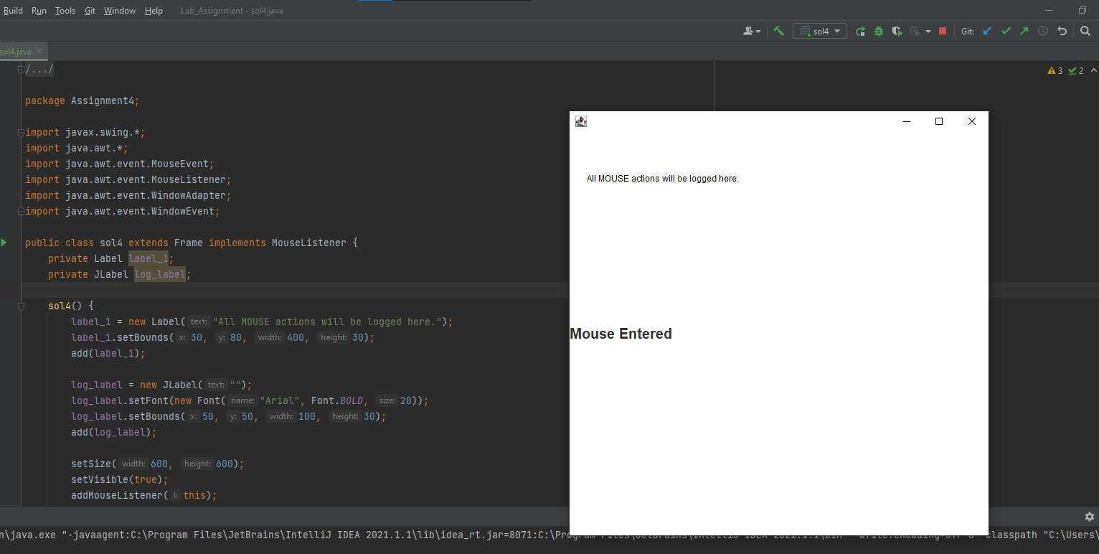

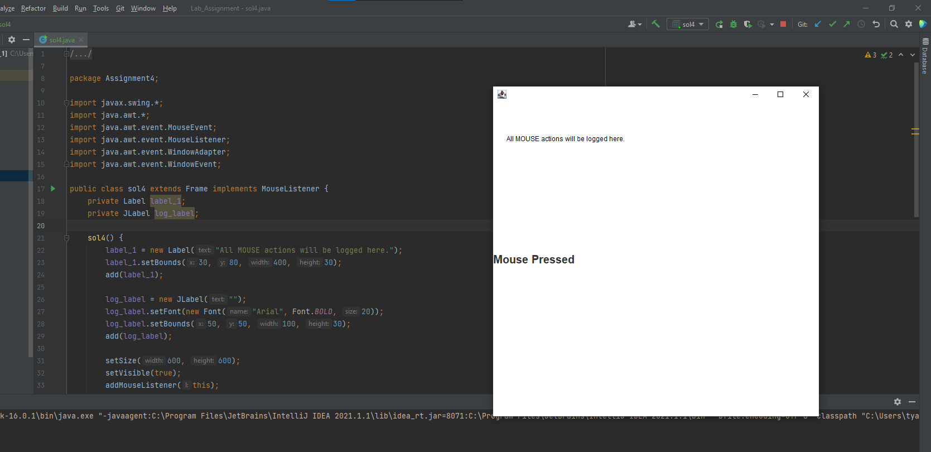

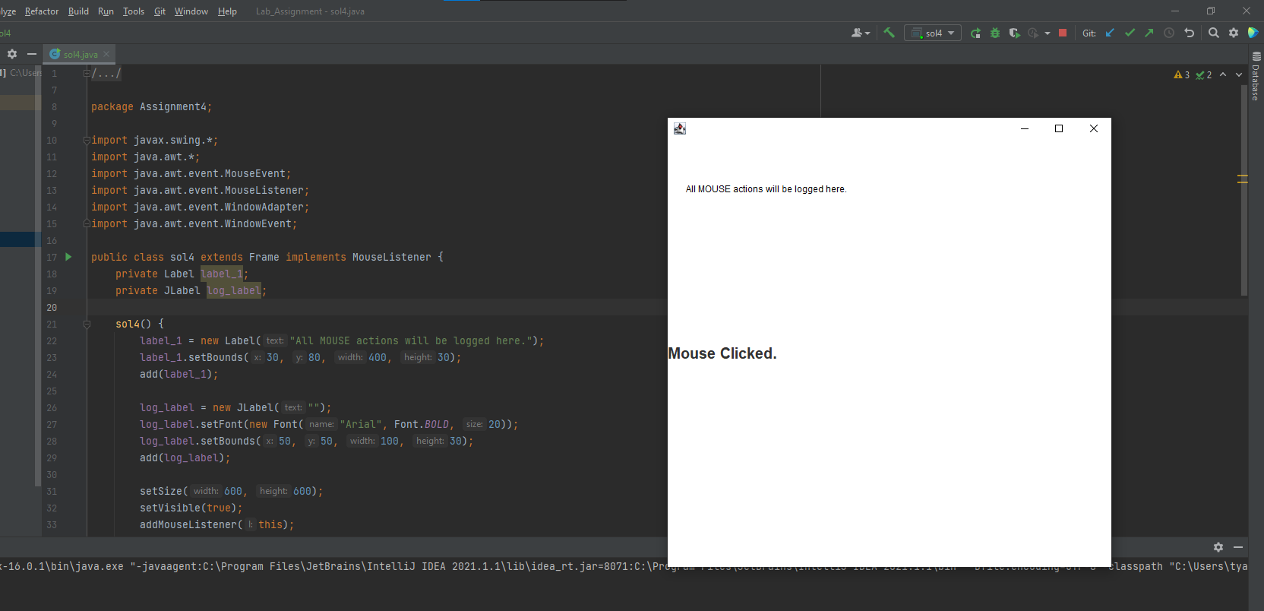

**Q5. Write a java program to draw the following paintings and one message at bottom.**

**Solu.**

/*  
 * Copyright (c) 2021.  
 * Divyanshu Tyagi  
 * NIT Warangal  
 * 207919  
 */  
  
package Assignment4;  
  
import javax.swing.*;  
import java.awt.*;  
import java.awt.geom.Ellipse2D;  
  
class AlgerianFlag extends JComponent {  
 public void paint(Graphics g) {  
 Graphics2D g2 = ( Graphics2D ) g;  
  
 // draw the orange space  
 g2.setColor(Color.ORANGE);  
 g2.fillRect(50, 50, 200, 50);  
  
 // draw the white space  
 g2.setColor(Color.WHITE);  
 g2.fillRect(50, 101, 200, 50);  
  
 // draw the green space  
 g2.setColor(Color.GREEN);  
 g2.fillRect(50, 152, 200, 50);  
  
 // draw black pole  
 g2.setColor(Color.BLACK);  
 g2.fillRect(45, 52, 4, 400);  
  
 // drawing inner blue chakra  
 Shape circle=new Ellipse2D.Float(124.3f,103,50,46);  
 Graphics2D ga=(Graphics2D)g;  
 ga.draw(circle);  
 ga.setPaint(Color.blue);  
 ga.fill(circle);  
  
 Graphics g1 = (Graphics) g;  
 g1.setColor(Color.BLACK);  
 g1.setFont(Font.getFont("Arial"));  
 g1.drawString("Message should appear here : Random Text message",50,500);  
  
 g1.setColor(Color.*YELLOW*);  
 g1.fillOval(300,130,300,300);  
  
// g1.setColor(Color.ORANGE);  
 g1.setColor(Color.*BLACK*);  
 g1.fillOval(350, 165, 80, 80);  
 g1.fillOval(460, 165, 80, 80);  
  
 // Arc for the smile  
 g1.setColor(Color.*BLACK*);  
 g1.drawArc(360, 300, 170, 80, 180, 180);  
 }  
}  
  
public class sol5 {  
 public static void main(String[] args) {  
  
 //create new frame object  
 JFrame frame = new JFrame ("Algeria");  
  
 // set the size of the frame  
 frame.setSize(900 ,600);  
  
 // set the location of the frame  
 frame.setLocation(50,100);  
  
 // create new object of type flag  
 AlgerianFlag flag = new AlgerianFlag();  
  
 // add the object flag to the frame  
 frame.add(flag);  
  
  
 frame.setVisible(true);  
 frame.setDefaultCloseOperation(JFrame.*EXIT_ON_CLOSE*);  
  
 }  
}

**OUTPUT:**

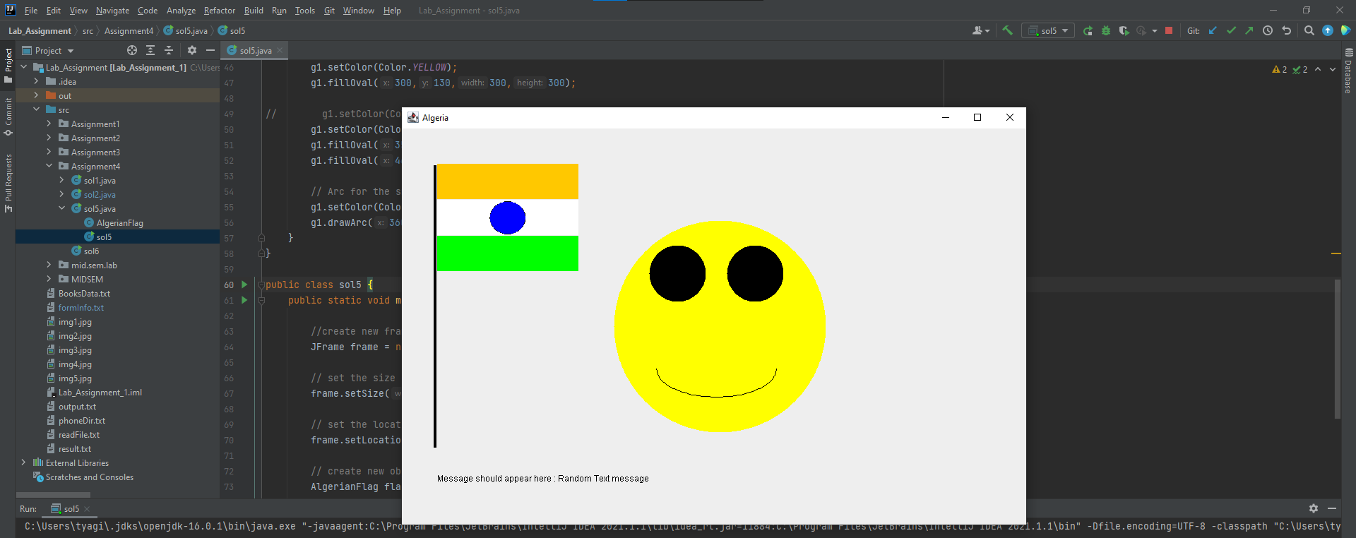

**Q6. Write a java program to implement the following In a frame left side add several buttons in one by one, on clicking each button one image should appear on right side of the frame, initially no image should be there, have totally 5 buttons, once you click on a button, an image will be appear there and after that if you click another button another image should appear at same place where previous image is appeared. Which images to**

**show is up to you**

**Solu.**

/*  
 * Copyright (c) 2021.  
 * Divyanshu Tyagi  
 * NIT Warangal  
 * 207919  
 */  
  
package Assignment4;  
  
import javax.swing.*;  
import java.awt.*;  
import java.awt.event.ActionEvent;  
import java.awt.event.ActionListener;  
  
class MyFramePicture extends JFrame implements ActionListener {  
  
 private Button b1;  
 private Button b2;  
 private Button b3;  
 private Button b4;  
 private Button b5;  
 private JPanel imagePanel;  
 private JLabel label;  
 private ImageIcon im;  
  
 MyFramePicture() {  
 setDefaultCloseOperation(*EXIT_ON_CLOSE*);  
 setSize(900, 800);  
  
 b1 = new Button("Image 1");  
 b1.addActionListener(this);  
  
 b2 = new Button("Image 2");  
 b2.addActionListener(this);  
 b3 = new Button("Image 3");  
 b3.addActionListener(this);  
 b4 = new Button("Image 4");  
 b4.addActionListener(this);  
 b5 = new Button("Image 5");  
 b5.addActionListener(this);  
  
 JPanel buttonPanel = new JPanel(new FlowLayout());  
 buttonPanel.add(b1);  
 buttonPanel.add(b2);  
 buttonPanel.add(b3);  
 buttonPanel.add(b4);  
 buttonPanel.add(b5);  
 label = new JLabel();  
 imagePanel = new JPanel();  
  
 JSplitPane splitPane = new JSplitPane(JSplitPane.*HORIZONTAL_SPLIT*, buttonPanel, imagePanel);  
 splitPane.setOneTouchExpandable(true);  
 splitPane.setDividerLocation(50);  
 add(splitPane, BorderLayout.*CENTER*);  
 setVisible(true);  
 }  
  
 public void actionPerformed(ActionEvent e) {  
 Object source = e.getSource();  
 try {  
 if (source == b1) {  
 imagePanel.removeAll();  
 imagePanel.repaint();  
 imagePanel.revalidate();  
 im = new ImageIcon("img1.jpg");  
 label.setIcon(im);  
 imagePanel.add(label);  
 } else if (source == b2) {  
 imagePanel.removeAll();  
 imagePanel.repaint();  
 imagePanel.revalidate();  
 im = new ImageIcon("img2.jpg");  
 label.setIcon(im);  
 imagePanel.add(label);  
 } else if (source == b3) {  
 imagePanel.removeAll();  
 imagePanel.repaint();  
 imagePanel.revalidate();  
 im = new ImageIcon("img3.jpg");  
 label.setIcon(im);  
 imagePanel.add(label);  
 } else if (source == b4) {  
 imagePanel.removeAll();  
 imagePanel.repaint();  
 imagePanel.revalidate();  
 im = new ImageIcon("img4.jpg");  
 label.setIcon(im);  
 imagePanel.add(label);  
 } else if (source == b5) {  
 imagePanel.removeAll();  
 imagePanel.repaint();  
 imagePanel.revalidate();  
 im = new ImageIcon("img5.jpg");  
 label.setIcon(im);  
 imagePanel.add(label);  
 }  
 }catch (Exception exception) {  
 exception.printStackTrace();  
 }  
 }  
}  
  
public class sol6 {  
  
 public static void main(String[] args) {  
 MyFramePicture c = new MyFramePicture();  
 }  
  
}

**OUTPUT:**

