Designing a Disaster-Resilient Hybrid Communication Network for a Himalayan Smart City: Analog Radio, Mobile and Satellite Layers for Gangtok, Sikkim
Manasvi Choudhary (2430112) · Kumari Sweta (2430211) · Srishti Anand (2430221)
Group members and roll numbers
Abstract
Communication networks tend to fail at the moment a disaster makes them most necessary. This article designs a three-layer hybrid network for Gangtok, Sikkim, made of an analog AM/FM emergency broadcast, a digital mobile network and a Ku-band geostationary satellite backup, and tests it with a Python simulator. The scenario is a monsoon cloudburst followed by landslides and a glacial lake outburst flood (GLOF) on the Teesta, on real elevation and road data. We calculate modulation index and bandwidth for AM and FM, sampling, quantisation and bandwidth for PCM with ASK and BPSK, path loss and link budgets for the satellite, and cell-splitting capacity, and we simulate BER under Gaussian noise. During the storm, the mobile network alone reaches 25% of citizens and the satellite alone 72%, while the hybrid reaches 79% for two-way traffic and 96% for alerts.
Keywords: hybrid network, disaster resilience, FM broadcast, PCM, BPSK, satellite link budget, Himalaya, GLOF
1. Introduction
When a disaster strikes, the public mobile network is often one of the first services to go down. Base stations lose power, the fibre that connects them is cut, and the cells that survive are flooded with calls. After the 2011 Great East Japan Earthquake, the loss of base stations led Sakano et al. to propose movable and deployable network units [1]. After Hurricane Maria in 2017, up to 95.6 percent of cell sites in Puerto Rico were out of service [2]. A single network, however well built, is a single point of failure.
Most designs for this problem take a coastal city and a cyclone. We chose a mountain city, because its problems are different. In Gangtok, ridges block radio signals, landslides cut the roads along which cables run, and some hazards have nothing to do with local weather. In October 2023 the South Lhonak glacial lake in north Sikkim burst, and the flood overwhelmed roads, bridges and hydropower installations along the Teesta [3].
Our objectives are to (i) draw the transmitter-to-receiver chain of each of the three layers and show how they connect, (ii) calculate how each layer uses bandwidth and spectrum, (iii) model noise, SNR and BER, and (iv) judge whether the hybrid beats any single network in mountain terrain.
2. Study area and disaster scenario
Gangtok (27.33° N, 88.61° E) lies along a ridge at about 1,600 m, with steep slopes falling to the Ranikhola and Teesta valleys. The simulator uses a 30 m elevation grid from the Shuttle Radar Topography Mission [4] and the roads, rivers and settlements from OpenStreetMap [5], and places homes, cell sites and shelters on this map.
The scenario has four phases. A cloudburst drops rain at up to 80 mm/h. A slope fails when rainfall exceeds the Caine threshold [6], I = 14.82·D⁻⁰·³⁹ (I in mm/h, D in hours), blocking the road below it and cutting the fibre on that road, so 40% of cell sites go off-air. About two days later a GLOF floods the low ground along the Teesta, which we mark by height above the nearest drainage [7]. Finally, crews reopen roads and the network recovers.
The terrain is real, but the hazard values are design assumptions set with sliders. As a check, we replayed the real weather of the 2023 GLOF week from the ERA5 archive [8]: Gangtok received only 59 mm in six days. A GLOF can therefore arrive with no warning from local weather.
3. System architecture and block diagram
Figure 1 shows the transmitter-to-receiver chain of each layer. An emergency operations centre (EOC) feeds all layers through a hybrid controller that routes traffic by priority and switches to a backup when a channel fails.
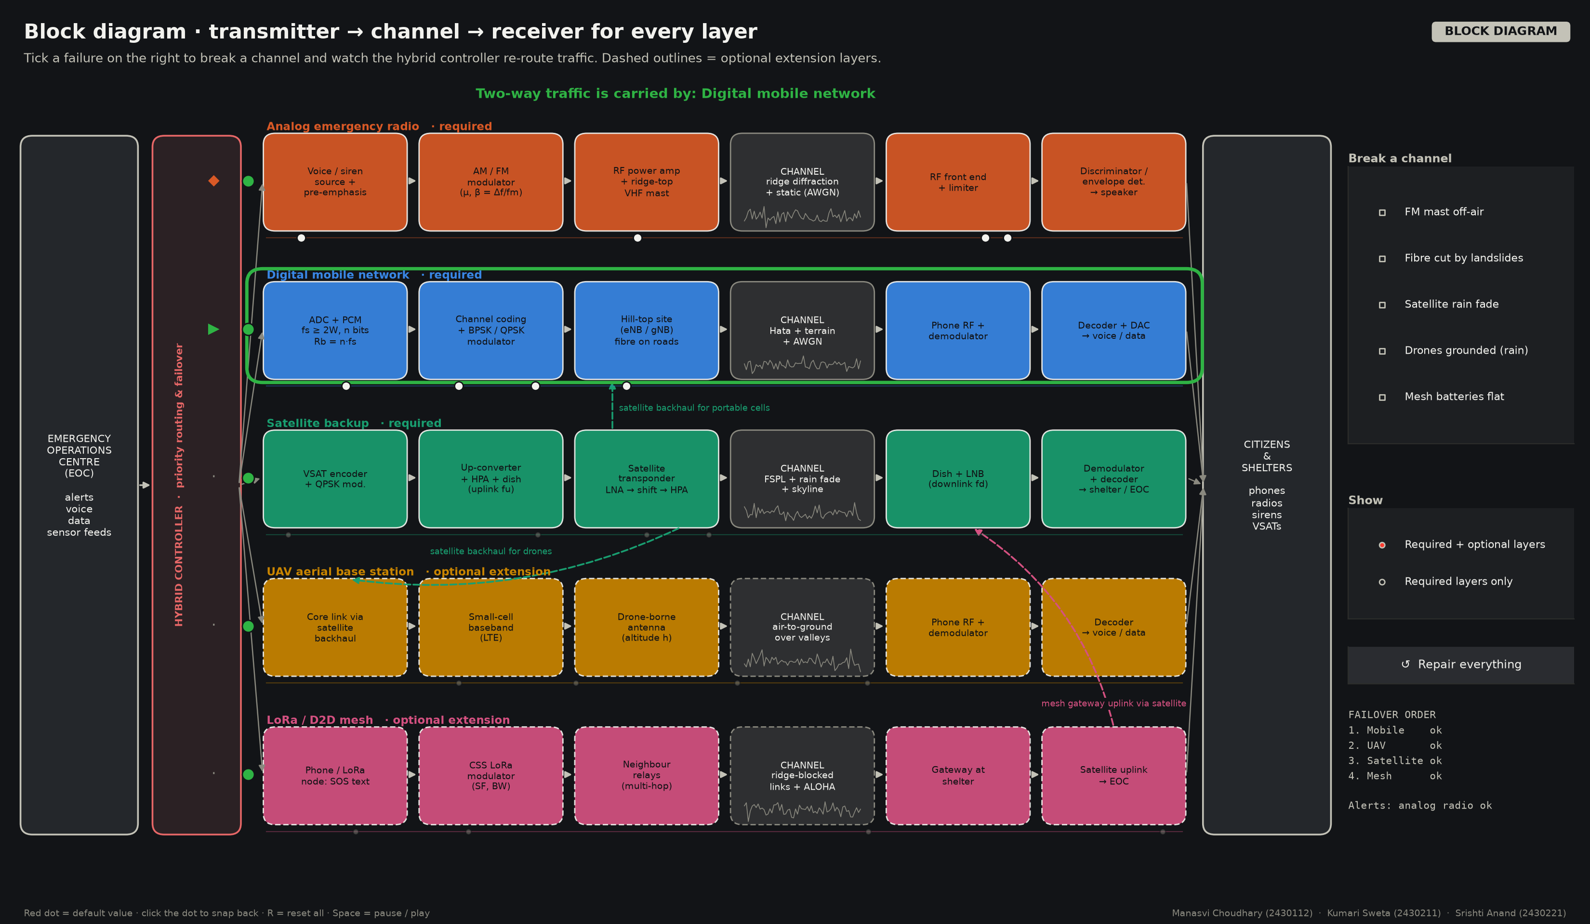
Figure 1. Block diagram of the hybrid network. Each row is one transmitter → channel → receiver chain; dashed rows are optional extensions.
In the analog layer, a voice or siren signal passes through pre-emphasis, an AM or FM modulator, a power amplifier and a ridge-top VHF mast. The channel adds ridge diffraction and Gaussian noise, and the receiver uses a limiter and discriminator (FM) or an envelope detector (AM). The layer is one-way, but one mast reaches everyone with a battery radio.
In the mobile layer, speech is converted by pulse code modulation (PCM), channel coded and modulated with BPSK or QPSK. Hill-top base stations transmit over a channel modelled by the Okumura–Hata equation [9] plus terrain loss and noise, and the phone demodulates and decodes it. Each site depends on fibre laid along roads.
In the satellite layer, a VSAT terminal QPSK-modulates the data and sends it up at 14 GHz through a 1.2 m dish. The transponder amplifies it and sends it down at 12 GHz. The channel adds free-space loss, rain fade and possible skyline blockage, and a dish and LNB feed the demodulator at a shelter or the EOC.
The layers are linked: the satellite carries backhaul for portable cells and connects shelters to the EOC. Two-way traffic uses mobile first, then satellite, while the analog layer broadcasts alerts throughout. A drone base station [10], [11] and a LoRa mesh for SOS messages [12] could also be used as optional extensions. If layer i reaches a fraction p_i of citizens and layers fail independently, the hybrid reach is
A = 1 − Π (1 − p_i)
4. Mathematical calculations
4.1 Analog layer: AM and FM
For AM we take a voice bandwidth fm = 3 kHz and a modulation index μ = Am/Ac = 0.8, below 1 to avoid over-modulation [13]. The bandwidth is B = 2fm = 6 kHz and the total power is Pt = Pc(1 + μ²/2) = 1.32 Pc, so the power efficiency is η = μ²/(2 + μ²) = 24.2%. The spectrum has a carrier at fc and sidebands at fc ± 3 kHz, 8 dB below the carrier.
For FM with deviation Δf = 5 kHz, the modulation index is β = Δf/fm = 1.67, and Carson's rule [14] gives B_T = 2(Δf + fm) = 16 kHz. The spectral lines follow Bessel functions, J0 = 0.417, J1 = 0.576, J2 = 0.274 and J3 = 0.081, so two sideband pairs carry nearly all the power. FM improves the output SNR by 3β²/2, or 6.2 dB.
For each of 420 sample homes, the simulator finds the highest ridge between the mast and the home and computes the knife-edge loss J(v) of ITU-R P.526 [15]. The median loss is 23.1 dB, and 17% of homes lose more than 30 dB. At 100 MHz and 20 km, the path loss is 133.5 dB and the received power is −87.5 dBm. With man-made noise [16] and a 6 dB storm rise, the noise floor is −104.4 dBm and the carrier-to-noise ratio is 16.9 dB. The output SNR is then 30.4 dB for FM but only 18.0 dB for AM. For a 20 dB target, FM covers 55 km against 16 km for AM, and 90.2% of homes receive intelligible FM (Figure 2). FM uses 2.7 times the bandwidth of AM but gains over 12 dB of SNR, a good trade for an emergency channel.
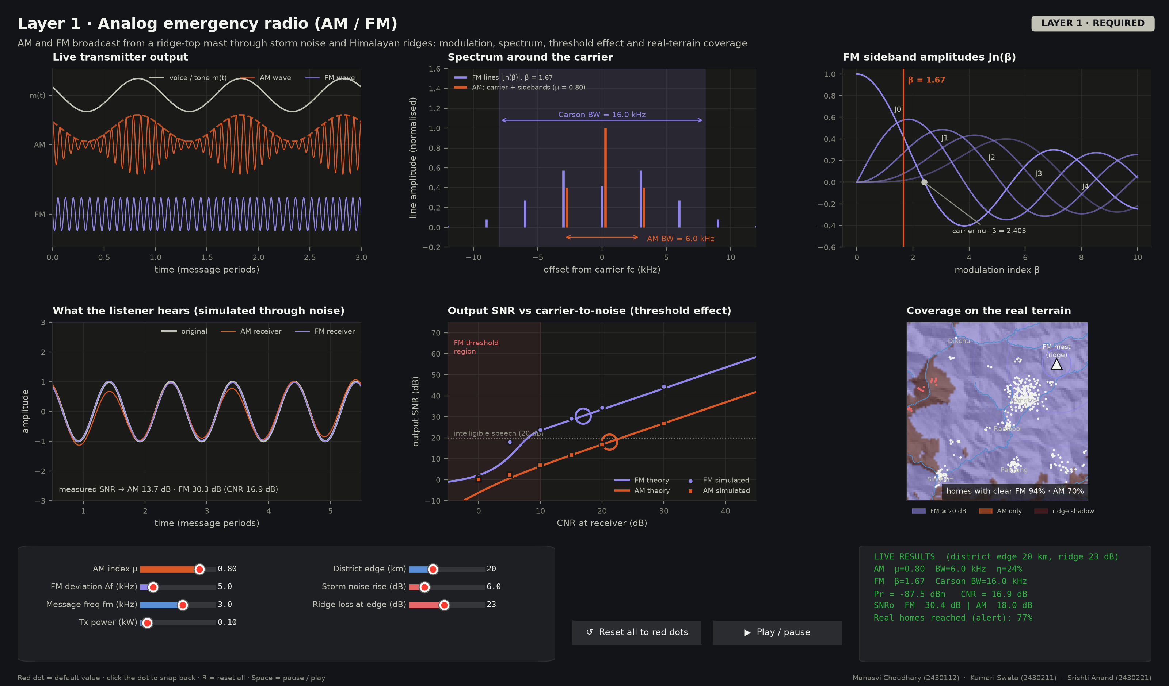
Figure 2. Analog layer: AM and FM waveforms, the FM Bessel spectrum, and FM coverage over the real Gangtok terrain.
4.2 Digital layer: PCM, ASK and BPSK
Speech is limited to W = 3.4 kHz, so the Nyquist rate is 6.8 kHz. We sample at fs = 8 kHz (Ts = 125 µs) [17]. With n = 8 bits there are 256 levels; for a ±1 V range the step size is Δ = 7.81 mV, the maximum quantisation error is Δ/2 = 3.91 mV and the noise power is Δ²/12 = 5.09 × 10⁻⁶ V². The SQNR is 6.02n + 1.76 = 49.9 dB and the bit rate is Rb = n·fs = 64 kbit/s.
With raised-cosine filtering (α = 0.35), the bandwidth is B = Rb(1 + α)/log₂M: 86.4 kHz for ASK and BPSK, 43.2 kHz for QPSK and 21.6 kHz for 16-QAM.
The radio link at the cell edge is not the bottleneck. With 40% of sites off-air, the effective cell radius grows to 2/√(1 − 0.4) = 2.58 km, the Hata loss at 900 MHz is 140.9 dB, the edge SNR is 13.1 dB and Eb/N0 is 18 dB, so the BER is negligible.
Capacity is the real problem (Figure 3). A seven-cell cluster gives C/I = (√(3N))⁴/6 = 18.7 dB [18]. A cell normally carries 40 Erlang; with demand tripled and the load of failed sites shared by the survivors, this becomes 40 × 3 / 0.6 = 200 Erlang. With 56 channels, Erlang-B blocking is 72%. Splitting each cell into four cuts the load to 50 Erlang and the blocking to 4.6%, but splitting needs new sites, so it is a planning step rather than an emergency fix. During the storm only 25% of citizens can complete a call.
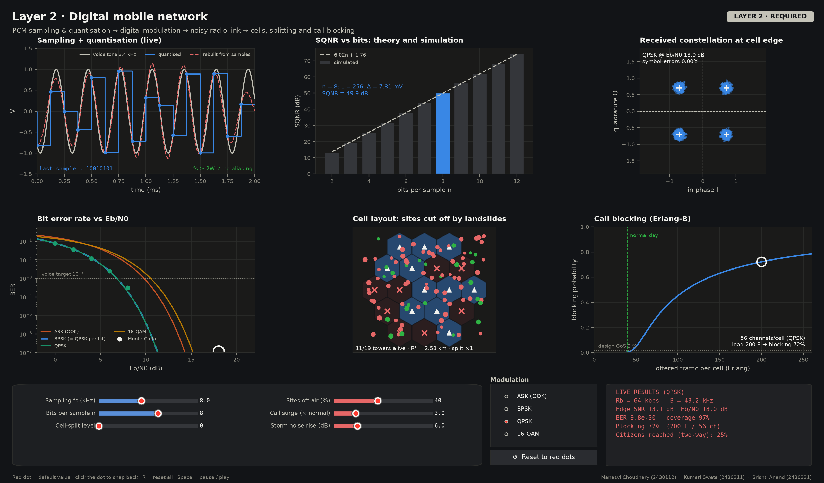
Figure 3. Digital layer: PCM sampling and quantisation, constellation, BER, cells cut off by landslides and Erlang-B blocking.
4.3 Satellite layer: path loss and link budget
The backup uses a geostationary satellite at 83° E, a slot of India's GSAT series, seen from Gangtok at 57.5° elevation and 192° azimuth. The slant range is
d = √((Re + h)² − (Re cos El)²) − Re sin El = 36,645 km
giving a user-to-gateway delay of 2d/c = 244.5 ms [19]. The free-space path loss L = 92.45 + 20 log d(km) + 20 log f(GHz) [20] is 206.6 dB for the 14 GHz uplink and 205.3 dB for the 12 GHz downlink.
Rain is the main weakness. At 80 mm/h the specific attenuation is γ = kRᵅ = 4.25 dB/km [21]. Altitude helps: with a rain height of about 5 km [22] and the terminal at 1.63 km, the slant path through rain is 3.99 km instead of 5.93 km at sea level. After path reduction [23], rain costs 13.0 dB on the downlink and 16.9 dB on the uplink and adds 261 K of noise. A 1.2 m dish gives 41.4 dBi and G/T = 14.7 dB/K [24]. The downlink and uplink C/N0 are 74.5 and 65.2 dB-Hz, and (C/N0)⁻¹ = (C/N0)up⁻¹ + (C/N0)down⁻¹ gives 64.7 dB-Hz. At 256 kbit/s, Eb/N0 is 10.7 dB, a margin of 4.7 dB over the 6 dB needed for coded QPSK.
The real skyline towards the satellite is at 0°, so the view is clear (Figure 4). A live CelesTrak check on 2 October 2026 found 42 Starlink satellites usable above the skyline; at 505 km their path loss is 167.9 dB and their one-way delay 1.7 ms, against 122 ms for GEO [25], so low-orbit satellites could also be used to cut latency.
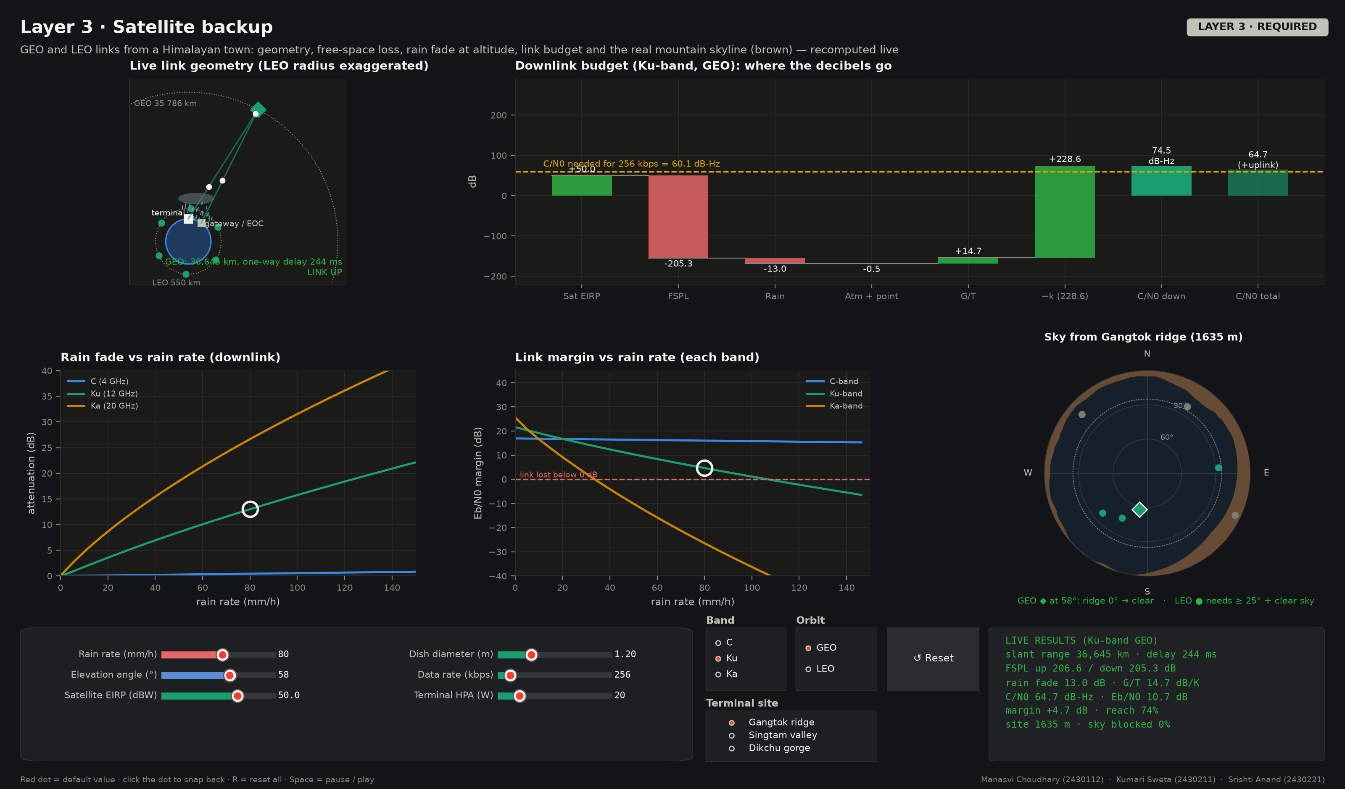
Figure 4. Satellite layer: GEO and LEO geometry, link-budget waterfall, rain fade and the sky view with the real skyline.
5. Noise and signal quality
We model the channel as r = s + n, where n is white Gaussian noise of variance N0/2 per dimension. Storms add impulsive noise from lightning and power lines [26], modelled as a small chance that a sample sees much stronger noise. BER is found from theory [27], Pb = Q(√(2Eb/N0)) for BPSK and Q(√(Eb/N0)) for on-off ASK, and by Monte-Carlo simulation of 200,000 bits (Table 1).
Table 1. Bit error rate at Eb/N0 = 8 dB (AWGN), theory and Monte-Carlo (200,000 bits), with the bandwidth needed for 64 kbit/s PCM.
Scheme | Es/N0 (dB) | BER (theory) | BER (simulated) | Bandwidth
ASK (OOK) | 8.0 | 6.00 × 10⁻³ | 6.10 × 10⁻³ | 86.4 kHz
BPSK | 8.0 | 1.91 × 10⁻⁴ | 1.70 × 10⁻⁴ | 86.4 kHz
QPSK | 11.0 | 1.91 × 10⁻⁴ | 1.85 × 10⁻⁴ | 43.2 kHz
16-QAM | 14.0 | 9.25 × 10⁻³ | 9.24 × 10⁻³ | 21.6 kHz

Simulation agrees with theory within random error (Figure 5). ASK needs about 3 dB more energy than BPSK for the same BER, because its symbols are closer together. QPSK matches BPSK's BER in half the bandwidth, so it suits the mobile and satellite layers, while 16-QAM saves more bandwidth at a much higher error rate and needs strong links. At 8 dB SNR the Shannon limit is 2.87 bit/s/Hz [28]. With impulsive noise the eye diagram closes and the BER curve flattens into a floor, since more transmit power cannot remove noise bursts; coding with interleaving is the usual remedy.
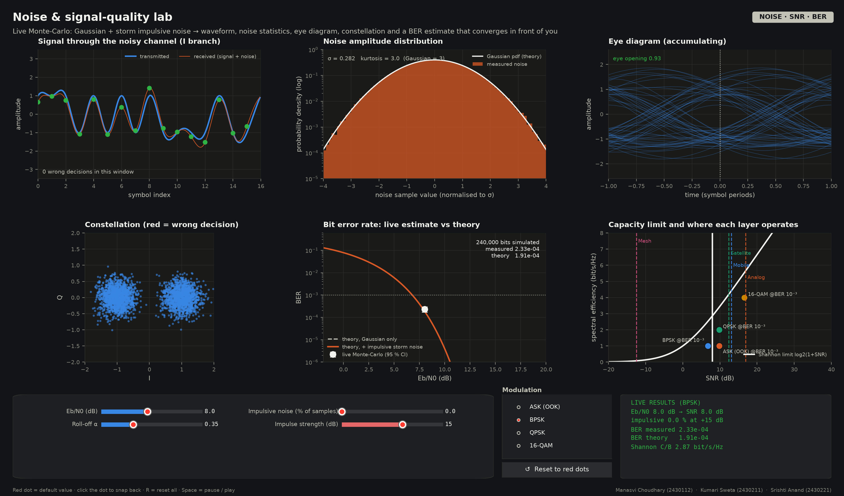
Figure 5. Noise lab: Gaussian and impulsive noise, eye diagram, and simulated BER converging to theory.
At the default storm, FM output SNR is 30.4 dB, mobile cell-edge SNR is 13.1 dB and satellite Eb/N0 is 10.7 dB. All are above threshold, so failures come from damaged infrastructure and congestion rather than noise.
6. Simulation results
Table 2 gives each layer's reach at hazard intensity 0.40 during the cloudburst.
Table 2. Citizens reached by each layer at hazard intensity 0.40 (during the cloudburst, whole district).
Layer | Reach | Data rate | One-way latency | Type
Analog emergency radio | 77% (alerts) | 15 kbit/s | 1 ms | Required
Digital mobile network | 25% | 2.0 Mbit/s | 30 ms | Required
Satellite backup | 72% | 512 kbit/s | 257 ms | Required
UAV base station | 0% | 10 Mbit/s | 35 ms | Optional
LoRa / D2D mesh | 22% | 1.8 kbit/s | 780 ms | Optional
Hybrid, 3 required layers | 79% |  |  | Two-way
Hybrid, with optional layers | 84% |  |  | Two-way
Alert through any layer | 96% |  |  | One-way

The best single two-way layer is the satellite at 72%. The hybrid reaches 79% for two-way traffic, and 96% of citizens receive an alert through at least one layer, mainly thanks to the analog broadcast. The drone layer reaches nobody here because 12 m/s gusts ground it.
In Figure 6, mobile reach falls steadily as the hazard grows, satellite reach stays flat and then drops sharply once rain fade exceeds the margin, and analog reach falls slowly. Because the curves fall at different points, the hybrid stays above every single layer.
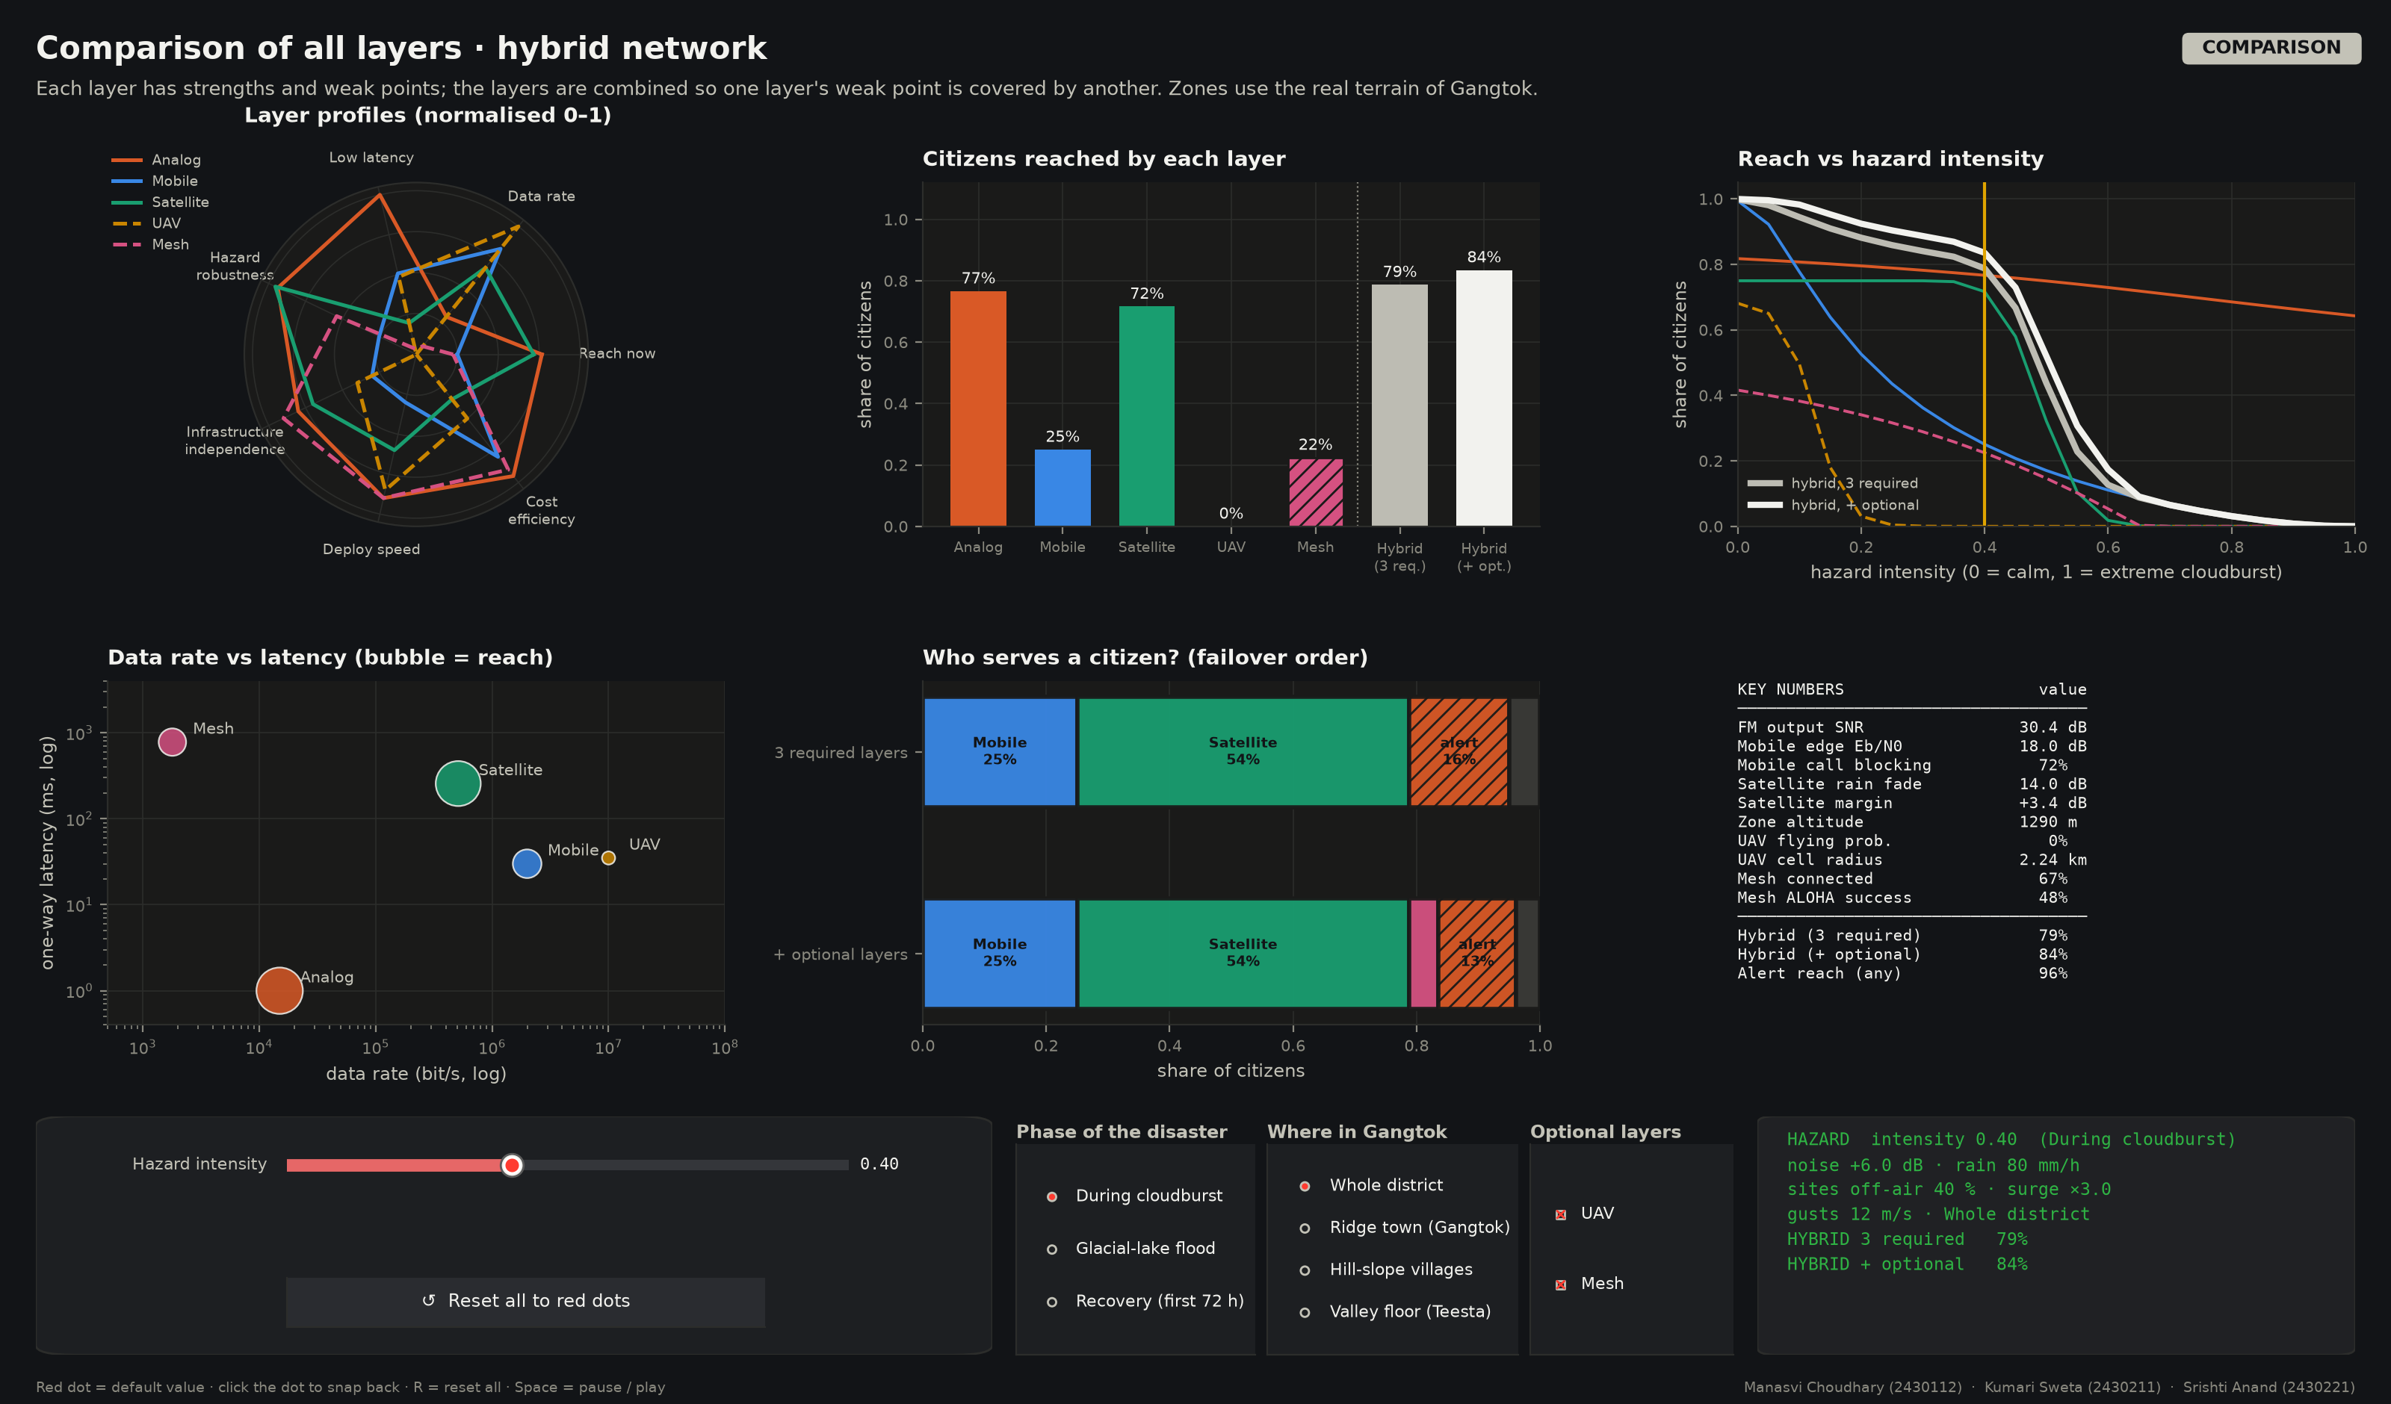
Figure 6. Comparison of all layers: profiles, citizens reached, reach versus hazard intensity and failover share.
Table 3. Two-way hybrid reach by zone and phase: three required layers → with optional layers.
Phase | Ridge town | Hill slopes | Valley floor | Whole district
During cloudburst | 81% → 82% | 77% → 87% | 57% → 74% | 79% → 84%
Glacial-lake flood | 79% → 82% | 79% → 92% | 39% → 75% | 79% → 89%
Recovery | 81% → 89% | 81% → 97% | 81% → 97% | 81% → 96%

Table 3 shows that the valley floor is the weak spot. During the GLOF only 39% of people there can be reached with the required layers, because the valley is ridge-shadowed, has a longer rain path and is where the flood cuts roads and fibre. The optional drone and mesh layers could raise this to 75%. Figure 7 shows the sequence on the map: landslides cut roads and sites, the flood moves down the river, and service returns as roads reopen.
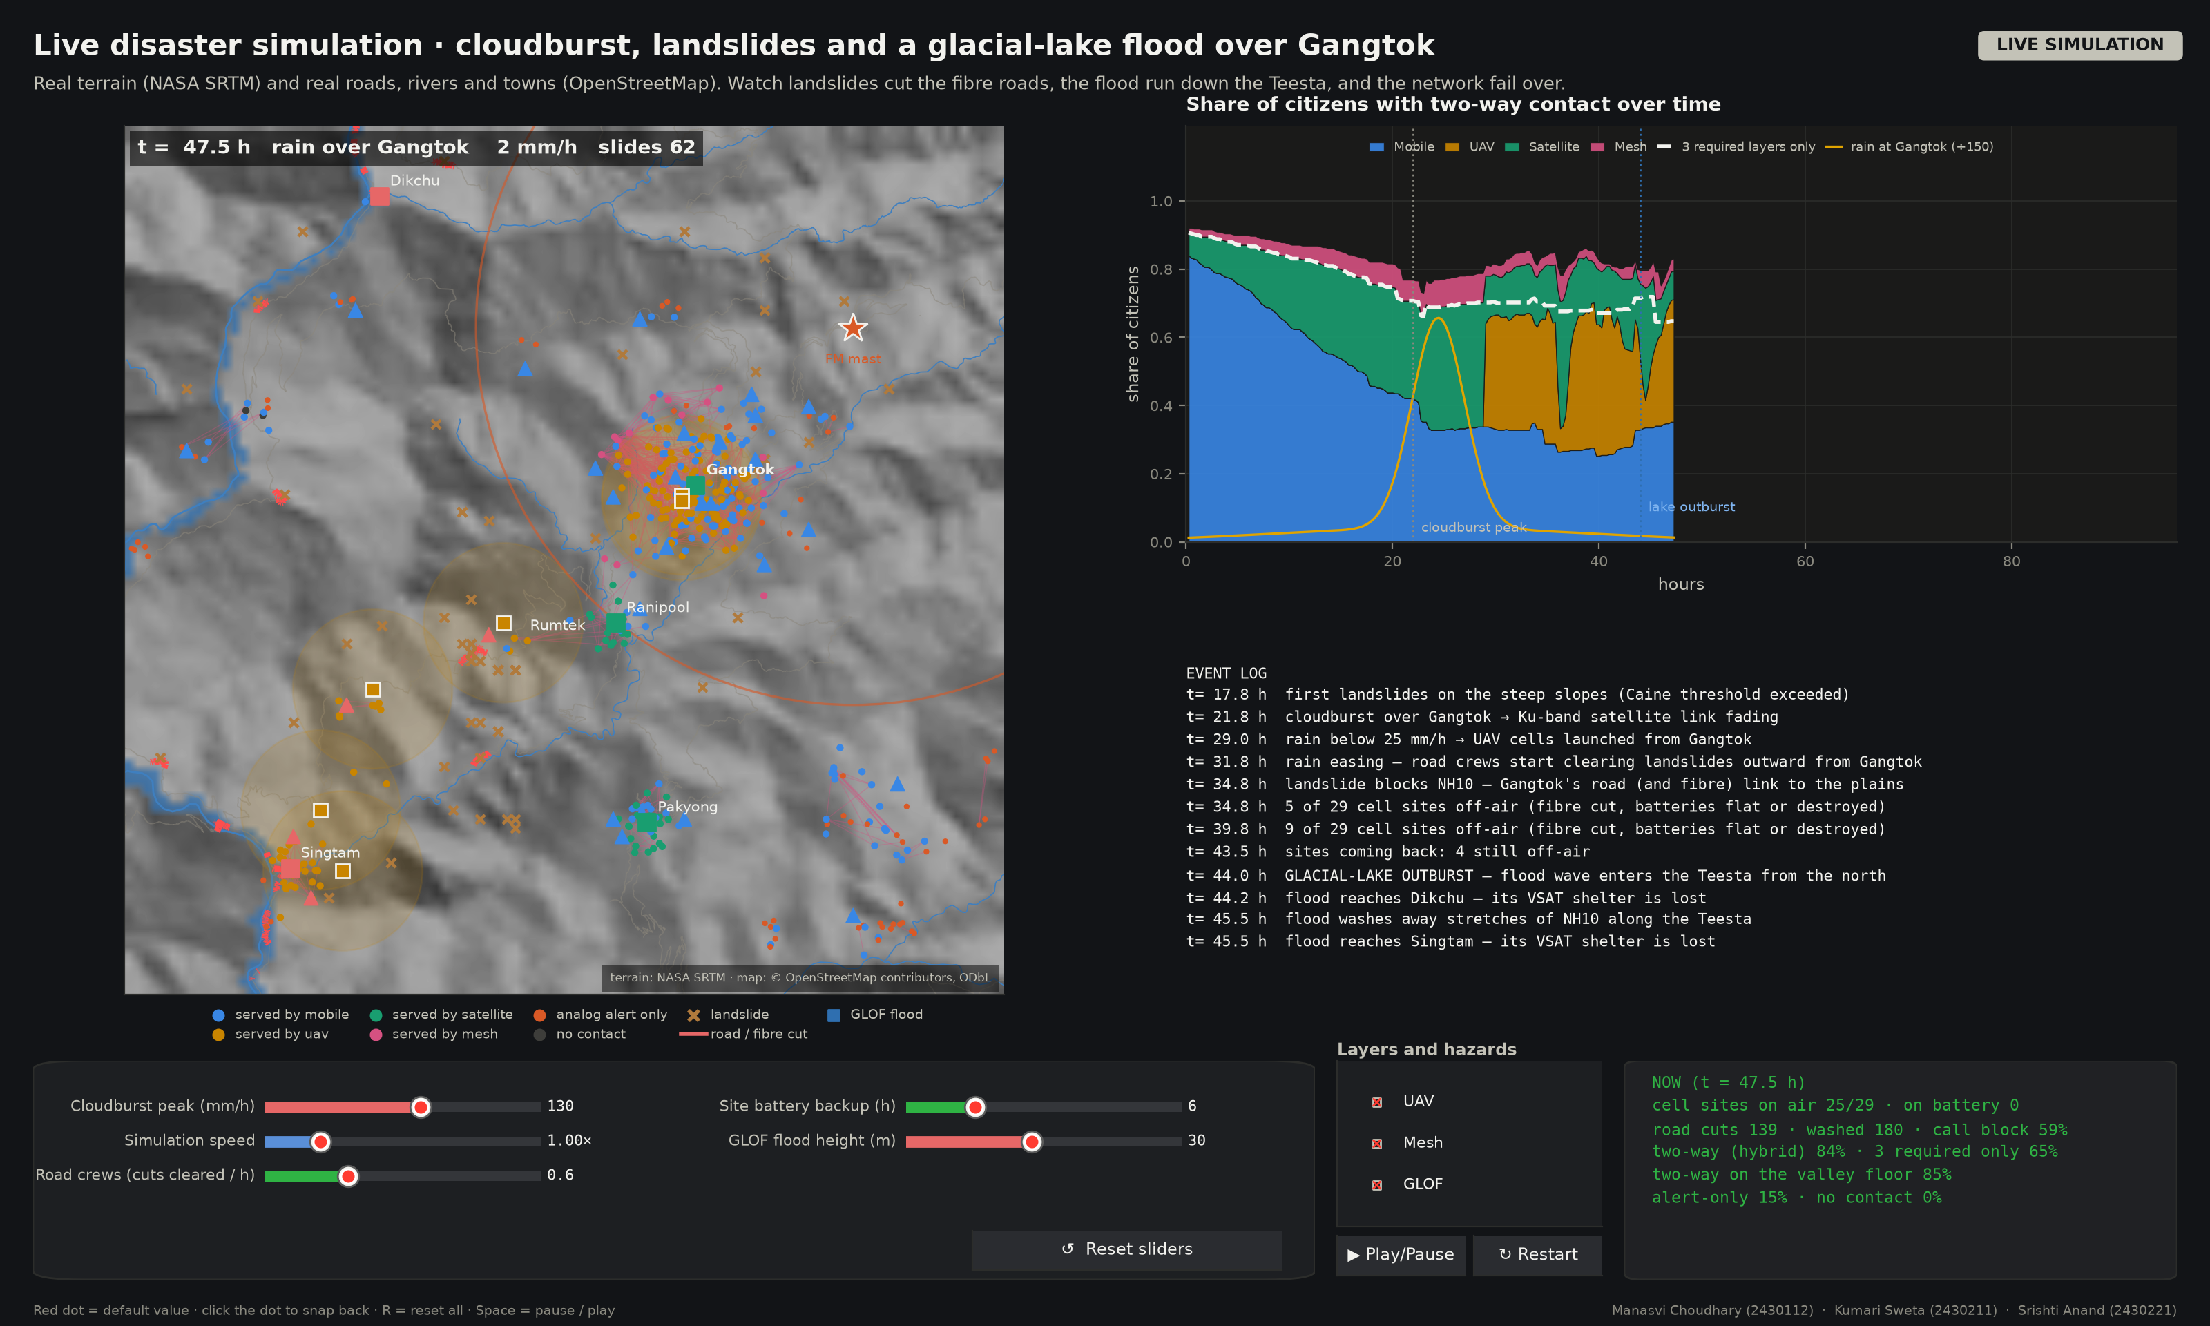
Figure 7. Live disaster simulation on the real map of Gangtok: cloudburst, landslides, the GLOF on the Teesta, and recovery.
7. Critical review and recommendation
The hybrid works better than any single network because in Gangtok the layers fail for different reasons. Analog radio is limited by geometry: a ridge blocks a home or it does not, whatever the weather. The mobile network is limited by infrastructure and load, as landslides cut fibre and power while demand surges. The satellite is limited by weather, and only while the storm cell is overhead. Since these causes are largely independent, one layer usually works where another has failed.
Mountains also bring advantages. A ridge-top mast sees most of the district, so one FM transmitter reaches 90% of homes. The satellite sits at 57.5°, above most ridges, and the town's altitude shortens the rain path by a third.
A flat urban city would differ. Without ridges, analog and mobile coverage would improve, though high-rise buildings cause their own shadowing. But a coastal cyclone hits every layer at once: wind damages masts, rain fades the satellite and storm surge cuts power city-wide. The layers then fail together and combining them helps less than our model predicts. In the mountains, failures are local, tied to particular slopes and the valley floor, so spreading service across layers pays off more.
The design has limitations. The independence assumption overstates reach where layers share a weak point, such as one power supply feeding both a cell site and a VSAT. The hazard values are illustrative, not calibrated against outage data. GEO delay of about 250 ms makes voice awkward, terminals are costly, and the analog layer cannot carry replies.
We recommend the following for Gangtok:
- FM emergency transmitters on at least two ridge tops, with battery and solar backup, so each covers the other's shadow zones.
- VSAT terminals at shelters, hospitals and the EOC, with satellite backhaul ready for portable cells.
- A second backhaul path for key cell sites that avoids the same road, and priority access for emergency services.
- GLOF sensors upstream on the Teesta linked to the EOC by satellite, since local rain gave no warning in 2023.
- Where the budget allows, drones and a LoRa mesh could also be used for the valley floor.
8. Conclusion
We designed and simulated a three-layer hybrid network for Gangtok on real terrain. FM trades 2.7 times the bandwidth of AM for 12 dB more SNR, QPSK carries 64 kbit/s PCM speech in 43.2 kHz, and the Ku-band link keeps a 4.7 dB margin in 80 mm/h rain. No single layer was enough: the mobile network reached only 25% of citizens during the storm, while the hybrid reached 79% for two-way traffic and 96% for alerts. In mountain terrain the layers fail for different reasons, which is the strongest argument for combining them. Future work should calibrate the hazard model against recorded outages from the 2023 Sikkim flood.
Code availability: the Python simulator and all calculations are included in the submitted zip file (run python main.py).
References
[1] T. Sakano et al., "Disaster-resilient networking: a new vision based on movable and deployable resource units," IEEE Network, vol. 27, no. 4, pp. 40–46, 2013. doi: 10.1109/MNET.2013.6574664
[2] FCC Public Safety and Homeland Security Bureau, "2017 Atlantic Hurricane Season Impact on Communications: Report and Recommendations," Aug. 2018. [Online]. Available: https://docs.fcc.gov/public/attachments/DOC-353805A1.pdf
[3] A. Sattar et al., "The Sikkim flood of October 2023: drivers, causes and impacts of a multihazard cascade," Science, vol. 387, no. 6740, eads2659, 2025. doi: 10.1126/science.ads2659
[4] T. G. Farr et al., "The Shuttle Radar Topography Mission," Reviews of Geophysics, vol. 45, no. 2, RG2004, 2007. doi: 10.1029/2005RG000183
[5] OpenStreetMap contributors, map data (roads, rivers, settlements), openstreetmap.org, ODbL licence. [Online]. Available: https://www.openstreetmap.org/copyright
[6] N. Caine, "The rainfall intensity–duration control of shallow landslides and debris flows," Geografiska Annaler: Series A, vol. 62, no. 1–2, pp. 23–27, 1980. doi: 10.1080/04353676.1980.11879996
[7] A. D. Nobre et al., "Height Above the Nearest Drainage – a hydrologically relevant new terrain model," Journal of Hydrology, vol. 404, no. 1–2, pp. 13–29, 2011. doi: 10.1016/j.jhydrol.2011.03.051
[8] Open-Meteo.com, Weather Forecast API and Historical Weather API (ERA5 reanalysis), CC BY 4.0; CelesTrak GP element sets, celestrak.org. Accessed: 2 Oct. 2026. [Online]. Available: https://open-meteo.com/
[9] M. Hata, "Empirical formula for propagation loss in land mobile radio services," IEEE Trans. Vehicular Technology, vol. 29, no. 3, pp. 317–325, 1980. doi: 10.1109/T-VT.1980.23859
[10] A. Al-Hourani, S. Kandeepan and S. Lardner, "Optimal LAP altitude for maximum coverage," IEEE Wireless Communications Letters, vol. 3, no. 6, pp. 569–572, 2014. doi: 10.1109/LWC.2014.2342736
[11] M. Mozaffari, W. Saad, M. Bennis, Y.-H. Nam and M. Debbah, "A tutorial on UAVs for wireless networks: applications, challenges, and open problems," IEEE Communications Surveys & Tutorials, vol. 21, no. 3, pp. 2334–2360, 2019. doi: 10.1109/COMST.2019.2902862
[12] A. Augustin, J. Yi, T. Clausen and W. M. Townsley, "A study of LoRa: long range & low power networks for the Internet of Things," Sensors, vol. 16, no. 9, 1466, 2016. doi: 10.3390/s16091466
[13] S. Haykin and M. Moher, Communication Systems, 5th ed. Wiley, 2009. [Online]. Available: https://books.google.com/books?vid=ISBN9780471697909
[14] J. R. Carson, "Notes on the theory of modulation," Proc. IRE, vol. 10, no. 1, pp. 57–64, 1922. doi: 10.1109/JRPROC.1922.219793
[15] ITU-R Recommendation P.526, Propagation by diffraction. [Online]. Available: https://www.itu.int/rec/R-REC-P.526/en
[16] ITU-R Recommendation P.372, Radio noise. [Online]. Available: https://www.itu.int/rec/R-REC-P.372/en
[17] B. P. Lathi and Z. Ding, Modern Digital and Analog Communication Systems, 4th ed. OUP, 2009. [Online]. Available: https://books.google.com/books?vid=ISBN9780195331455
[18] T. S. Rappaport, Wireless Communications: Principles and Practice, 2nd ed. Prentice Hall, 2002. [Online]. Available: https://books.google.com/books?vid=ISBN9780130422323
[19] G. Maral, M. Bousquet and Z. Sun, Satellite Communications Systems, 6th ed. Wiley, 2020. doi: 10.1002/9781119673811
[20] ITU-R Recommendation P.525, Calculation of free-space attenuation. [Online]. Available: https://www.itu.int/rec/R-REC-P.525/en
[21] ITU-R Recommendation P.838-3, Specific attenuation model for rain for use in prediction methods, 2005. [Online]. Available: https://www.itu.int/rec/R-REC-P.838-3-200503-I/en
[22] ITU-R Recommendation P.839, Rain height model for prediction methods. [Online]. Available: https://www.itu.int/rec/R-REC-P.839/en
[23] ITU-R Recommendation P.618, Propagation data and prediction methods required for the design of Earth-space telecommunication systems. [Online]. Available: https://www.itu.int/rec/R-REC-P.618/en
[24] T. Pratt and J. E. Allnutt, Satellite Communications, 3rd ed. Wiley, 2019. [Online]. Available: https://books.google.com/books?vid=ISBN9781119482178
[25] I. del Portillo, B. G. Cameron and E. F. Crawley, "A technical comparison of three low earth orbit satellite constellation systems to provide global broadband," Acta Astronautica, vol. 159, pp. 123–135, 2019. doi: 10.1016/j.actaastro.2019.03.040
[26] D. Middleton, "Statistical-physical models of electromagnetic interference," IEEE Trans. Electromagnetic Compatibility, vol. EMC-19, no. 3, pp. 106–127, 1977. doi: 10.1109/TEMC.1977.303527
[27] J. G. Proakis and M. Salehi, Digital Communications, 5th ed. McGraw-Hill, 2008. [Online]. Available: https://books.google.com/books?vid=ISBN9780072957167
[28] C. E. Shannon, "A mathematical theory of communication," Bell System Technical Journal, vol. 27, no. 3, pp. 379–423, 1948. doi: 10.1002/j.1538-7305.1948.tb01338.x

