INTEGRANDO PROYECTO QUINIELA CON JENKINS Y GITHUB

Creando Webhook

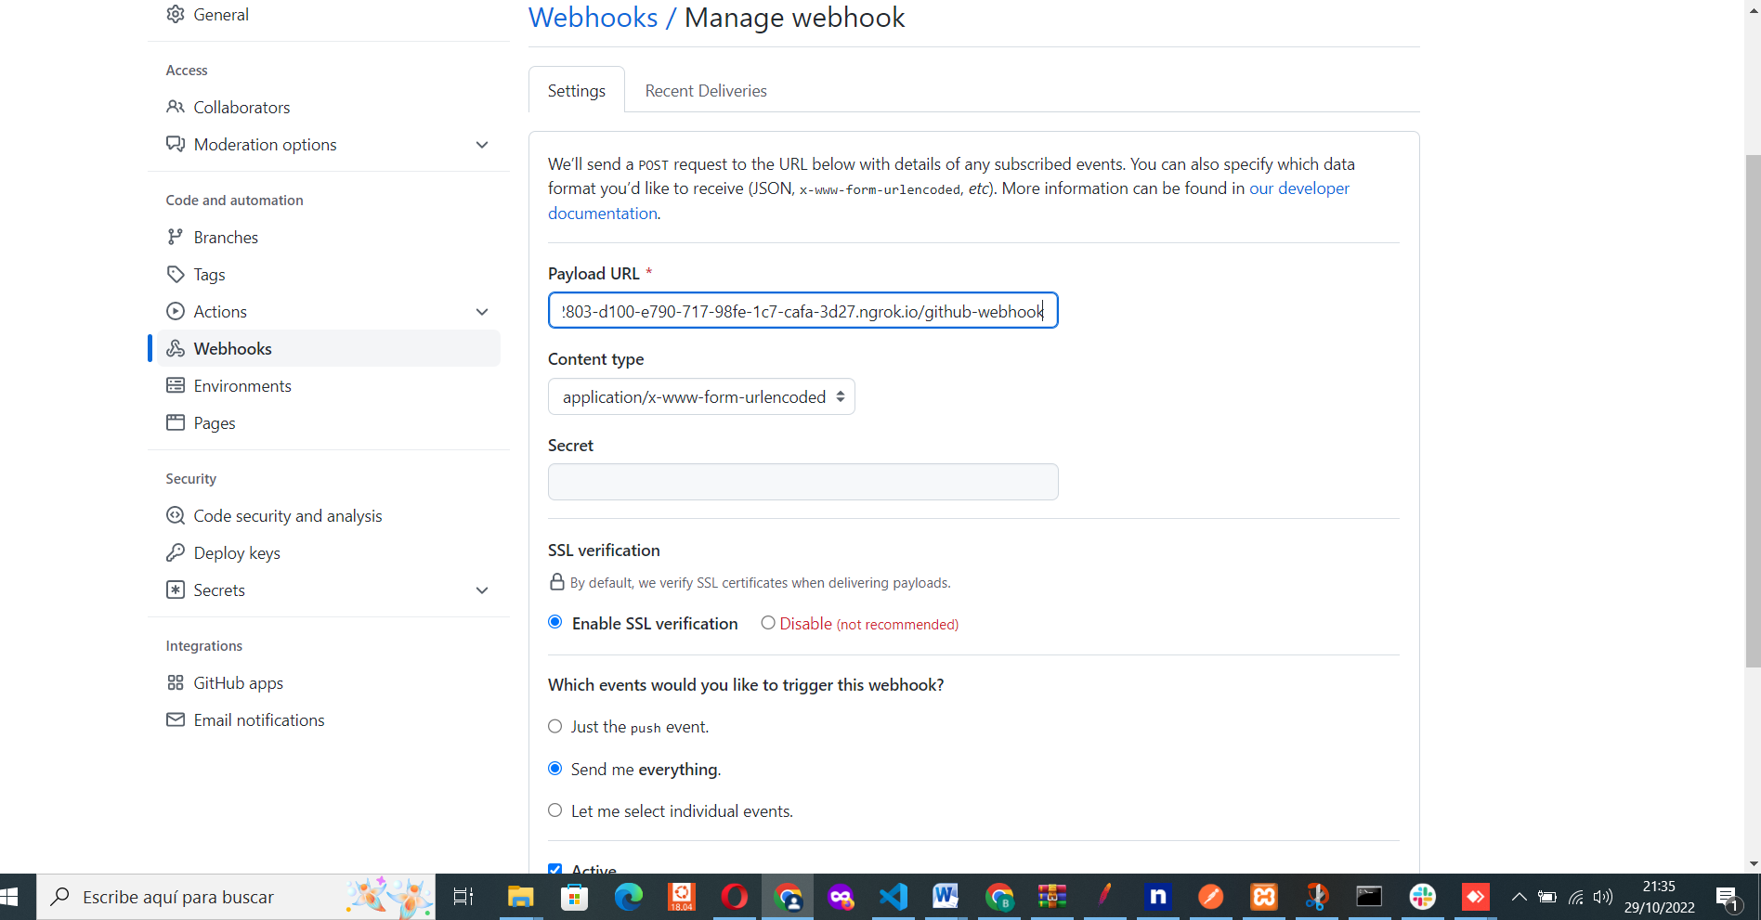

CREANDO JOB EN JENKINS

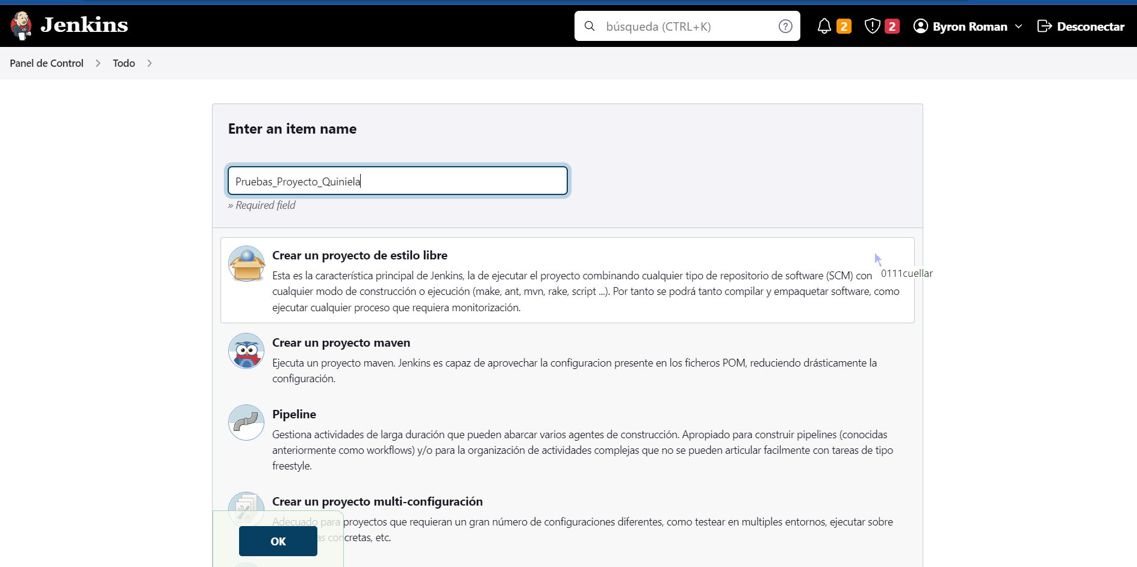

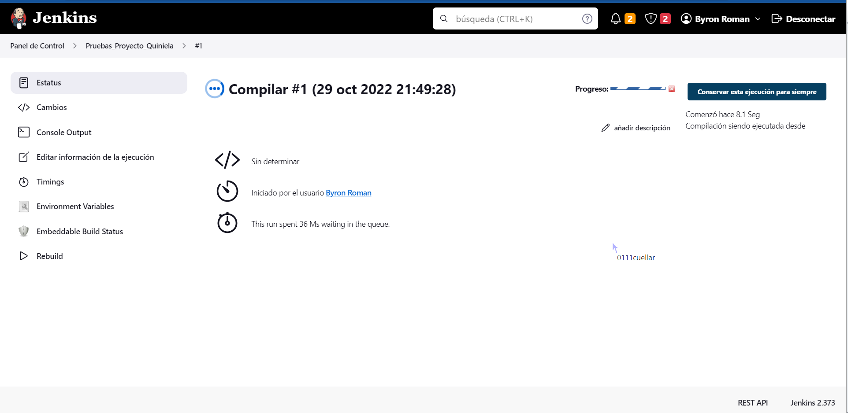

RESULTADO DE COMPILACION

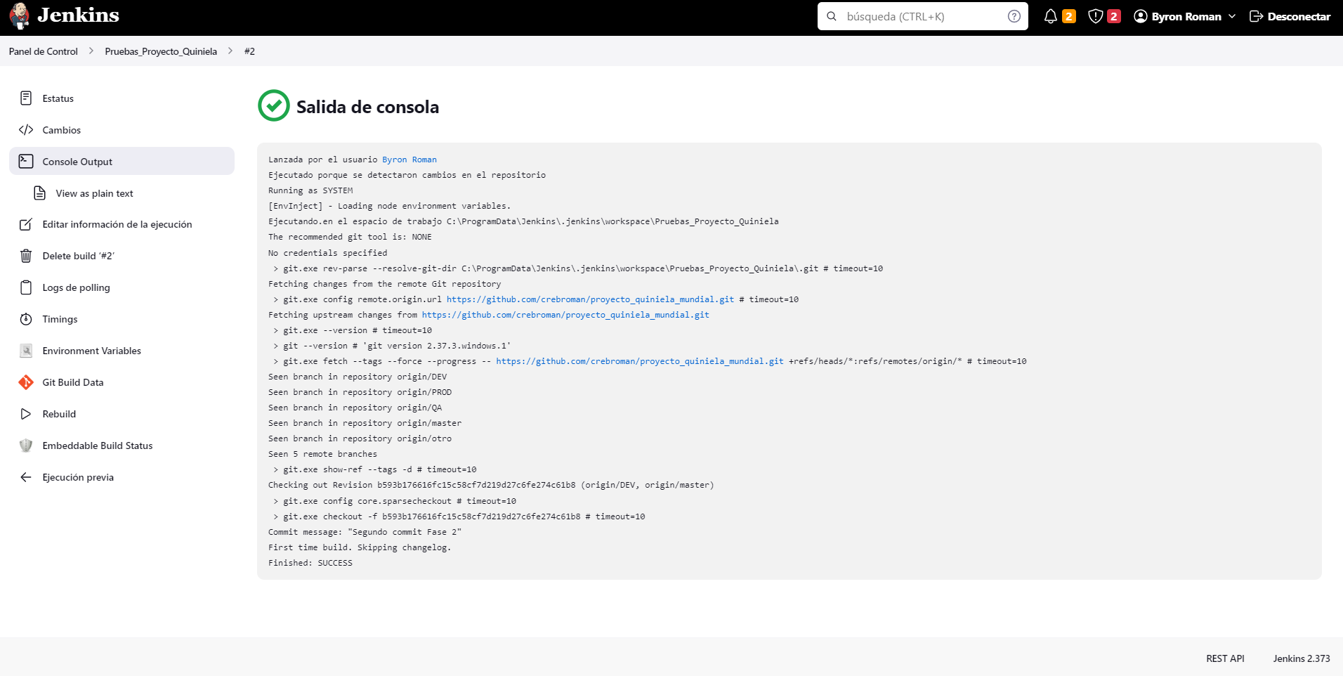

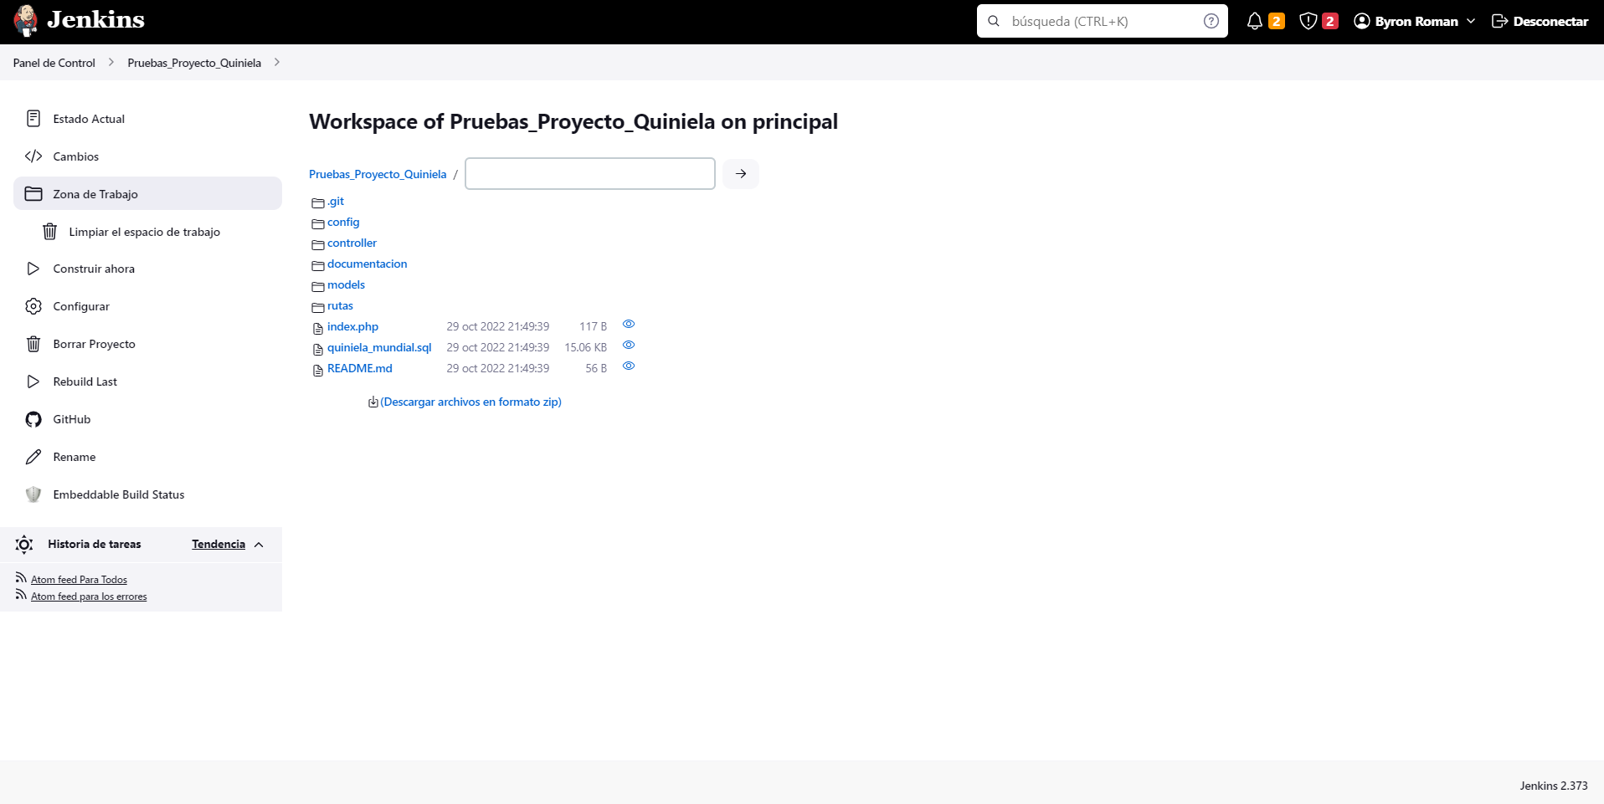

INTEGRANDO SONARQUBE CON JENKINS

**Salida de consola**

Lanzada por el usuario [Byron Roman](http://localhost:8181/user/admin)

Running as SYSTEM

[EnvInject] - Loading node environment variables.

Ejecutando.en el espacio de trabajo C:\ProgramData\Jenkins\.jenkins\workspace\Pruebas_Proyecto_Quiniela

The recommended git tool is: NONE

No credentials specified

> git.exe rev-parse --resolve-git-dir C:\ProgramData\Jenkins\.jenkins\workspace\Pruebas_Proyecto_Quiniela\.git # timeout=10

Fetching changes from the remote Git repository

> git.exe config remote.origin.url <https://github.com/crebroman/proyecto_quiniela_mundial.git> # timeout=10

Fetching upstream changes from <https://github.com/crebroman/proyecto_quiniela_mundial.git>

> git.exe --version # timeout=10

> git --version # 'git version 2.37.3.windows.1'

> git.exe fetch --tags --force --progress -- <https://github.com/crebroman/proyecto_quiniela_mundial.git> +refs/heads/*:refs/remotes/origin/* # timeout=10

Seen branch in repository origin/DEV

Seen branch in repository origin/PROD

Seen branch in repository origin/QA

Seen branch in repository origin/master

Seen branch in repository origin/otro

Seen 5 remote branches

> git.exe show-ref --tags -d # timeout=10

Checking out Revision f31675b7b254da5a419741522368e7075e7ce7c5 (origin/master)

> git.exe config core.sparsecheckout # timeout=10

> git.exe checkout -f f31675b7b254da5a419741522368e7075e7ce7c5 # timeout=10

Commit message: "Update README.md (#3)"

> git.exe rev-list --no-walk f31675b7b254da5a419741522368e7075e7ce7c5 # timeout=10

[Pruebas_Proyecto_Quiniela] $ C:\ProgramData\Jenkins\.jenkins\tools\hudson.plugins.sonar.SonarRunnerInstallation\ScannerSonarQ\bin\sonar-scanner.bat -Dsonar.host.url=[http://localhost:9000](http://localhost:9000/) -Dsonar.projectKey=Proyecto_Quiniela_Mundial -Dsonar.projectName=Fase2_Quiniela_Mundial -Dsonar.sourceEncoding=UTF-8 "-Dsonar.projectDescription=Proyecto Fase 2 Quiniela Mundial" -Dsonar.host.url=[http://localhost:9000](http://localhost:9000/) -Dsonar.login=UserJenkins -Dsonar.projectVersion=1 -Dsonar.sources=. -Dsonar.password=pwia.g1 -Dsonar.projectBaseDir=C:\ProgramData\Jenkins\.jenkins\workspace\Pruebas_Proyecto_Quiniela

WARN: Property 'sonar.host.url' with value '[http://localhost:9000](http://localhost:9000/)' is overridden with value '[http://localhost:9000](http://localhost:9000/)'

INFO: Scanner configuration file: C:\ProgramData\Jenkins\.jenkins\tools\hudson.plugins.sonar.SonarRunnerInstallation\ScannerSonarQ\bin\..\conf\sonar-scanner.properties

INFO: Project root configuration file: NONE

INFO: SonarScanner 4.7.0.2747

INFO: Java 17 Oracle Corporation (64-bit)

INFO: Windows 10 10.0 amd64

INFO: User cache: C:\Users\Byron\.sonar\cache

INFO: Scanner configuration file: C:\ProgramData\Jenkins\.jenkins\tools\hudson.plugins.sonar.SonarRunnerInstallation\ScannerSonarQ\bin\..\conf\sonar-scanner.properties

INFO: Project root configuration file: NONE

INFO: Analyzing on SonarQube server 9.7.0.61563

INFO: Default locale: "es_GT", source code encoding: "UTF-8"

INFO: Load global settings

INFO: Load global settings (done) | time=305ms

INFO: Server id: 147B411E-AYP5PROBVCmywltu2VeQ

INFO: User cache: C:\Users\Byron\.sonar\cache

INFO: Load/download plugins

INFO: Load plugins index

INFO: Load plugins index (done) | time=242ms

INFO: Load/download plugins (done) | time=347ms

INFO: Process project properties

INFO: Process project properties (done) | time=15ms

INFO: Execute project builders

INFO: Execute project builders (done) | time=3ms

INFO: Project key: Proyecto_Quiniela_Mundial

INFO: Base dir: C:\ProgramData\Jenkins\.jenkins\workspace\Pruebas_Proyecto_Quiniela

INFO: Working dir: C:\ProgramData\Jenkins\.jenkins\workspace\Pruebas_Proyecto_Quiniela\.scannerwork

INFO: Load project settings for component key: 'Proyecto_Quiniela_Mundial'

INFO: Load project settings for component key: 'Proyecto_Quiniela_Mundial' (done) | time=309ms

INFO: Auto-configuring with CI 'Jenkins'

INFO: Load quality profiles

INFO: Load quality profiles (done) | time=260ms

INFO: Load active rules

INFO: Load active rules (done) | time=7609ms

INFO: Load analysis cache

INFO: Load analysis cache (404) | time=298ms

INFO: Load project repositories

INFO: Load project repositories (done) | time=410ms

INFO: Indexing files...

INFO: Project configuration:

INFO: 38 files indexed

INFO: 0 files ignored because of scm ignore settings

INFO: Quality profile for php: Sonar way

INFO: ------------- Run sensors on module Fase2_Quiniela_Mundial

INFO: Load metrics repository

INFO: Load metrics repository (done) | time=413ms

INFO: Sensor JaCoCo XML Report Importer [jacoco]

INFO: 'sonar.coverage.jacoco.xmlReportPaths' is not defined. Using default locations: target/site/jacoco/jacoco.xml,target/site/jacoco-it/jacoco.xml,build/reports/jacoco/test/jacocoTestReport.xml

INFO: No report imported, no coverage information will be imported by JaCoCo XML Report Importer

INFO: Sensor JaCoCo XML Report Importer [jacoco] (done) | time=5ms

INFO: Sensor CSS Rules [javascript]

INFO: 34 source files to be analyzed

INFO: 34/34 source files have been analyzed

INFO: Hit the cache for 0 out of 0

INFO: Miss the cache for 0 out of 0

INFO: Sensor CSS Rules [javascript] (done) | time=23111ms

INFO: Sensor C# Project Type Information [csharp]

INFO: Sensor C# Project Type Information [csharp] (done) | time=3ms

INFO: Sensor C# Analysis Log [csharp]

INFO: Sensor C# Analysis Log [csharp] (done) | time=30ms

INFO: Sensor C# Properties [csharp]

INFO: Sensor C# Properties [csharp] (done) | time=0ms

INFO: Sensor HTML [web]

INFO: Sensor HTML [web] (done) | time=105ms

INFO: Sensor PHP sensor [php]

INFO: Starting PHP symbol indexer

INFO: 34 source files to be analyzed

INFO: 34/34 source files have been analyzed

INFO: Starting PHP rules

INFO: 34 source files to be analyzed

INFO: 34/34 source files have been analyzed

INFO: No PHPUnit tests reports provided (see 'sonar.php.tests.reportPath' property)

INFO: No PHPUnit coverage reports provided (see 'sonar.php.coverage.reportPaths' property)

INFO: Sensor PHP sensor [php] (done) | time=5656ms

INFO: Sensor Analyzer for "php.ini" files [php]

INFO: Sensor Analyzer for "php.ini" files [php] (done) | time=6ms

INFO: Sensor Text Sensor [text]

INFO: 34 source files to be analyzed

INFO: 34/34 source files have been analyzed

INFO: Sensor Text Sensor [text] (done) | time=58ms

INFO: Sensor VB.NET Project Type Information [vbnet]

INFO: Sensor VB.NET Project Type Information [vbnet] (done) | time=2ms

INFO: Sensor VB.NET Analysis Log [vbnet]

INFO: Sensor VB.NET Analysis Log [vbnet] (done) | time=27ms

INFO: Sensor VB.NET Properties [vbnet]

INFO: Sensor VB.NET Properties [vbnet] (done) | time=0ms

INFO: ------------- Run sensors on project

INFO: Sensor Analysis Warnings import [csharp]

INFO: Sensor Analysis Warnings import [csharp] (done) | time=3ms

INFO: Sensor Zero Coverage Sensor

INFO: Sensor Zero Coverage Sensor (done) | time=69ms

INFO: CPD Executor 3 files had no CPD blocks

INFO: CPD Executor Calculating CPD for 31 files

INFO: CPD Executor CPD calculation finished (done) | time=79ms

INFO: Analysis report generated in 327ms, dir size=355.2 kB

INFO: Analysis report compressed in 430ms, zip size=138.2 kB

INFO: Analysis report uploaded in 360ms

INFO: ANALYSIS SUCCESSFUL, you can find the results at: <http://localhost:9000/dashboard?id=Proyecto_Quiniela_Mundial>

INFO: Note that you will be able to access the updated dashboard once the server has processed the submitted analysis report

INFO: More about the report processing at <http://localhost:9000/api/ce/task?id=AYQnTnKym6UzHZciV9CI>

INFO: Analysis total time: 59.522 s

INFO: ------------------------------------------------------------------------

INFO: EXECUTION SUCCESS

INFO: ------------------------------------------------------------------------

INFO: Total time: 1:01.791s

INFO: Final Memory: 18M/74M

INFO: ------------------------------------------------------------------------

Lanzada por el usuario [Byron Roman](http://localhost:8181/user/admin)

Running as SYSTEM

[EnvInject] - Loading node environment variables.

Ejecutando.en el espacio de trabajo C:\ProgramData\Jenkins\.jenkins\workspace\Pruebas_Proyecto_Quiniela

The recommended git tool is: NONE

No credentials specified

> git.exe rev-parse --resolve-git-dir C:\ProgramData\Jenkins\.jenkins\workspace\Pruebas_Proyecto_Quiniela\.git # timeout=10

Fetching changes from the remote Git repository

> git.exe config remote.origin.url <https://github.com/crebroman/proyecto_quiniela_mundial.git> # timeout=10

Fetching upstream changes from <https://github.com/crebroman/proyecto_quiniela_mundial.git>

> git.exe --version # timeout=10

> git --version # 'git version 2.37.3.windows.1'

> git.exe fetch --tags --force --progress -- <https://github.com/crebroman/proyecto_quiniela_mundial.git> +refs/heads/*:refs/remotes/origin/* # timeout=10

Seen branch in repository origin/DEV

Seen branch in repository origin/PROD

Seen branch in repository origin/QA

Seen branch in repository origin/master

Seen branch in repository origin/otro

Seen 5 remote branches

> git.exe show-ref --tags -d # timeout=10

Checking out Revision f31675b7b254da5a419741522368e7075e7ce7c5 (origin/master)

> git.exe config core.sparsecheckout # timeout=10

> git.exe checkout -f f31675b7b254da5a419741522368e7075e7ce7c5 # timeout=10

Commit message: "Update README.md (#3)"

> git.exe rev-list --no-walk f31675b7b254da5a419741522368e7075e7ce7c5 # timeout=10

[Pruebas_Proyecto_Quiniela] $ C:\ProgramData\Jenkins\.jenkins\tools\hudson.plugins.sonar.SonarRunnerInstallation\ScannerSonarQ\bin\sonar-scanner.bat -Dsonar.host.url=[http://localhost:9000](http://localhost:9000/) -Dsonar.projectKey=Proyecto_Quiniela_Mundial -Dsonar.projectName=Fase2_Quiniela_Mundial -Dsonar.sourceEncoding=UTF-8 "-Dsonar.projectDescription=Proyecto Fase 2 Quiniela Mundial" -Dsonar.host.url=[http://localhost:9000](http://localhost:9000/) -Dsonar.login=UserJenkins -Dsonar.projectVersion=1 -Dsonar.sources=. -Dsonar.password=pwia.g1 -Dsonar.projectBaseDir=C:\ProgramData\Jenkins\.jenkins\workspace\Pruebas_Proyecto_Quiniela

WARN: Property 'sonar.host.url' with value '[http://localhost:9000](http://localhost:9000/)' is overridden with value '[http://localhost:9000](http://localhost:9000/)'

INFO: Scanner configuration file: C:\ProgramData\Jenkins\.jenkins\tools\hudson.plugins.sonar.SonarRunnerInstallation\ScannerSonarQ\bin\..\conf\sonar-scanner.properties

INFO: Project root configuration file: NONE

INFO: SonarScanner 4.7.0.2747

INFO: Java 17 Oracle Corporation (64-bit)

INFO: Windows 10 10.0 amd64

INFO: User cache: C:\Users\Byron\.sonar\cache

INFO: Scanner configuration file: C:\ProgramData\Jenkins\.jenkins\tools\hudson.plugins.sonar.SonarRunnerInstallation\ScannerSonarQ\bin\..\conf\sonar-scanner.properties

INFO: Project root configuration file: NONE

INFO: Analyzing on SonarQube server 9.7.0.61563

INFO: Default locale: "es_GT", source code encoding: "UTF-8"

INFO: Load global settings

INFO: Load global settings (done) | time=236ms

INFO: Server id: 147B411E-AYP5PROBVCmywltu2VeQ

INFO: User cache: C:\Users\Byron\.sonar\cache

INFO: Load/download plugins

INFO: Load plugins index

INFO: Load plugins index (done) | time=287ms

INFO: Load/download plugins (done) | time=781ms

INFO: Process project properties

INFO: Process project properties (done) | time=18ms

INFO: Execute project builders

INFO: Execute project builders (done) | time=5ms

INFO: Project key: Proyecto_Quiniela_Mundial

INFO: Base dir: C:\ProgramData\Jenkins\.jenkins\workspace\Pruebas_Proyecto_Quiniela

INFO: Working dir: C:\ProgramData\Jenkins\.jenkins\workspace\Pruebas_Proyecto_Quiniela\.scannerwork

INFO: Load project settings for component key: 'Proyecto_Quiniela_Mundial'

INFO: Load project settings for component key: 'Proyecto_Quiniela_Mundial' (done) | time=364ms

INFO: Auto-configuring with CI 'Jenkins'

INFO: Load quality profiles

INFO: Load quality profiles (done) | time=514ms

INFO: Load active rules

INFO: Load active rules (done) | time=6999ms

INFO: Load analysis cache

INFO: Load analysis cache (404) | time=237ms

INFO: Load project repositories

INFO: Load project repositories (done) | time=267ms

INFO: Indexing files...

INFO: Project configuration:

INFO: 38 files indexed

INFO: 0 files ignored because of scm ignore settings

INFO: Quality profile for php: Sonar way

INFO: ------------- Run sensors on module Fase2_Quiniela_Mundial

INFO: Load metrics repository

INFO: Load metrics repository (done) | time=438ms

INFO: Sensor JaCoCo XML Report Importer [jacoco]

INFO: 'sonar.coverage.jacoco.xmlReportPaths' is not defined. Using default locations: target/site/jacoco/jacoco.xml,target/site/jacoco-it/jacoco.xml,build/reports/jacoco/test/jacocoTestReport.xml

INFO: No report imported, no coverage information will be imported by JaCoCo XML Report Importer

INFO: Sensor JaCoCo XML Report Importer [jacoco] (done) | time=8ms

INFO: Sensor CSS Rules [javascript]

INFO: 34 source files to be analyzed

INFO: 34/34 source files have been analyzed

INFO: Hit the cache for 0 out of 0

INFO: Miss the cache for 0 out of 0

INFO: Sensor CSS Rules [javascript] (done) | time=27406ms

INFO: Sensor C# Project Type Information [csharp]

INFO: Sensor C# Project Type Information [csharp] (done) | time=1ms

INFO: Sensor C# Analysis Log [csharp]

INFO: Sensor C# Analysis Log [csharp] (done) | time=24ms

INFO: Sensor C# Properties [csharp]

INFO: Sensor C# Properties [csharp] (done) | time=0ms

INFO: Sensor HTML [web]

INFO: Sensor HTML [web] (done) | time=87ms

INFO: Sensor PHP sensor [php]

INFO: Starting PHP symbol indexer

INFO: 34 source files to be analyzed

INFO: 34/34 source files have been analyzed

INFO: Starting PHP rules

INFO: 34 source files to be analyzed

INFO: 34/34 source files have been analyzed

INFO: No PHPUnit tests reports provided (see 'sonar.php.tests.reportPath' property)

INFO: No PHPUnit coverage reports provided (see 'sonar.php.coverage.reportPaths' property)

INFO: Sensor PHP sensor [php] (done) | time=3708ms

INFO: Sensor Analyzer for "php.ini" files [php]

INFO: Sensor Analyzer for "php.ini" files [php] (done) | time=3ms

INFO: Sensor Text Sensor [text]

INFO: 34 source files to be analyzed

INFO: 34/34 source files have been analyzed

INFO: Sensor Text Sensor [text] (done) | time=29ms

INFO: Sensor VB.NET Project Type Information [vbnet]

INFO: Sensor VB.NET Project Type Information [vbnet] (done) | time=2ms

INFO: Sensor VB.NET Analysis Log [vbnet]

INFO: Sensor VB.NET Analysis Log [vbnet] (done) | time=12ms

INFO: Sensor VB.NET Properties [vbnet]

INFO: Sensor VB.NET Properties [vbnet] (done) | time=0ms

INFO: ------------- Run sensors on project

INFO: Sensor Analysis Warnings import [csharp]

INFO: Sensor Analysis Warnings import [csharp] (done) | time=1ms

INFO: Sensor Zero Coverage Sensor

INFO: Sensor Zero Coverage Sensor (done) | time=43ms

INFO: CPD Executor 3 files had no CPD blocks

INFO: CPD Executor Calculating CPD for 31 files

INFO: CPD Executor CPD calculation finished (done) | time=41ms

INFO: Analysis report generated in 121ms, dir size=355.2 kB

INFO: Analysis report compressed in 302ms, zip size=138.2 kB

INFO: Analysis report uploaded in 314ms

INFO: ANALYSIS SUCCESSFUL, you can find the results at: <http://localhost:9000/dashboard?id=Proyecto_Quiniela_Mundial>

INFO: Note that you will be able to access the updated dashboard once the server has processed the submitted analysis report

INFO: More about the report processing at <http://localhost:9000/api/ce/task?id=AYQnT33Ym6UzHZciV9CJ>

ERROR: Failed to delete temp folder

java.nio.file.FileSystemException: C:\ProgramData\Jenkins\.jenkins\workspace\Pruebas_Proyecto_Quiniela\.scannerwork\.sonartmp\eslint-bridge-bundle\package\node_modules\proxy-addr: El proceso no tiene acceso al archivo porque está siendo utilizado por otro proceso

at java.base/sun.nio.fs.WindowsException.translateToIOException(WindowsException.java:92)

at java.base/sun.nio.fs.WindowsException.rethrowAsIOException(WindowsException.java:103)

at java.base/sun.nio.fs.WindowsException.rethrowAsIOException(WindowsException.java:108)

at java.base/sun.nio.fs.WindowsFileSystemProvider.implDelete(WindowsFileSystemProvider.java:275)

at java.base/sun.nio.fs.AbstractFileSystemProvider.deleteIfExists(AbstractFileSystemProvider.java:110)

at java.base/java.nio.file.Files.deleteIfExists(Files.java:1191)

at org.sonar.api.impl.utils.DefaultTempFolder$DeleteRecursivelyFileVisitor.postVisitDirectory(DefaultTempFolder.java:128)

at org.sonar.api.impl.utils.DefaultTempFolder$DeleteRecursivelyFileVisitor.postVisitDirectory(DefaultTempFolder.java:117)

at java.base/java.nio.file.Files.walkFileTree(Files.java:2828)

at java.base/java.nio.file.Files.walkFileTree(Files.java:2882)

at org.sonar.api.impl.utils.DefaultTempFolder.clean(DefaultTempFolder.java:98)

at org.sonar.api.impl.utils.DefaultTempFolder.stop(DefaultTempFolder.java:113)

at org.sonar.core.platform.StartableBeanPostProcessor.postProcessBeforeDestruction(StartableBeanPostProcessor.java:48)

at org.springframework.beans.factory.support.DisposableBeanAdapter.destroy(DisposableBeanAdapter.java:197)

at org.springframework.beans.factory.support.DefaultSingletonBeanRegistry.destroyBean(DefaultSingletonBeanRegistry.java:587)

at org.springframework.beans.factory.support.DefaultSingletonBeanRegistry.destroySingleton(DefaultSingletonBeanRegistry.java:559)

at org.springframework.beans.factory.support.DefaultListableBeanFactory.destroySingleton(DefaultListableBeanFactory.java:1163)

at org.springframework.beans.factory.support.DefaultSingletonBeanRegistry.destroySingletons(DefaultSingletonBeanRegistry.java:520)

at org.springframework.beans.factory.support.DefaultListableBeanFactory.destroySingletons(DefaultListableBeanFactory.java:1156)

at org.springframework.context.support.AbstractApplicationContext.destroyBeans(AbstractApplicationContext.java:1106)

at org.springframework.context.support.AbstractApplicationContext.doClose(AbstractApplicationContext.java:1075)

at org.springframework.context.support.AbstractApplicationContext.close(AbstractApplicationContext.java:1021)

at org.sonar.core.platform.SpringComponentContainer.stopComponents(SpringComponentContainer.java:196)

at org.sonar.core.platform.SpringComponentContainer.execute(SpringComponentContainer.java:172)

at org.sonar.scanner.bootstrap.SpringGlobalContainer.doAfterStart(SpringGlobalContainer.java:135)

at org.sonar.core.platform.SpringComponentContainer.startComponents(SpringComponentContainer.java:188)

at org.sonar.core.platform.SpringComponentContainer.execute(SpringComponentContainer.java:167)

at org.sonar.batch.bootstrapper.Batch.doExecute(Batch.java:72)

at org.sonar.batch.bootstrapper.Batch.execute(Batch.java:66)

at org.sonarsource.scanner.api.internal.batch.BatchIsolatedLauncher.execute(BatchIsolatedLauncher.java:46)

at java.base/jdk.internal.reflect.NativeMethodAccessorImpl.invoke0(Native Method)

at java.base/jdk.internal.reflect.NativeMethodAccessorImpl.invoke(NativeMethodAccessorImpl.java:77)

at java.base/jdk.internal.reflect.DelegatingMethodAccessorImpl.invoke(DelegatingMethodAccessorImpl.java:43)

at java.base/java.lang.reflect.Method.invoke(Method.java:568)

at org.sonarsource.scanner.api.internal.IsolatedLauncherProxy.invoke(IsolatedLauncherProxy.java:60)

at jdk.proxy1/jdk.proxy1.$Proxy0.execute(Unknown Source)

at org.sonarsource.scanner.api.EmbeddedScanner.doExecute(EmbeddedScanner.java:189)

at org.sonarsource.scanner.api.EmbeddedScanner.execute(EmbeddedScanner.java:138)

at org.sonarsource.scanner.cli.Main.execute(Main.java:112)

at org.sonarsource.scanner.cli.Main.execute(Main.java:75)

at org.sonarsource.scanner.cli.Main.main(Main.java:61)

INFO: Analysis total time: 59.325 s

INFO: ----------------------------------------------------------------------

INFO: EXECUTION SUCCESS

INFO: ------------------------------------------------------------------------

INFO: Total time: 1:02.532s

INFO: Final Memory: 19M/68M

INFO: ----------------------------------------------------------------------

Finished: SUCCESS

REPORTE DE SONARQUBE

