SURVEY PAGE:

* Font sizes: questions to follow size of current “The first few seconds” line, and “The first few seconds” line to follow size of current “THE DISCOVERY PHASE” line : Not Clear

**Increase the font size as follows.**

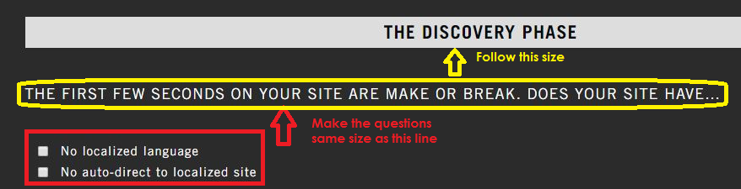

RESULTS PAGE:

* Increase copy size for “Your webstore’s cross border readiness…” and “It needs immediate attention” lines : Not Cleard

**Increase the font size as follows.**

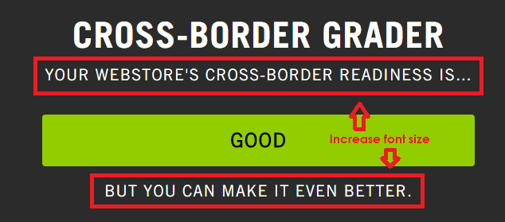

Increase space between callout and recommendations Not Clear

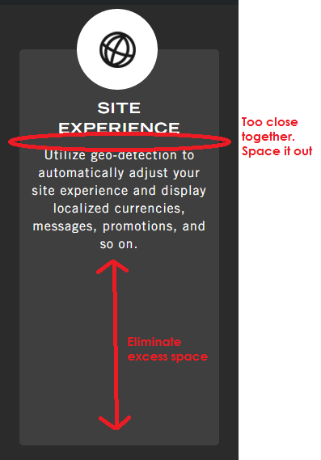

Also, the new Book Demo button is misaligned:

