**Position Paper**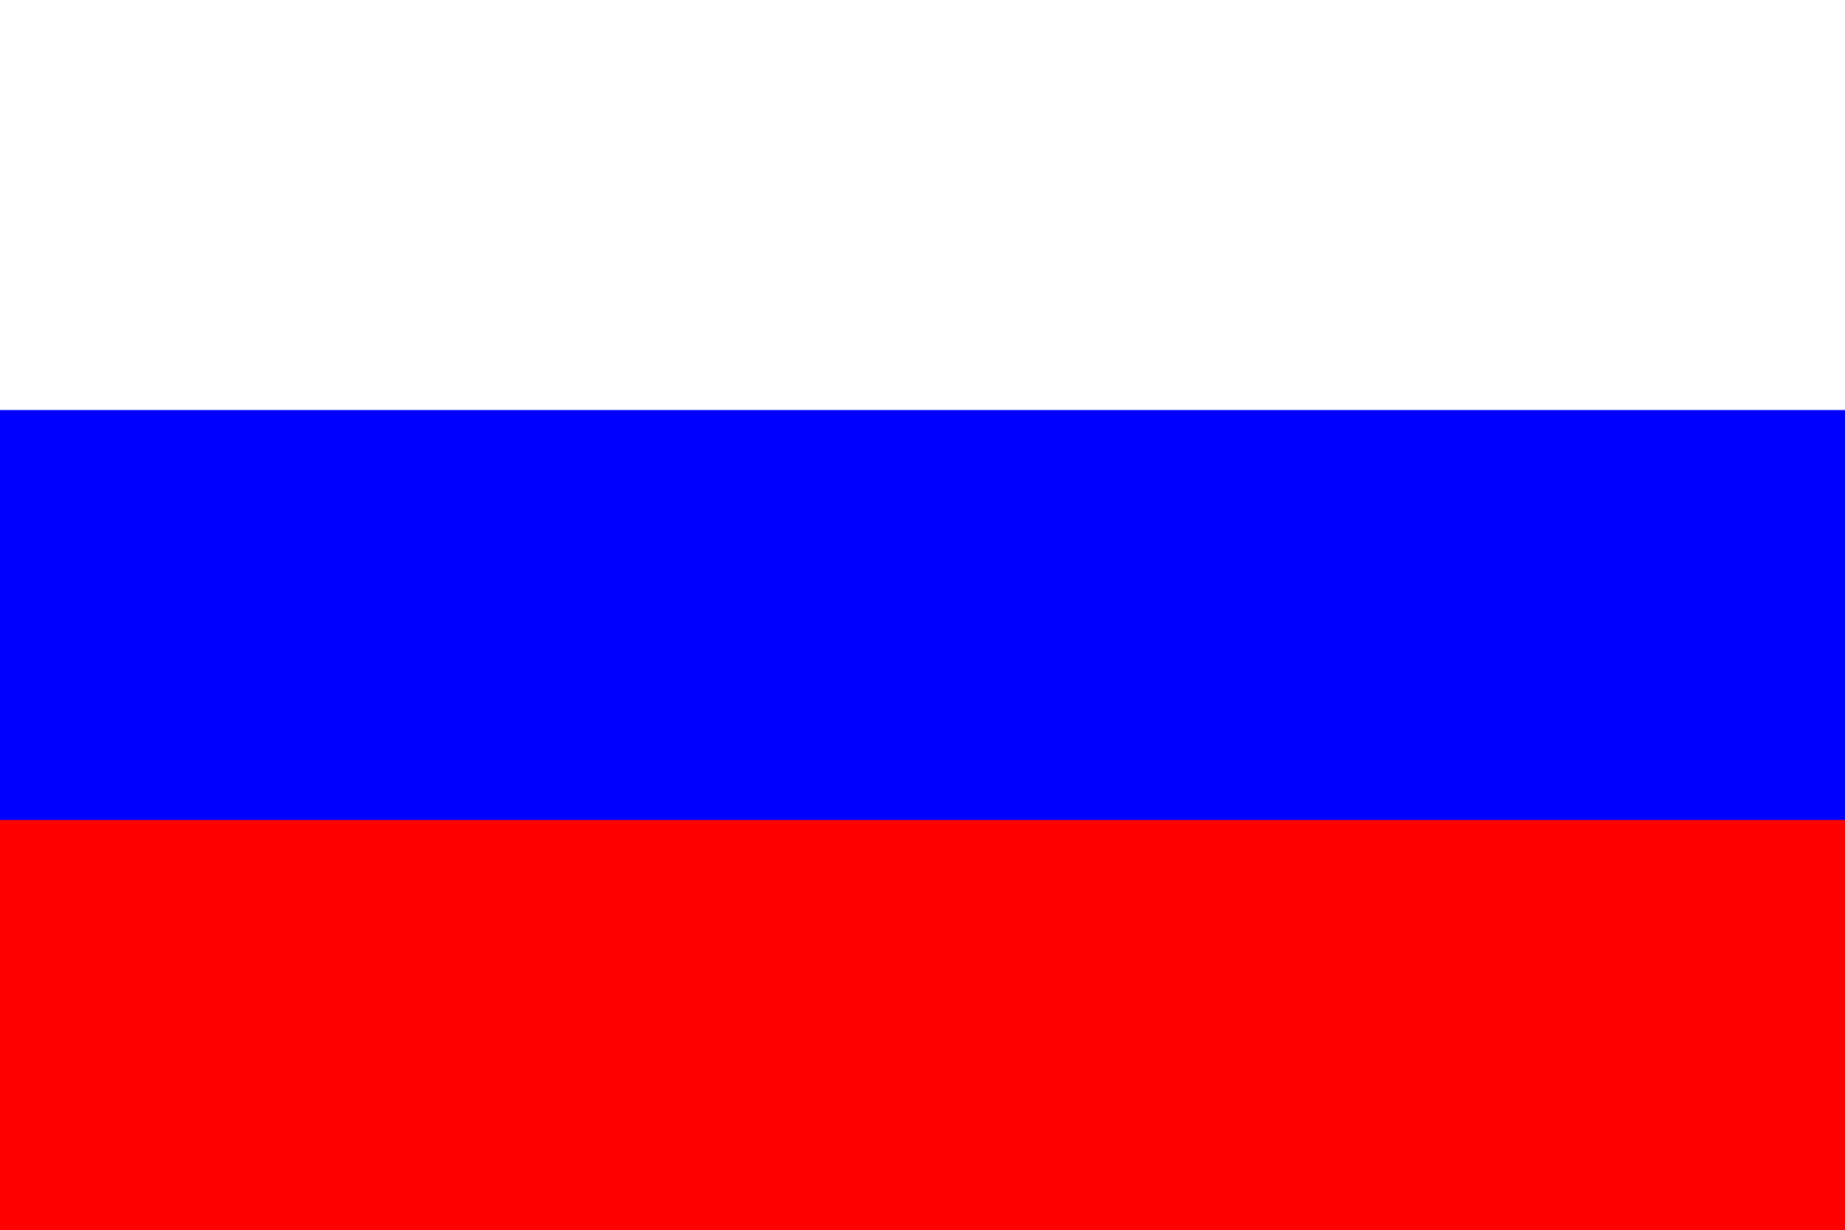

**Committee:** ECOSOC

**Country:** Russia

**Agenda:** Solving the Oligopoly Problem in the International Petroleum Markets to Reduce Embargoes

**Introduction**

The Russian Federation acknowledges the urgency and significance of addressing the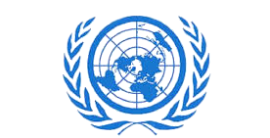 oligopoly problem in the international petroleum markets to mitigate embargoes and promote stability in global energy trade. As one of the world’s leading producers and exporters of petroleum, Russia is deeply invested in ensuring fair and equitable practices within the industry. However, it is essential to approach this complex issue with a comprehensive understanding of its root causes and potential solutions.

**Background**

The international petroleum market is dominated by a handful of major players, leading to oligopolistic tendencies that can distort pricing mechanisms and hinder market access for smaller producers. This oligopoly dynamic often exacerbates geopolitical tensions and can result in the imposition of embargoes or sanctions, disrupting global energy supply chains and contributing to economic instability.

**Russia’s Perspective**

Russia, a significant participant in the global petroleum business, supports a multilateral strategy to solve the oligopoly issue. Stability and resilience in the energy sector, in our opinion, can only be advanced by encouraging competition and diversification. While acknowledging the significance of striking a balance between domestic interests and international collaboration, Russia is dedicated to preserving the ideals of free trade and fair competition.

**Conclusion**

Embargoes could Impact in following areas:

• All countries will get affected by increase in products prices.

• Sectors like transport, industry and services will be more affected by the increases in oil and gas prices.

• Controlling inflation will be challenging for economic authorities all over the world.

• Poor African countries economy shall be badly impacted and overall supply chain will get affected which may lead to increase in hunger index.

While acknowledging the significance of striking a balance between domestic interests and international collaboration, Russia is dedicated to preserving the ideals of free trade and fair competition.

**Bibliography**

* [**https://www.sciencedirect.com/science/article/pii/S0301420723008255**](https://www.sciencedirect.com/science/article/pii/S0301420723008255)
* [**https://www.cia.gov/the-world-factbook/countries/russia/**](https://www.cia.gov/the-world-factbook/countries/russia/)