**Delegate Name:** Arjun Sunny

**Country:** BRAZIL

**Institution:** UNICEF (United Nations International Children’s Emergency Fund)

**Topic:** Providing Stable Medical Supplies to Regions in Need

**“Ensuring stable medical supplies to regions in need isn’t just a matter of logistics; it’s about safeguarding the basic right to health for every child, regardless of where they are born or live.”**

Brazil, as a member of UNICEF, recognizes the importance of providing stable medical supplies to regions in need, especially to vulnerable populations such as children. Access to necessary medical supplies is crucial for ensuring the health and well-being of children in critical and emergency situations. UNICEF has been in the lead regarding this issue, promoting initiatives to provide lifesaving vaccines, medications, and medical equipment to children, increase access to healthcare services, and reduce child mortality rates across the world. Brazil recognizes UNICEF's efforts and reinforces its commitment to supporting initiatives that promote every child's right and well-being, providing access to quality healthcare and necessary medical supplies. Further, Brazil's rich and lively culture, influenced by Indigenous, Portuguese, African, and immigrant communities, enriches its identity. Music, dance, cuisine, and traditions reflect the country's cultural diversity, which makes it a melting pot of cultures.

Brazil has taken great steps to improve its healthcare infrastructure and established laws and regulations focused on guaranteeing its citizens, especially children, access to dependable medical supplies. However, difficulties still exist, particularly in remote and underdeveloped regions where access to medical supplies is limited. According to statistical data, there are disparities in healthcare access and outcomes, with children from underprivileged groups often experiencing greater rates of malnutrition, deadly diseases, and preventable deaths. Brazil has implemented efforts to address these challenges by expanding basic medical services, investing in maternity and child health programs, and running vaccination campaigns. Brazil is home to several prominent non-governmental organizations (NGOs) and civil society groups working to address various social, environmental, and health-related issues. Some of the notable NGOs and civil society organizations in Brazil include- ISA, GIFE, DOCTORS WITHOUT BORDERS

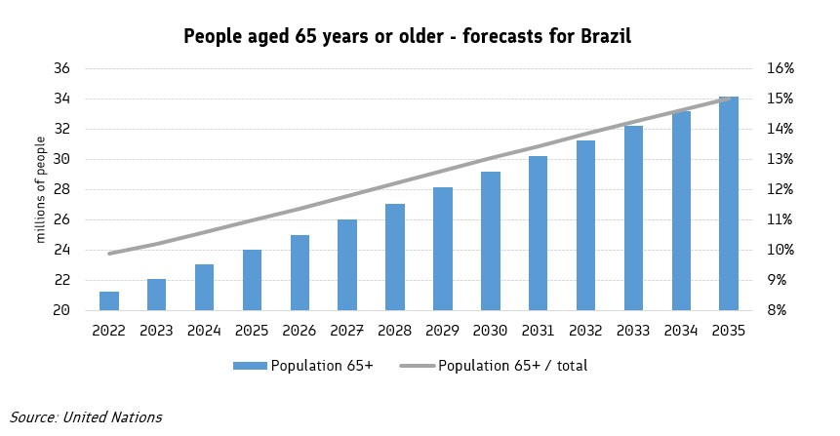

Brazil recommends a diverse strategy in solving the difficulty of providing stable medical supplies to regions in need. Firstly, Brazil promotes community-based healthcare efforts that prioritize preventive care, health education, and early treatment. Empowering local communities and healthcare providers can help address health disparities and lower the percentage of preventable diseases among children. Secondly, Brazil promotes using technology to improve supply chain management. This includes using data analytics, mobile health technology, and digital platforms to streamline medical supply purchase, distribution, and surveillance. Brazil further advocates for expanded international cooperation to develop health systems and build capacity for sustainable healthcare delivery in crisis-affected areas. Brazil collaborates with UNICEF and other partners to make sure that every child has access to the reliable medical supplies they need to thrive.

X - - - - - - - - - - - - - - - - - - - - - - - - - - - - - - - - - - - - - - - - - - - - - - - - - - - - - - - - - - - - - - - - - - - X

**BIBLIOGRAPHY**

<https://www.childfriendlycities.org/initiatives/brazil>

<https://www.unicef.org/lac/en/topics/brazil>

<https://www.unicef.org/supply/ensuring-quality>

<https://www.who.int/health-topics/ethics-and-health#tab=tab>

<https://www.unicef.org/social-policy/child-poverty>

<https://www.unicef.org/supply/education>

https://www.unicef.org/social-policy/programmes

<https://www.unicef.org/education/programmes>

https://www.transmonee.org/topics/child-rights

<https://www.unicef.org/eu/unicefs-development-aid-work-children>

https://www.unicef.org/reimagine/education