**ADMIN PANEL**

The administrator has complete control over the system. He or she has access to all of the hospital’s existing records. Patients, doctors, departments, treatment kinds, and medical records may all be managed by an administrator. A doctor’s account may only be created by an administrator. In order to do so, the administrator must also create accounts for the doctor in other hospital departments. All appointment records can also be seen by the administrator. In addition, the administrator must keep track of each patient’s treatment and payment information.

**DOCTOR’S PANEL**

The technology will be accessible to each doctor through their own personal account. All pending appointments may be viewed by the doctor here. There are choices available for the doctor to approve or deny each visit. The doctor can check the patient’s profile and appointment record after approving the appointment. For the remainder, the doctor must keep each patient healthy by prescribing the appropriate therapies.

**PATIENT’S ACCOUNT**

The user may log in to the system and monitor the status of their appointment after making it for the first time. Each appointment is set to pending by default. In order to begin their treatment procedure, the doctor must first authorize or reject it. Patients also have a right to cancel their appointments at any time.

**AVAILABLE FEATURES:**

* Admin Panel
* Doctor Panel
* Patient Panel
* Make Appointment
* Approve/Reject Appointments
* Payment Report
* Patient Report Panel
* Set Doctor’s Timing
* Set Doctor’s Personal Charge
* Update Profile

**REQUIREMENTS**

Project Name: Whitecliff Martenity and Clinic

Language/s Used: PHP

PHP version (Recommended): 5.6 or Newer

Database: MySQL

Type: Web Application, Website

**STEPS INVOLVED**

Step 1:Copy the source code folder and paste it into the xampp/htdocs folder.

Step 2: Open XAMPP

Open XAMPP and start the apache and MySQL

Step 3: Open your favorite Browser

Open a browser and go to URL “http://localhost/phpmyadmin/”

Step 4: Create a Database Name

Click on the databases tab and Create a database naming “whitecliff”.

Step 5: Import “whitecliff.sql” file

Click on browse file and select “whitecliff.sql” file which is inside the “Database” folder and after import click “Go“.

Step 6: Open a new tab and type the folder name “hms”

Open a browser and go to the URL “http://localhost/wmc/”.

Step 7:The final step, explore the system and you can manipulate the Patient, Doctor, and Admin accounts.

**Admin Account**

Username: 01

Password: admin123

**Doctor Account**

Username: 4

Password: mike1234

**Patient Account**

Username: 03

Password: patient01

**SITE SCREENSHOTS**

Home View



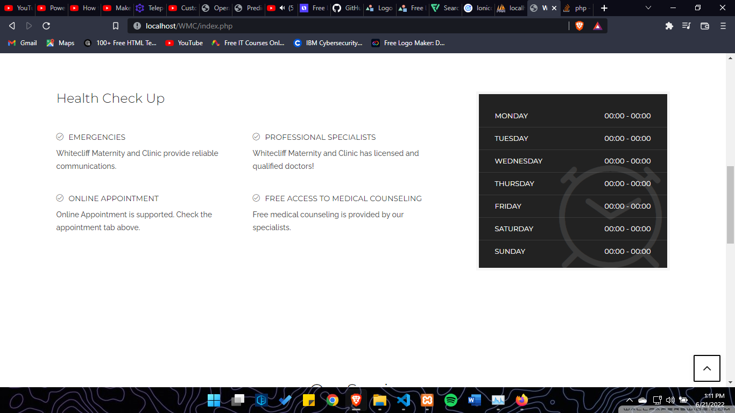

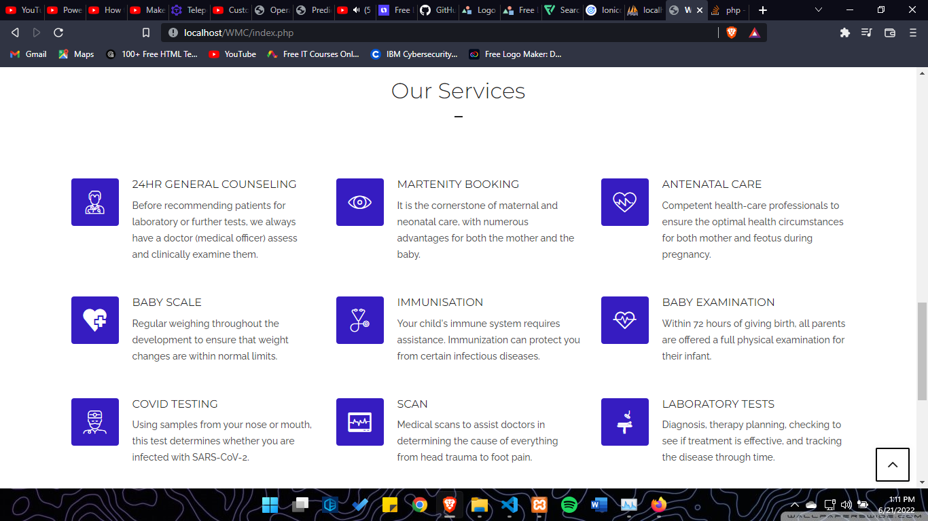

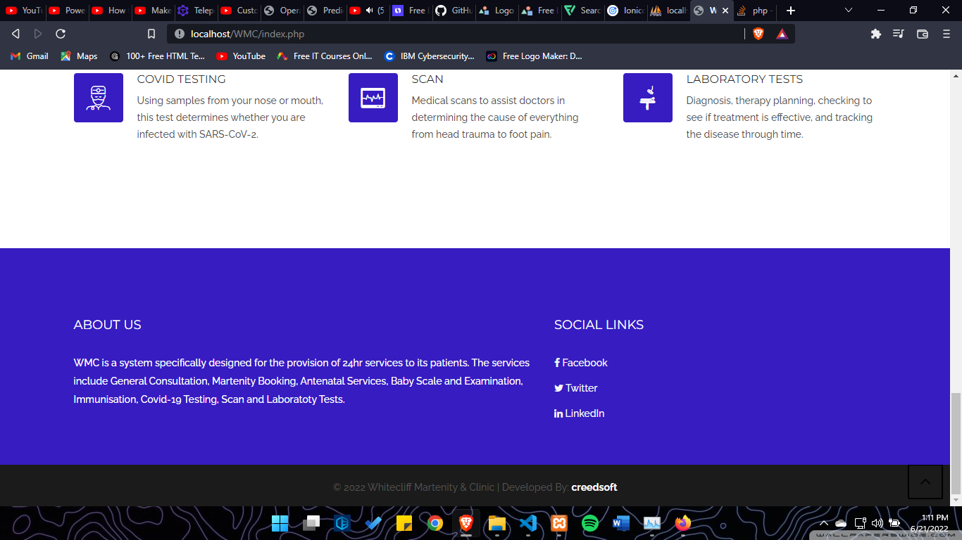

Login View (same design with Doctor and Patient login)

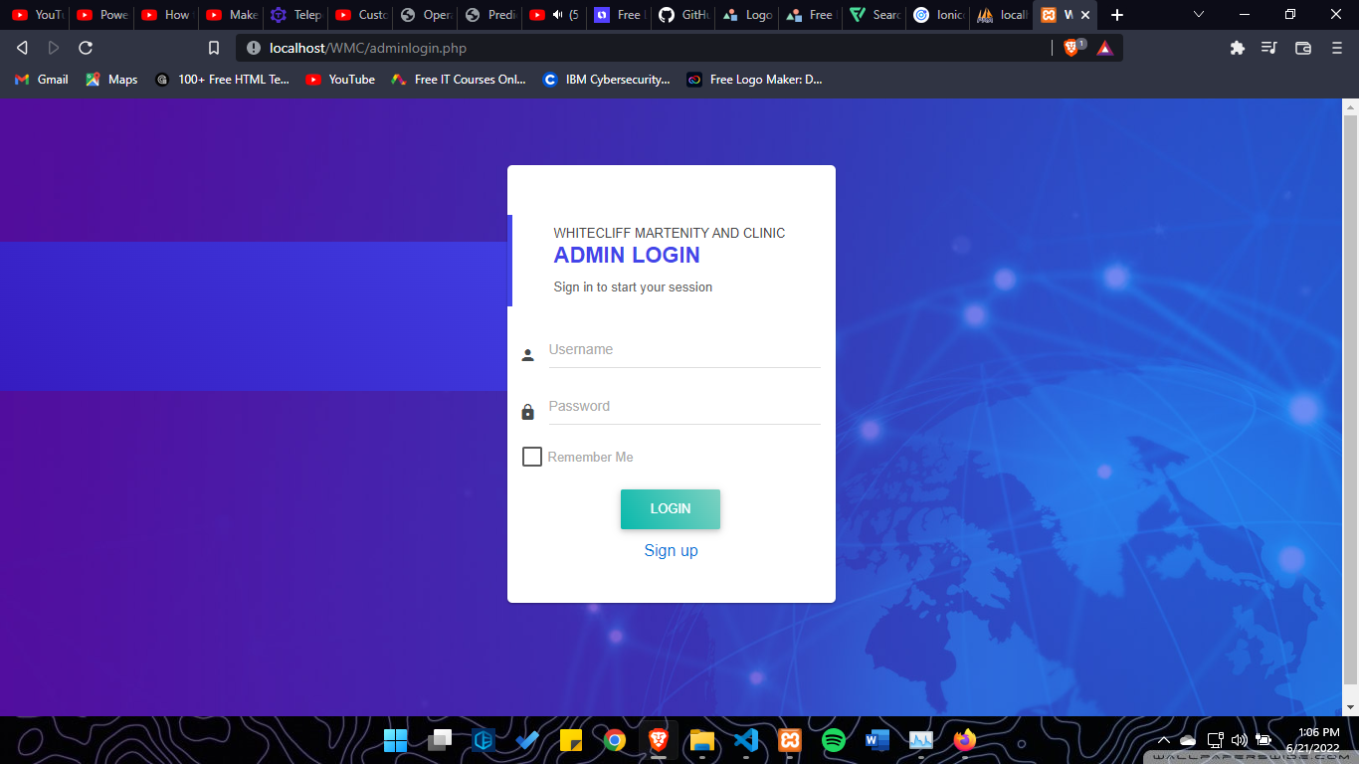

Inside View (same design applied on Doctor and Patient)

