A Short Introduction To Principal Component Analysis
David Goody

- Principal Component Analysis is a technique for understanding the level variance within a dataset and how much of this can be explain in a small number of components. The following graphic shows a simple two-dimensional example. The initial scatterplot has the points spread around. We can divide this up into a red line that explains most of the variance and then a green line drawn at right angles to the red line that explains the rest of the variance. There is no correlation between the red and green lines (this can be seen in how there is no pattern within the second charts).

- In dataset 2 (on the left) there is more variance in component 2 than in dataset 1 (the green line is bigger on the left than the right). In this case the second component is the noise that exists around a linear relationship.
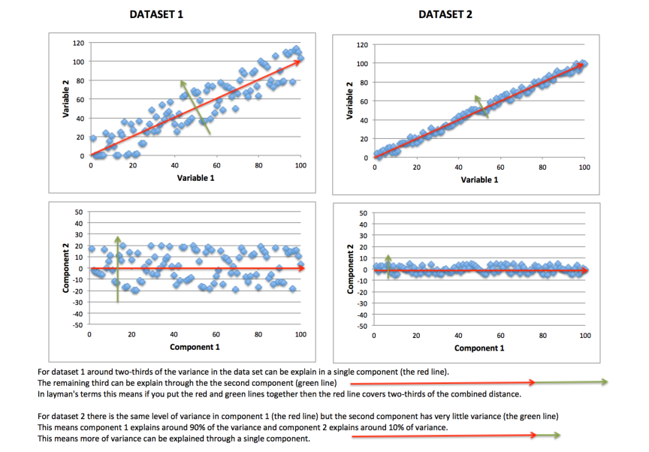

- This approach can be used for any number of variables. For each component the PCA procedure tells us
  - the amount of variance explained (the relative length of the line in the 2D example)
  - how closely each variable is correlated with this contribution (how closely each variable aligns with the line in the 2D example)

- The amount of variance explained is often pictured on a scree plot. Where the scree plot levels off is often used to determine the number of principal components you want to use. This scree plot can be shown as a line chart or a bar chart.

- The correlation values (or factor loadings) for each variable are between +1 and -1. With +1 or -1 meaning there is perfect correlation and 0 meaning the variable is not correlated at all with the component. By looking at the variables with high (towards +1) or low (towards -1) correlation values within a single component, you can see how which variables appear to be linked with each other. This helps understand the relationships within our dataset at a more detailed level than just looking at the correlation between 1 variable and all the others in a dataset.

- Principal component analysis can also be used to try and reduce the number of dimensions in your dataset by the following means:
  - replacing your source variables with the newly calculated components that explain the greatest variance –
  - by dropping variables make little contribution to the main components
  - where variables are highly correlated with each other (they contribute to the same components) only retaining one of these of a subset of them

- Principal component analysis is not typically used to look at the relationship with a dependent variable. So you may find that some variables explain a lot of variance in your dataset – but are not correlated with the indicator you are trying to measure.

Further Reading
Penn State - https://onlinecourses.science.psu.edu/stat505/node/49
PCA 4 Dummies - https://georgemdallas.wordpress.com/2013/10/30/principal-component-analysis-4-dummies-eigenvectors-eigenvalues-and-dimension-reduction/
Wikipedia - http://en.wikipedia.org/wiki/Principal_component_analysis

ANNEX A – Using Principal Component Analysis In R

#EXAMPLE OF APPLYING PRINCIPAL COMPONENT ANALYSIS IN R
#This example uses is based on the passenger list from the Titanic. We are trying to
#predict who survived and who died based on their age (Age), the fare they paid (Fare)
#gender (Female), embarkation point (South), how many siblings/spouses in each party (SibSp)
#how many parents/children in each passengers party (Parch)

#The dataset is used is publically available. It is the basis of a machine learning
#example on Kaggle (https://www.kaggle.com/c/titanic-gettingStarted).

####################################################################

#SET-UP
#Set the working directory where you will be loading and saving data from
setwd("/Users/datascientist3/Desktop/R Packages/Kaggle Titanic")
#Load Titanic dataset that we will train the data on
Titanic.Train <- read.csv("titanic_train_kaggle.csv", stringsAsFactors=FALSE)

#TIDY UP DATA TO ENABLE THE MODELS TO BE FITTED
#Convert text fields to dummy variables with 1/0 flags for use in equation
#Convert gender field into a 1/0 flag for female status
Titanic.Train$Female[Titanic.Train$Sex=='female'] <- 1
Titanic.Train$Female[Titanic.Train$Sex=='male'] <- 0
#Convert embarkation point 1/0 flag for those boarding at Southampton
Titanic.Train$South[Titanic.Train$Embarked=='S'] <- 1
Titanic.Train$South[Titanic.Train$Embarked!='S'] <- 0
#Over-write NA value for age with average as Lasso package can’t handle NA values
Titanic.Train$Age[is.na(Titanic.Train$Age)] <- 29.70

#Run Principal Component Analysis on the 6 relevant variables in the dataset
Titanic.Train.pc <- princomp(Titanic.Train[,c(6,7,8,10,13,14)], cor = TRUE, scores = TRUE)

#Generate a scree plot (the level of variance explained by each of the components)
plot(Titanic.Train.pc)
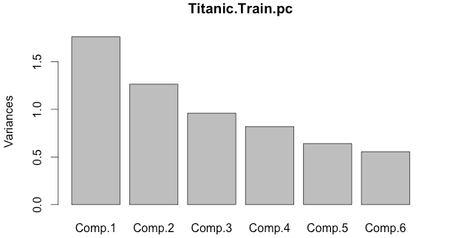

#If you want to see the exact standard deviation for each component use this
summary(Titanic.Train.pc)[[1]]

#Show factor loadings (values under 0.1 hidden)
loadings(Titanic.Train.pc)
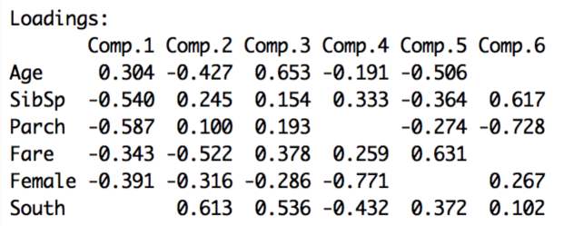
#If you want to see all the factor loadings use this
loadings(Titanic.Train.pc)[,1:6]

#Can also plot the principal component values (scores) for each individual case
plot(Titanic.Train.pc$scores[,1],Titanic.Train.pc$scores[,2],
xlab = "Component 1", ylab = "Component 2")