**C868 – Software Capstone Project Summary**

**Task 2 – Section C**

|  |  |
| --- | --- |
| **Capstone Proposal Project Name:** | http://www.idevnews.com/views/images/uploads/general/wgu_logo.png  The Massage Center – Scheduling Solution |
| **Student Name:** | Carol Reid |

Table of Contents

Task 2 Part C – C868 Software Development Capstone 5

Application Design and Testing 5

Design Document 5

Class Design 5

UI Design 6

Unit Test Plan 20

Introduction 20

Purpose 20

Log In Screen 20

Appointments Screen 21

Add An Appointment Screen 22

Modify An Appointment Screen 22

Clients Screen 23

Add A Client Screen 24

Modify A Client Screen 24

Monthly Appointments Report Screen 25

Therapist Schedules Screen 25

Client Appointments Report Screen 26

Overview 26

Test Plan 27

Items 27

Features 27

Deliverables 27

Tasks 28

Needs 28

Pass/Fail Criteria 28

Results 28

C4. Source Code 29

User Guide 29

Introduction 29

Installation and Updating the Database 29

Login Screen 30

Appointments Screen 31

Upcoming Appointment Alert 31

Filter Appointments 31

Add An Appointment 31

Modify An Appointment 32

Delete An Appointment 33

Sign Out 34

Clients Screen 34

Add A Client 34

Modify A Client 35

Delete A Client 36

Sign Out 36

Monthly Appointments Report 36

Therapist Schedules 37

Client Appointments Report 38

Search Client 39

Display Clients Appointments 39

Task 2 Part C – C868 Software Development Capstone

# Application Design and Testing

# Design Document

## Class Design

The image below represents the layout of the MySQL database in an Entity-Relationship Diagram (ERD). It contains six tables that the software uses to create, update and store data.

There are classes for each table represented in the ERD, along with a class for the menu, appointment time calculations, Java Database Connectivity (JDBC), and to validate content. The menu is visible on every screen and directs the user to a new screen when selected. Due to the complexity of restricting the available times for appointments, based on clients and therapists prohibited from having overlapping appointment's, the apptTime class handles all times provided when adding or modifying appointment's. The JDBC class securely facilitates the connection to the MySQL database and closes the connection when the user exits the program. Validation is confirmed on all data before being added to the database by checking that each entry meets the requirements of the database.

## UI Design

The user interface (UI) design includes ten layouts: Log In, Appointments, Add An Appointment, Modify An Appointment, Clients, Add A Client, Modify A Client, Monthly Appointments Report, Therapist Schedule, and Client Appointment Report. The application begins with a log in screen, prompting the user to enter their credentials.

Log In Screen: High Fidelity

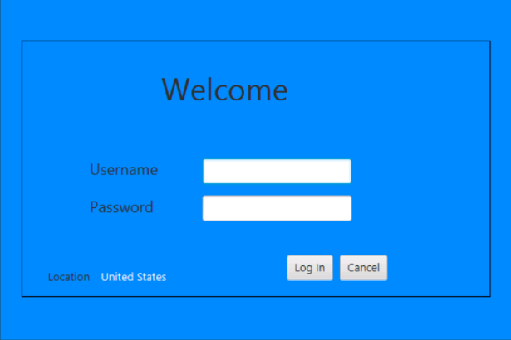

Log In Screen: Low Fidelity

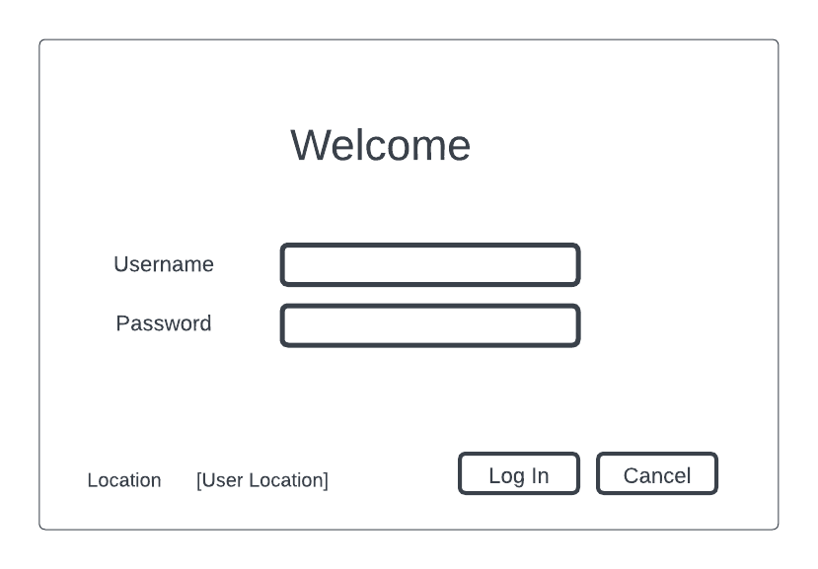

Once the user has entered a valid username and password, the Appointments screen will load. The appointments table will initially populate with all appointments but can be filtered to show the current week or month. Users can also add, modify, or delete appointments from the appointments screen. The menu provides easy access to the client pages, therapist schedules and reports.

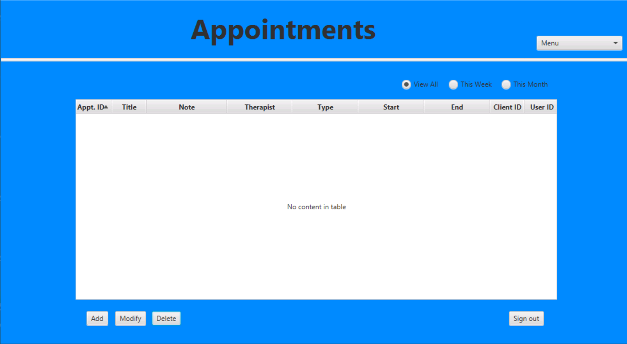

Appointments Screen: High Fidelity

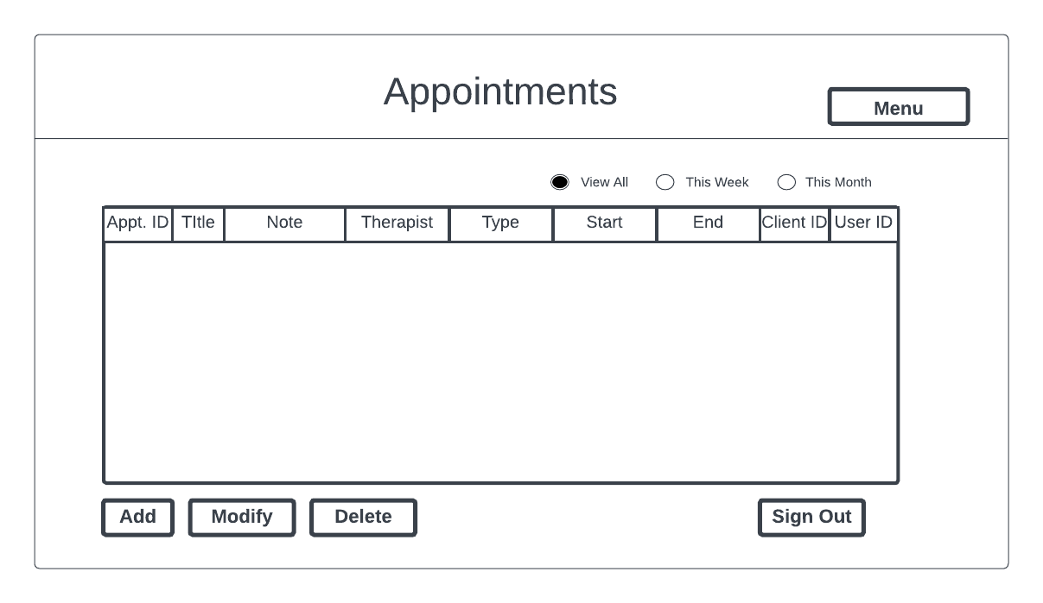

Appointments Screen: Low Fidelity

The user can click on the “Add” button or choose the screen name in the menu to get to the Add An Appointment screen. From there, the user can select the client, user, therapist, date, time, title, type, and note.

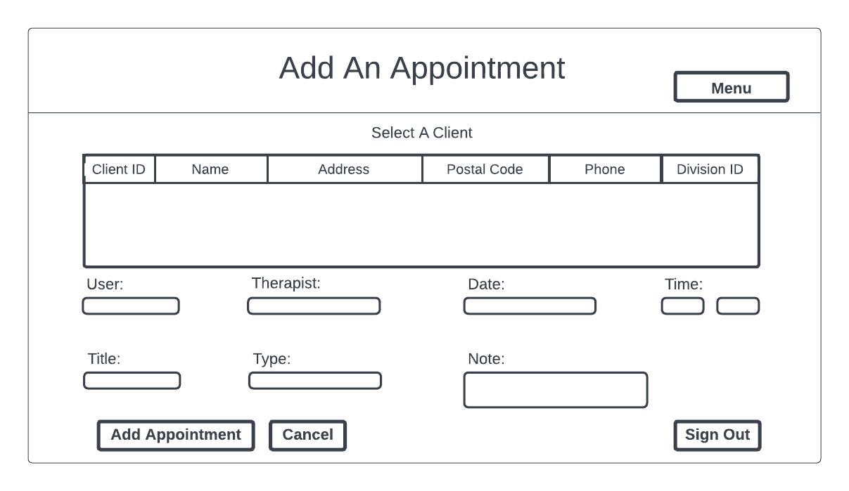

Add An Appointment Screen: Low Fidelity

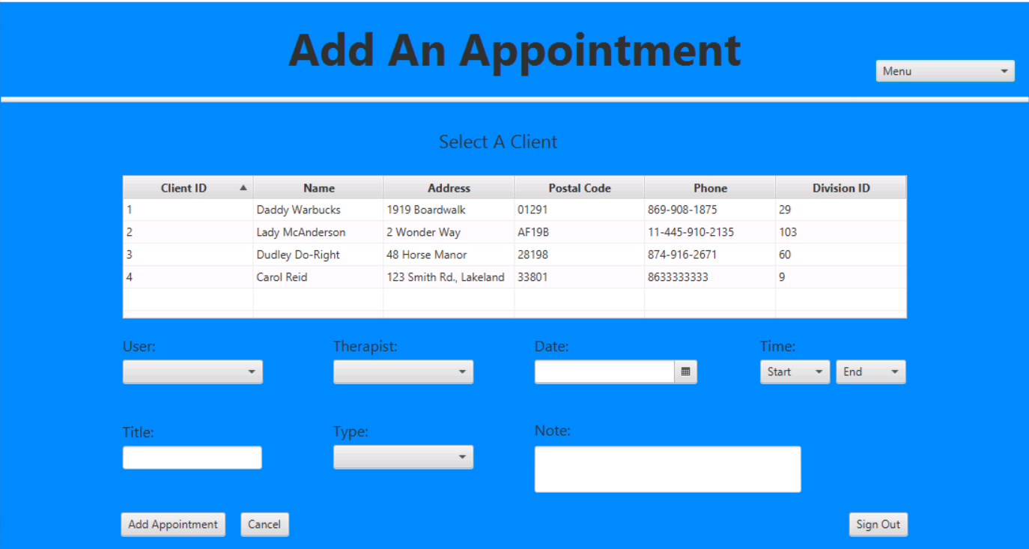

Add An Appointment Screen: High Fidelity

By choosing an appointment and clicking the “Modify” button on the Appointments screen, the Modify An Appointment screen will load and populate with the selected appointments information. The Modify An Appointment screen layout is the same as the Add An Appointment screen.

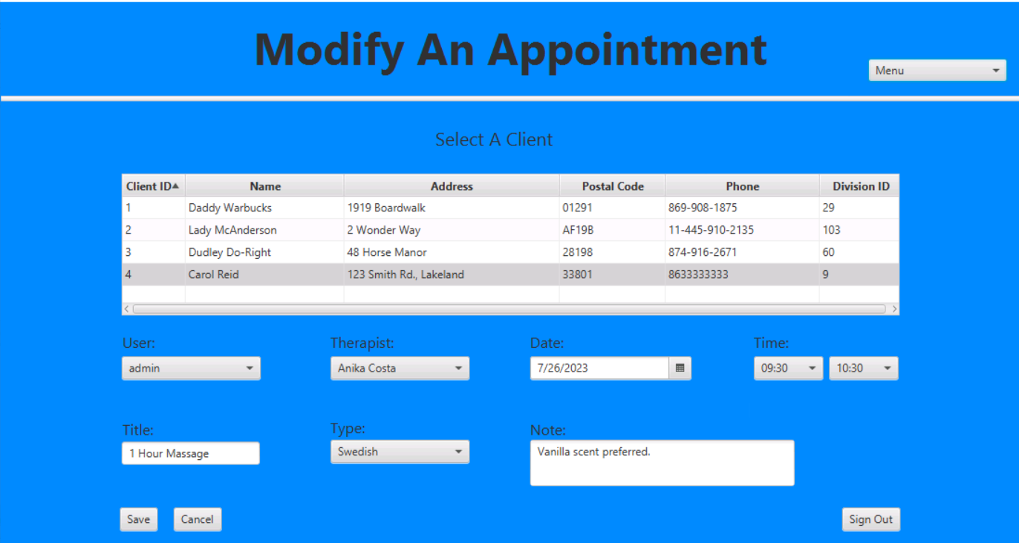

Modify An Appointment Screen: High Fidelity

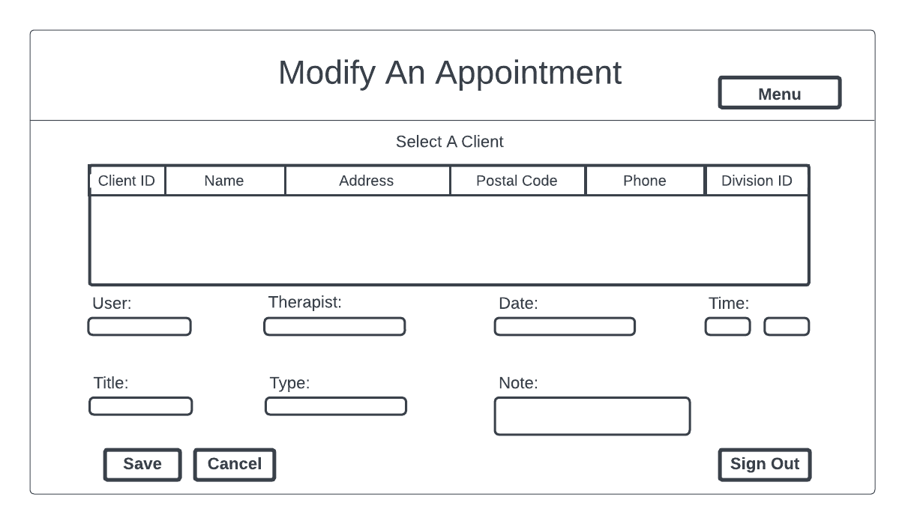

Modify An Appointment Screen: Low Fidelity

Users can access the Clients screen by using the menu and clicking the screen name. The clients table will populate with the information of all clients. From this screen, the user can add, modify, and delete clients.

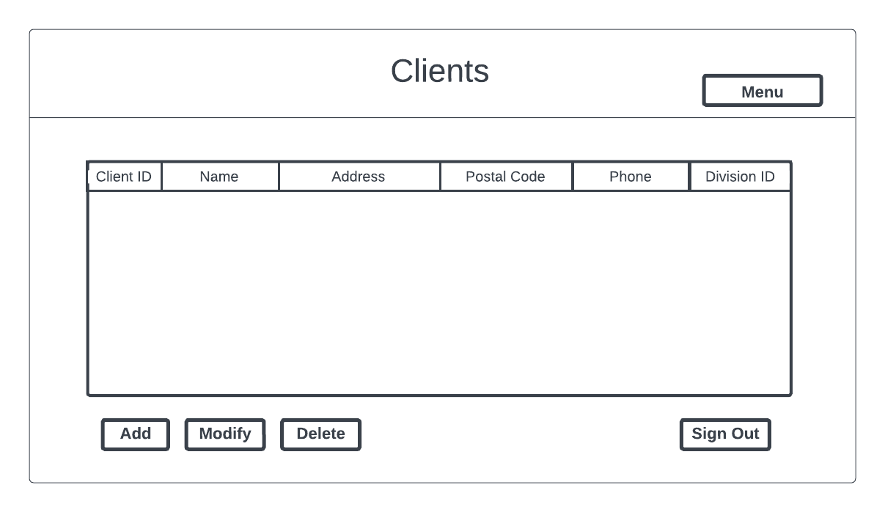

Clients Screen: Low Fidelity

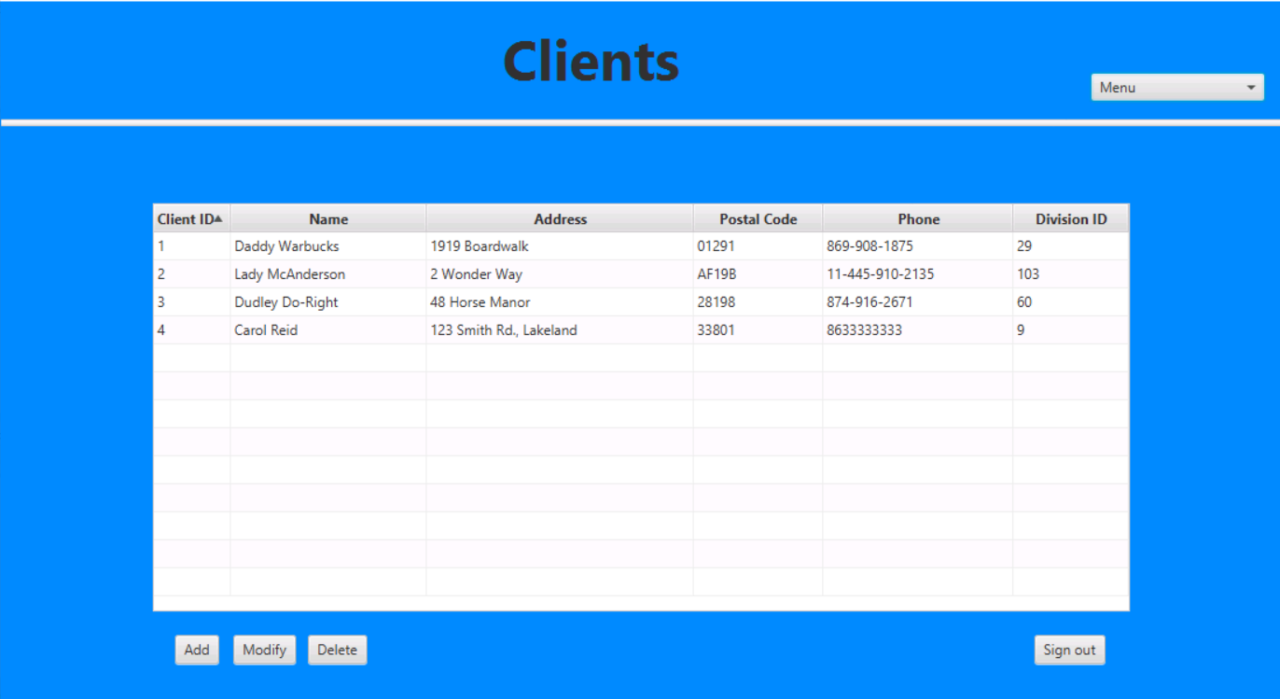

Clients Screen: High Fidelity

The user can click on the “Add” button or choose the screen name in the menu to get to the Add A Client screen. From there, the user can enter all of the client’s information.

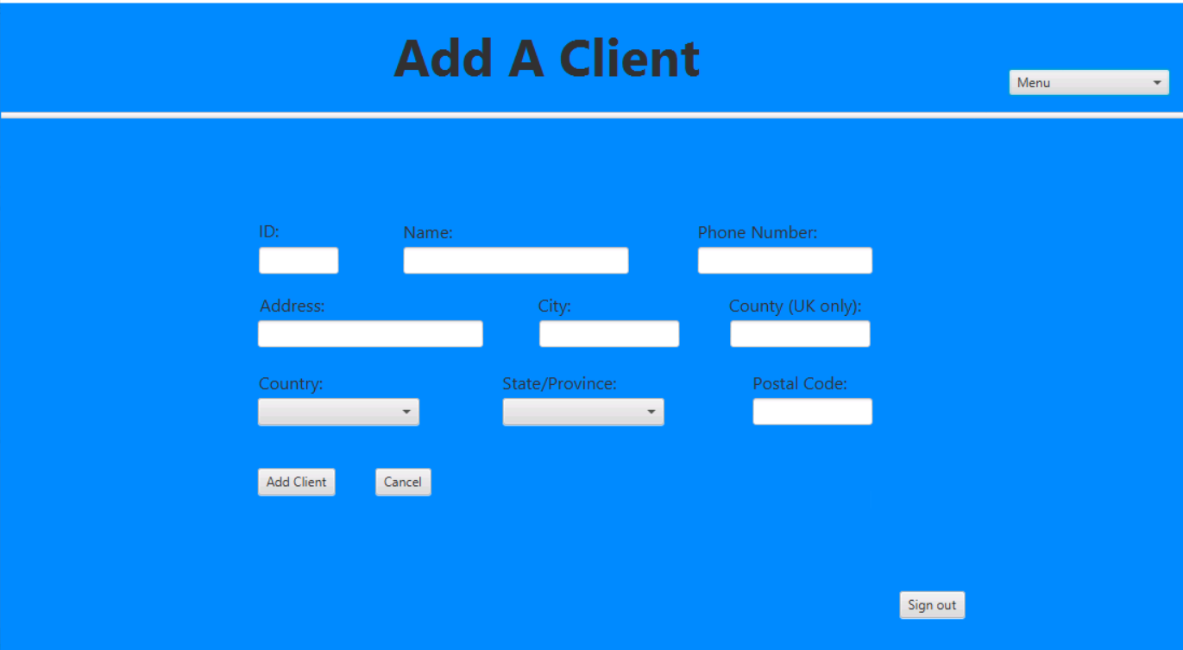

Add A Client Screen: High Fidelity

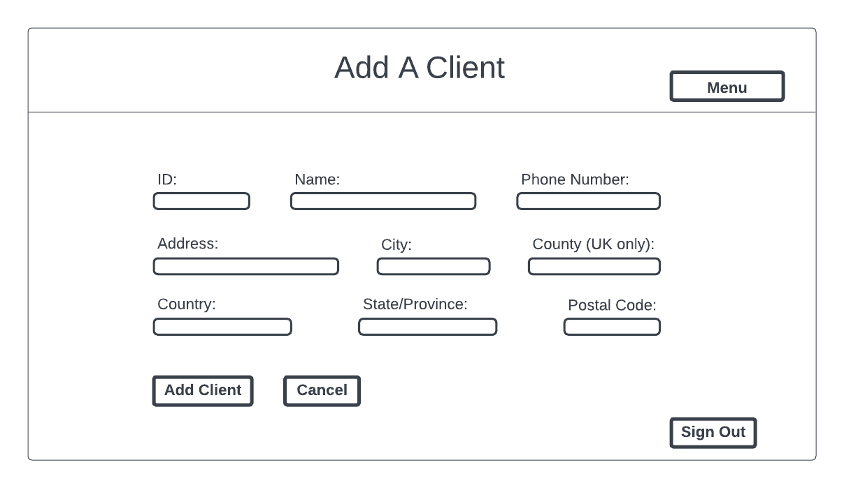

Add A Client Screen: Low Fidelity

By choosing a client and clicking on the “Modify” button on the Clients screen, the Modify A Client screen will load with the selected client information populated. The layout of the Modify A Client screen is the same as the Add A Client screen, but it is prepopulated.

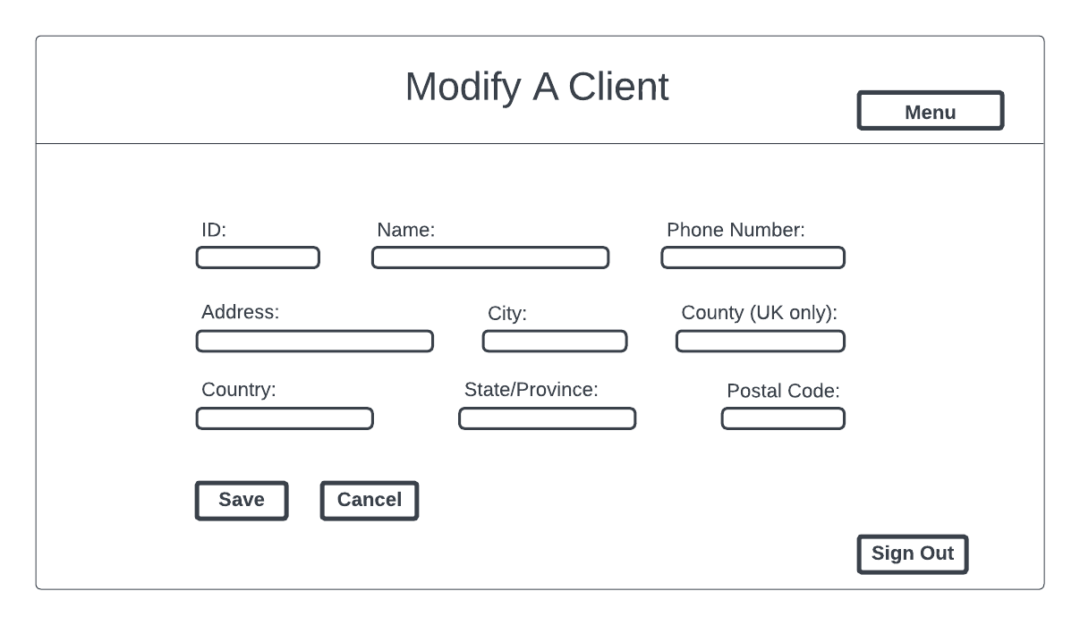

Modify A Client Screen: Low Fidelity

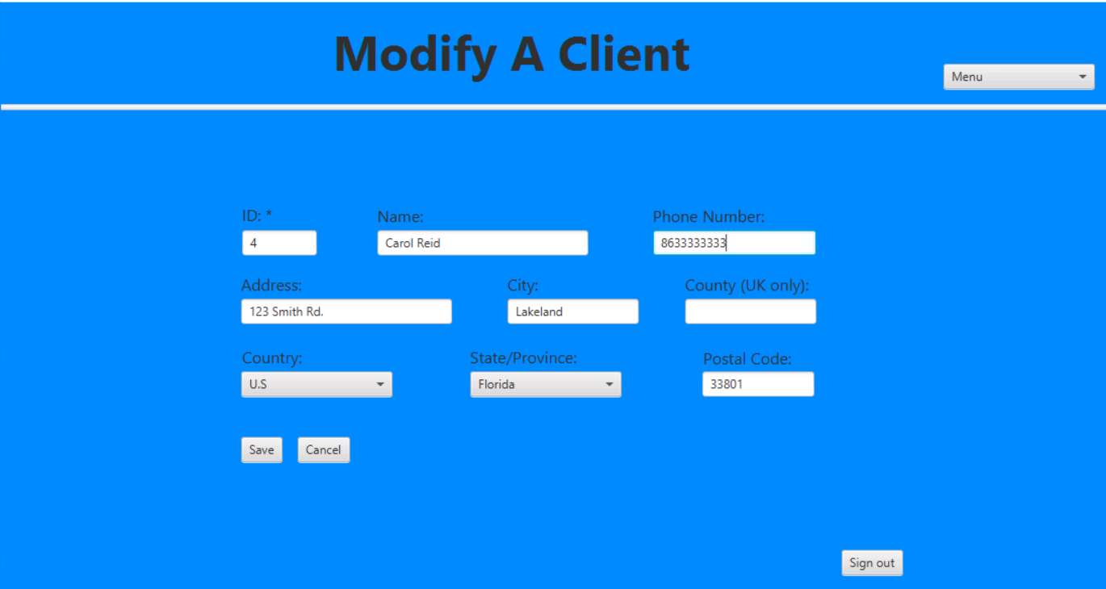

Modify A Client Screen: High Fidelity

Clicking on the menu and choosing “Monthly Appointments Report” will load that screen with the user’s current year and month prepopulated in the drop-downs with a bar chart. The bar chart shows the number of appointments for each treatment type.

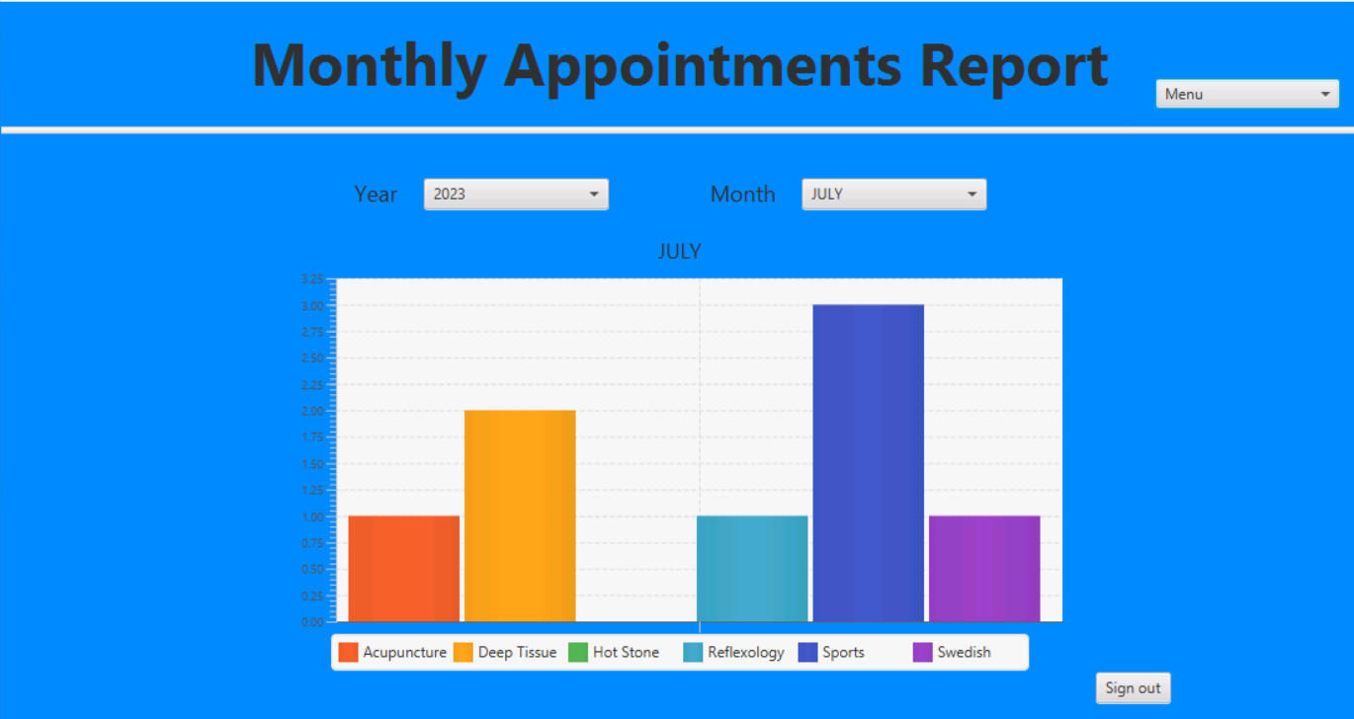

Monthly Appointments Report Screen: High Fidelity

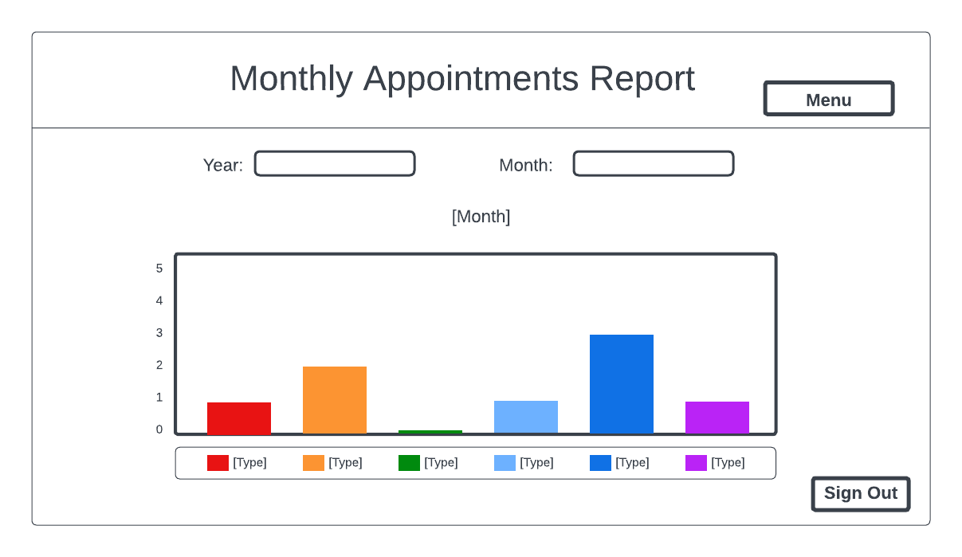

Monthly Appointments Report Screen: Low Fidelity

Clicking on the menu and choosing “Therapist Schedules,” the screen will load with a blank table and no selections made. The user can select a therapist and a date, which will populate the table with all appointments related to what the user selected.

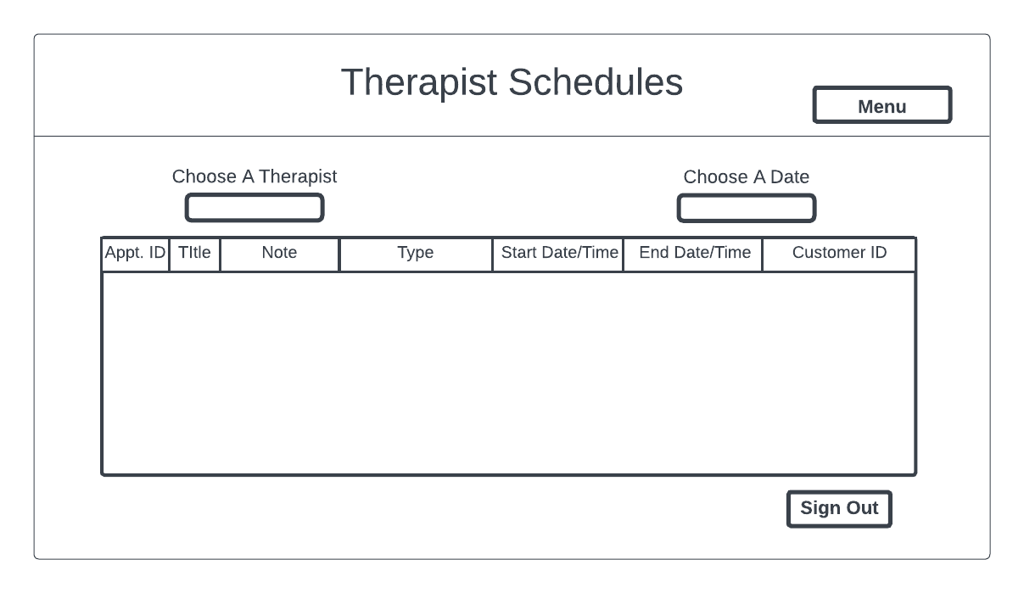

Therapist Schedules Screen: Low Fidelity

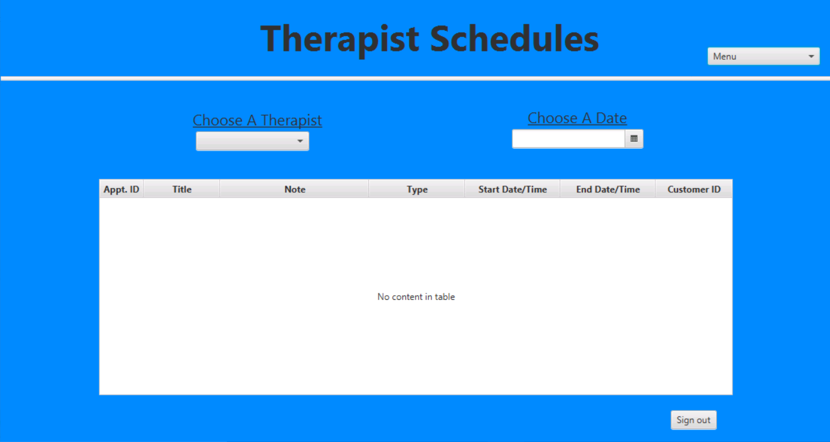

Therapist Schedules Screen: High Fidelity

Client Appointment Report Screen: Low Fidelity

Clicking on the menu and selecting “Client Appointments Report,” the screen will load with the top table prepopulated with all clients. By choosing a client, the bottom table will populate with all appointments associated with the client. There is a search area that can find clients by name or ID, providing quicker access for users.

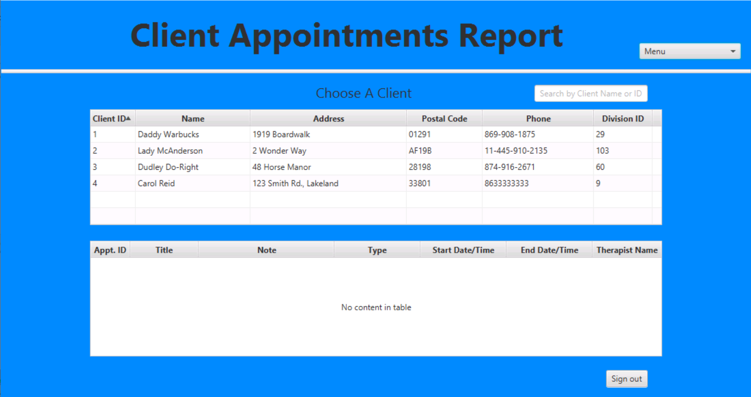

Client Appointment Report Screen: High Fidelity

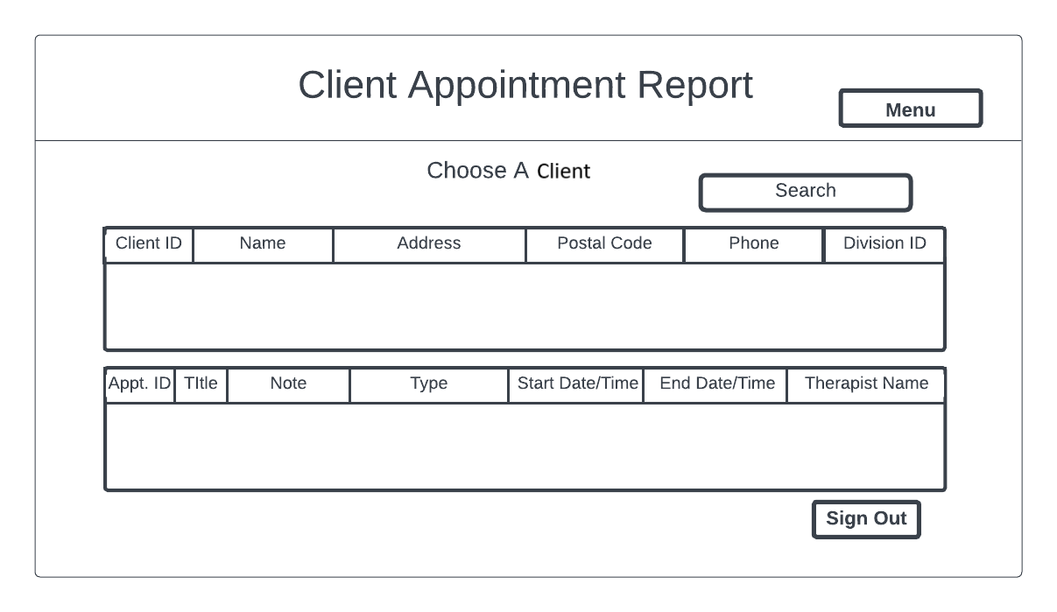

Client Appointment Report Screen: Low Fidelity

# Unit Test Plan

## Introduction

### Purpose

The purpose of the following manual tests is to evaluate how the application handles input from the user. Testing was performed through the application's User Interface (UI) to accurately test the users' experience while concurrently testing the functionality, validation, and error-handling capabilities. While each screen interacts with the application, each screen must be tested separately for errors to accurately pinpoint where each error exists and fix them when located. Once a screen passed all tests, it was integrated into the application and tested again to ensure it continued to pass all tests.

### Log In Screen

|  |  |  |  |  |  |
| --- | --- | --- | --- | --- | --- |
| **Test Case** | **Description** | **Test Steps** | **Expected Results** | **Actual Results** | **Pass/Fail** |
| 1 | Log in with valid username and password | 1. Enter username: “test”  2. Enter password: “test”  3. Click on “Log In” button | Log in is successful and upcoming appointment alert is displayed | Log in is successful and upcoming appointment alert is displayed | Pass |
| 2 | Log in with blank username and password | 1. Leave username and password blank  2. Click on “Log In” button | Log in is unsuccessful and blank username error is displayed | Log in is unsuccessful and blank username error is displayed | Pass |
| 3 | Log in with valid username and invalid password | 1. Enter username: “test”  2. Enter password: “invalid”  3. Click on “Log In” button | Log in is unsuccessful and invalid alert is displayed | Log in is unsuccessful and invalid alert is displayed | Pass |
| 4 | Exit Application | 1. Click on “Cancel” button | Application closes | Application closes | Pass |

### Appointments Screen

|  |  |  |  |  |  |
| --- | --- | --- | --- | --- | --- |
| **Test Case** | **Description** | **Test Steps** | **Expected Results** | **Actual Results** | **Pass/Fail** |
| 5 | Filter by current week | 1. Click on the radio button by “This Week” | Table shows appointments scheduled for current week | Table shows appointments scheduled for current week | Pass |
| 6 | Filter by current month | 1. Click on the radio button by “This Month” | Table shows appointments scheduled for current month | Table shows appointments scheduled for current month | Pass |
| 7 | Show all appointments | 1. Click on the radio button by “View All” | Table shows all appointments | Table shows all appointments | Pass |
| 8 | Add button | 1. Click on the “Add” button | Application loads Add An Appointment screen | Application loads Add An Appointment screen | Pass |
| 9 | Modify button with appointment selected | 1. Choose an appointment  2. Click on the “Modify” button | Application loads Modify An Appointment screen with selected appointment information populated | Application loads Modify An Appointment screen with selected appointment information populated | Pass |
| 10 | Modify button without appointment selected | 1. Click on the “Modify” button | Alert displayed and stayed on Appointment screen | Alert displayed and stayed on Appointment screen | Pass |
| 11 | Delete button | 1. Choose an appointment  2. Click on the “Delete” button  3. Click “OK” button | Confirmation alert works and appointment is removed from the table | Confirmation alert works and appointment is removed from the table | Pass |
| 12 | Sign Out button | 1. Click “Sign Out” button | Application closes | Application closes | Pass |

### Add An Appointment Screen

|  |  |  |  |  |  |
| --- | --- | --- | --- | --- | --- |
| **Test Case** | **Description** | **Test Steps** | **Expected Results** | **Actual Results** | **Pass/Fail** |
| 13 | Add Valid Appointment | 1. Enter valid information in all fields  2. Click “Add Appointment” button | Pop-up confirms appointment added and application loads Appointments screen | Pop-up confirms appointment added and application loads Appointments screen | Pass |
| 14 | Add Invalid Appointment | 1. Enter valid information in all fields except one  2. Click “Add Appointment” button | Blank alert appears and appointment is not added | Blank alert appears and appointment is not added | Pass |
| 15 | Cancel button | 1. Click “Cancel” button | Application loads Appointments screen | Application loads Appointment screen | Pass |
| 16 | Sign Out button | 1. Click “Sign Out” button | Application closes | Application closes | Pass |

### Modify An Appointment Screen

|  |  |  |  |  |  |
| --- | --- | --- | --- | --- | --- |
| **Test Case** | **Description** | **Test Steps** | **Expected Results** | **Actual Results** | **Pass/Fail** |
| 17 | Modify Valid Appointment | 1. Change one field of information  2. Click “Save” button | Pop-up confirms appointment modified and application loads Appointments screen | Pop-up confirms appointment modified and application loads Appointments screen | Pass |
| 18 | Modify Invalid Appointment | 1. Delete all information from one field  2. Click “Save” button | Blank alert appears and appointment is not modified | Blank alert appears and appointment is not modified | Pass |
| 19 | Cancel button | 1. Click “Cancel” button | Application loads Appointments screen | Application loads Appointments screen | Pass |
| 20 | Sign Out button | 1. Click “Sign Out” button | Application closes | Application closes | Pass |

### Clients Screen

|  |  |  |  |  |  |
| --- | --- | --- | --- | --- | --- |
| **Test Case** | **Description** | **Test Steps** | **Expected Results** | **Actual Results** | **Pass/Fail** |
| 21 | Add button | 1. Click “Add” button | Application loads Add A Client screen | Application loads Add A Client screen | Pass |
| 22 | Modify button with client selected | 1. Choose a client  2. Click “Modify” button | Application loads Modify A Client screen with selected client information populated | Application loads Modify A Client screen with selected client information populated | Pass |
| 23 | Modify button without client selected | 1. Click “Modify” button | Alert displayed and stayed on Clients screen | Alert displayed and stayed on Clients screen | Pass |
| 24 | Valid Delete | 1. Choose client  2. Click on the “Delete” button  3. Click “OK” button | Confirmation alert works and client is removed from the table | Confirmation alert works and client is removed from the table | Pass |
| 25 | Invalid Delete | 1. Choose client that has an associated appointment  2. Click on the “Delete” button | Error alert works and client is not removed | Error alert works and client is not removed | Pass |
| 26 | Sign Out button | 1. Click “Sign Out” button | Application closes | Application closes | Pass |

### Add A Client Screen

|  |  |  |  |  |  |
| --- | --- | --- | --- | --- | --- |
| **Test Case** | **Description** | **Test Steps** | **Expected Results** | **Actual Results** | **Pass/Fail** |
| 27 | Add A Valid Client | 1. Enter valid information in all fields  2. Click “Add Client” button | Pop-up confirms client added and application loads Clients screen | Pop-up confirms client added and application loads Clients screen | Pass |
| 28 | Add Invalid Client | 1. Enter valid information in all fields except one  2. Click “Add Client” button | Blank alert appears and client is not added | Blank alert appears and client is not added | Pass |
| 29 | Cancel button | 1. Click “Cancel” button | Application loads Clients screen | Application loads Clients screen | Pass |
| 30 | Sign Out button | 1. Click “Sign Out” button | Application closes | Application closes | Pass |

### Modify A Client Screen

|  |  |  |  |  |  |
| --- | --- | --- | --- | --- | --- |
| **Test Case** | **Description** | **Test Steps** | **Expected Results** | **Actual Results** | **Pass/Fail** |
| 31 | Modify Valid Client | 1. Change one field of information  2. Click “Save” button | Pop-up confirms client modified and application loads Clients screen | Pop-up confirms client modified and application loads Clients screen | Pass |
| 32 | Modify Invalid Client | 1. Delete all information from one field  2. Click “Save” button | Blank alert appears and client is not modified | Blank alert appears and client is not modified | Pass |
| 33 | Cancel button | 1. Click “Cancel” button | Client not modified and application loads Clients screen | Client not modified and application loads Clients screen | Pass |
| 34 | Sign Out button | 1. Click “Sign Out” button | Application closes | Application closes | Pass |

### Monthly Appointments Report Screen

|  |  |  |  |  |  |
| --- | --- | --- | --- | --- | --- |
| **Test Case** | **Description** | **Test Steps** | **Expected Results** | **Actual Results** | **Pass/Fail** |
| 35 | Verify correct information populated for current year and month | 1. Observe year selected  2. Observe month selected | Year and Month populated in dropdowns are current | Year and Month populated in dropdowns are current | Pass |
| 36 | Verify correct number of treatments displayed in bar chart | 1. Observe bar chart | Correct number of treatments represented in the bar chart | Correct number of treatments represented in the bar chart | Pass |
| 37 | Load different month in bar chart | 1. Choose year  2. Choose month  3. Observe bar chart | Correct number of treatments for new month represented in the bar chart | Correct number treatments for new month represented in the bar chart | Pass |
| 38 | Sign Out button | 1. Click “Sign Out” button | Application closes | Application closes | Pass |

### Therapist Schedules Screen

|  |  |  |  |  |  |
| --- | --- | --- | --- | --- | --- |
| **Test Case** | **Description** | **Test Steps** | **Expected Results** | **Actual Results** | **Pass/Fail** |
| 39 | Generate therapist schedule | 1. Choose therapist  2. Choose date | All appointments associated with selected therapist and date displayed in table | All appointments associated with selected therapist and date displayed in table | Pass |
| 40 | Sign Out button | 1. Click “Sign Out” button | Application closes | Application closes | Pass |

### Client Appointments Report Screen

|  |  |  |  |  |  |
| --- | --- | --- | --- | --- | --- |
| **Test Case** | **Description** | **Test Steps** | **Expected Results** | **Actual Results** | **Pass/Fail** |
| 41 | Verify correct appointments load for selected client | 1. Choose client in top table  2. Observe the appointments in bottom table | Appointments associated with selected client is displayed | Appointments associated with selected client is displayed | Pass |
| 42 | Search client name | 1. Enter client name in search bar  2. Hit enter on keyboard | Clients containing the name entered is displayed in top table | Clients containing the name entered is displayed in top table | Pass |
| 43 | Search client ID | 1. Enter client ID in search bar  2. Hit enter on keyboard | Client matching ID entered is displayed in top table | Client matching ID entered is displayed in top table | Pass |
| 44 | Sign Out button | 1. Click “Sign Out” button | Application closes | Application closes | Pass |

## Overview

In addition to the above unit testing, the development team performed iterative testing throughout the development lifecycle. As functions were developed and testing performed, if an error was detected, it would then be documented, assigned to a developer for correction, and upon completion, retested.

The development team diligently worked on and tested the validity of appointment times presented to the user when scheduling or modifying an appointment due to the complexity of appointment times when scheduling an appointment. Each test was checked for validity against the database to ensure that therapists and clients cannot have overlapping appointment times.

Every table, button, combo box, date picker, text field, search field, and bar chart has been thoroughly tested to ensure the application functions as intended and that all user input is accurately represented in the database.

## Test Plan

### Items

The following is the list of items required for the above test cases:

* A working environment with the application running
* Access to the database and knowledge of how to perform simple queries for comparing data accuracy
* Valid username and password
* Proper documentation at hand for error reporting, when appropriate
* Testing will continue until all tests are completed and have been passed

### Features

The usability and functional tests presented above have been performed within the application's UI and checked for validity and accuracy against the database. Each test unit is vital to the project and rigorously tested before being integrated into the others.

### Deliverables

A completed test results document includes all tests performed, the results, and documentation regarding all bugs and errors discovered during testing.

### Tasks

* Follow instructions for each unit test until completed.
* Provide documentation on every error and bug discovered, then assign developers to fix them.
* Iterate through the process until all bugs and errors are fixed.
* Testing will be completed once all unit tests result in a pass.

### Needs

* Access to the IntelliJ IDEA 2021.1.3(Community Edition) software located within the VM provided.
* Access and a connection to the MySQL database to verify the validity and accuracy of data entered in the UI.
* Java version 17.0.1 – provided within the VM
* JavaFX-SDK-17.0.1 – provided within the VM

### Pass/Fail Criteria

The test plan includes step-by-step instructions with detailed information about the expected test results, the actual test results and whether the test passed. Any deviation from the expected results within the actual results was documented and assigned to a developer to be corrected. Once the expected and actual results matched, the test was marked passed.

## Results

The unit tests provided were performed manually by a Quality Assurance (QA) member. Once all tests passed, regression testing was conducted on the entire application to ensure every screen functioned successfully as one cohesive program. At this time, all unit and regression tests were completed with a passing score, making the testing phase complete.

# C4. Source Code

The source code can be found within the FIXME.zip file.

# User Guide

## Introduction

This user guide provides the user with step-by-step instructions that will aid them in installing the application. Once installed, the guide shows users how to log in so that they may view, add, and modify appointments or clients within the GUI and how to generate monthly reports, client reports, and therapist schedules. Visual aids included are to confirm that the user's actions are correct. The application requires that the user’s operating system be Windows 10, and is connected to the VM found at: <https://lrps.wgu.edu/provision/270736724>

## Installation and Updating the Database

* Navigate to the zip folder containing the application - > Right click on the folder - > Extract All... - > Select a destination - > Extract
* Open IntelliJ - > File - > Open
* Locate and select the CapstoneCReid-master project folder - > OK
* Select where you would like to open the project - > OK
* File - > Project Structures - > Project
* Select Project SDK 17 version "17.0.1"
* Libraries - > + - > Java -> Locate and open javafx-SDK-17.0.1 - > select the lib folder - > OK - > OK
* + - > Java - > Locate and open the mysql-connector-java-8.0.25 folder - > select the .jar file - > OK
* SDKs - > 17 - > Apply - > OK
* Run - > Edit Configurations - > + - > Application
* Enter a name - > Click on Modify Options - > Add VM options
* Enter in the VM Options text field:

--module-path ${PATH_TO_FX} --add-modules javafx.base,javafx.controls,javafx.fxml,javafx.graphics,javafx.media,javafx.swing,javafx.web

* Enter in the Main Class text field: C195.Main - > Apply - > OK
* Open CarolReidCapstoneSQLQueries.txt
* Copy all text from CarolReidCapstoneSQLQueries.txt
* Open My SQL WorkBench
* Open a new tab to query the database
* Paste text into new query and hit the execute button

## Login Screen

1. Once the login screen is visible, enter:

Username: test Password: test

1. Click on the Sign In button to continue to the Appointments screen or the Cancel button to exit the application.

## Appointments Screen

### Upcoming Appointment Alert

* Once successfully logged in, a popup will display whether there is an appointment scheduled to begin within the next 15 minutes.
* Click the OK button to proceed to the appointments screen.

### Filter Appointments

By default, the appointment table will populate with all appointments. By changing the radio button selected, the appointment table will be filtered to display the appointments that fit the filtered requirements.

* View all: Displays all appointments
* This Week: Displays all appointments scheduled for the current week
* This Month: Displays all appointments scheduled for the current month

### Add An Appointment

1. Click on the Add button A screenshot of a computer

   Description automatically generated on the Appointments screen or choose the Add An Appointment selection within the menu located in the top right corner of the screen. A screenshot of a appointment form

   Description automatically generated
2. The Add An Appointment screen will load.

1. Select a client, user, therapist, date, start and end time, and type. Enter a title for the appointment and a note.
2. Click on the Add Appointment button to save the appointment.
3. Click on the Cancel button to return to the Appointments screen without saving the appointment.
4. Click on the Sign Out button to exit the application.

### Modify An Appointment

1. Click on the appointment that you would like to modify within the appointments table on the Appointments screen.
2. Click on the Modify button A screenshot of a computer

   Description automatically generated
3. The Modify An Appointment screen will load with the data from the selected appointment pre-populated in all fields.

1. You may change any of the information located on this screen to update the appointment.
2. Click on the Save button to save any changes made and return to the Appointments screen.
3. Click on the Cancel button to discard any changes and then return to the Appointments screen.
4. Click on the Sign Out button to exit the application.

### Delete An Appointment

1. Click on the appointment that you would like to delete within the appointments table on the Appointments screen.
2. Click on the Delete button. A screenshot of a computer

   Description automatically generated

### Sign Out

1. Click on the Sign Out button to exit the application. A screenshot of a computer

   Description automatically generated

## Clients Screen

1. To access the Clients screen, choose the All Clients selection within the menu located in the top right corner of any screen. A screenshot of a appointment form

   Description automatically generated

### Add A Client

1. Click on the Add button A screenshot of a computer

   Description automatically generated on the Clients screen or choose the Add A Client selection within the menu located in the top right corner of the screen. A screenshot of a appointment form

   Description automatically generated
2. The Add A Client screen will load.

3. Enter a name, phone number, address, city, county (if applicable), and postal code. Select a country and state/province.

4. Click on the Add Client button to save the client.

5. Click on the Cancel button to return to the Clients screen without saving the client.

6. Click on the Sign Out button to exit the application.

### Modify A Client

1. Click on the client that you would like to modify within the clients table on the Clients screen.
2. Click on the Modify button A screenshot of a computer

   Description automatically generated
3. The Modify A Client screen will load with the data from the selected client pre-populated in all fields.

4. You may change any of the information located on this screen to update the client.

5. Click on the Save button to save any changes made and return to the Clients screen.

6. Click on the Cancel button to discard any changes and then return to the Clients screen.

7. Click on the Sign Out button to exit the application.

### Delete A Client

1. Click on the client that you would like to delete within the clients table on the Clients screen.
2. Click on the Delete button. A screenshot of a computer

   Description automatically generated

### Sign Out

1. Click on the Sign Out button to exit the application.

## Monthly Appointments Report

1. To access the Monthly Appointments Report screen, choose the Monthly Appointments Report selection within the menu located in the top right corner of any screen. A screenshot of a appointment form

   Description automatically generated
2. The Monthly Appointments Report screen will load with the current month and year pre-populated along with the corresponding bar chart.

1. Choose a different year and/or month to view the corresponding bar chart for the appointments scheduled within the selected month and year.

## Therapist Schedules

1. To access the Therapist Schedules screen, choose the Therapist Schedules selection within the menu located in the top right corner of any screen. A screenshot of a appointment form

   Description automatically generated
2. The Therapist Schedules screen will load.

1. Choose a therapist and a date to view the scheduled appointments associated with the selected therapist and date.

## Client Appointments Report

1. To access the Client Appointments Report screen, choose the Client Appointments Report selection within the menu located in the top right corner of any screen. A screenshot of a appointment form

   Description automatically generated
2. The Client Appointments Report screen will load. By default, the Client Appointments Report screen will pre-populate the top table with all clients, and the bottom table will display no content.

### Search Client

1. Enter a client name or ID in the search field to filter the top table and only display the clients who meet the search criteria. A screenshot of a appointment report

   Description automatically generated

### Display Clients Appointments

1. Click on the client whose appointments you would like to view. All appointments associated with the selected client will populate in the bottom table.