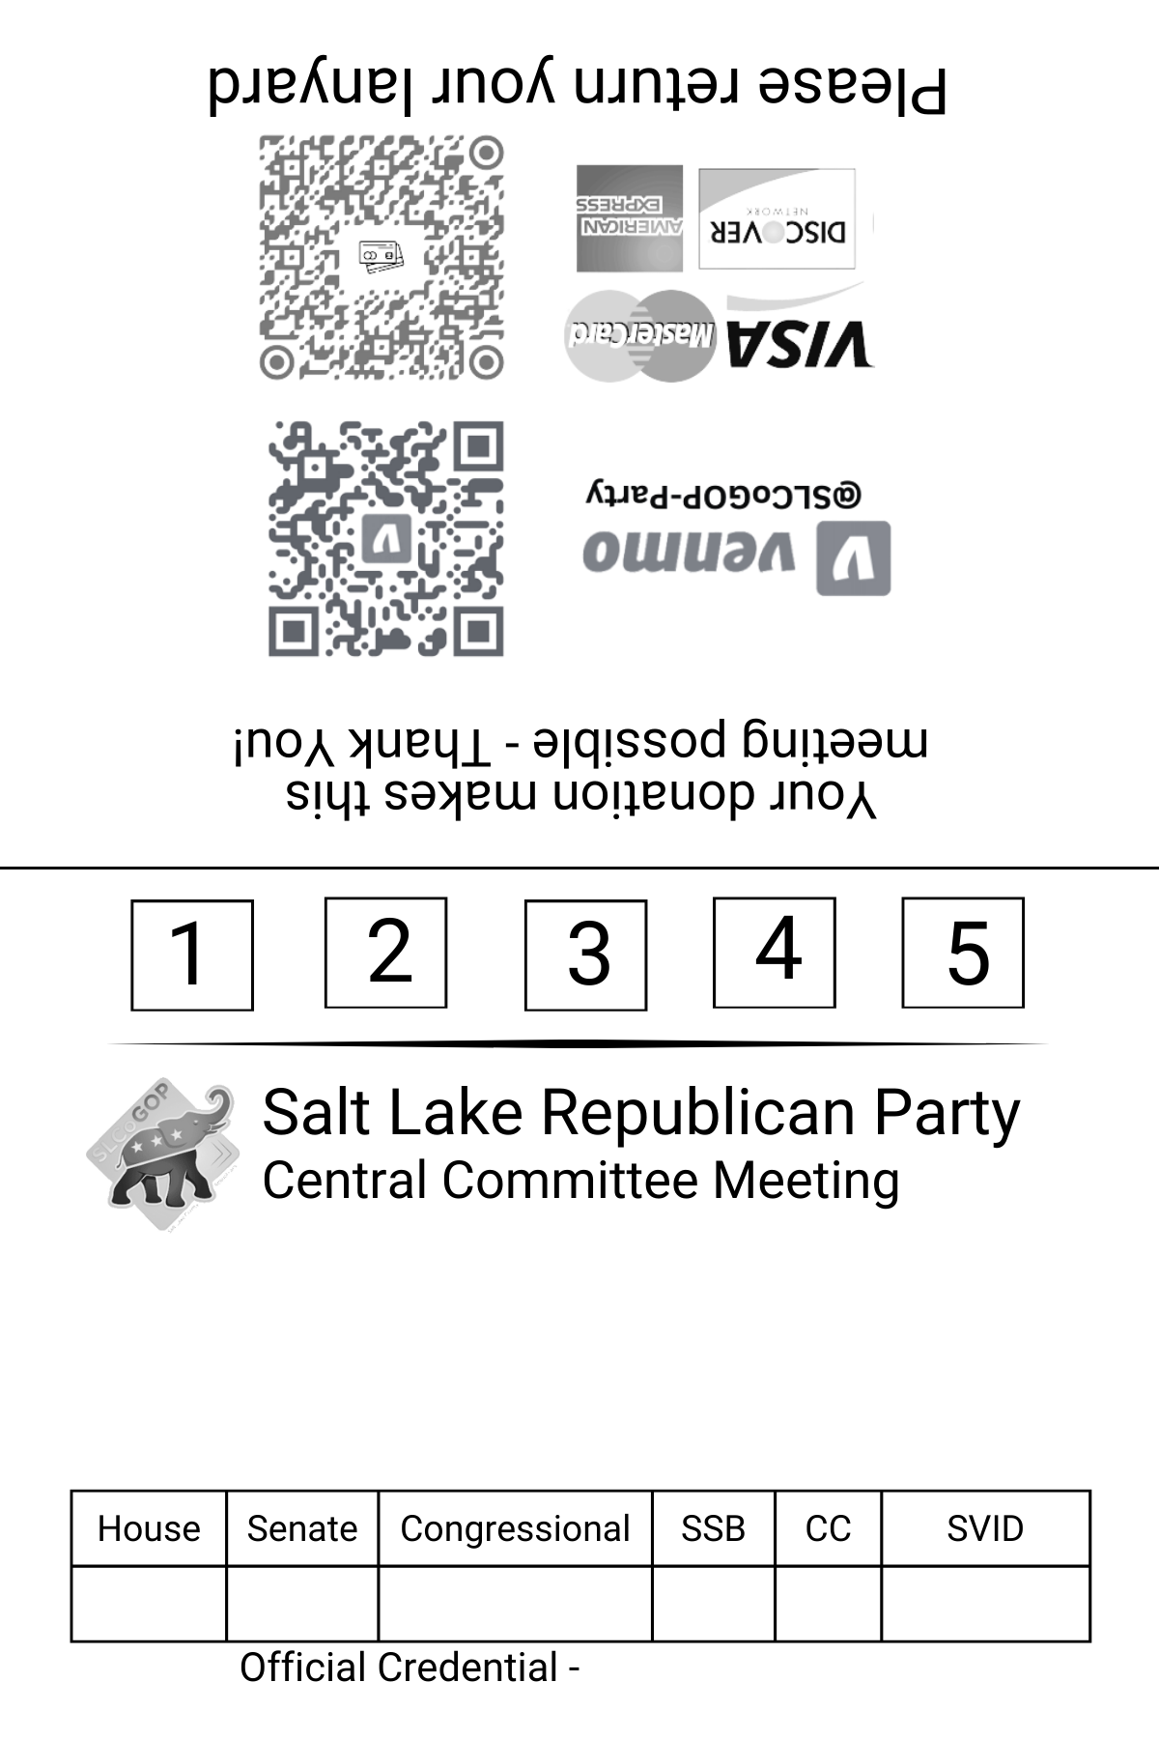

{{first_name}} {{last_name}}  
{{title}}

{{precinct}} / {{caucus_precinct}}

{{house_district_1}}

{{senate_district_1}}

{{congressional_district_1}}

{{state_school_board_1}}

{{county_council_1}}

{{state_voter_id}}

{{eventDate}}