Monthly Lesson Completion Report
June 2026

From: CREOLEAP TECHNOLOGIES PVT LTD
Month: June 2026
Submitted by: demo1

School Information
School Name: Creoleap International School
Class/Grade: 3,A, 4,A, 9,A, 1,A, 1,B, 8,A, 2,B, 10,A
Subject/Program: Embed, AI Integrated STEM Robotics, Python for grade VIII, IGNITE
No. of Sessions/Periods Planned: 50
No. of Sessions/Periods Completed: 3

Session Summary
Date | Class/Section | Chapter Name | Topic Name | Remarks
1 June 2026 | 3–A | Embed
1 June 2026 | 4–A | AI Integrated STEM Robotics
1 June 2026 | 9–A | AI Integrated STEM Robotics
2 June 2026 | 1–A | AI Integrated STEM Robotics
3 June 2026 | 1–B | AI Integrated STEM Robotics
4 June 2026 | 3–A | AI Integrated STEM Robotics
4 June 2026 | 8–A | AI Integrated STEM Robotics
5 June 2026 | 8–A | Python for grade VIII
5 June 2026 | 8–A | AI Integrated STEM Robotics
5 June 2026 | 2–B | IGNITE
5 June 2026 | 2–B | AI Integrated STEM Robotics
5 June 2026 | 10–A | AI Integrated STEM Robotics
8 June 2026 | 3–A | Embed
8 June 2026 | 4–A | AI Integrated STEM Robotics
8 June 2026 | 9–A | AI Integrated STEM Robotics
9 June 2026 | 1–A | AI Integrated STEM Robotics
10 June 2026 | 1–B | AI Integrated STEM Robotics
11 June 2026 | 3–A | AI Integrated STEM Robotics
11 June 2026 | 8–A | AI Integrated STEM Robotics
12 June 2026 | 8–A | Python for grade VIII
12 June 2026 | 2–B | IGNITE
12 June 2026 | 2–B | AI Integrated STEM Robotics
12 June 2026 | 10–A | AI Integrated STEM Robotics
15 June 2026 | 3–A | Embed
15 June 2026 | 4–A | AI Integrated STEM Robotics
15 June 2026 | 9–A | AI Integrated STEM Robotics
16 June 2026 | 1–A | AI Integrated STEM Robotics
17 June 2026 | 1–B | AI Integrated STEM Robotics
18 June 2026 | 8–A | Chapter 1: Lists in Python | 1.2 - List - Video, 1.3 - List in Python - Program
18 June 2026 | 8–A | AI Integrated STEM Robotics
19 June 2026 | 8–A | Python for grade VIII
19 June 2026 | 2–B | IGNITE
19 June 2026 | 2–B | AI Integrated STEM Robotics
19 June 2026 | 10–A | AI Integrated STEM Robotics
22 June 2026 | 3–A | Embed
22 June 2026 | 4–A | AI Integrated STEM Robotics
22 June 2026 | 9–A | AI Integrated STEM Robotics
23 June 2026 | 1–A | AI Integrated STEM Robotics
24 June 2026 | 8–A | Chapter 1: Introducing Robotics & Kit Overview | 1.1 - Introduction to Robotics and Kit Overview
24 June 2026 | 1–B | AI Integrated STEM Robotics | test
25 June 2026 | 3–A | AI Integrated STEM Robotics
25 June 2026 | 8–A | AI Integrated STEM Robotics
26 June 2026 | 8–A | Python for grade VIII
26 June 2026 | 2–B | IGNITE
26 June 2026 | 2–B | AI Integrated STEM Robotics
26 June 2026 | 10–A | AI Integrated STEM Robotics
29 June 2026 | 3–A | Embed
29 June 2026 | 4–A | AI Integrated STEM Robotics
29 June 2026 | 9–A | AI Integrated STEM Robotics
30 June 2026 | 1–A | AI Integrated STEM Robotics
Submitted on: 23 June 2026
 | 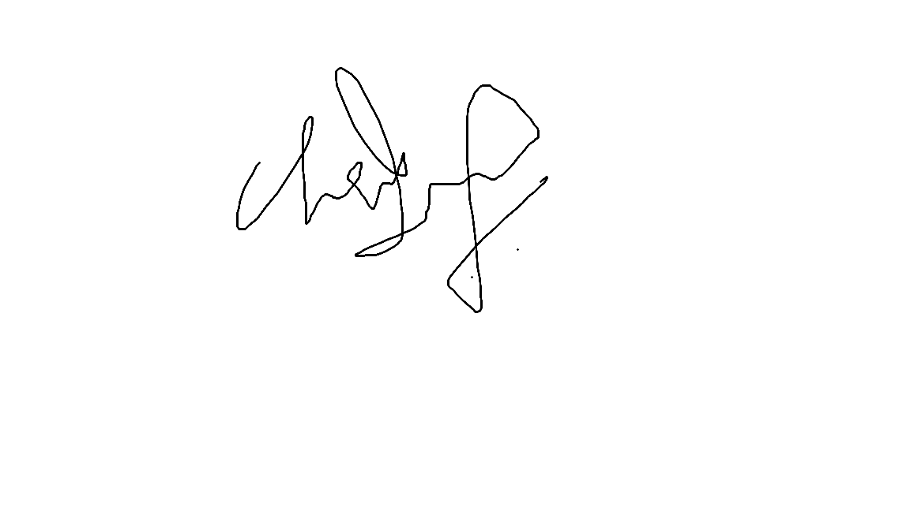
Principal's Signature | Trainer's Signature

